Certificate of e-Project Completion

Car-Breezy Automobile Website

September 2022

BY

* Ugwoke Ifenna => Student1360530
* Ezeaku Blessing => Student1368629
* Udechukwu Ebuka => Student1434698
* Emeka Iheonu
* Chimaobi => Student1434704

TABLE OF CONTENTS

Acknowledgment --------------------------------------- 3

Problem Definition--------------------------------------- 4

E-Project Specification ---------------------------------- 5

System Design--------------------------------------------- 7

Process Diagram ----------------------------------------- 8

Web Forum Screenshots ------------------------------- 9

Source Code ---------------------------------------------- 12

**ACKNOWLEDGMENT**

I on behalf of my team would like to thank God Almighty for his grace and blessings and aspirations throughout the challenging times on this e-project.

To all those who have given us moral support and helped us make this project a success.

I also express my sincere gratitude to my project guide, for his guidance and support for the completion of this project.

And finally, thanks to all my colleagues for their valuable suggestions and supportive feedback.

**Problem Definition**

Car-Breezy is a leading automotive digital market place that seeks to make car buying and selling easy, transparent and efficient.

From discovery to delivery, consumers can use Car Breezy to explore vehicles from an expansive, cross-brand selection of inventory from our vast network.

Car Breezy has built a trusted brand and a strong reputation for providing consumers with useful tools, research, market context and pricing transparency as they embark on their car buying journey.

We built this app to make car buying as fast and easy as possible.

**E-Pro****ject Specifications**

* The website should provide user friendly environment and navigation.
* The important menu must be stated in the top section of the webpage.
* The website is a single-page application and responsive

**Hardware Requirements**:

* Intel Core i3/i5 Processor or higher
* 8 GB RAM or above
* 500 GB Hard disk space
* Color SVGA
* Mouse
* Keyboard

**Software**: Technologies to be used

* Frontend: HTML5, CSS, Bootstrap, JavaScript, jQuery, AngularJS, XML
* Data Store: JSON files or TXT files

**Other Requirements:**

* Operating portal: Windows
* Browsers: Edge, Chrome, Mozilla Firefox, Safari.

System design

Car Breezy is designed as a single-page-application with a basic front end to enable easy and user friendly interface where potential users can navigate through the page to get a view and understand what Car Breezy is all about to help encourage users to believe in Car Breezy. The menu options change color on hover and after clicking. The first section details all about most sort after car in in the automobile market. It also includes details of the car specifications, types/styles, brands, and prices.

**Process Diagram**

**HOME**

USER

**Popular Vehicles**

**Featured Cars**

**Car Services**

**News letter**

**Gallery**

**End Process**

**Web Forum Screenshots**

**Home Section:**

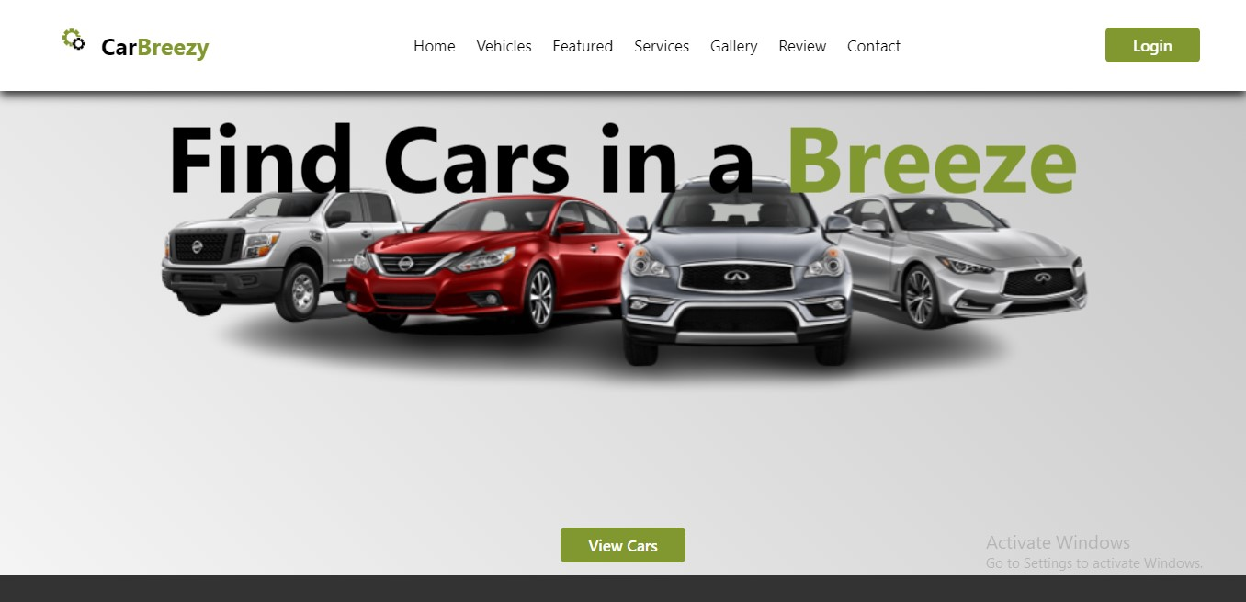

**Popular Vehicles:**

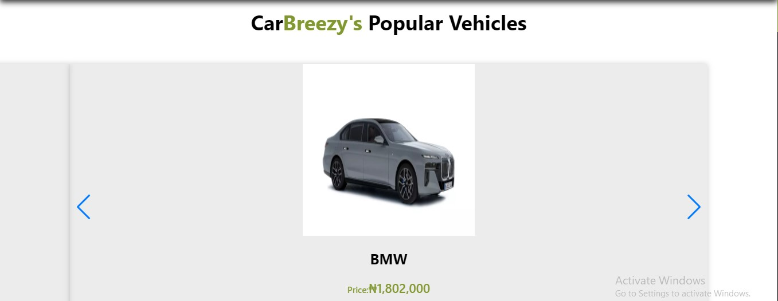

**Featured Cars:**

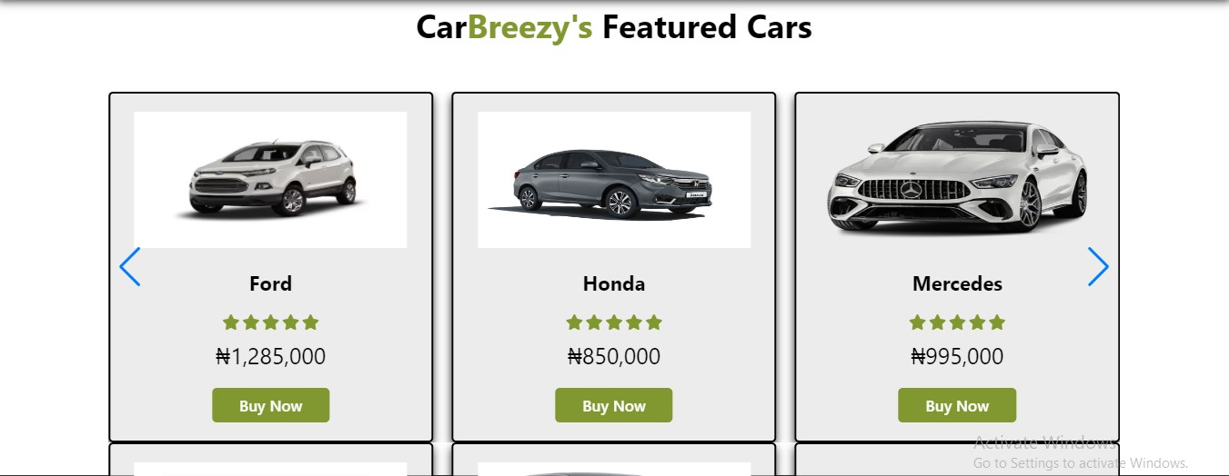

**Services:**

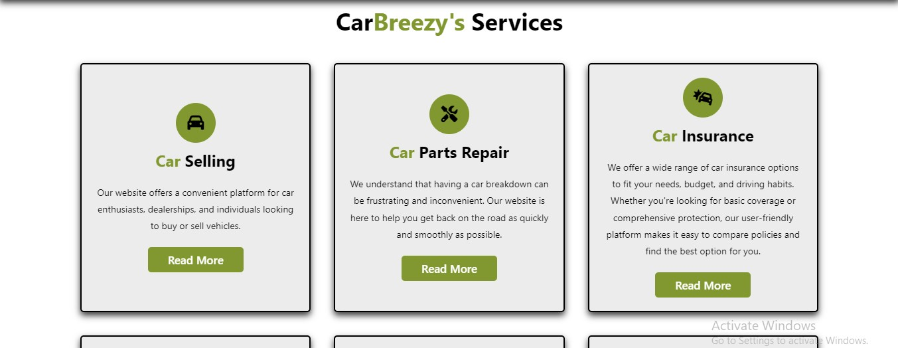

**Newsletter:**

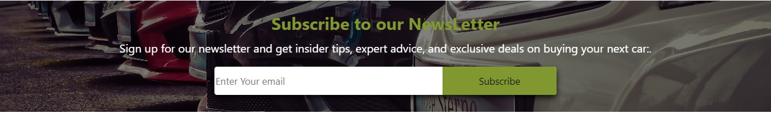

**Car Gallery:**

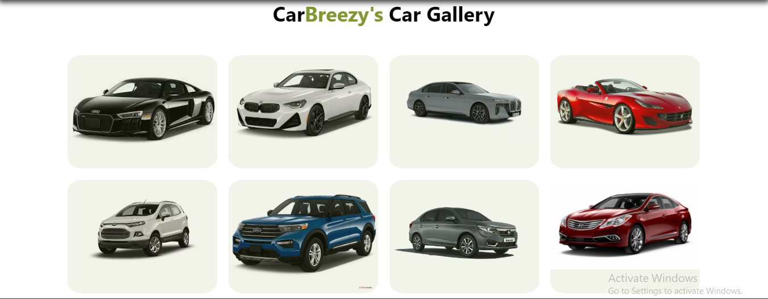

**Client Review:**

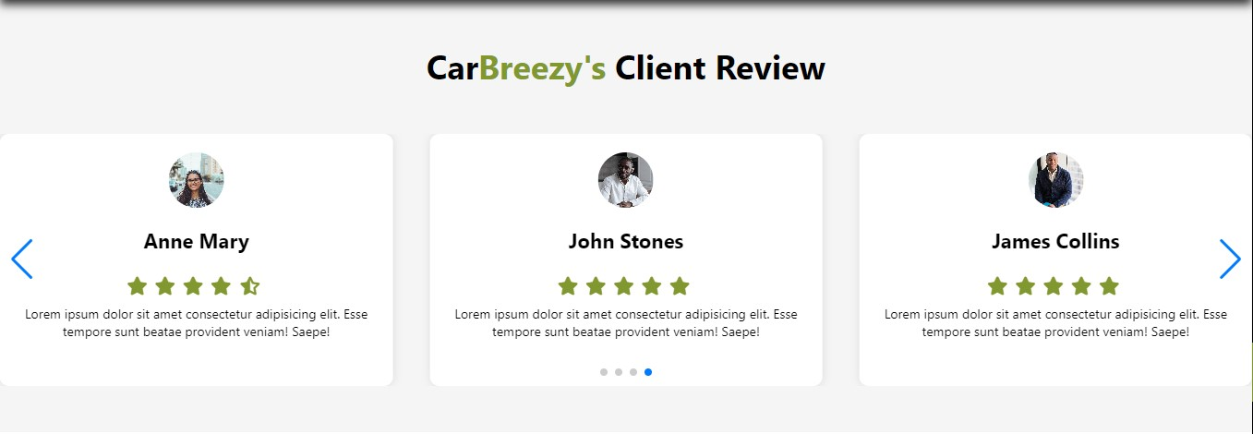

**Contact Section:**



**Source Code**

**Html Code:**

<!DOCTYPE html>

<html lang="en">

<head>

    <meta charset="UTF-8">

    <meta http-equiv="X-UA-Compatible" content="IE=edge">

    <meta name="viewport" content="width=device-width, initial-scale=1.0">

    <script src="https://cdnjs.cloudflare.com/ajax/libs/Swiper/9.2.4/swiper-bundle.min.js" integrity="sha512-hJrV+LKHbu+Hxkn/+ZwGOCMUkap0ZfjJbca9WT38z69+MYmRzMlvUd401TOs1b4byAm4fGDESpEcCbG2A6cibQ==" crossorigin="anonymous" referrerpolicy="no-referrer"></script>

    <title>CarBreezy</title>

    <link rel="apple-touch-icon" sizes="180x180" href="/apple-touch-icon.png">

   <link rel="icon" type="image/png" sizes="32x32" href="/favicon-32x32.png">

   <link rel="icon" type="image/png" sizes="16x16" href="/favicon-16x16.png">

   <link rel="manifest" href="/site.webmanifest">

    <link rel="stylesheet" href="style.css">

    <link rel="stylesheet" href="https://cdnjs.cloudflare.com/ajax/libs/font-awesome/6.4.0/css/all.min.css"></head>

    <link rel="stylesheet" href="https://unpkg.com/swiper/swiper-bundle.min.css" />

</head>

<body>

    <!-- Header/Navbar start -->

    <header>

      <div id="MenuBtn" class="fas fa-bars"></div>

      <a href="" class="logo"><img src="removed_bg_images/Untitled_design_2_-removebg-preview.png" alt="">Car<span>Breezy</span></a>

      <nav class="navbar">

        <a href="#Home" id="home">Home</a>

        <a href="#Vehicle" id="vehicles">Vehicles</a>

        <a href="#Featured" id="featured">Featured</a>

        <a href="#Services" id="services">Services</a>

        <a href="#gallery" id="services">Gallery</a>

        <a href="#Review" id="review">Review</a>

        <a href="#Contact" id="contact">Contact</a>

      </nav>

      <div id="LoginBtn">

        <button class="btn">Login</button>

        <i class="fa fa-user"></i>

      </div>

    </header>

    <!-- Header/Navbar end -->

    <!-- LoginformContainer -->

    <div class="loginFormContainer">

      <span id="CloseLoginForm">

          <i class="fa fa-times"></i>

      </span>

      <form action="">

          <h3>User Login</h3>

          <input type="email" placeholder="Your email" required class="box">

          <input type="password" placeholder="Your Password" required class="box">

          <p>Forgot your password? <a href="#">Click Here</a></p>

          <button class="btn">Submit</button>

          <p>or Login with</p>

          <div class="buttons">

              <a href="#" class="btn">Google &nbsp;&nbsp;<i class="fab fa-google"></i></a>

              <a href="#" class="btn">Facebook&nbsp;&nbsp;<i class="fab fa-facebook"></i> </a>

          </div>

      </form>

  </div>

    <!-- LoginformContainer -->

    <!-- *************** -->

    <!-- <div class="loginFormContainer2">

      <span id="CloseLoginForm2">

        <i class="fa fa-times"></i>

    </span>

      <div class="carImage">

        <img src="removed_bg_images/car3-removebg-preview.png" alt="Car Image">

      </div>

      <div class="carPrice">

        <p>Price: $50,000</p>

      </div>

      <div class="carTabsContainer">

        <ul class="carTabs">

          <li class="active">Internal Specification</li>

          <li>External</li>

          <li>Engine</li>

          <li>Dimensions</li>

        </ul>

        <div class="carTabContent">

          <div class="tabContent active">

            <ul>

              <li>Model: ABC-123</li>

              <li>Color: Red</li>

              <li>Interior: Leather</li>

              <li>Seats: 5</li>

              <li>Sound System: Bose</li>

            </ul>

          </div>

          <div class="tabContent">

            <ul>

              <li>Body Type: Sedan</li>

              <li>Wheels: Alloy</li>

              <li>Tires: Michelin</li>

              <li>Windows: Tinted</li>

              <li>Lights: LED</li>

            </ul>

          </div>

          <div class="tabContent">

            <ul>

              <li>Engine Type: V6</li>

              <li>Transmission: Automatic</li>

              <li>Power: 300 HP</li>

              <li>Torque: 280 lb-ft</li>

              <li>Fuel Economy: 20 mpg (city), 30 mpg (highway)</li>

            </ul>

          </div>

          <div class="tabContent">

            <ul>

              <li>Length: 195 inches</li>

              <li>Width: 72 inches</li>

              <li>Height: 58 inches</li>

              <li>Wheelbase: 112 inches</li>

              <li>Cargo Volume: 15 cubic feet</li>

            </ul>

          </div>

        </div>

      </div>

      <div class="carButtonsContainer">

        <button class="buyNowButton"><i class="fas fa-shopping-cart"></i> Buy Now</button>

        <button class="likeButton"><i class="far fa-thumbs-up"></i></button>

      </div>

    </div> -->

    <!-- *************** -->

    <!-- Home Section start -->

    <section id="Home" class="home">

        <h3 class="homeParallexEffect" id="homeText">Find Cars in a <span>Breeze</span> </h3>

        <img src="Images/background-removebg-preview.png" class="homeParallexEffect" id="homeImage" alt="">

        <a href="#" class="btn" id="Btn">View Cars</a>

    </section>

    <!-- Home section end -->

    <!-- Icon Container Start -->

    <section class="iconsContainer">

        <div class="icons">

            <i class="fa-solid fa-home"></i>

            <div class="content">

                <h3>100+</h3>

                <p>Branches</p>

            </div>

        </div>

        <div class="icons">

            <i class="fa-solid fa-car"></i>

            <div class="content">

                <h3>5870+</h3>

                <p>Cars Sold</p>

            </div>

        </div>

        <div class="icons">

            <i class="fa-solid fa-users"></i>

            <div class="content">

                <h3>2256+</h3>

                <p>Happy Customers</p>

            </div>

        </div>

        <div class="icons">

            <i class="fa-solid fa-fire"></i>

            <div class="content">

                <h3>1000+</h3>

                <p>New Launches</p>

            </div>

        </div>

    </section>

    <!-- Icon Container end -->

    <!-- Vehicle section start -->

    <section id="Vehicle" class="vehicle">

        <h1 class="heading">Car<span>Breezy's</span> Popular Vehicles</h1>

        <div class="vehicle-slider swiper-container">

          <div class="swiper-wrapper">

            <div class="swiper-slide box">

              <img src="./Images/mustang1.webp" alt="">

              <div class="content">

                <h3>Mustang</h3>

                <div class="price"><span>Price:</span>&#8358;1,002,000</div>

                <p>

                  <i class="fa-solid fa-calendar-days"></i>2022

                  <i class="fa fa-gear"></i>Automatic

                  <i class="fas fa-bolt"></i>Electric

                  <i class="fas fa-car"></i>200mph

                </p>

              </div>

            </div>

            <div class="swiper-slide box">

              <img src="./Images/bmw2.webp" alt="">

              <div class="content">

                <h3>BMW</h3>

                <div class="price"><span>Price:</span>&#8358;1,802,000</div>

                <p>

                    <i class="fa-solid fa-calendar-days"></i>2019

                    <i class="fa-solid fa-gear"></i>Manual

                    <i class="fas fa-bolt"></i>Non-electric

                    <i class="fas fa-car"></i>1100mph

                </p>

              </div>

            </div>

            <div class="swiper-slide box">

              <img src="./Images/Audi R8.jpg" alt="">

              <div class="content">

                <h3>Audi R8</h3>

                <div class="price"><span>Price:</span>&#8358;2,402,000</div>

                <p>

                    <i class="fa-solid fa-calendar-days"></i>2020

                    <i class="fa fa-gear"></i>Manual

                    <i class="fas fa-bolt"></i>Electric

                    <i class="fas fa-car"></i>300mph

                </p>

              </div>

            </div>

            <div class="swiper-slide box">

              <img src="./Images/nissan.png" alt="">

              <div class="content">

                <h3>Nissan</h3>

                <div class="price"><span>Price:</span>&#8358;902,000</div>

                <p>

                    <i class="fa-solid fa-calendar-days"></i>2023

                    <i class="fa fa-gear"></i>Manual

                    <i class="fas fa-bolt"></i>Non-electric

                    <i class="fas fa-car"></i>800mph

                </p>

              </div>

            </div>

            <div class="swiper-slide box">

              <img src="./Images/toyota1.png" alt="">

              <div class="content">

                <h3>Toyota</h3>

                <div class="price"><span>Price:</span>&#8358;3,402,000</div>

                <p>

                    <i class="fa-solid fa-calendar-days"></i>2023

                    <i class="fa fa-gear"></i>Automatic

                    <i class="fas fa-bolt"></i>Electric

                    <i class="fas fa-car"></i>1300mph

                </p>

              </div>

            </div>

            <!-- Add more swiper-slide boxes here -->

          </div>

          <div class="swiper-pagination"></div>

          <div class="swiper-button-prev"></div>

          <div class="swiper-button-next"></div>

        </div>

      </section>

    <!-- Vehicle section end -->

    <!-- Featured section start -->

    <section id="Featured" class="feature">

      <h1 class="heading">Car<span>Breezy's</span> Featured Cars</h1>

      <div class="swiper FeaturesSlider">

        <div class="swiper-wrapper">

          <div class="swiper-slide box">

            <img src="./Images/img3.webp" alt="">

            <div class="content">

              <h3>New Model</h3>

              <div class="stars">

                  <i class="fas fa-star"></i>

                  <i class="fas fa-star"></i>

                  <i class="fas fa-star"></i>

                  <i class="fas fa-star"></i>

                  <i class="fas fa-star"></i>

              </div>

              <div class="price">&#8358;2,985,000</div>

              <a href="#" class="btn">Buy Now</a>

            </div>

          </div>

          <div class="swiper-slide box">

            <img src="./Images/ford1.avif" alt="">

            <div class="content">

              <h3>Ford</h3>

              <div class="stars">

                  <i class="fas fa-star"></i>

                  <i class="fas fa-star"></i>

                  <i class="fas fa-star"></i>

                  <i class="fas fa-star"></i>

                  <i class="fas fa-star"></i>

              </div>

              <div class="price">&#8358;1,285,000</div>

              <a href="#" class="btn">Buy Now</a>

            </div>

          </div>

          <div class="swiper-slide box">

            <img src="./Images/Honda1.jpg" alt="">

            <div class="content">

              <h3>Honda</h3>

              <div class="stars">

                  <i class="fas fa-star"></i>

                  <i class="fas fa-star"></i>

                  <i class="fas fa-star"></i>

                  <i class="fas fa-star"></i>

                  <i class="fas fa-star"></i>

              </div>

              <div class="price">&#8358;850,000</div>

              <a href="#" class="btn">Buy Now</a>

            </div>

          </div>

          <div class="swiper-slide box">

            <img src="./Images/mercedes1.webp" alt="">

            <div class="content">

              <h3>Mercedes</h3>

              <div class="stars">

                  <i class="fas fa-star"></i>

                  <i class="fas fa-star"></i>

                  <i class="fas fa-star"></i>

                  <i class="fas fa-star"></i>

                  <i class="fas fa-star"></i>

              </div>

              <div class="price">&#8358;995,000</div>

              <a href="#" class="btn">Buy Now</a>

            </div>

          </div>

          <div class="swiper-slide box">

            <img src="./Images/hyundai1.png" alt="">

            <div class="content">

              <h3>Hyundai</h3>

              <div class="stars">

                  <i class="fas fa-star"></i>

                  <i class="fas fa-star"></i>

                  <i class="fas fa-star"></i>

                  <i class="fas fa-star"></i>

                  <i class="fas fa-star"></i>

              </div>

              <div class="price">&#8358;2,285,000</div>

              <a href="#" class="btn">Buy Now</a>

            </div>

          </div>

        </div>

        <div class="swiper-pagination"></div>

          <div class="swiper-button-prev"></div>

          <div class="swiper-button-next"></div>

      </div>

        <!-- Second featured -->

    <div class="swiper FeaturesSlider">

      <div class="swiper-wrapper">

        <div class="swiper-slide box">

          <img src="./Images/innova.jpg" alt="">

          <div class="content">

            <h3>Innova</h3>

            <div class="stars">

                <i class="fas fa-star"></i>

                <i class="fas fa-star"></i>

                <i class="fas fa-star"></i>

                <i class="fas fa-star"></i>

                <i class="fas fa-star"></i>

            </div>

            <div class="price">&#8358;3,485,000</div>

            <a href="#" class="btn">Buy Now</a>

          </div>

        </div>

        <div class="swiper-slide box">

          <img src="./Images/bmw1.avif" alt="">

          <div class="content">

            <h3>BMW</h3>

            <div class="stars">

                <i class="fas fa-star"></i>

                <i class="fas fa-star"></i>

                <i class="fas fa-star"></i>

                <i class="fas fa-star"></i>

                <i class="fas fa-star"></i>

            </div>

            <div class="price">&#8358;895,000</div>

            <a href="#" class="btn">Buy Now</a>

          </div>

        </div>

        <div class="swiper-slide box">

          <img src="./Images/ferrari1.jpg" alt="">

          <div class="content">

            <h3>Ferrari</h3>

            <div class="stars">

                <i class="fas fa-star"></i>

                <i class="fas fa-star"></i>

                <i class="fas fa-star"></i>

                <i class="fas fa-star"></i>

                <i class="fas fa-star"></i>

            </div>

            <div class="price">&#8358;9,985,000</div>

            <a href="#" class="btn">Buy Now</a>

          </div>

        </div>

        <div class="swiper-slide box">

          <img src="./Images/ford1.jpg" alt="">

          <div class="content">

            <h3>Ford</h3>

            <div class="stars">

                <i class="fas fa-star"></i>

                <i class="fas fa-star"></i>

                <i class="fas fa-star"></i>

                <i class="fas fa-star"></i>

                <i class="fas fa-star"></i>

            </div>

            <div class="price">&#8358;185,000</div>

            <a href="#" class="btn">Buy Now</a>

          </div>

        </div>

        <div class="swiper-slide box">

          <img src="./Images/venza1.jpg" alt="">

          <div class="content">

            <h3>Venza</h3>

            <div class="stars">

                <i class="fas fa-star"></i>

                <i class="fas fa-star"></i>

                <i class="fas fa-star"></i>

                <i class="fas fa-star"></i>

                <i class="fas fa-star"></i>

            </div>

            <div class="price">&#8358;3,385,000</div>

            <a href="#" class="btn">Buy Now</a>

          </div>

        </div>

        <div class="swiper-slide box">

          <img src="./Images/jeep1.jpeg" alt="">

          <div class="content">

            <h3>Jeep</h3>

            <div class="stars">

                <i class="fas fa-star"></i>

                <i class="fas fa-star"></i>

                <i class="fas fa-star"></i>

                <i class="fas fa-star"></i>

                <i class="fas fa-star"></i>

            </div>

            <div class="price">&#8358;1,985,000</div>

            <a href="#" class="btn">Buy Now</a>

          </div>

        </div>

      </div>

    </div>

    </section>

    <!-- featured section end -->

    <!-- Service Section Start -->

    <section id="Services" class="services">

      <h1 class="heading">Car<span>Breezy's</span> Services</h1>

      <div class="boxContainer">

        <div class="box">

          <i class="fas fa-car"></i>

          <h3><span>Car</span> Selling</h3>

          <p> Our website offers a convenient platform for car enthusiasts, dealerships, and individuals looking to buy or sell vehicles.</p>

          <button class="btn">Read More</button>

        </div>

        <div class="box">

          <i class="fas fa-tools"></i>

          <h3><span>Car</span> Parts Repair</h3>

          <p>We understand that having a car breakdown can be frustrating and inconvenient. Our website is here to help you get back on the road as quickly and smoothly as possible.</p>

          <button class="btn">Read More</button>

        </div>

        <div class="box">

          <i class="fas fa-car-crash"></i>

          <h3><span>Car</span> Insurance</h3>

          <p>We offer a wide range of car insurance options to fit your needs, budget, and driving habits.

            Whether you're looking for basic coverage or comprehensive protection, our user-friendly platform

            makes it easy to compare policies and find the best option for you.</p>

          <button class="btn">Read More</button>

        </div>

        <div class="box">

          <i class="fas fa-car-battery"></i>

          <h3><span>Car</span> Battery Replacement</h3>

          <p>We offer a wide range of car battery options to fit your vehicle and driving needs, including

            high-performance batteries for luxury cars and eco-friendly options for hybrid and electric vehicles. </p>

          <button class="btn">Read More</button>

        </div>

        <div class="box">

          <i class="fa-solid fa-headset"></i>

          <h3>24/7 <span>Car</span> Support</h3>

          <p>We offer a wide range of car support services, including emergency roadside assistance, towing, lockout services,

            fuel delivery, battery jump-starts, and more. </p>

          <button class="btn">Read More</button>

        </div>

        <div class="box">

          <i class="fa-solid fa-gas-pump"></i>

          <h3><span>Car</span> Oil Change</h3>

          <p>We offer a wide range of oil change options, including conventional, synthetic, and high-mileage oils, as well as oil

            filters and other related services. </p>

          <button class="btn">Read More</button>

        </div>

      </div>

    </section>

    <!-- Service Section End -->

    <!-- News Letter Section Start -->

     <section id="NewsLetter" class="newsletter">

      <h3>Subscribe to our NewsLetter</h3>

      <p>Sign up for our newsletter and get insider tips, expert advice, and exclusive deals on buying your next car:.</p>

        <form action="">

          <input type="email" required placeholder="Enter Your email" class="email">

          <input type="submit" value="Subscribe" class="subscribe">

        </form>

     </section>

     <!-- News Letter Section End -->

    <!-- Gallery Section start -->

    <section id="gallery" class="gallery">

      <h2 class="heading">Car<span>Breezy's</span> Car Gallery</h2>

      <div class="gallery-container">

        <div class="gallery-item" onclick="openPopup()">

          <img src="./Images/Audi R8.jpg" alt="Car 1">

        </div>

        <div class="gallery-item" onclick="openPopup()">

          <img src="./Images/bmw1.avif" alt="Car 1">

        </div>

        <div class="gallery-item" onclick="openPopup()">

          <img src="./Images/bmw2.webp" alt="Car 1">

        </div>

        <div class="gallery-item" onclick="openPopup(this)">

          <img src="./Images/ferrari1.jpg" alt="Car 1">

        </div>

        <div class="gallery-item" onclick="openPopup(this)">

          <img src="./Images/ford1.avif" alt="Car 1">

        </div>

        <div class="gallery-item" onclick="openPopup(this)">

          <img src="./Images/ford1.jpg" alt="Car 1">

        </div>

        <div class="gallery-item" onclick="openPopup(this)">

          <img src="./Images/Honda1.jpg" alt="Car 1">

        </div>

        <div class="gallery-item" onclick="openPopup(this)">

          <img src="./Images/hyundai1.png" alt="Car 1">

        </div>

        <div class="gallery-item" onclick="openPopup(this)">

          <img src="./Images/innova.jpg" alt="Car 1">

        </div>

        <div class="gallery-item" onclick="openPopup(this)">

          <img src="./Images/jeep1.jpeg" alt="Car 1">

        </div>

        <div class="gallery-item" onclick="openPopup(this)">

          <img src="./Images/mercedes1.webp" alt="Car 1">

        </div>

        <div class="gallery-item" onclick="openPopup(this)">

          <img src="./Images/mustang1.webp" alt="Car 1">

        </div>

        <!-- Add more gallery-item divs with car images here -->

      </div>

    </section>

    <div id="popup" class="popup">

      <div class="PopupContainer">

        <span id="closePopup" onclick="closePopup()">

          <i class="fa fa-times"></i>

        </span>

        <div class="carImage" onclick="showPopup()">

          <img src="removed_bg_images/car3-removebg-preview.png" alt="Car Image">

        </div>

        <div class="carPrice">

          <p>Price: $50,000</p>

        </div>

        <div class="carTabsContainer">

          <ul class="carTabs">

            <li class="active" onclick="openTab(event, 'internal')">Internal Specification</li>

            <li onclick="openTab(event, 'external')">External</li>

            <li onclick="openTab(event, 'engine')">Engine</li>

            <li onclick="openTab(event, 'dimensions')">Dimensions</li>

          </ul>

          <div class="carTabContent">

            <div id="internal" class="tabContent active">

              <ul>

                <li>Model: ABC-123</li>

                <li>Color: Red</li>

                <li>Interior: Leather</li>

                <li>Seats: 5</li>

                <li>Sound System: Bose</li>

              </ul>

            </div>

            <div id="external" class="tabContent">

              <ul>

                <li>Body Type: Sedan</li>

                <li>Wheels: Alloy</li>

                <li>Tires: Michelin</li>

                <li>Windows: Tinted</li>

                <li>Lights: LED</li>

              </ul>

            </div>

            <div id="engine" class="tabContent">

              <ul>

                <li>Engine Type: V6</li>

                <li>Transmission: Automatic</li>

                <li>Power: 300 HP</li>

                <li>Torque: 280 lb-ft</li>

                <li>Fuel Economy: 20 mpg (city), 30 mpg (highway)</li>

              </ul>

            </div>

            <div id="dimensions" class="tabContent">

              <ul>

                <li>Length: 195 inches</li>

                <li>Width: 72 inches</li>

                <li>Height: 58 inches</li>

                <li>Wheelbase: 112 inches</li>

                <li>Cargo Volume: 15 cubic feet</li>

              </ul>

            </div>

          </div>

        </div>

        <div class="carButtonsContainer">

          <button class="buyNowButton"><i class="fas fa-shopping-cart"></i> Buy Now</button>

          <button class="likeButton"><i class="far fa-thumbs-up"></i></button>

        </div>

      </div>

    </div>

    <!-- Gallery section end -->

    <!-- Review Section Start -->

    <section class="review" id="Review">

      <h1 class="heading">Car<span>Breezy's</span> Client Review</h1>

      <div class="swiper ReviewSlider">

        <div class="swiper-wrapper">

          <div class="swiper-slide box">

            <img alt="" src="Images/user.jpg">

            <div class="content">

              <h3>James Collins</h3>

              <div class="stars">

                <i class="fas fa-star"></i>

                <i class="fas fa-star"></i>

                <i class="fas fa-star"></i>

                <i class="fas fa-star"></i>

                <i class="fas fa-star"></i>

              </div>

              <p>Lorem ipsum dolor sit amet consectetur adipisicing elit. Esse tempore sunt beatae provident veniam! Saepe!</p>

            </div>

          </div>

          <div class="swiper-slide box">

            <img alt="" src="Images/user man in office.jpg">

            <div class="content">

              <h3>Joshua Allen</h3>

              <div class="stars">

                <i class="fas fa-star"></i>

                <i class="fas fa-star"></i>

                <i class="fas fa-star"></i>

                <i class="fas fa-star"></i>

                <i class="fas fa-star-half-stroke"></i>

              </div>

              <p>Lorem ipsum dolor sit amet consectetur adipisicing elit. Esse tempore sunt beatae provident veniam! Saepe!</p>

            </div>

          </div>

          <div class="swiper-slide box">

            <img alt="" src="Images/user-fine girl-smiling.jpg">

            <div class="content">

              <h3>Anne Mary</h3>

              <div class="stars">

                <i class="fas fa-star"></i>

                <i class="fas fa-star"></i>

                <i class="fas fa-star"></i>

                <i class="fas fa-star"></i>

                <i class="fas fa-star-half-stroke"></i>

              </div>

              <p>Lorem ipsum dolor sit amet consectetur adipisicing elit. Esse tempore sunt beatae provident veniam! Saepe!</p>

            </div>

          </div>

          <div class="swiper-slide box">

            <img alt="" src="Images/user man in office.jpg">

            <div class="content">

              <h3>John Stones</h3>

              <div class="stars">

                <i class="fas fa-star"></i>

                <i class="fas fa-star"></i>

                <i class="fas fa-star"></i>

                <i class="fas fa-star"></i>

                <i class="fas fa-star"></i>

              </div>

              <p>Lorem ipsum dolor sit amet consectetur adipisicing elit. Esse tempore sunt beatae provident veniam! Saepe!</p>

            </div>

          </div>

        </div>

        <div class="swiper-pagination"></div>

        <div class="swiper-button-prev"></div>

        <div class="swiper-button-next"></div>

      </div>

    </section>

     <!-- Review Section End -->

    <!-- Contact Form Start  -->

    <section id="Contact" class="contact">

      <h1 class="heading">Contact Car<span>Breezy</span></h1>

      <div class="row">

        <iframe src="https://www.google.com/maps/embed?pb=!1m14!1m12!1m3!1d15859.618073746393!2d7.4922416!3d6.40630075!2m3!1f0!2f0!3f0!3m2!1i1024!2i768!4f13.1!5e0!3m2!1sen!2sng!4v1682938435996!5m2!1sen!2sng"

          width="600" height="523" style="border:0;" allowfullscreen="" loading="lazy"

          referrerpolicy="no-referrer-when-downgrade"></iframe>

        <form action="" class="contact-form">

          <h3>Book a Car<span>Breezy</span> Appointment</h3>

          <div class="form-group">

            <input type="text" placeholder="Your Name" required class="input-box">

          </div>

          <div class="form-group">

            <input type="email" placeholder="Your Email" required class="input-box">

          </div>

          <div class="form-group">

            <textarea class="input-box" required placeholder="Your Message" name="" id="" cols="30" rows="6"></textarea>

          </div>

          <button class="btn">Send</button>

        </form>

        <div class="contact-info">

          <h3>Car<span>Breezy's</span> Contact Information</h3>

          <p><i class="fas fa-envelope"></i> <a href="mailto:info@carbreezy.com">info@carbreezy.com</a></p>

          <p><i class="fas fa-phone"></i> <a href="tel:+1234567890">+1 (234) 567-890</a></p>

          <p><i class="fas fa-map-marker-alt"></i> 123 Main St, Anytown USA</p>

        </div>

      </div>

    </section>

    <!-- Contact Form End -->

    <div id="ticker"></div>

    <!-- Footer Start -->

     <section class="footer">

      <h4>About Car<span>Breezy</span></h4>

      <p>Car Breezy is a premier car buying website that provides a seamless and hassle-free

        car buying experience for customers. With a focus on transparency and convenience,

        Car Breezy is revolutionizing the way people buy cars.

        Their user-friendly website allows customers to easily search and compare different cars

        based on their preferences, including make, model, year, mileage, and price range. Car Breezy

        provides detailed vehicle history reports and high-quality photos for each car listed on their

        site, so customers can make informed decisions before making a purchase.</p>

           <div class="icons">

              <i class="fab fa-facebook"></i>

              <i class="fab fa-instagram"></i>

              <i class="fab fa-tiktok"></i>

              <i class="fab fa-twitter"></i>

              <i class="fab fa-linkedin"></i>

           </div>

           <p>Copyright  &#169. Made with <i class="fa-solid fa-heart"></i> by Chima Micheal</p>

           <a href="#">&copy; Sem1Project</a>

  </section>

    <!-- Footer End -->

    <!-- JS linking -->

    <script src="script.js"></script>

    <script src="nodemailer.js"></script>

    <!-- Swiper JS -->

</body>

</html>

**CSS CODE:**

:root{

    --main:#819830;

    --border:0.2rem solid rgba(0,0,0.5);

    --box-shadow:0 0.5rem 1rem rgba(0,0,0,0.8);

}

*{

    margin: 0;

    padding: 0;

    box-sizing: border-box;

    font-family: 'Segoe UI', Tahoma, Geneva, Verdana, sans-serif;

    text-decoration: none;

    border: none;

    outline: none;

    transition: linear 0.2s;

}

section{

    padding: 2rem 9%;

}

::selection {

  background-color: var(--main);

  color: black;

}

html{

    font-size: 62.5%;

    overflow-x: hidden;

    scroll-behavior: smooth;

    scroll-padding-top: 7rem;

}

html::-webkit-scrollbar{

    width: 10px;

}

html::-webkit-scrollbar-thumb{

    background: var(--main);

}

html::-webkit-scrollbar-track{

    background: #000;

}

.btn{

    background: var(--main);

    padding: 0.8rem 3rem;

    display: inline-block;

    margin-top: 1rem;

    color: #fff;

    cursor: pointer;

    font-size: 1.7rem;

    font-weight: 500;

    text-align: center;

    border-radius: 0.5rem;

}

/* Header/Navbar Start */

header{

    z-index: 10000;

    position: fixed;

    top: 0;

    left: 0;

    right: 0;

    padding: 3rem 9%;

    background: #fff;

    box-shadow: var(--box-shadow);

    display: flex;

    justify-content: space-between;

    align-items: center;

}

header .logo{

    color: black;

    font-size: 2.5rem;

    font-weight: 700;

    display: flex;

    align-items: center;

}

.heading{

    padding-bottom: 2rem;

    font-size: 6.5rem;

    text-align: center;

}

.heading span{

    color: var(--main );

}

header span{

    color: var(--main);

}

header .navbar a{

    font-size: 1.7rem;

    color: #000;

    margin: 0 1rem;

}

header nav a:hover {

    font-size: 20px;

    color: var(--main);

    transition:  0.5s ease-in-out;

}

header nav a {

    font-size: 20px;

    color: var(--main);

    transition:  0.5s ease-in-out;

}

header .logo img {

    width: 60px; /* adjust the width as needed */

    height: auto;

    margin-right: 0rem; /* adjust the margin as needed */

}

#LoginBtn .btn{

    margin-top: 0;

}

#LoginBtn i{

    color: var(--main);

    font-size: 2.5rem;

    display: none;

}

header {

    position: fixed;

    top: 0;

    left: 0;

    width: 100%;

    padding: 20px 50px;

    background-color: #fff;

    z-index: 10; /* Ensure the header is on top of other elements */

}

h3{

    position: relative;

    z-index: 9;

}

#MenuBtn{

    font-size: 2.5rem;

    color: var(--main);

    cursor: pointer;

    display: none;

}

@media(max-width:991px){

    html{

        font-size: 50%;

    }

}

@media(max-width:768px){

    #MenuBtn{

        display: initial;

    }

    .fa-times{

        transform: rotate(360deg);

    }

    header .navbar{

        position: absolute;

        top: 99%;

        left: 0;

        right: 0;

        border: var(--border);

        background: #fff;

        clip-path: polygon(0 0,100% 0, 100% 0,0 0);

    }

    header .navbar .active{

        clip-path: polygon(0 0,100% 0,100% 100%, 0 100% );

    }

}

/* Header/Navbar End */

/* LoginformContainer */

.loginFormContainer.active{

   top: 0;

}

.loginFormContainer{

    position: fixed;

    top: -105%;

    left: 0;

    height: 100%;

    width: 100%;

    display: flex;

    justify-content: center;

    align-items: center;

    background: rgba(255,255,255,0.9);

    z-index: 1000;

}

.loginFormContainer form{

    margin: 2rem;

    border-radius: 0.5rem;

    border: var(--border);

    box-shadow: var(--box-shadow);

    padding: 2rem;

    text-align: center;

    width: 40rem;

}

.loginFormContainer form h3{

    font-size: 2.5rem;

    text-transform: uppercase;

    padding-bottom: 1rem;

}

.loginFormContainer form .box{

    font-size: 1.6rem;

    width: 100%;

    margin: 0.7rem 0;

    border: var(--border);

    padding: 1rem 1.2rem;

    border-radius: 0.5rem;

    text-transform: none;

}

.loginFormContainer form p{

    font-size: 1.5rem;

    color: var(--main);

    padding: 1rem 0;

}

.loginFormContainer form p a{

    color: var(--main);

    text-decoration: underline;

}

#CloseLoginForm{

    position: absolute;

    top: 1.5rem;

    right: 2.5rem;

    font-size: 5rem;

    cursor: pointer;

}

.loginFormContainer form .buttons{

    display: flex;

    gap: 1rem;

    align-items: center;

}

.loginFormContainer form .btn{

    width: 100%;

    display: block;

    margin: 0.5rem 0;

}

.loginFormContainer span i{

    color: var(--main);

    font-size: 4.5rem;

}

/* LoginformContainer */

/* Home Section Start */

.home {

    height: 100vh;

    background: linear-gradient(45deg, #f5f5f5, #c5c5c5);

    overflow: hidden;

}

.home{

    padding-top: 10rem;

    overflow-x: hidden;

    text-align: center;

}

.home h3{

    font-size: 7.5vw;

}

.home h3 span{

    color: var(--main);

}

.home img{

    width: 100%;

    margin-top: -10rem;

}

section a #Btn{

    margin-top: -9rem;

}

/* Home Section ENd */

/* iconsConatiner */

.iconsContainer{

    margin-bottom: 200px;

    display: grid;

    grid-template-columns: repeat(auto-fit,minmax(25rem,1fr));

    gap: 1.5rem;

    padding-top: 5rem;

    padding-bottom: 5rem;

}

.iconsContainer .icons{

    background: linear-gradient(45deg, #f5f5f5, #c5c5c5);

    display: flex;

    align-items: center;

    box-shadow: var(--box-shadow);

    border-radius: 0.5rem;

    gap: 1.5rem;

    padding: 2rem;

    cursor: pointer;

}

.iconsContainer .icons i{

    background: #fff;

    height: 5rem;

    width: 5rem;

    line-height: 5rem;

    font-size: 2.5rem;

    text-align: center;

    border-radius: 50%;

}

.iconsContainer .icons h3{

    font-size: 2.5rem;

    color: var(--main);

}

.iconsContainer .icons p{

    font-size: 1.5rem;

    color: var(--main);

}

.iconsContainer .icons:hover{

    background:  #353718;

}

/* iconsContainer end*/

/* vehicle section start */

.heading{

    margin-bottom: 2rem;

    font-size: 7.5rem;

}

.vehicle{

    margin-bottom: 200px;

}

.vehicle-slider .box .content h3{

    font-size: 2.5rem;

}

.vehicle-slider .box .content .price{

    color: var(--main);

    font-weight: 600;

    padding: 1rem 0;

    font-size: 2.2rem;

}

.vehicle-slider span{

    color: var(--main);

    font-size: 1.5rem;

    font-weight: 500;

}

.vehicle-slider p{

    font-size: 1.6rem;

    color: var(--main);

    padding: 1rem 0;

    padding-top: 1.5rem;

    border-top: var(--border);

}

.vehicle img{

    width: 100%;

}

/* Styles for the slider container */

.vehicle-slider {

    position: relative;

    width: 100%;

    height: 500px;

  }

  .heading span{

    color: var(--main);

  }

  /* Styles for the slide content */

  .box {

    display: flex;

    justify-content: center;

    align-items: center;

    flex-direction: column;

    text-align: center;

    height: 100%;

    background-color: rgba(217, 217, 217, 0.5);

    box-shadow: 0 0 10px rgba(0, 0, 0, 0.2);

  }

  .box img {

    width: 100%;

    max-width: 300px;

    margin-bottom: 20px;

  }

  .box h3 {

    font-size: 24px;

    margin-bottom: 10px;

  }

  .box .price {

    font-size: 18px;

    margin-bottom: 10px;

  }

  .box p {

    font-size: 14px;

    margin-bottom: 0;

  }

  .box p i {

    margin-left: 10px;

    margin-right: 1rem;

  }

  /* Styles for the pagination container */

  .swiper-pagination {

    position: absolute;

    bottom: 20px;

    left: 50%;

    transform: translateX(-50%);

  }

  .vehicle-slider .swiper-slide img {

    width: 100%;

    height: 300px; /* adjust height as needed */

  }

  /* Styles for the pagination dots */

  .swiper-pagination-bullet {

    width: 12px;

    height: 12px;

    background-color: #000;

    opacity: 0.5;

    border-radius: 50%;

    margin-right: 10px;

    cursor: pointer;

  }

/* Vehicles Section end */

/* Featured section start */

.heading{

    margin-bottom: 50px;

}

.feature img{

  height: 15rem;

}

.heading span{

    color: var(--main);

}

.FeaturesSlider .box{

    padding: 2rem;

    text-align: center;

    border: var(--border);

    border-radius: 0.5rem;

    box-shadow: var(--box-shadow);

}

.feature .box img:hover{

    transform: scale(1.08);

}

.feature .box .content h3{

    font-size: 2.2rem;

}

.feature .box .content .stars{

    padding: 1rem 0;

}

.feature .box .content .stars i{

    color: var(--main);

    font-size: 1.7rem;

}

.feature .price{

    font-size: 2.5rem;

}

/* Featured section end */

/* Services Section Start */

.services{

    margin-bottom: 50px;

}

.services .boxContainer{

    display: grid;

    grid-template-columns: repeat(auto-fit,minmax(30rem,1fr));

    gap: 3.5rem;

}

.services .boxContainer span{

    color: var(--main);

}

.services .heading{

    margin-bottom: 20px;

    margin-top: 190px;

}

.services .boxContainer .box p{

    line-height: 1.8;

    padding: 1rem 0;

    font-size: 1.4rem;

}

.services .boxContainer .box{

    box-shadow: var(--box-shadow);

    border: var(--border);

    border-radius: 0.5rem;

    padding: 20px;

    text-align: center;

    cursor: pointer;

}

.services .boxContainer .box:hover{

    background: #000;

    color: #c5c5c5;

}

.services .boxContainer .box i{

    height: 6rem;

    width: 6rem;

    border-radius: 50%;

    line-height: 6rem;

    background: var(--main);

    color: #000;

    font-size: 2.5rem;

    margin-bottom: 1rem;

}

/* Services Section End */

/* Review Section Start */

.review {

    padding: 50px 0;

    background-color: #f5f5f5;

    margin-bottom: 50px;

    position: relative;

    z-index: -100;

}

.ReviewSlider{

    padding-bottom: 3rem;

}

.ReviewSlider .box {

    background-color: #fff;

    padding: 20px;

    margin: 0 auto;

    width: 80%;

    max-width: 600px;

    box-shadow: 0 0 10px rgba(0, 0, 0, 0.1);

    border-radius: 10px;

    text-align: center;

}

.ReviewSlider .box img {

    display: block;

    margin: 0 auto 20px;

    max-width: 100%;

    border-radius: 50%;

    width: 60px;

    height: 60px;

    object-fit: cover;

}

.ReviewSlider .box .content {

    margin-bottom: 20px;

}

.ReviewSlider .box .stars {

    margin-top: 20px;

    color:var(--main);

}

.ReviewSlider .box .stars i {

    font-size: 20px;

    margin-right: 5px;

}

.ReviewSlider .box h3{

    font-size: 2.2rem;

    padding-bottom: 0.5rem;

}

.ReviewSlider .box p{

    font-size: 1.4rem;

    padding: 1rem 0;

}

/*Review Section End */

/* News Letter Section Start */

.newsletter {

    position: relative; /* Make the pseudo-element relative to this element */

    background: url(Images/newsletter\ Background\ \(2\).jpg) no-repeat;

    background-size: cover;

    background-position: center;

    text-align: center;

}

.newsletter form{

    position: relative;

    z-index: 1;

}

.newsletter::before {

    content: "";

    position: absolute;

    top: 0;

    left: 0;

    width: 100%;

    height: 100%;

    background-color: black;

    opacity: 0.5; /* Change the opacity to control the darkness */

  }

.newsletter h3{

    color: var(--main);

    font-size: 3rem;

}

.newsletter p{

    font-size: 2rem;

    color:#fff;

    padding: 1rem 0;

    z-index: 3;

    position: relative;

}

.newsletter form{

    height: 5rem;

    max-width: 60rem;

    background: #fff;

    border-radius: 0.5rem;

    box-shadow: var(--box-shadow);

    display: flex;

    margin: 1rem auto;

    overflow: hidden;

}

form input[type="email"] {

  font-size: 1.7rem;

  height: 100%;

  width: 40rem;

  text-transform: none;

  padding: 0 .2rem;

}

form input[type="submit"] {

  font-size: 1.7rem;

  height: 100%;

  width: 20rem;

  background: var(--main);

  cursor: pointer;

}

/* News Letter Section End */

/* Gallery Section start */

.gallery {

  margin-top: 50px;

  text-align: center;

}

.heading {

  font-size: 36px;

  font-weight: bold;

  margin-bottom: 30px;

}

.gallery-container {

  display: grid;

  grid-template-columns: repeat(4, 1fr);

  gap: 20px;

}

.gallery .heading h2 span{

    color: var(--main);

}

.gallery-item {

  position: relative;

  overflow: hidden;

}

.gallery-item img {

  width: 100%;

  height: auto;

  transition: transform 0.3s ease-in-out;

  cursor: pointer;

}

.gallery-item:hover img {

  transform: scale(1.1);

}

.gallery-item::before {

  content: '';

  position: absolute;

  top: 0;

  left: 0;

  width: 100%;

  height: 100%;

  background-color: var(--main);

  opacity: .1;

  border-radius: 10%;

  transition: opacity 0.3s ease-in-out;

}

.gallery-item:hover::before {

  opacity: 1;

}

/* Popup Container */

.popup {

    display: none;

    z-index: 100;

    position: absolute;

    position: fixed;

    z-index: 1;

    left: 0;

    top: 0;

    width: 100%;

    height: 100%;

    overflow: auto;

    background-color: rgba(0, 0, 0, 0.7);

  }

  /* Popup Content */

  .PopupContainer {

    position: relative;

    background-color: white;

    margin: 10% auto;

    padding: 20px;

    border-radius: 5px;

    max-width: 600px;

  }

  /* Close Button */

  #closePopup {

    position: absolute;

    top: 10px;

    right: 10px;

    font-size: 20px;

    font-weight: bold;

    cursor: pointer;

  }

  /* Car Image */

  .carImage {

    text-align: center;

  }

  .carImage img {

    width: 100%;

    max-width: 400px;

  }

  /* Car Price */

  .carPrice {

    text-align: center;

    margin-top: 10px;

  }

  .carPrice p {

    font-weight: bold;

    font-size: 24px;

    color: #333;

  }

  /* Car Tabs */

  .carTabs {

    list-style: none;

    margin: 0;

    padding: 0;

    display: flex;

    justify-content: space-around;

    margin-top: 20px;

  }

  .carTabs li {

    cursor: pointer;

    padding: 10px 20px;

    border-radius: 5px;

    background-color: #eee;

    transition: background-color 0.2s ease-in-out;

  }

  .carTabs li.active {

    background-color: var(--main);

    color: white;

  }

  /* Tab Content */

  .carTabContent {

    margin-top: 20px;

  }

  .tabContent {

    display: none;

  }

  .tabContent.active {

    display: block;

  }

  .tabContent ul {

    list-style: none;

    margin: 0;

    padding: 0;

  }

  .tabContent li {

    margin: 10px 0;

    font-size: 18px;

  }

  /* Car Buttons */

  .carButtonsContainer {

    display: flex;

    justify-content: space-between;

    margin-top: 20px;

  }

  .buyNowButton {

    background-color: var(--main);

    color: white;

    border: none;

    border-radius: 5px;

    padding: 10px 20px;

    cursor: pointer;

    font-size: 18px;

  }

  .buyNowButton i {

    margin-right: 10px;

  }

  .likeButton {

    background-color: "";

    border: none;

    border-radius: 50%;

    width: 40px;

    height: 40px;

    cursor: pointer;

    font-size: 18px;

    display: flex;

    justify-content: center;

    align-items: center;

  }

  .likeButton i {

    color: #333;

  }

  .likeButton:hover {

    background-color: #333;

  }

  .likeButton:hover i {

    color: white;

  }

/* Gallery Section End */

/* Contact Section Start */

.contact{

    margin-bottom: 50px;

}

.contact .row{

    display: flex;

    flex-wrap: wrap;

    gap: 1.5rem;

}

.contact iframe{

    flex: 1 1 42rem;

    width: 100%;

    padding: 2rem;

    box-shadow: var(--box-shadow);

    border: var(--border);

    border-radius: 0.5rem;

}

.contact form{

    flex: 1 1 42rem;

    padding: 7rem;

    box-shadow: var(--box-shadow);

    text-align: center;

    border-radius: 0.5rem;

}

.contact h3{

    font-size: 3rem;

    padding-bottom: 1rem;

}

.contact h3 span{

    color: var(--main);

}

.contact form .input-box{

    width: 100%;

    border-radius: 0.5rem;

    padding: 1rem 1.2rem;

    text-transform: none;

    border: var(--border);

    font-size: 1.6rem;

    margin: 0.7rem 0;

}

.contact form textarea{

    resize: none;

}

.contact-info {

    display: block;

    justify-content: center;

    align-items: center;

    background-color: #f5f5f5;

    padding: 2rem;

    border-radius: 0.5rem;

    margin-bottom: 2rem;

    max-width: 100%;

    width: 919rem;

    box-shadow: var(--box-shadow);

}

.contact-info h3 span{

    color: var(--main);

}

.contact-info h3 {

    margin: 0;

    font-weight: 500;

    font-size: 4rem;

    font-weight: 500;

    text-align: center;

    /* align-items: center;

    justify-content: center; */

}

.contact-info p {

    margin: 0;

    font-size: 2rem;

    text-align: center;

    color: #333;

}

.contact-info i{

    color: var(--main);

}

.contact-info a {

    color: #333;

    text-decoration: none;

}

.contact-info a:hover {

    text-decoration: underline;

}

@media only screen and (max-width: 768px) {

  .contact-info {

    flex-direction: column;

    text-align: center;

  }

  .contact-info h4 {

    font-size: 2rem;

  }

  .contact-info p {

    font-size: 1.6rem;

    margin-top: 0.5rem;

  }

}

/* Contact section end */

/* Footer Start */

.footer a{

    color: #000;

    text-decoration: none;

}

.footer{

    width: 100%;

    text-align: center;

    padding: 30px 0;

    background-color:#f5f5f5;

}

.footer h4 span{

    color: var(--main);

}

.footer h4{

    margin-bottom: 25px;

    margin-top: 60px;

    font-weight: 600;

    font-size:3rem;

}

.footer p{

    font-size: 1.5rem;

}

.icons .fab{

    color: var(--main);

    margin: 0 13px;

    cursor: pointer;

    padding: 18px 0;

}

.fa-heart{

    color: var(--main);

}

/* Footer End */

/* Scrolling Ticker Start*/

#ticker {

  position: fixed;

  bottom: 0;

  left: 0;

  width: 100%;

  height: 30px;

  background-color: #333;

  color: #fff;

  font-size: 18px;

  line-height: 30px;

  text-align: center;

}

/* Scrolling Ticker End */

/* Media Queries */

**JAVASCRIPT CODE:**

let MenuBtn=document.querySelector("#MenuBtn")

let Navbar=document.querySelector("navbar")

MenuBtn.onclick=()=>{

  MenuBtn.classList.toogle("fas fa-times");

  Navbar.classList.toggle("active")

}

function changeColor(menuItem) {

  menuItem.style.color = '#819830'; // set the color to red

}

// LoginForm

// document.querySelector("#LoginBtn").onclick=()=>{

// document.querySelector(".loginFormContainer").classList.toggle("active");

// };

// Get the login button and the login form container

const loginBtn = document.querySelector('#LoginBtn button');

const loginFormContainer = document.querySelector('.loginFormContainer');

// Add a click event listener to the login button

loginBtn.addEventListener('click', () => {

  // Toggle the active class on the login form container to show/hide it

  loginFormContainer.classList.toggle('active');

});

// Get the close button and add a click event listener to hide the login form

const closeBtn = document.querySelector('#CloseLoginForm');

closeBtn.addEventListener('click', () => {

  // Remove the active class to hide the login form

  loginFormContainer.classList.remove('active');

});

// CAR GALLERY

// Get the popup element and the close button

const popup = document.getElementById('popup');

const closePopupButton = document.getElementById('closePopup');

// Get all the gallery items and add a click event listener to each one

const galleryItems = document.querySelectorAll('.gallery-item');

galleryItems.forEach(function(item) {

  item.addEventListener('click', function() {

    // Display the popup and set the image and price

    popup.style.display = 'block';

    const carImage = popup.querySelector('.carImage img');

    carImage.src = this.querySelector('img').src;

    const carPrice = popup.querySelector('.carPrice p');

    carPrice.innerText = 'Price: $50,000'; // Replace with actual price

    // Set the first tab as active and show its content

    const firstTab = popup.querySelector('.carTabs li');

    firstTab.classList.add('active');

    const firstTabContent = popup.querySelector('#internal');

    firstTabContent.classList.add('active');

  });

});

// Add a click event listener to the close button to hide the popup

closePopupButton.addEventListener('click', function() {

  popup.style.display = 'none';

});

// Gallery end

// Car PopUp Tab

// Add click event listeners to the tab buttons to switch between tabs

const tabButtons = popup.querySelectorAll('.carTabs li');

tabButtons.forEach(function(button) {

  button.addEventListener('click', function() {

    // Remove the active class from all buttons and tab contents

    tabButtons.forEach(function(tab) {

      tab.classList.remove('active');

    });

    const tabContents = popup.querySelectorAll('.tabContent');

    tabContents.forEach(function(content) {

      content.classList.remove('active');

    });

    // Add the active class to the clicked button and show its content

    const clickedTab = this;

    clickedTab.classList.add('active');

    const correspondingTab = popup.querySelector('#' + clickedTab.getAttribute('data-tab'));

    correspondingTab.classList.add('active');

  });

});

  function openTab(evt, tabName) {

    var i, tabContent, tabLinks;

    tabContent = document.getElementsByClassName("tabContent");

    for (i = 0; i < tabContent.length; i++) {

      tabContent[i].style.display = "none";

    }

    tabLinks = document.getElementsByClassName("carTabs")[0].getElementsByTagName("li");

    for (i = 0; i < tabLinks.length; i++) {

      tabLinks[i].className = tabLinks[i].className.replace(" active", "");

    }

    document.getElementById(tabName).style.display = "block";

    evt.currentTarget.className += " active";

  }

  document.getElementsByClassName("carTabs")[0].getElementsByTagName("li")[0].click();

  // Like Button Animation

  // get the like button element

var likeButton = document.querySelector('.likeButton');

// add event listener to the like button

likeButton.addEventListener('click', function() {

  // toggle the liked class on the like button element

  this.classList.toggle('liked');

  // check if the like button is currently liked

  if (this.classList.contains('liked')) {

    // change the background color of the like button to green

    this.style.backgroundColor = '#819830';

  } else {

    // change the background color of the like button back to the default color

    this.style.backgroundColor = '';

  }

});

// const loginBtn2 = document.querySelector('.gallery-item');

// const loginFormContainer2 = document.querySelector('.loginFormContainer2');

// // Add a click event listener to the login button

// loginBtn2.addEventListener('click', () => {

//   // Toggle the active class on the login form container to show/hide it

//   loginFormContainer2.classList.toggle('active');

// });

// // Get the close button and add a click event listener to hide the login form

// const closeBtn2 = document.querySelector('#CloseLoginForm2');

// closeBtn2.addEventListener('click', () => {

//   // Remove the active class to hide the login form

//   loginFormContainer2.classList.remove('active');

// });

// Car gallery End

// const homeImage = document.getElementById("homeImage");

// const homeText = document.getElementById("homeText");

// Mouse movement effect

// document.addEventListener("mousemove", function(event) {

//   const mouseX = event.clientX;

//   const mouseY = event.clientY;

//   const offsetX = window.innerWidth / 2 - mouseX;

//   const offsetY = window.innerHeight / 2 - mouseY;

//   const imgMoveX = offsetX * -0.02;

//   const imgMoveY = offsetY * -0.02;

//   const textMoveX = offsetX * 0.02;

//   const textMoveY = offsetY * 0.02;

//   homeImage.style.transform = `translate(${imgMoveX}px, ${imgMoveY}px)`;

//   homeText.style.transform = `translate(${textMoveX}px, ${textMoveY}px)`;

// });

// const homeSection = document.getElementById('Home');

// const homeImage = document.getElementById('homeImage');

// const homeHeading = document.getElementById('homeHeading');

// const followMouse = (event) => {

//   // Calculate the position of the mouse relative to the center of the home section

//   const mouseX = event.clientX - (homeSection.offsetLeft + homeSection.offsetWidth / 2);

//   const mouseY = event.clientY - (homeSection.offsetTop + homeSection.offsetHeight / 2);

//   // Set the position of the home image based on the mouse position

//   homeImage.style.transform = `translate(${mouseX / 10}px, ${mouseY / 10}px)`;

//   // Set the position of the home heading in the opposite direction of the mouse position

//   homeHeading.style.transform = `translate(${-mouseX / 20}px, ${-mouseY / 20}px)`;

// };

// const stopFollowingMouse = () => {

//   // Reset the position of the home image and heading when the mouse leaves the home section

//   homeImage.style.transform = '';

//   homeHeading.style.transform = '';

// };

// homeSection.addEventListener('mousemove', followMouse);

// homeSection.addEventListener('mouseleave', stopFollowingMouse);

// get the home section, image, and h3 elements

const homeSection = document.getElementById("Home");

const homeImage = homeSection.querySelector("img");

const homeHeading = homeSection.querySelector("h3");

// define the mousemove event handler

function handleMouseMove(event) {

  // get the mouse position relative to the center of the home section

  const bounds = homeSection.getBoundingClientRect();

  const mouseX = event.clientX - (bounds.left + bounds.width / 2);

  const mouseY = event.clientY - (bounds.top + bounds.height / 2);

  // set the image position to follow the mouse direction at a speed of 0.1

  homeImage.style.transform = `translate(${mouseX * 0.1}px, ${mouseY * 0.1}px)`;

  // set the heading position to go in the opposite direction at a speed of -0.05

  homeHeading.style.transform = `translate(${-mouseX * 0.05}px, ${-mouseY * 0.05}px)`;

}

// add the mousemove event listener to the home section

homeSection.addEventListener("mousemove", handleMouseMove);

// define the mouseleave event handler to reset the image and heading positions

function handleMouseLeave() {

  homeImage.style.transform = "";

  homeHeading.style.transform = "";

}

// add the mouseleave event listener to the home section

homeSection.addEventListener("mouseleave", handleMouseLeave);

// Home section end................

// Swiper Js for vehicle slider

// Initialize the swiper slider

// Initialize the swiper slider

var swiper = new Swiper('.vehicle-slider', {

  grabCursor:true,

  slidesPerView: 1,

  spaceBetween: 0,

  loop: true,

  autoplay: {

    delay: 5000, // Set the delay to 5 seconds

    disableOnInteraction: false, // Enable autoplay even when the user interacts with the slider

  },

  pagination: {

    el: '.swiper-pagination',

    clickable: true,

  },

  navigation: {

    nextEl: '.swiper-button-next',

    prevEl: '.swiper-button-prev',

  },

});

// Pause the autoplay when the mouse is hovered over the slider

var sliderContainer = document.querySelector('.vehicle-slider');

sliderContainer.addEventListener('mouseenter', function() {

  swiper.autoplay.stop();

});

sliderContainer.addEventListener('mouseleave', function() {

  swiper.autoplay.start();

});

// Swiper JS for Featured slider

var swiper=new  Swiper(".FeaturesSlider",{

  grabCursor:true,

  spaceBetween:20,

  centeredSlides:true,

  loop:true,

  autoplay:{

    delay:5000,

    disableOnInteraction:false,

  },

  pagination:{

    el:".swiper-paginatin",

    clickable:true,

  },

  navigation: {

    nextEl: '.swiper-button-next',

    prevEl: '.swiper-button-prev',

  },

  // This is for responsive

  breakpoints:{

    0:{

      slidesPerView:1,

    },

    768:{

      slidesPerView:2

    },

    1024:{

      slidesPerView:3

    },

  }

})

// Swiper JS for Review slider

// var swiper=new  Swiper(".ReviewSlider",{

//   grabCursor:true,

//   spaceBetween:20,

//   centeredSlides:true,

//   loop:true,

//   autoplay:{

//     delay:5000,

//     disableOnInteraction:false,

//   },

//   pagination:{

//     el:".swiper-pagination",

//     clickable:true,

//   },

//   navigation: {

//     nextEl: '.swiper-button-next',

//     prevEl: '.swiper-button-prev',

//   },

//   // This is for responsive

//   breakpoints:{

//     0:{

//       slidesPerView:1,

//     },

//     768:{

//       slidesPerView:2

//     },

//     1024:{

//       slidesPerView:3

//     },

//   }

// })

// Initialize Swiper

const mySwiper = new Swiper('.ReviewSlider', {

  // Optional parameters

  direction: 'horizontal',

  loop: true,

  grabCursor:true,

  centeredSlides:true,

  // If we need pagination

  pagination: {

    el: '.swiper-pagination',

    clickable:true,

  },

  // Navigation arrows

  navigation: {

    nextEl: '.swiper-button-next',

    prevEl: '.swiper-button-prev',

  },

  // Enable keyboard navigation

  keyboard: {

    enabled: true,

  },

  // Enable mousewheel navigation

  mousewheel: {

    enabled: false,

  },

  // Automatically slide after 3 seconds

  autoplay: {

    delay: 3000,

  },

  // Responsive breakpoints

  breakpoints: {

    // when window width is >= 768px

    0:{

      slidesPerView:1,

      spaceBetween:20,

    },

    768: {

      slidesPerView: 2,

      spaceBetween: 30

    },

    // when window width is >= 1200px

    1200: {

      slidesPerView: 3,

      spaceBetween: 40

    }

  }

});

function updateTicker() {

  var now = new Date();

  var date = now.toLocaleDateString();

  var time = now.toLocaleTimeString();

  // Get the user's location

  navigator.geolocation.getCurrentPosition(function(position) {

    var latitude = position.coords.latitude;

    var longitude = position.coords.longitude;

    var locationStr = "Lat: " + latitude.toFixed(2) + ", Long: " + longitude.toFixed(2);

    // Display the date, time, and location in the ticker

    var tickerElem = document.getElementById("ticker");

    tickerElem.textContent = date + " " + time + " | " + locationStr;

  });

}

// Update the ticker every second

setInterval(updateTicker, 1000);