Team Meeting #2 – Dalaney, Robert G, Robert S, Colleen

Date: September 12, 2016

Location: Room 264B

Start/End: 07:30PM – 08:00PM

All attended

None absent

Roles:

* Robert G: Researcher
* Everyone: Discusser
* Colleen: Scribe

Goals:

* Get used to terminal again
* Have wireframes ready for next meeting
* Take a look at timber and check out its perks/customization aka liquid

What was accomplished/discussed:

* Made shopify account
* Set deadlines for wireframes
* Talked about when two group members take photos
* Created group in Github (Need to add Dalaney)

Visual Representation: <https://www.shopify.com/>

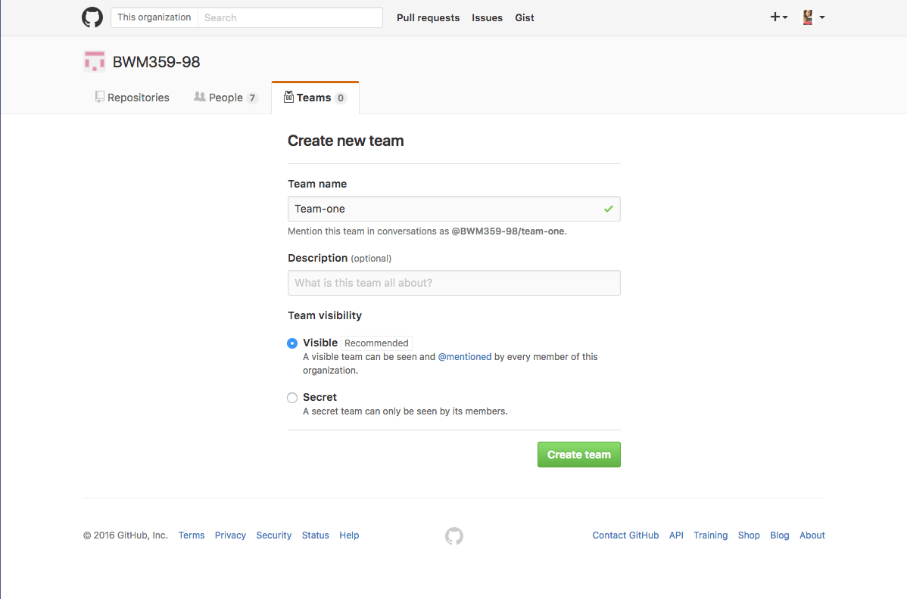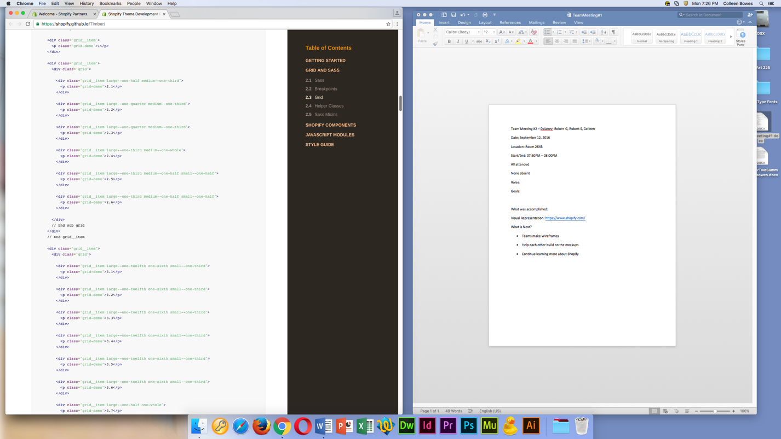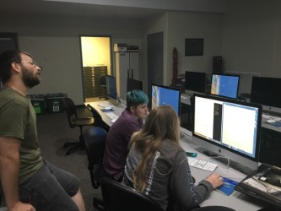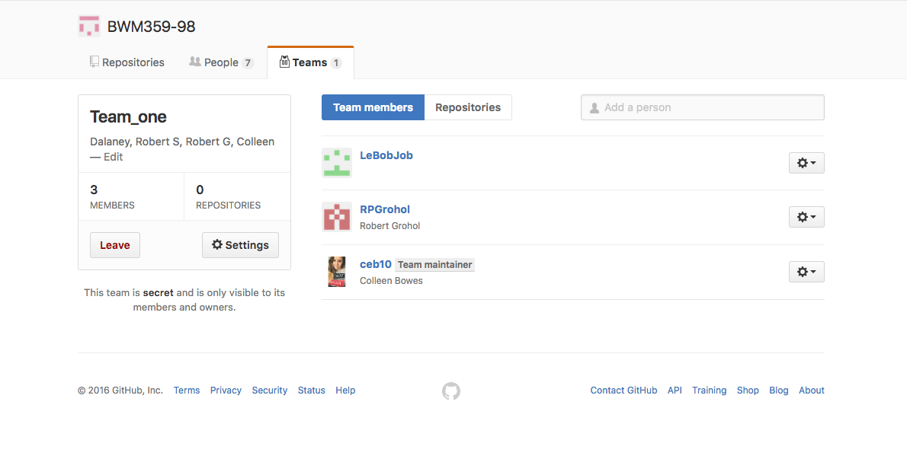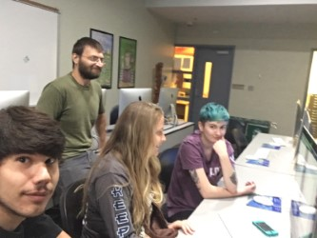

What is Next?

* Teams make Wireframes/Site map
* Robert S and Dalaney take photos
* Continue learning more about Shopify/timber
* Download timber/fork it on GIT Group
* Get familiar with Terminal commands again for GIT
* Start group proposal next meeting

Sites we are using:

* <https://www.shopify.com/partners/blog/the-ultimate-list-of-resources-for-shopify-theme-developers>
* <https://shopify.github.io/Timber/>
* <https://github.com/Shopify/Timber>
* <https://help.shopify.com/themes/development/getting-started>