Football Game V3 Wiring
Updated with MP3-TF-16P integration and control wiring

ESP32 Pin Allocation Detail
ESP32 GPIO | Connection | Notes
0 | Reserved / boot strap | Do not use for normal peripherals.
1, 3 | USB serial | Programming and Serial Monitor.
2 | Home TFT DC | Boot-strapping pin; existing display.
4 | Home TFT reset | Existing display use.
5 | Home TFT chip select | Existing display use.
12 | Visitor TFT reset | Boot-strapping pin; existing display.
13 | Home encoder A | EC11 rotary encoder.
14 | Visitor TFT chip select | Existing display use.
15 | Visitor TFT DC | Boot-strapping pin; existing display.
16 | LED strip data | FastLED data signal.
17 | Home encoder B | EC11 rotary encoder.
18 | TFT SPI clock | Shared by both TFT displays.
19 | MP3 UART receive | ESP32 RX; receives data MP3 player.
21 | I2C LCD SDA | 20x4 LCD.
22 | I2C LCD SCL | 20x4 LCD.
23 | TFT SPI MOSI | Shared by both TFT displays.
25 | Visitor encoder push | EC11 push switch.
26 | Home encoder push | EC11 push switch.
27 | MP3 UART transmit | ESP32 TX; commands to player.
32 | Visitor encoder A | EC11 rotary encoder.
33 | Visitor encoder B | EC11 rotary encoder.
34 | Action button 1 | Input only; requires external 10K R
35 | Action button 2 | Input only; requires external 10K R
36, 39 | Spare input-only pins | Available for future inputs.
6 through 11 | Do not use | Connected internally to ESP32 flash.

MP3-TF-16P Player
MP3-TF-16P pin | Connect to | Wiring detail
VCC | ESP32 3v3 | 3v3 should be enough
GND | ESP32 GND | All modules must share ground.
RX | ESP32 GPIO 27 (TX) | If 3v3 used do not need logic leveler
TX | ESP32 GPIO 19 (RX) | If 3v3 used do not need logic leveler
SPK1 and SPK2 | Speaker | Connect a suitable speaker directly between these two terminals.
USB+ / USB- | Not required | Leave unconnected
UART configuration: use ESP32 Serial2 at 9600 baud, with RX = GPIO 19 and TX = GPIO 27. Do not use GPIO 1 or GPIO 3 because they are needed for USB programming and the Serial Monitor.
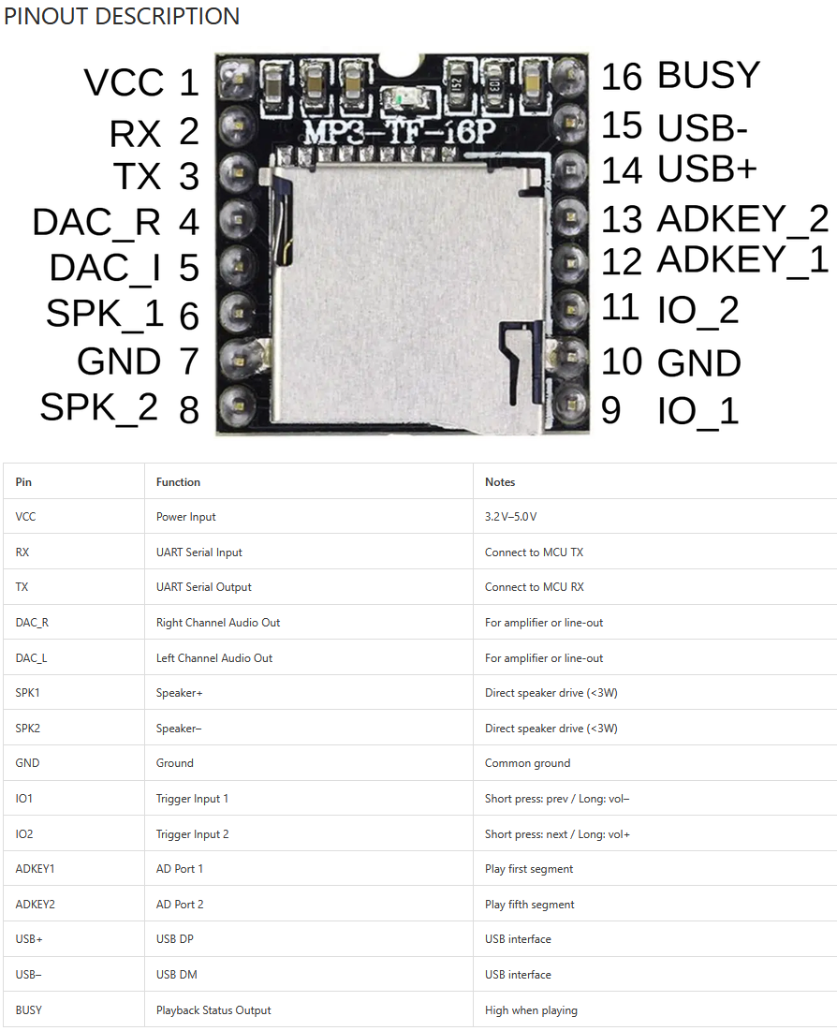

Action Buttons
Action button 1 moves to GPIO 34 and action button 2 moves to GPIO 35. GPIO 34 and GPIO 35 are input-only pins and do not provide internal pull-up resistors.
Button | Signal wiring | Required pull-up
Action button 1 | GPIO 34 to button; other button terminal to GND | 10K resistor from GPIO 34 to 3.3V.
Action button 2 | GPIO 35 to button; other button terminal to GND | 10K resistor from GPIO 35 to 3.3V.
Each input is normally HIGH. Pressing a button connects its GPIO to GND, making it LOW. Configure both pins as INPUT in firmware, not INPUT_PULLUP.

Rotary Encoder and TFT Boards
Board | TFT connections | EC11 encoder connections
Home display | SPI SCL: GPIO 18; SPI SDA/MOSI: GPIO 23; DC: GPIO 2; CS: GPIO 5; RESET: GPIO 4 | A: GPIO 13; B: GPIO 17; PUSH: GPIO 26; encoder common to GND.
Visitor display | SPI SCL: GPIO 18; SPI SDA/MOSI: GPIO 23; DC: GPIO 15; CS: GPIO 14; RESET: GPIO 12 | A: GPIO 32; B: GPIO 33; PUSH: GPIO 25; encoder common to GND.
Both TFT boards share SPI clock (GPIO 18) and MOSI (GPIO 23), while each board has its own DC, CS, and RESET signals. The EC11 A, B, and PUSH lines use ESP32 internal pull-ups in the current firmware.

Other Connections
Device | ESP32 pins | Notes
LED strip | GPIO 16 data | Use the appropriate external LED power supply and a common ground.
20x4 I2C LCD | GPIO 21 SDA; GPIO 22 SCL | The firmware uses I2C address 0x27 and 100 kHz bus speed.

Firmware Changes Required for This Wiring
Set Action_button_1_PIN to 34 and Action_button_2_PIN to 35. Configure both with pin Mode(pin, INPUT). Configure Serial2 with GPIO 19 as RX and GPIO 27 as TX for the MP3 player.

Display Detail

Ribbon wire color | Description | Display 1 (left) | Display 2  (right)
brown1 | ground | Ground bus | Ground bus
red1: | VCC | 3V3 bus | 3V3 bus
orange: | SCL | GPIO 18 | GPIO 18
yellow: | SDA | GPIO 23 | GPIO 23
green: | RES | GPIO 4 | GPIO 12
blue: | DC | GPIO 2 | GPIO 15
violet: | CS | GPIO 5 | GPIO 14
grey: | BLK | 3V3 bus | 3V3 bus
white: | A | GPIO 13 | GPIO 32
black: | B | GPIO 17 | GPIO 33
brown2: | PUSH | GPIO 26 | GPIO 25
red2: | KO | GPIO 19 | GPIO 27

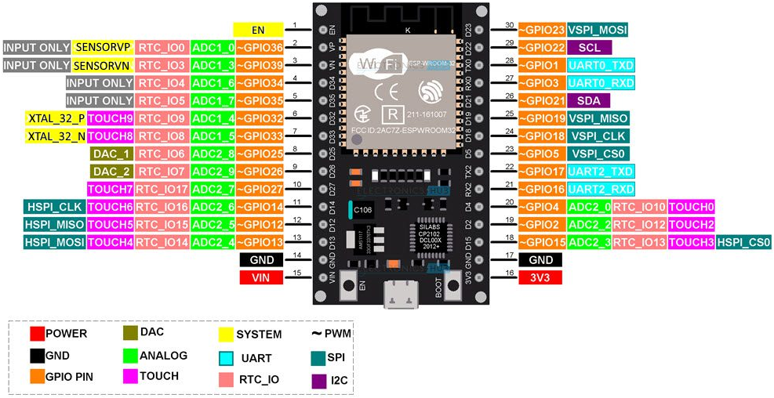
Figure D-1 - The pin layout
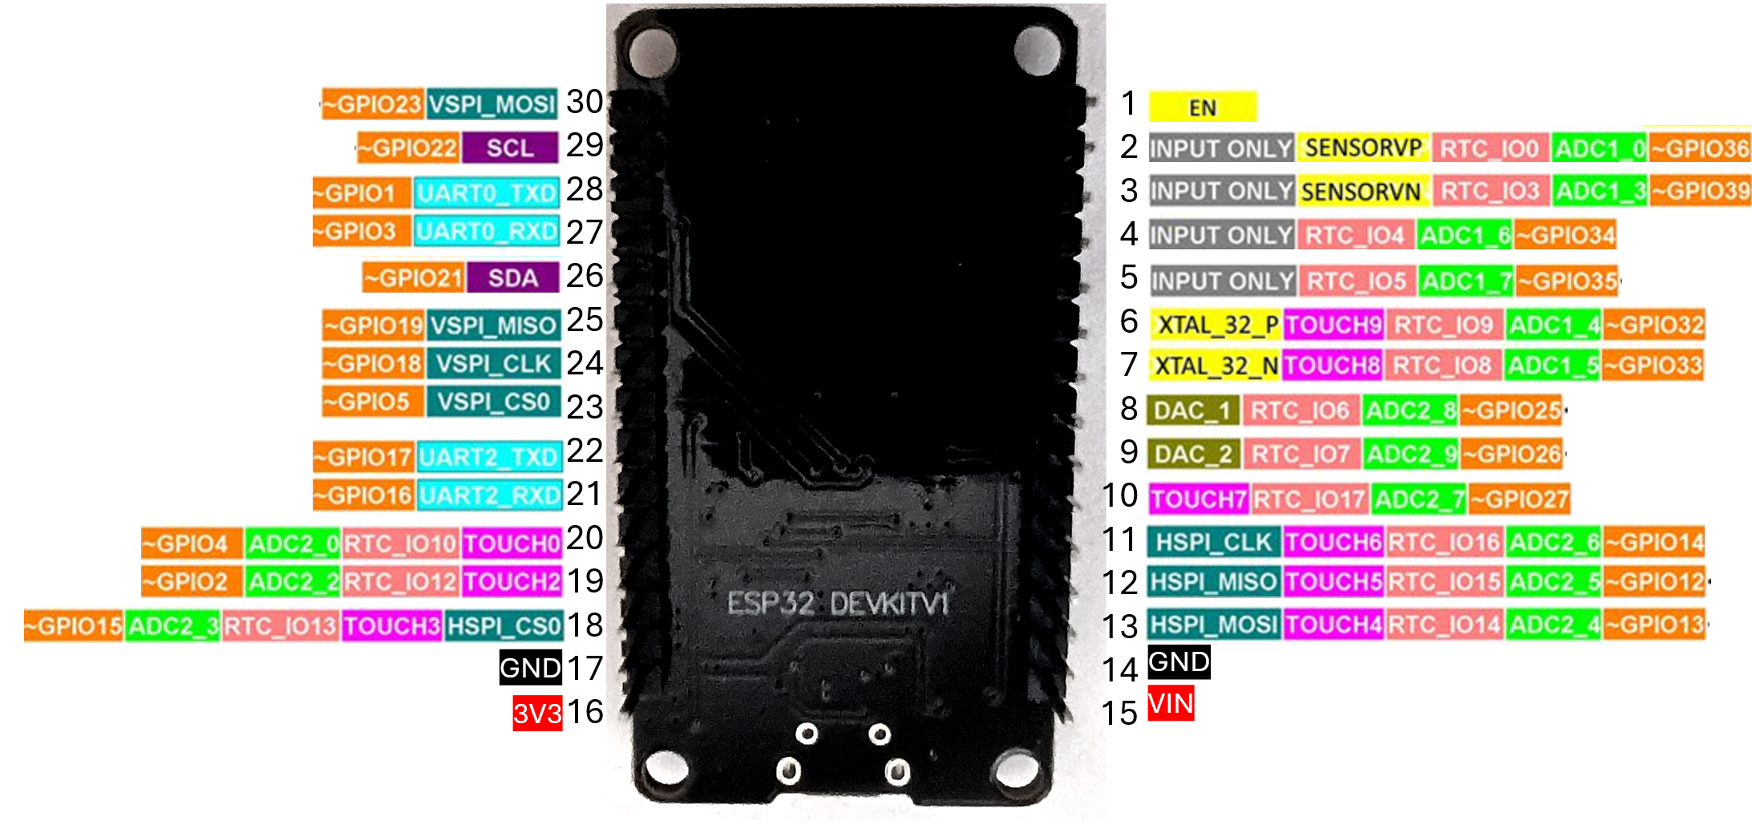
Figure D-2 - The pin layout (an underside view, since many times it is mount face down)

