Maintenance Features: IT Elective 3 Presentation
Example 1: Maintaining the Subject Catalog
Screenshot 1: The Subject Maintenance Form
In this system, educational lists such as Subjects and Strands are not hardcoded. The administrator uses the Subject Catalog maintenance form to add, edit, or delete subjects for Junior and Senior High. This list dynamically acts as the source for combo boxes and selections in other areas of the system.
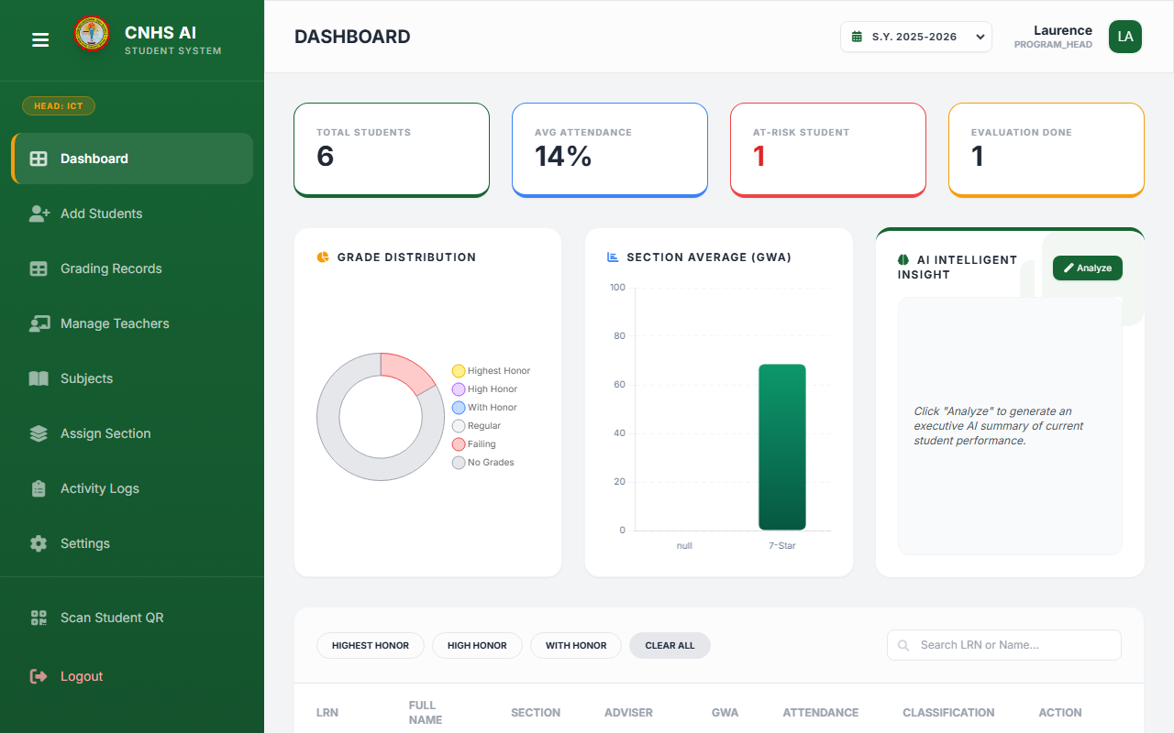

Screenshot 2: Corresponding Data-Entry Form (Manage Teachers)
When registering a new teacher, selecting the 'Senior High' school level automatically populates a 'Strand' combo box dropdown and displays the 'Assigned Subjects' options. These subject choices are pulled in real-time directly from the Subject Catalog maintenance module shown above.
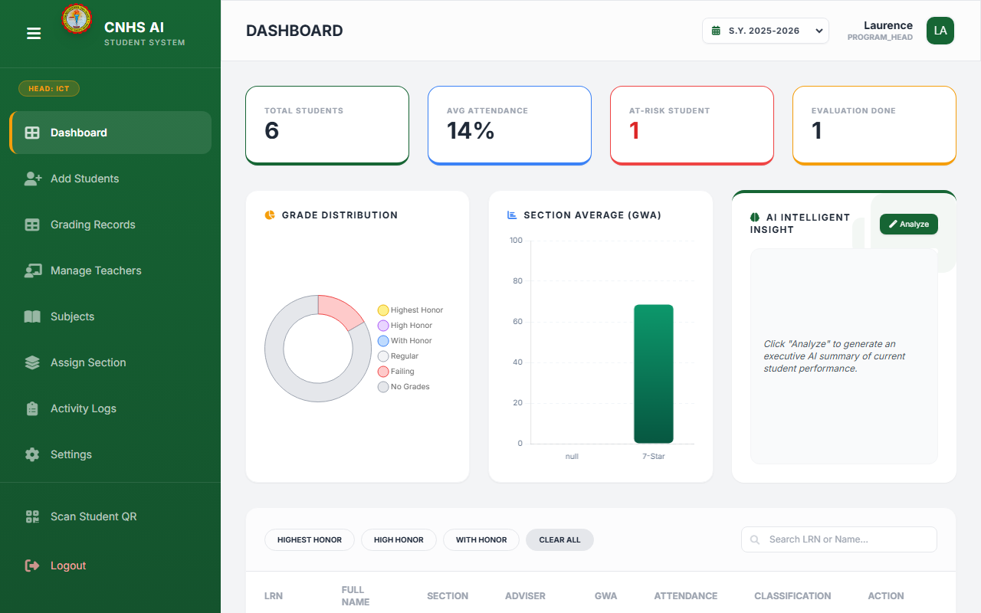

Example 2: Maintaining the Section List
Screenshot 3: The Section Maintenance Form
Similar to the subject catalog, school sections are managed through the 'Assign Section' module. The administrator can create new sections (e.g., '7-Einstein'), assign a Year level, and organize them into the system database.
