Hi Director,

PFB **team level** performance report for FY13.

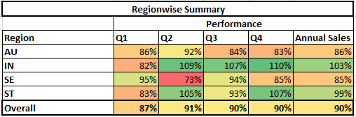

Key findings:

* Overall achievement being **90%** with team **IN** and **ST** being top performing teams(**103% and 99%** achmnt resp), although higher revenue came from **AU followed by SE** team(both around 85% achmnt).
* **Manager 6** grossed highest sales(~**11M**) from team **AU** followed by **Manager 16 (~9M)** of team **SE** with their resp performance being **102% and 78%** resp.
* Out of total **141** reps, **16** were inactive, majorly from **AU and SE** team. **Rep 76 and 44** grossed highest sales with **177% and 108%** achmnt respectively.
* **Annual Sales per representative** was highest for **Manager 6 of AU team(~1M per rep).**
* **Q2 and Q4** observed **75% and 53% overall growth** over resp previous quarters depicting a **seasonality** trend in sales.

Please find attached detailed summary of sales at various cut.

Thanks,

Shiv