Unterrichts-Ablauf:
Dauer | Thema | Schueler Aktivitaet
3 Minuten | Einfuehrung in das Thema mit “01-intro.py” | Zuhoeren
10 Minuten | Vorstellung von Gueligkeitsbereichen mit “02-scopes/” | Zuhoeren und wenn noetig Fragen stellen
10 Minuten | Erklaerung des ‘return’ Befehls mit “02-scopes/04-hoch.png” und “./03-loesung.py” | Zuhoeren und wenn noetig Fragen stellen
15-20 Minuten | Experimentieren mit “./04-example/01-beispiel.py” | Verschiedende Anwendungen von Gueltigkeitsbereichen und dem ‘return’ Befehl ausprobieren
10 Minuten | Vorstellung eines echten Beispiels anhand von “./04-example/example.py” | Zuhoeren und wenn noetig Fragen stellen
≈ 10 Minuten | Zeitpuffer fuer moeglichen Verzug

Code:

01-intro.py:

from turtle import *

def rect(laenge):
for ii in range(2):
forward(laenge)
right(90)
forward(laenge)
right(90)

def dach(laenge):
for jj in range(3):
forward(laenge)
right(120)

def change_pos(laenge, back):
if back:
left(30)
backward(laenge)
else:
forward(laenge)
right(30)

def haus(laenge):
rect(laenge)
change_pos(laenge, back=False)
dach(laenge)
change_pos(laenge, back=True)

def strasse(laenge, num_hauss):
for kk in range(num_hauss):
haus(laenge)

right(90)
forward(laenge)
left(90)

laenge += 20
laenge += 20

def main():
left(90)
speed(100000)

laenge = 100
laenge = 50

strasse(laenge, 5)

#haus(laenge)
done()
if __name__ == "__main__":
main()

02-scopes/

01-scopes.py
x = 7

def outer():
y = 5

def inner():
z = 6

print("x=", x)
print("y=", y)
print("z=", z)
inner()

print("x=", x)
print("y=", y)
print("z=", z)
outer()

print("x=", x)
print("y=", y)
print("z=", z)

02-treppe.png

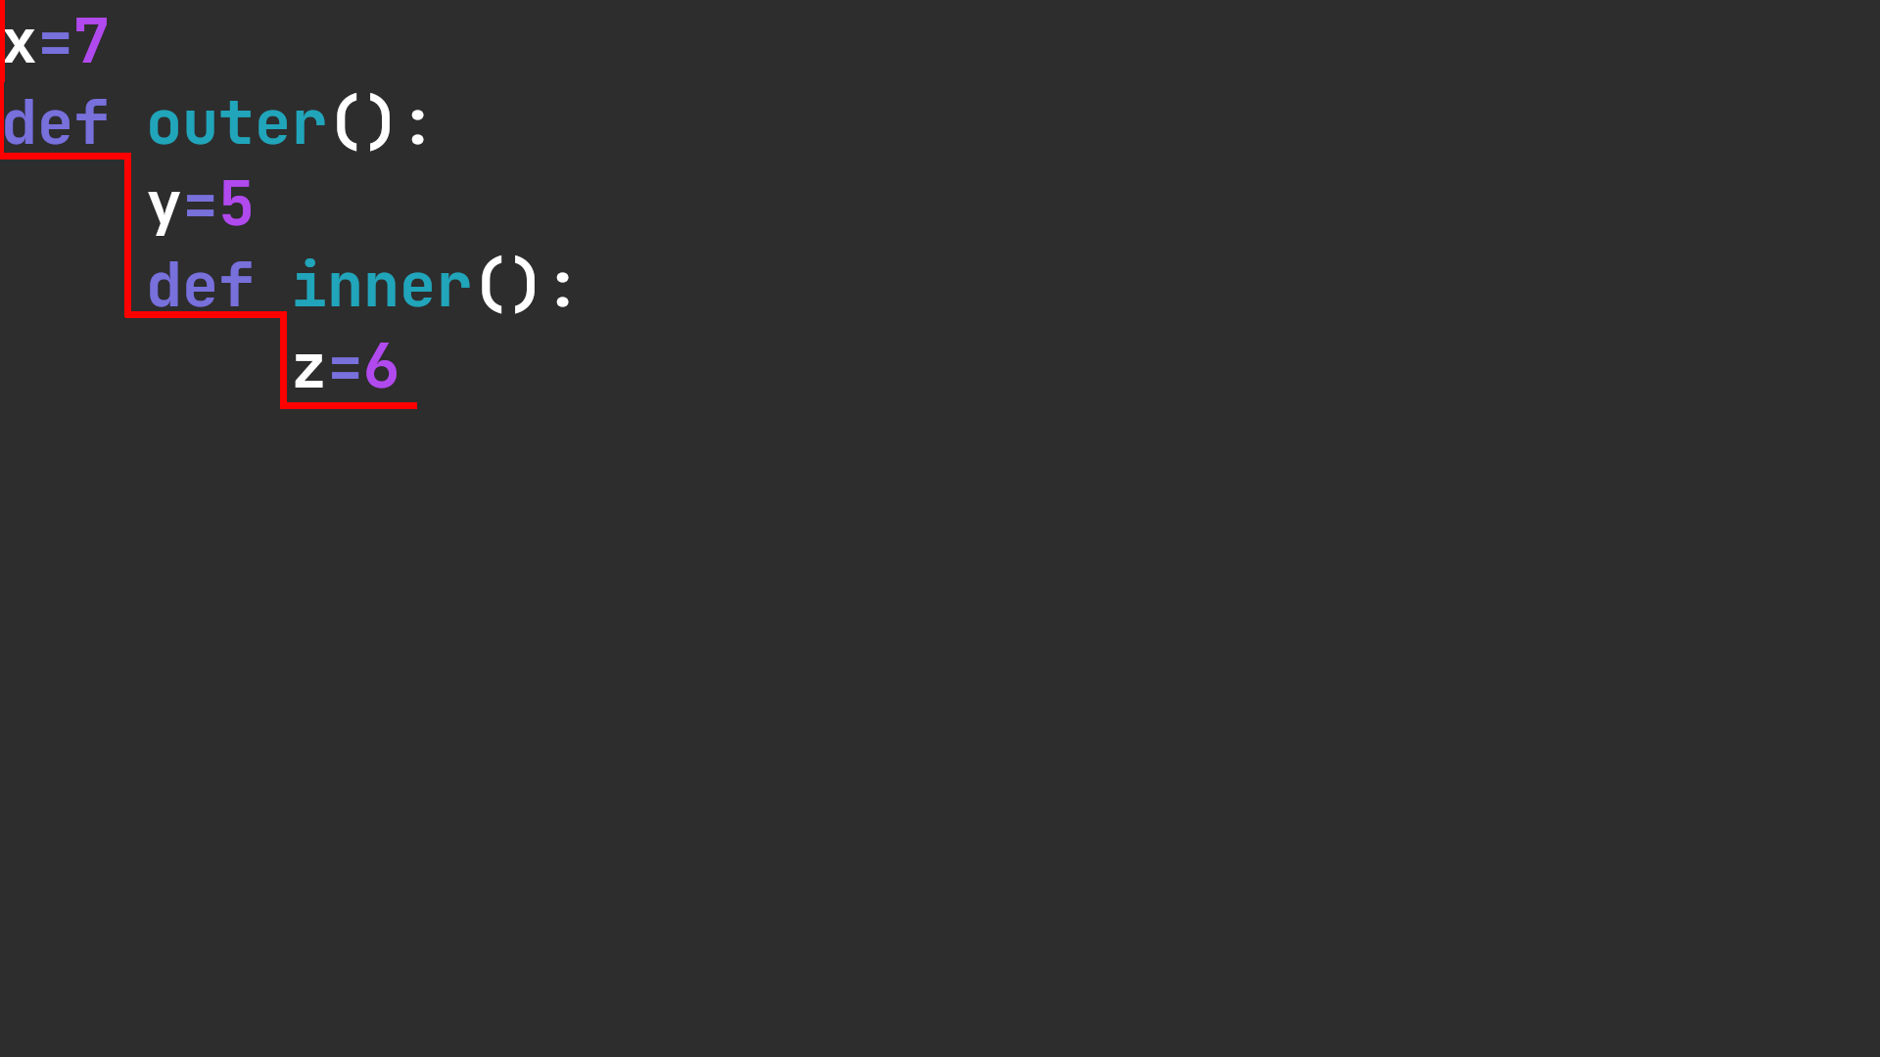
03-runter.png
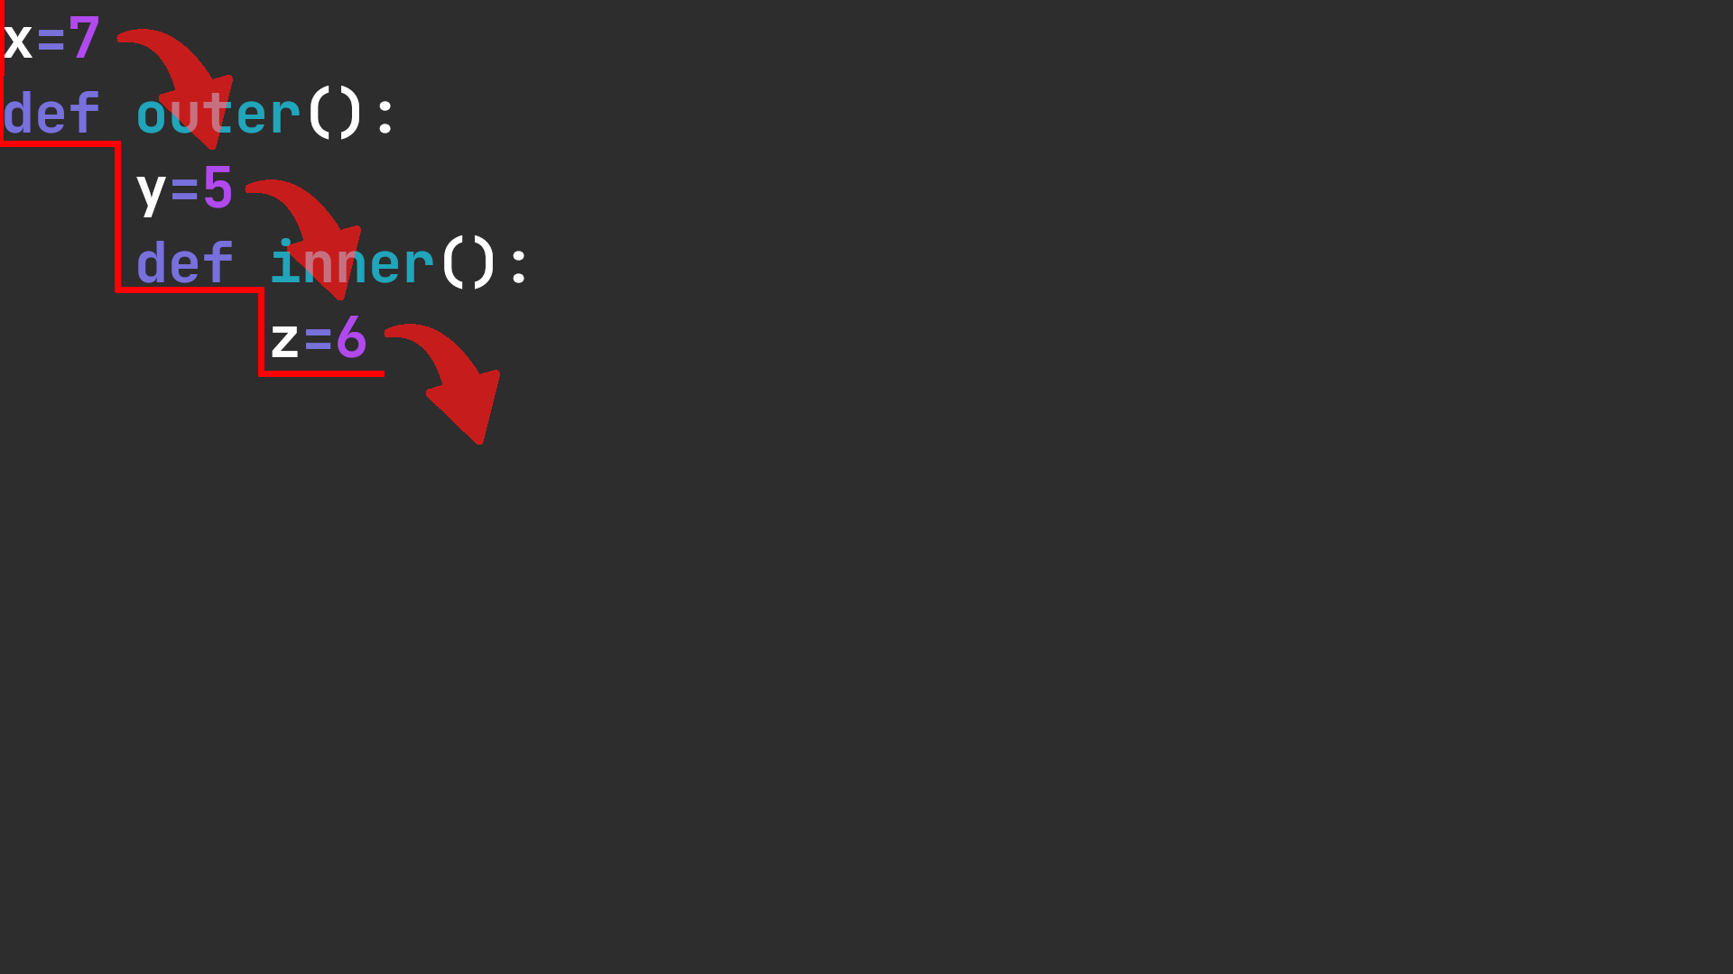

04-hoch.png
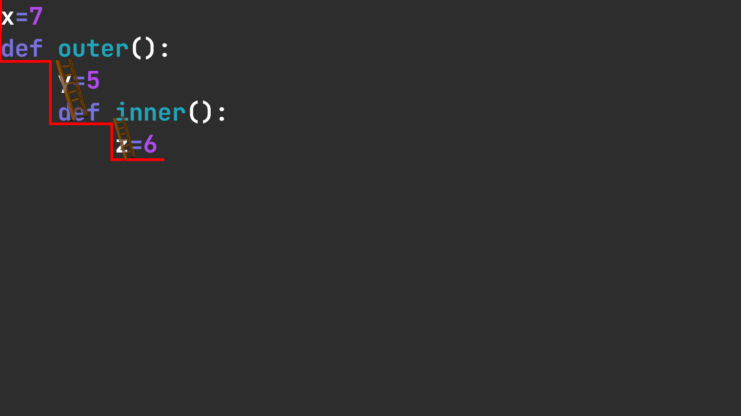

./03-loesung.py
from turtle import *

def rect(laenge):
for ii in range(2):
forward(laenge)
right(90)
forward(laenge)
right(90)

def dach(laenge):
for jj in range(3):
forward(laenge)
right(120)

def change_pos(laenge, back):
if back:
left(30)
backward(laenge)
else:
forward(laenge)
right(30)

def haus(laenge):
rect(laenge)
change_pos(laenge, back=False)
dach(laenge)
change_pos(laenge, back=True)

def strasse(laenge, num_hauss):
for kk in range(num_hauss):
haus(laenge)

right(90)
forward(laenge)
left(90)

laenge += 20
laenge += 20

return laenge

def main():
left(90)
speed(100000)

laenge = 100
laenge = 50

laenge = strasse(laenge, 5)

haus(laenge)
done()

if __name__ == "__main__":
main()

04-example/

01-bleispiel.py
num1 = 5
num2 = 6

def addition():
solution = num1 + num2
print(solution)

return solution

print(addition())

example.py
import os.path
import time

from forex_python.converter import CurrencyRates
from forex_python.bitcoin import BtcConverter

from openpyxl import Workbook, load_workbook
from datetime import date, datetime

def save_to_xlsx(BTC_USD, BTC_EUR, USD_EUR):
workbook = load_workbook('data.xlsx')
sheet = workbook.active

date = str(datetime.now())

row = (date, BTC_USD, BTC_EUR, USD_EUR)
sheet.append(row)

workbook.save(filename="data.xlsx")

def setup_xlsx():
workbook = Workbook()
sheet = workbook.active

sheet["A1"] = "date"
sheet["B1"] = "1 BTC in USD"
sheet["C1"] = "1 BTC in EUR"
sheet["D1"] = "1 USD in EUR"

workbook.save(filename="data.xlsx")

def usd_in_eur():
c = CurrencyRates()
EUR = c.get_rate('USD', 'EUR') #convert USD to EURO
return(EUR)

def btc_in_usd():
b = BtcConverter()
USD = b.get_latest_price('USD') #convert BTC to USD
return(USD)

def btc_in_eur():
b = BtcConverter()
EUR = b.get_latest_price('EUR') #convert BTC to EUR
return(EUR)

def main():
if os.path.isfile('data.xlsx'):
pass
else:
setup_xlsx()

while True:
BTC_USD = round(btc_in_usd(), 2)
USD_EUR = round(usd_in_eur(), 2)
BTC_EUR = round(btc_in_eur(), 2)

save_to_xlsx(BTC_USD, BTC_EUR, USD_EUR)

# Sleep for 24 hours
# (For testing purposes you can set it to a lower number)
time.sleep(24 * 60 * 60)

if __name__ == '__main__':
main()

