Hans Abrahamsen's Second Period: An Analysis of *Wald*

Christopher Chandler

# Biographical Sketch

Here is the biography.

# Acknowledgements

Here are the acknowledgements.

# Abstract

Here is the abstract.

# Introduction

Danish composer Hans Abrahamsen’s piece for large ensemble, *Wald* (2009), is a "series of variations" building on the opening of his earlier piece for woodwind quintet entitled *Walden* (1978). This return to his own music stemmed from a crisis in Abrahamsen’s compositional life, between 1991 and 1999, when he took an extended break from composing. During this time, Abrahamsen experienced debilitating writer's block; he wrote that he was "paralyzed by the white paper" and "felt that his music had become so complex that he no longer had the tools to create what he tried to imagine."[1] While he slowed in producing new work, he did not stop working. Throughout this period, which he calls the "fermata" of his compositional life, Abrahamsen found inspiration in arranging and orchestrating other composers' works as well as his own earlier pieces. This period of reflection, contemplation, and private work provided the necessary catalyst leading to a new stylistic period, one built upon the foundations of his first period but extended beyond it to new territory.

A precocious young composer, Abrahamsen had written a confident body of work by age 27 (1979) and was a prominent figure associated with the Danish "New Simplicity" movement. This movement was largely a reaction against Darmstadt serialism which sought to "establish a perceptible sense of form and to evolve a new relationship with past musical styles and objects."[2] Abrahamsen's works of this first period, including *Ten Preludes for String Quartet* (1973), *Stratifications* (1975), *Winternacht* (1976-78), and *Walden* (1978), blended the clarity of expression and economy of musical materials associated with "New Simplicity" along with elements of neo-classicism, neo-romanticism, and collage-like polystylism. Later first period works, like *Six Pieces* (1984) for horn, violin, and piano, and *Märchenbilder* (1984), and *Lied in Fall* (1987) show a greater sense of chromaticism and denser, more granular textures, perhaps revealing the influence of his teacher György Ligeti.

The musical style of Abrahamsen's second period is deeply informed by the groundwork he laid during the period of his "fermata." He returned to his older works and reorchestrated them for alternate ensembles, most notably the woodwind quintet *Walden* and septet *Winternacht*. He arranged and orchestrated works by Ives, Nielsen, Nørgård, and Ravel for ensembles ranging in size from woodwind quintet to chamber orchestra. Most importantly, Abrahamsen found inspiration in a set of canons by J.S. Bach[3] that he arranged with a distinctly Minimalist aesthetic, a pairing he would later revisit in *Schnee* (2006-08).

Abrahamsen's "fermata" ended with the *Concerto for Piano and Orchestra* (1999-2000); this work initiated a fertile period of artistic synthesis that combined the practice of returning to previous works (and referencing other composers' works) with new innovations in compositional technique. In this second period, Abrahamsen has returned to previous works in two ways: arrangement for a larger ensemble and starting from an existing germinal motive and expanding upon it significantly. For instance, Abrahamsen recasts the first four movements and eighth movement of *Ten Studies for Piano* (1984-98) for orchestral forces in *Four Pieces for Orchestra* (2004) and in the final movement of the *Piano Concerto*, respectively. *Air* (2006), for solo accordion, is a reworking and development of material from his first piece for accordion, *Canzone* (1978), and *Air* further serves as a point of departure for *String Quartet No. 3* (2008).[4]

Beginning with *Schnee* (2006-08) and *Wald* (2008-09), Abrahamsen's style crystalized into one based on tightly constrained musical materials, microtonal sonorities, repeating material delineated by repeat signs, frequent changes of meter, tempo modulations, and complex polyrhythms. The two works are drastically different in scope and instrumentation, with *Schnee* scored for nine musicians lasting an hour and *Wald* scored for fifteen musicians lasting eighteen minutes. Abrahamsen has nonetheless indicated that *Wald* is a "twin piece" to *Schnee*,[5] and indeed they share not only the aforementioned characteristics but also clearly articulated forms and symmetrical ensemble seating plans.

While *Schnee* has gained greater notoriety, due in part to its dramatic hour-long length, *Wald* better exemplifies the synthesis of his second period, where previous materials are recast and further developed within the context of these new compositional resources. It consists of seven variations based on the beginning of his woodwind quintet *Walden* (1978), and Abrahamsen has indicated there are additional connections to Robert Schumann's *Waldszenen*.[6] The thematic material appearing in both *Walden* and *Wald* is a rising perfect fourth horn call that elicits responses from other instruments.[7] The horn call repeats but has a slower periodicity than the other responses leading to a gradual change in the order of call and response. The passing of material around the instruments of the ensemble figures prominently throughout the work, and Abrahamsen controls this feature through the symmetrical arrangement of the ensemble into six groups. With these characteristics in mind, *Wald* represents an excellent case study to discuss the features of Abrahamsen's second period.

# Part 1: Historical Context

| Work | Related Work |
| --- | --- |
| *Ten Preludes* (1973) | *Ten Sinfonias* (2010) |
| *Ten Studies* (1984-98) I-IV | *Six Pieces* (1984) |
| *Ten Studies* (1984-98) I-IV | *Four Pieces for Orchestra* (2004) I-IV |
| *Ten Studies* (1984-98) VIII | *Concerto for Piano and Orchestra* (1999-2000) IV |
| *Canzone* (1978) | *Air* (2006) |
| *Air* (2006) | *String Quartet No. 3* (2008) |
| *Walden* (1978) I | *Wald* (2008-09) |
| *Schnee* (2006-08) | *Wald* (2008-09) |
| *Schnee* (2006-08) | *Double Concerto* (2010-11) IV |
| *Schnee* (2006-08) Canon 1A | *let me tell you* (2013) I |
| *Traumlieder* (2009) | *Six Pieces* (1984) |
| *Liebeslied* (2010) | *Double Concerto* (2011) I |

Table 1. Abrahamsen's Related Works

# Part 2: An Overview of *Walden* and *Wald*

**importance of horn to Abrahamsen**

* principle instrument
* physicality of horn and his cerebral palsy (mentioned in left alone program note and NY Times article)
* connection to *Six Pieces* (companion piece to Danish premiere of Ligeti's *Horn Trio*)
* connection to Ligeti's Horn Trio and Hamburg Concerto (?)
* connection to German romanticism
* connection to Schumann's *Waldenszen*
* discuss "Waldhorn" (from program note) and natural horn/microtonality
* connection to hunting:
* from Cheung Dissertation: Raymond Monelle explains, "The medieval hunting horn was primarily a signaling instrument. During the course of personnel and hounds could become dispersed over wide area, and it was often necessary to communicate certain water, the release sight of the quarry, the loss of the scent, the plunging of the quarry into probable route of of (relais, small teams of huntsmen and hounds posted along the the hunt), the stag at bay, the stag and many other important steps in the process of hunting needed to be broadcast to the various members of the hunting party. The sound of the horns was also found to stimulate the hounds." Mondelle, Raymond. *The Musical Topic: Hunt, Military and Pastoral*. Bloomington, IN: Indiana University Press, 2006.

**Left, alone** program note:

I was born with a right hand that is not fully functional, and though it never prevented me from loving playing the piano as well as I could with this physical limitation, it has obviously given me an alternative focus on the whole piano literature and has given me a close relationship with the works written for the left hand by Ravel and others. This repertoire has been with me since my youth.

My very first public performance of one of my own works was in autumn 1969. The piece was called *October* and I played the piano with my left hand and the horn, my principal instrument (the only instrument that can be played with only the left hand). Part of the piece requires the performer to play natural harmonics of the horn directly into the open strings of the grand piano to create resonance. The pedal was kept down by an assistant lying on the floor.

Through decades the idea of writing a larger work for piano left hand has been in my mind. This new work is not written for a pianist with only one hand, but rather by a composer who can only play with the left hand. The title Left, alone contains all kinds of references, not only to the obvious fact that the left hand is playing alone. Left, alone is divided into two large parts, each consisting of three smaller movements – in effect, six in total.

* *Left, alone* Part 2: IV. Horn and piano solo in orchestral context perhaps reminiscent of this earlier work

## Walden

### Background and Instrumentation

An analysis of *Wald* must first begin with *Walden*, as it provides the germinal material later recast in *Wald*. Abrahamsen composed *Walden* in 1978 on a commission from the Funen Wind Quintet. The title of the four-movement work comes from Henry David Thoreau's novel of the same name that documented the American philosopher's "attempt to strip away all the artificial needs imposed by society and rediscover man’s lost unity with nature."[8] In the program note for the piece, Abrahamsen describes the musical material and the kinds of processes that interested him:

The title is taken from the American philosopher and poet Henry David Thoreau’s novel from 1854 about living in the woods, which Thoreau did for two years. His stay there was an experiment, an attempt to strip away all the artificial needs imposed by society and rediscover man’s lost unity with nature. In that particular sense his novel is a documentation of social inadequacy and a work of poetry (Utopia) as well.

All thought Thoreau himself never completed any actual social analysis he was way ahead of his own time in his perception of the economy and cyclic character of Nature, today known as ecology. His ideas are particularly relevant now that pollution caused by society has reached alarming proportions.

Walden was written in a style of re-cycling and “new simplicity”. A lot of superfluous material has been peeled away in order to give space to different qualities such as identity and clarity. Various layers are encountered in the quintet such as the organic (growth, flowering, Decay), concretism (mechanical patterns) and finally the descriptive (distant horn calls and other ghost-like music of the past enter our consciousness like a dream). Walden consist of four movements.

In 1995 another version for reed quintet was written to the Calefax Reed Quintet.[9]

Walden was written in a style of re-cycling and "new simplicity." A lot of superfluous material has been peeled away in order to give space to different qualities such as identity and clarity. Various layers are encountered in the quintet such as the organic (growth, flowering, decay), concretism (mechanical patterns) and finally the descriptive (distant horn calls and other ghost-like music of the past enter our consciousness like a dream).[10]

**section on rearrangement for reed quintet**

### Form

The layers of organicism, concretism, and descriptive are fitting descriptions of how the material unfolds in each movement. Organicism is central to the first and second movements where motives develop gradually through additive processes, for instance melodic expansion and rhythmic augmentation and diminution. The third movement features a three-note pattern articulated heterophonically with polyrhythms (10 over 7 over 4). This susurrous texture gradually decreases in speed and gives way to slow legato oscillating patterns that mechanistically compress in rhythm, ascend in register, and coalesce into an interlocking sixteenth note texture. The "ghost-like music of the past" has relevance to both the horn call of the first movement as well as the fourth movement whose contrapuntal texture is stylistically reminiscent of Baroque music. This final movement features a composite texture of an E-major flute and bassoon duo in 3/4 and an Eb-major trio of oboe, clarinet, and horn in 6/8.

Walden's movement durations decrease successively

| Section | Duration |
| --- | --- |
| First Movement | 2:57 |
| Second Movement | 2:51 |
| Third Movement | 2:33 |
| Fourth Movement | 1:04 |

Table 2. *Walden* Movement Proportions.

The first movement of *Walden* begins with a call and response that Abrahamsen develops further in *Wald*. A brief examination of the process he uses to gradually unfold this material will illustrate the concept of rhythmic displacement, which is central to *Wald*. Figure 1 shows the first two of four phrases separated by grand pauses.

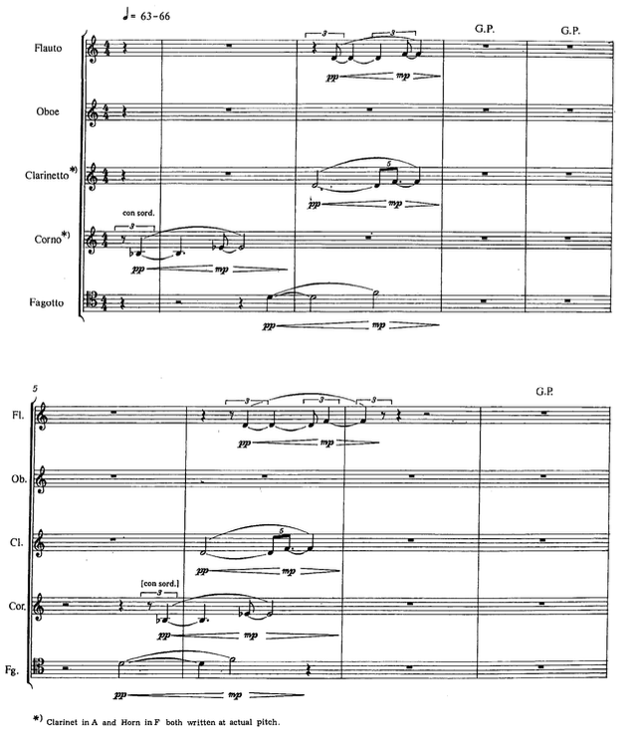

Figure 1. Horn call and responses.

The phrases contain two motives: a single rising Bb-Eb call and three D-F echoing responses. Each instance of the motive differs slightly in rhythmic subdivision, and over the course of the four phrases, the order of the call and responses changes by rhythmic displacement each instance. Comparing the second phrase to the first, the horn enters within beat 4 as before, but the bassoon enters 5 quarter notes earlier, the clarinet 4 quarter notes, and the flute 4 quarter notes plus one triplet eighth note. This process continues through phrases three and four and ends with the horn motive isolated from the other instruments and rotated to its last order position (see Figure 2). **orient the displacement discussion around the clarinet since its rhythmic position never changes**

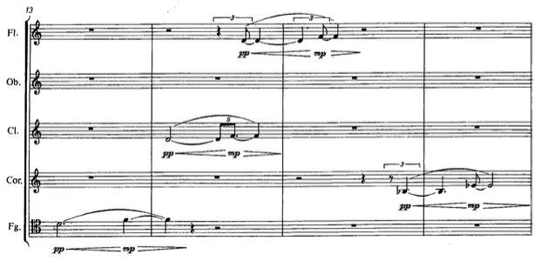

Figure 2. Horn motive phrase four.

**cross relationships between movements**

* first movement: perfect fourth motive and displacement
* first movement: limited melodic motives
* second movement: picking up where the first left off after the punctuated interruption
* second movement: oboe F# C# at mm. 5-6, 15-16, and 24-25
* third movement: oboe F# C# at climax
* third movement: punctuated gesture towards end
* fourth movement: most unrelated; scalar material suggestive of scalar motion in first and second movements
* fourth movement: polymeter and various subsets

**connect aspects of Walden to other music**

* Winternacht: movement picking up where the last left off
* Winternacht: material returning in another movement
* Winternacht:

### Relationships to Wald

## Wald

The simplicity and straightforward process-driven development of this material is indicative of Abrahamsen's first period compositional technique. His reworking of this material in *Wald* retains these qualities yet recasts the material with greater emphasis on timbral nuance. The form of *Wald* consists of an introduction and seven variations whose successive durations decrease over the course of the work. The listing of durations in Table 3, measured from the commercially released recording,[11] shows that this decrease is not linear but illustrates Abrahamsen's affinity for compressing global proportions, a technique he also used in *Schnee*.

| Section | Duration |
| --- | --- |
| Introduction | 3:10 |
| Variation 1 | 2:38 |
| Variation 2 | 2:09 |
| Variation 3 | 2:35 |
| Variation 4 | 2:00 |
| Variation 5 | 1:39 |
| Variation 6 | 1:31 |
| Variation 7 | 1:18 |

Table 3. *Wald* Formal Proportions.

These variations are juxtaposed with little to no transitional material. Their boundaries and subsections are clearly demarcated in the score through the use of different tempi, meters, descriptive markings, and double bar lines. Table 4 gives a comprehensive list of every tempo change and descriptive marking that accompanies a new subsection or variation.

| Section | Measures | Tempo | Descriptive markings |
| --- | --- | --- | --- |
| Intro | mm. 1-108 |  |  |
|  | 1 | Tempo I = 88 | Allegro con brio |
|  |  |  | "wie aus der Ferne" |
|  |  |  | ("as from a distance") |
|  | 37 | Tempo II = 66 | Poco meno ma maestoso |
|  |  |  | poco grottesco e ironico |
|  | 73 | Tempo III = 100 | Allegro vivace e agitato |
|  |  |  | "aufgeregt" ("excited") |
|  | 91 | Tempo IV = 88 | Meno mosso, soave e fluente |
| Var 1 | mm. 109-267 |  |  |
|  | 109 | Tempo I = 92 | Allegro con brio |
|  |  |  | ma un poco piu mosso |
|  |  |  | ancora "wie aus der Ferne" |
|  |  |  | (yet "as from a distance") |
|  | 171 | Tempo II = 77 | Poco meno maestoso |
|  |  |  | ma un poco piu mosso |
|  |  |  | ma poco lamentoso |
|  | 238 | Tempo III = 100 | Allegro vivace e piu agitato |
|  |  |  | "sehr aufgeregt" ("very excited") |
|  | 254 | Tempo IV = 88 | Meno mosso, soave e fluente |
| Var 2 | mm. 268-408 |  |  |
|  | 268 | Tempo I = 94 | Allegro con brio |
|  |  |  | ma sempre poco piu mosso |
|  | 322 | Tempo II = 82 | Un poco meno |
|  |  |  | ma ancora piu mosso |
|  |  |  | lamentoso e melancolico |
|  | 382 | Tempo III = 100 | Allegro vivace e agitato |
|  |  |  | "wieder aufgeregt" |
|  |  |  | ("excited again") |
|  | 402 | Tempo IV = 88 | Meno mosso, soave e fluente |
| Var 3 | mm. 409-442 |  |  |
|  | 409 | = 32 | Adagio misterioso ("Nachtmusik") |
| Var 4 | mm. 443-473 |  |  |
|  | 443 | = 32 | Stesso tempo |
| Var 5 | mm. 474-581 |  |  |
|  | 474 | = 64 | Con nuova energia |
|  |  |  | "Wie ein plötzliches Erwachen" |
|  |  |  | ("Like a sudden awakening") |
|  | 490 | = 144 | Vivo furioso |
|  |  |  | ("vielleicht eine Jagd") |
|  |  |  | ("perhaps a hunting") |
|  | 522 | = 165 | Presto volante |
|  |  |  | ("galoppierend, immer vorwärts") |
|  |  |  | ("galloping, always forward") |
|  | 562 | = 132 | Più mosso |
| Var 6 | mm. 582-594 |  |  |
|  | 582 | = 66 | Andante mesto |
| Var 7 | mm. 595-605 |  |  |
|  | 595 | = 64 | Piu lento |

Table 4. *Wald* Tempo and Descriptive Markings

This table highlights variations and sections that are musically connected by these indications, but does not describe the full extent of their relationships. There are interrelated sections and variations across the piece that are not captured by this table. The entire form of the work can be grouped in the following way:

Part A: Introduction, Variation 1, Variation 2

Part B: Variation 3 and Variation 4

Part C: Variation 5

Part D: Variation 6 and Variation 7

The introduction establishes the primary motivic and harmonic material, while variations 1 and 2 are very close re-readings of the introduction with differences in proportion, orchestration, and motivic development. These three sections, grouped as Part A, each contain four subsections differing in tempo, harmony, and activity. Variation 3 and 4 contain the quietest, calmest, and most introverted music, while Variation 5 functions as the climax, with the loudest, most chaotic, and texturally dense music. Variations 6 and 7 are harmonically related to the fourth part of Part A and contain similar harmonic material with different orchestrations.

The introduction establishes the primary motivic and harmonic material, while variations 1 and 2 are very close re-readings of the introduction with differences in proportion, orchestration, and motivic development. These three sections, grouped as Part A, each contain four subsections differing in tempo, harmony, and activity. Variation 3 and 4 contain the quietest, calmest, and most introverted music, while Variation 5 functions as the climax, with the loudest, most chaotic, and texturally dense music. Variations 6 and 7 are harmonically related to the fourth part of Part A and contain similar harmonic material with different orchestrations.

Abrahamsen's arrangement of the 15 musicians[12] into a semi-circle of six symmetrical groups guides his approach to orchestration. Figure 3 shows a diagram of the seating plan in the score and indicates the 4 groups of duos and 2 groups of trios with the piano occupying the central position outside of any group.

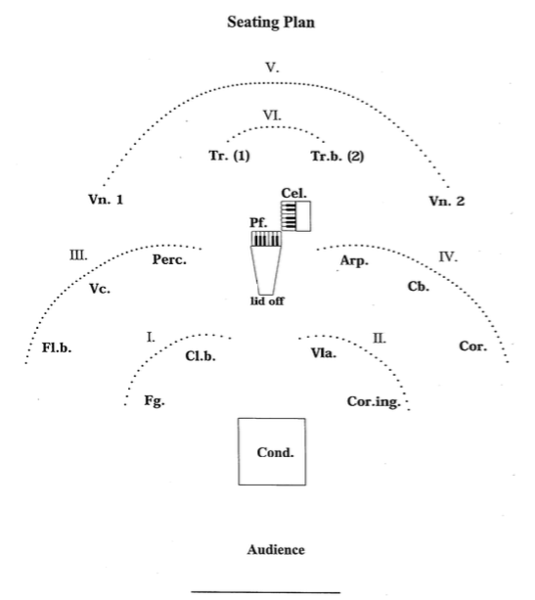

Figure 3. *Wald* seating plan.

Throughout the variations, the six groups exchange musical ideas in a way that is balanced and symmetrical: phrases performed by one group of instruments are answered by phrases from the corresponding symmetrical groups. A brief examination of the first sections of the introduction (measures 1-36) illustrates this process.

# Part 3: An Analysis of *Wald*

## Introduction, Variation 1, and Variation 2

### Section 1

Like *Walden*, the first section of the introduction features four phrases where the rising perfect fourth motive and three echoing motives undergo rhythmic displacement. Each of the four phrases features a specific collection of instruments from Group III and Group IV (see Figure 3). Furthermore, each phrase repeats verbatim from the extensive use of repeat signs, characteristic of Abrahamsen's second period works. These phrases alternate lengths of 9 measures and 8 measures following an unrepeated 2 measure intro:

2 mm. ||: 9mm. :||: 8mm. :||: 9mm. :||: 8mm. :||

This alternating structure determines the motives that the instrumental groups perform as well as their harmonic material, which consists of only a D4-G4 dyad and a 1/6th-tone flat D4-G4. The 9-measure phrases feature the bass flute performing the rising perfect fourth motive equally tempered and colored by bisbigliando trills. The trio of instruments from Group IV (horn, bass, and harp) perform the echoing motives with the 1/6th tone flat intonation. These characteristics flip in the 8-measure phrases: the horn (seated symmetrically opposite the bass flute) performs the fourth motive with the 1/6th flat intonation while the trio of instruments in Group III (bass flute, cello, and percussion) perform equally tempered echoing motives. Unlike *Walden*, as the group exchanges material and the motivic displacement occur, the echoing motives increase in duration; for instance, the horn's repeated note gesture in the first phrase is doubled rhythmically when compared to its reappearance in phrase 3 (measure 23). Like the global form, this durational transformation is not strictly linear, but nonetheless gives an aural sensation of a ritardando.

These aspects of Abrahamsen's tight, almost obsessive, control over orchestration, harmony, form, and motivic development are evident throughout *Wald*. The piece is uniquely situated in his output as it directly follows his landmark work *Schnee* and builds upon the new techniques there and in the *Piano Concerto*. It is a work highly representative of his second period style where materials from an earlier work are revisited and developed in a markedly different direction, one informed by new approaches to timbre and development.

### Section 2

The second section of the introduction contrasts the first by way of tempo, meter, rhythmic activity, pitch collection, and orchestration, but it retains the same basic principle of gradual displacement and expands it to both motivic ordering and pitch ordering. Like the first section, the second begins with 2 unrepeated measures and then repeats four phrases verbatim that alternate 8-measure and 9-measure lengths:

2 mm. ||: 8mm. :||: 9mm. :||: 8mm. :||: 9mm. :||

The starting 2 measures abruptly break the perfect fourth pedal point as the pianist performs punctuated <123678> clusters. The two violins of Group V that were previously alternating repetitions of the D4-G4 and 1/6th tone flat D4-G4 dyads begin exchanging dyads a half-step higher and lower (C#4-F#4 and Eb4-Ab4). The bass flute and horn (the most active of the first section) rest during the second section. The rest of the ensemble joins in articulating one of two motives: the calling perfect fourth gesture now harmonized as <123> and <678> clusters and a chromatically ascending percussive line.

Again the presentation of these two motives is largely connected to the ensemble seating plan. During the 8-measure phrases, Group I and Group VI play the perfect fourth motive, with the bassoon and bass clarinet (Group I) playing in equal temperament and the trumpet and bass trumpet (Group VI) playing a 1/6th tone flat intonation. The ascending chromatic line is fully presented by the harp, and additionally doubled in Group II, where the viola and English horn alternate each note of the line. The roles flip symmetrically during the 9-measure phrases (e.g. Group I divides the chromatic line while Group II plays the perfect fourth motive).

As is the case with the first section, these two motives gradually change position over the course of the four phrases. Additionally, the order of the pitches in the chromatically ascending line also undergoes a rotational procedure. With each phrase, the pitch class 6 moves forward one position (with the exception of phrase 3 where it occurs simultaneously with 2), and during the final phrase, pitch class 7 also shifts forward one position creating a series of chromatically ascending perfect fourths:

Phrase 1: <1 2 3 6 7 8>

Phrase 2: <1 2 6 3 7 8>

Phrase 3: <1 6 3 7 8 >

< 2 >

Phrase 4: <1 6 2 7 3 8>

### Section 3

### Section 4

* Cascading material in marimba/harp and piano
* Interval cycles at play
* Interlocking voices of the pentatonic 5-34[02469] material from Section 3

## Variation 3 and Variation 4

## Variation 5

* More interval cycles: 5-cycle and 6-cycle
* Two primary motives:
* ascending repeated figures voiced in fifths
* descending dyads of tritones, fourths, and

## Variation 6 and Variation 7

# Bibliography

Abrahamsen, Hans. *Hans Abrahamsen: Walden/Wald*. Compact disc. Edited by Reinbert de Leeuw. Winter; Winter, 2013.

———. “*String Quartet No. 3*,” 2008. <http://www.musicsalesclassical.com/composer/work/1/36682>.

———. “*Walden*,” 1978. <http://www.musicsalesclassical.com/composer/work/1/21805>.

———. “*Wald*,” 2009. <http://www.musicsalesclassical.com/composer/work/1/43185>.

Ernste, Kevin. “Hans Abrahamsen’s *Winternacht:* Reflections on an Etching by M.C. Escher.” PhD thesis, University of Rochester, 2006.

Johnson, Stephen. “*Fire Stykker for Orkester*,” 2004. <http://www.musicsalesclassical.com/composer/work/1/20289>.

Rasmussen, Karl Aage. *Noteworthy Danes: Portraits of Eleven Danish Composers*. Copenhagen: Wilhelm Hansen, 1991.

Robin, William. “Hans Abrahamsen: Fame and Snow Falling on a Composer,” 2016. <http://www.nytimes.com/2016/03/13/arts/music/hans-abrahamsen-fame-and-snow-falling-on-a-composer.html>.

White, John David. *New Music of the Nordic Countries*. Hillsdale, NY: Pendragon Press, 2002.

1. Robin, “Hans Abrahamsen: Fame and Snow Falling on a Composer.”
2. Ernste, “Hans Abrahamsen’s *Winternacht:* Reflections on an Etching by M.C. Escher,” 8.
3. BWV 1072-1078
4. Abrahamsen, “*String Quartet No. 3*” Program note.
5. Abrahamsen, “*Wald*” Program note.
6. Ibid. Program note.
7. Ibid. Program note.
8. Abrahamsen, “*Walden*” Program note.
9. Ibid. Program note.
10. Ibid. Program note.
11. Abrahamsen, *Hans Abrahamsen: Walden/Wald*.
12. Scored for: bass flute, English horn, bass clarinet, bassoon, French horn, trumpet, bass trumpet, percussion, harp, piano, 2 violins, viola, cello, and double bass.