Pasta de dientes

Carlota Echevarria

20/11/2019

Librerias

library(openxlsx)  
library(skimr)  
library(fpp2)  
library(ggplot2)  
library(zoo)  
library(ggfortify)  
require(forecast)  
require(xts)  
library(readr)  
library(tidyverse)  
library(dplyr)  
library(tsoutliers)  
library(TSA)

datos<-read.xlsx("data/data.xlsx")  
datos$Date <- as.Date(paste(datos$Year, datos$Week, 1, sep = "-"), "%Y-%U-%u")

#dividimos la serie en 2 y conversion en datos  
  
xcolgate <- ts(datos$Colgate, start = 1958, frequency = 52)  
  
xcrest <- ts(datos$Crest, start = 1958, frequency = 52)  
  
#conversion de datos  
  
#Transformamos a zoo  
zcolgate<-as.zoo(xcolgate)  
zcrest<-as.zoo(xcrest)  
  
names(zcolgate)<-"Colgate"  
names(zcrest)<-"Crest"  
  
view(zcolgate)  
#Plot serie  
  
autoplot(zcolgate)+ggtitle("Cuota de mercado")+ xlab("Semanas") + ylab("Colgate")

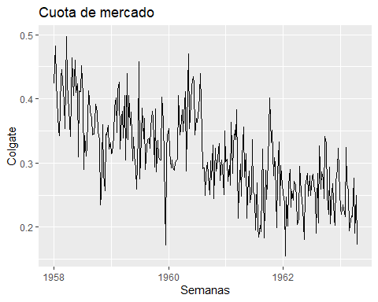

autoplot(zcrest)+ggtitle("Cuota de mercado")+ xlab("Semanas") + ylab("Crest")

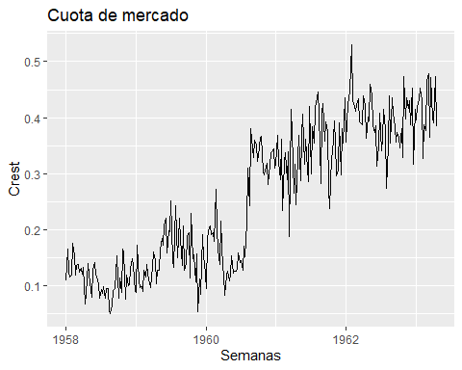

#Seleccion del numero de observaciones para comparar la prediccion  
#Eliminamos las semanas de 1963  
cOmit = 16  
  
#Dara Size  
nObsColgate=length(zcolgate)  
nObsCrest= length(zcrest)  
  
  
#Sub_sample: para hacer el forecast  
oColgate <- window(zcolgate,start=index(zcolgate[1]),end=index(zcolgate[nObsColgate-cOmit]))   
  
oCrest <- window(zcrest,start=index(zcrest[1]),end=index(zcrest[nObsCrest-cOmit]))   
  
View(oColgate)

#MODELO ARIMA

#Diferencia para hacerlo estacionario en media para colgate  
ggtsdisplay(diff(zcolgate))

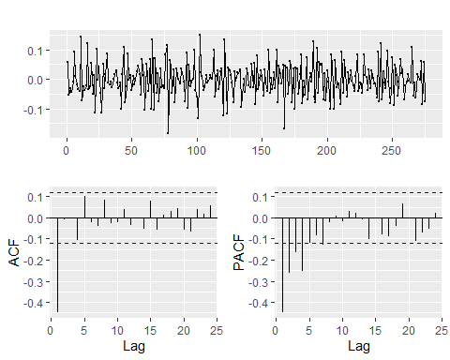

zcrest_log<-log(zcrest)

#Se ha aplicado para crest logaritmos y diferencia en media  
ggtsdisplay(diff(zcrest_log))

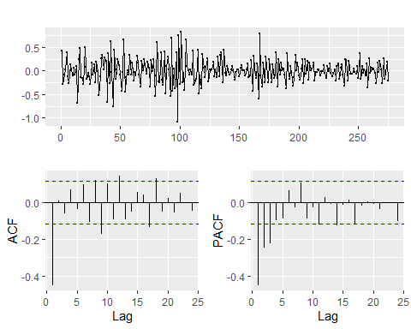

fit1<-auto.arima(oColgate, lambda = 0)  
summary(fit1)

## Series: oColgate   
## ARIMA(0,1,1)   
## Box Cox transformation: lambda= 0   
##   
## Coefficients:  
## ma1  
## -0.7688  
## s.e. 0.0480  
##   
## sigma^2 estimated as 0.02572: log likelihood=106.6  
## AIC=-209.2 AICc=-209.15 BIC=-202.08  
##   
## Training set error measures:  
## ME RMSE MAE MPE MAPE  
## Training set 0.0001499824 0.04794299 0.03787449 -2.139878 12.73175  
## MASE ACF1  
## Training set 0.6059918 0.06055707

fit2<-auto.arima(oCrest, lambda = "auto")  
summary(fit2)

## Series: oCrest   
## ARIMA(0,1,1)   
## Box Cox transformation: lambda= 0.5803491   
##   
## Coefficients:  
## ma1  
## -0.6396  
## s.e. 0.0452  
##   
## sigma^2 estimated as 0.006994: log likelihood=275.4  
## AIC=-546.8 AICc=-546.76 BIC=-539.69  
##   
## Training set error measures:  
## ME RMSE MAE MPE MAPE MASE  
## Training set 0.004125602 0.04538404 0.034642 -2.278906 17.21842 0.3821147  
## ACF1  
## Training set -0.0510282

#Residuos colgate  
ggtsdisplay(fit1$residuals)

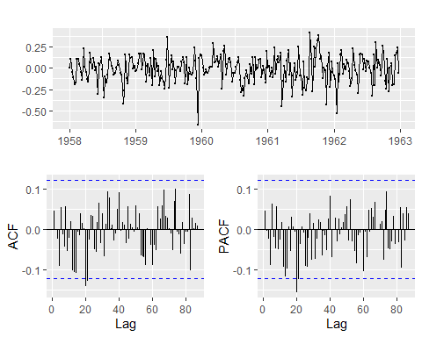

#Residuos crest  
  
ggtsdisplay(fit2$residuals)

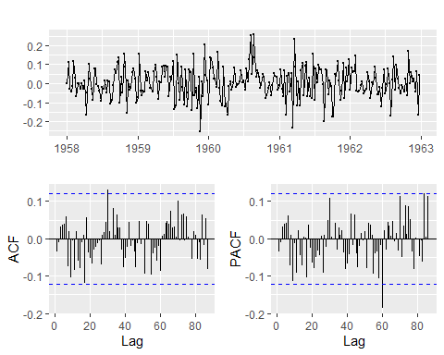

fColgate.arima<-forecast(fit1)  
  
  
df_new <- data.frame(value = as.vector(zcolgate), time = time(zcolgate))   
  
ggplot(df_new)+geom_point(aes(x=time,y=value))+geom_line(aes(x=time,y=value))+ geom_forecast(fColgate.arima,alpha=0.4)+xlab("Fecha")+ylab("Colgate")+ggtitle("ARIMA: Predicción Colgate") + theme_bw()

## Warning in geom_forecast(fColgate.arima, alpha = 0.4): Use autolayer  
## instead of geom_forecast to add a forecast layer to your ggplot object.

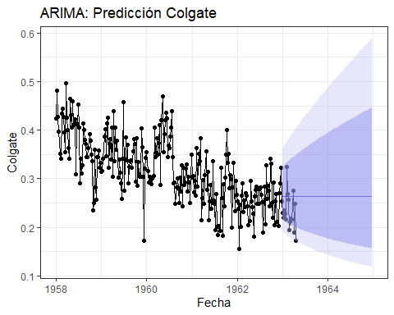

fColgate.arima

## Point Forecast Lo 80 Hi 80 Lo 95 Hi 95  
## 1963.000 0.2642873 0.2151901 0.3245865 0.1930074 0.3618917  
## 1963.019 0.2642873 0.2140266 0.3263509 0.1914138 0.3649047  
## 1963.038 0.2642873 0.2128984 0.3280803 0.1898728 0.3678662  
## 1963.058 0.2642873 0.2118028 0.3297774 0.1883805 0.3707803  
## 1963.077 0.2642873 0.2107377 0.3314442 0.1869336 0.3736503  
## 1963.096 0.2642873 0.2097009 0.3330829 0.1855289 0.3764793  
## 1963.115 0.2642873 0.2086907 0.3346952 0.1841638 0.3792699  
## 1963.135 0.2642873 0.2077055 0.3362827 0.1828358 0.3820247  
## 1963.154 0.2642873 0.2067438 0.3378470 0.1815427 0.3847459  
## 1963.173 0.2642873 0.2058043 0.3393894 0.1802824 0.3874354  
## 1963.192 0.2642873 0.2048857 0.3409110 0.1790532 0.3900951  
## 1963.212 0.2642873 0.2039870 0.3424130 0.1778535 0.3927266  
## 1963.231 0.2642873 0.2031071 0.3438963 0.1766815 0.3953315  
## 1963.250 0.2642873 0.2022451 0.3453620 0.1755361 0.3979112  
## 1963.269 0.2642873 0.2014002 0.3468109 0.1744158 0.4004670  
## 1963.288 0.2642873 0.2005716 0.3482436 0.1733195 0.4030001  
## 1963.308 0.2642873 0.1997585 0.3496611 0.1722461 0.4055115  
## 1963.327 0.2642873 0.1989603 0.3510640 0.1711946 0.4080023  
## 1963.346 0.2642873 0.1981763 0.3524528 0.1701640 0.4104734  
## 1963.365 0.2642873 0.1974059 0.3538283 0.1691534 0.4129258  
## 1963.385 0.2642873 0.1966486 0.3551908 0.1681619 0.4153602  
## 1963.404 0.2642873 0.1959039 0.3565411 0.1671890 0.4177775  
## 1963.423 0.2642873 0.1951713 0.3578795 0.1662337 0.4201783  
## 1963.442 0.2642873 0.1944503 0.3592064 0.1652954 0.4225633  
## 1963.462 0.2642873 0.1937405 0.3605224 0.1643736 0.4249332  
## 1963.481 0.2642873 0.1930415 0.3618278 0.1634675 0.4272886  
## 1963.500 0.2642873 0.1923530 0.3631230 0.1625766 0.4296300  
## 1963.519 0.2642873 0.1916745 0.3644084 0.1617004 0.4319580  
## 1963.538 0.2642873 0.1910057 0.3656842 0.1608384 0.4342731  
## 1963.558 0.2642873 0.1903464 0.3669509 0.1599901 0.4365757  
## 1963.577 0.2642873 0.1896962 0.3682086 0.1591550 0.4388664  
## 1963.596 0.2642873 0.1890548 0.3694578 0.1583328 0.4411455  
## 1963.615 0.2642873 0.1884220 0.3706986 0.1575229 0.4434134  
## 1963.635 0.2642873 0.1877975 0.3719314 0.1567251 0.4456706  
## 1963.654 0.2642873 0.1871810 0.3731564 0.1559390 0.4479173  
## 1963.673 0.2642873 0.1865724 0.3743737 0.1551642 0.4501540  
## 1963.692 0.2642873 0.1859713 0.3755837 0.1544003 0.4523811  
## 1963.712 0.2642873 0.1853776 0.3767865 0.1536471 0.4545987  
## 1963.731 0.2642873 0.1847911 0.3779824 0.1529043 0.4568072  
## 1963.750 0.2642873 0.1842116 0.3791716 0.1521715 0.4590069  
## 1963.769 0.2642873 0.1836388 0.3803541 0.1514486 0.4611981  
## 1963.788 0.2642873 0.1830727 0.3815303 0.1507351 0.4633810  
## 1963.808 0.2642873 0.1825130 0.3827003 0.1500309 0.4655560  
## 1963.827 0.2642873 0.1819596 0.3838642 0.1493357 0.4677231  
## 1963.846 0.2642873 0.1814123 0.3850222 0.1486494 0.4698828  
## 1963.865 0.2642873 0.1808710 0.3861745 0.1479716 0.4720352  
## 1963.885 0.2642873 0.1803356 0.3873212 0.1473021 0.4741804  
## 1963.904 0.2642873 0.1798058 0.3884624 0.1466408 0.4763188  
## 1963.923 0.2642873 0.1792816 0.3895983 0.1459875 0.4784506  
## 1963.942 0.2642873 0.1787628 0.3907289 0.1453419 0.4805758  
## 1963.962 0.2642873 0.1782493 0.3918546 0.1447038 0.4826947  
## 1963.981 0.2642873 0.1777409 0.3929752 0.1440732 0.4848075  
## 1964.000 0.2642873 0.1772377 0.3940910 0.1434498 0.4869144  
## 1964.019 0.2642873 0.1767394 0.3952021 0.1428335 0.4890155  
## 1964.038 0.2642873 0.1762460 0.3963086 0.1422241 0.4911109  
## 1964.058 0.2642873 0.1757573 0.3974105 0.1416214 0.4932009  
## 1964.077 0.2642873 0.1752732 0.3985081 0.1410253 0.4952855  
## 1964.096 0.2642873 0.1747937 0.3996013 0.1404357 0.4973650  
## 1964.115 0.2642873 0.1743186 0.4006903 0.1398524 0.4994394  
## 1964.135 0.2642873 0.1738480 0.4017751 0.1392753 0.5015089  
## 1964.154 0.2642873 0.1733815 0.4028559 0.1387042 0.5035736  
## 1964.173 0.2642873 0.1729193 0.4039328 0.1381391 0.5056337  
## 1964.192 0.2642873 0.1724612 0.4050057 0.1375798 0.5076892  
## 1964.212 0.2642873 0.1720072 0.4060749 0.1370262 0.5097404  
## 1964.231 0.2642873 0.1715570 0.4071403 0.1364782 0.5117872  
## 1964.250 0.2642873 0.1711108 0.4082021 0.1359356 0.5138298  
## 1964.269 0.2642873 0.1706684 0.4092603 0.1353985 0.5158683  
## 1964.288 0.2642873 0.1702297 0.4103149 0.1348666 0.5179029  
## 1964.308 0.2642873 0.1697947 0.4113662 0.1343398 0.5199336  
## 1964.327 0.2642873 0.1693632 0.4124141 0.1338182 0.5219605  
## 1964.346 0.2642873 0.1689354 0.4134586 0.1333015 0.5239837  
## 1964.365 0.2642873 0.1685110 0.4144999 0.1327896 0.5260033  
## 1964.385 0.2642873 0.1680900 0.4155381 0.1322826 0.5280194  
## 1964.404 0.2642873 0.1676724 0.4165730 0.1317803 0.5300321  
## 1964.423 0.2642873 0.1672580 0.4176050 0.1312826 0.5320414  
## 1964.442 0.2642873 0.1668469 0.4186339 0.1307895 0.5340475  
## 1964.462 0.2642873 0.1664391 0.4196598 0.1303008 0.5360505  
## 1964.481 0.2642873 0.1660343 0.4206829 0.1298165 0.5380503  
## 1964.500 0.2642873 0.1656326 0.4217031 0.1293365 0.5400471  
## 1964.519 0.2642873 0.1652340 0.4227204 0.1288607 0.5420410  
## 1964.538 0.2642873 0.1648383 0.4237351 0.1283891 0.5440320  
## 1964.558 0.2642873 0.1644456 0.4247470 0.1279216 0.5460202  
## 1964.577 0.2642873 0.1640558 0.4257562 0.1274582 0.5480056  
## 1964.596 0.2642873 0.1636688 0.4267629 0.1269986 0.5499884  
## 1964.615 0.2642873 0.1632847 0.4277669 0.1265430 0.5519686  
## 1964.635 0.2642873 0.1629033 0.4287684 0.1260913 0.5539463  
## 1964.654 0.2642873 0.1625246 0.4297675 0.1256433 0.5559214  
## 1964.673 0.2642873 0.1621486 0.4307641 0.1251990 0.5578942  
## 1964.692 0.2642873 0.1617752 0.4317582 0.1247583 0.5598646  
## 1964.712 0.2642873 0.1614044 0.4327501 0.1243213 0.5618327  
## 1964.731 0.2642873 0.1610362 0.4337395 0.1238878 0.5637986  
## 1964.750 0.2642873 0.1606706 0.4347267 0.1234578 0.5657622  
## 1964.769 0.2642873 0.1603074 0.4357117 0.1230313 0.5677238  
## 1964.788 0.2642873 0.1599466 0.4366944 0.1226081 0.5696832  
## 1964.808 0.2642873 0.1595883 0.4376749 0.1221883 0.5716406  
## 1964.827 0.2642873 0.1592323 0.4386532 0.1217717 0.5735960  
## 1964.846 0.2642873 0.1588788 0.4396295 0.1213584 0.5755495  
## 1964.865 0.2642873 0.1585275 0.4406036 0.1209483 0.5775011  
## 1964.885 0.2642873 0.1581785 0.4415758 0.1205413 0.5794509  
## 1964.904 0.2642873 0.1578318 0.4425458 0.1201375 0.5813989  
## 1964.923 0.2642873 0.1574872 0.4435139 0.1197366 0.5833451  
## 1964.942 0.2642873 0.1571449 0.4444800 0.1193388 0.5852896  
## 1964.962 0.2642873 0.1568048 0.4454442 0.1189440 0.5872325  
## 1964.981 0.2642873 0.1564668 0.4464065 0.1185521 0.5891737

fCrest.arima<-forecast(fit2)  
  
  
df_new <- data.frame(value = as.vector(zcrest), time = time(zcrest))   
  
ggplot(df_new)+geom_point(aes(x=time,y=value))+geom_line(aes(x=time,y=value))+ geom_forecast(fCrest.arima,alpha=0.4)+xlab("Fecha")+ylab("Crest")+ggtitle("ARIMA: Predicción Crest") + theme_bw()

## Warning in geom_forecast(fCrest.arima, alpha = 0.4): Use autolayer instead  
## of geom_forecast to add a forecast layer to your ggplot object.

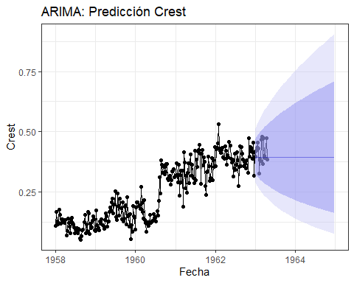

fCrest.arima

## Point Forecast Lo 80 Hi 80 Lo 95 Hi 95  
## 1963.000 0.3943299 0.3246298 0.4696300 0.29005934 0.5117045  
## 1963.019 0.3943299 0.3204322 0.4745553 0.28394663 0.5195210  
## 1963.038 0.3943299 0.3164909 0.4792244 0.27822654 0.5269452  
## 1963.058 0.3943299 0.3127670 0.4836762 0.27283979 0.5340364  
## 1963.077 0.3943299 0.3092307 0.4879404 0.26774073 0.5408403  
## 1963.096 0.3943299 0.3058584 0.4920406 0.26289326 0.5473930  
## 1963.115 0.3943299 0.3026311 0.4959959 0.25826828 0.5537235  
## 1963.135 0.3943299 0.2995333 0.4998219 0.25384192 0.5598558  
## 1963.154 0.3943299 0.2965518 0.5035315 0.24959430 0.5658096  
## 1963.173 0.3943299 0.2936759 0.5071356 0.24550867 0.5716019  
## 1963.192 0.3943299 0.2908961 0.5106437 0.24157074 0.5772468  
## 1963.212 0.3943299 0.2882045 0.5140637 0.23776823 0.5827567  
## 1963.231 0.3943299 0.2855940 0.5174026 0.23409047 0.5881422  
## 1963.250 0.3943299 0.2830586 0.5206666 0.23052812 0.5934126  
## 1963.269 0.3943299 0.2805929 0.5238608 0.22707298 0.5985762  
## 1963.288 0.3943299 0.2781921 0.5269902 0.22371775 0.6036403  
## 1963.308 0.3943299 0.2758520 0.5300590 0.22045597 0.6086112  
## 1963.327 0.3943299 0.2735689 0.5330709 0.21728180 0.6134950  
## 1963.346 0.3943299 0.2713392 0.5360294 0.21419004 0.6182967  
## 1963.365 0.3943299 0.2691600 0.5389375 0.21117594 0.6230210  
## 1963.385 0.3943299 0.2670284 0.5417980 0.20823524 0.6276724  
## 1963.404 0.3943299 0.2649418 0.5446136 0.20536402 0.6322547  
## 1963.423 0.3943299 0.2628980 0.5473865 0.20255872 0.6367714  
## 1963.442 0.3943299 0.2608949 0.5501188 0.19981607 0.6412259  
## 1963.462 0.3943299 0.2589303 0.5528125 0.19713308 0.6456210  
## 1963.481 0.3943299 0.2570026 0.5554695 0.19450695 0.6499597  
## 1963.500 0.3943299 0.2551101 0.5580914 0.19193515 0.6542445  
## 1963.519 0.3943299 0.2532512 0.5606797 0.18941530 0.6584776  
## 1963.538 0.3943299 0.2514245 0.5632359 0.18694520 0.6626614  
## 1963.558 0.3943299 0.2496286 0.5657613 0.18452279 0.6667979  
## 1963.577 0.3943299 0.2478623 0.5682572 0.18214618 0.6708890  
## 1963.596 0.3943299 0.2461245 0.5707247 0.17981357 0.6749364  
## 1963.615 0.3943299 0.2444140 0.5731649 0.17752330 0.6789419  
## 1963.635 0.3943299 0.2427299 0.5755788 0.17527380 0.6829071  
## 1963.654 0.3943299 0.2410711 0.5779675 0.17306360 0.6868333  
## 1963.673 0.3943299 0.2394368 0.5803318 0.17089132 0.6907220  
## 1963.692 0.3943299 0.2378260 0.5826725 0.16875565 0.6945744  
## 1963.712 0.3943299 0.2362382 0.5849904 0.16665538 0.6983919  
## 1963.731 0.3943299 0.2346723 0.5872864 0.16458934 0.7021755  
## 1963.750 0.3943299 0.2331278 0.5895611 0.16255643 0.7059263  
## 1963.769 0.3943299 0.2316040 0.5918152 0.16055562 0.7096455  
## 1963.788 0.3943299 0.2301002 0.5940494 0.15858593 0.7133340  
## 1963.808 0.3943299 0.2286158 0.5962642 0.15664641 0.7169926  
## 1963.827 0.3943299 0.2271502 0.5984602 0.15473618 0.7206224  
## 1963.846 0.3943299 0.2257029 0.6006380 0.15285441 0.7242242  
## 1963.865 0.3943299 0.2242734 0.6027981 0.15100028 0.7277986  
## 1963.885 0.3943299 0.2228612 0.6049411 0.14917303 0.7313467  
## 1963.904 0.3943299 0.2214657 0.6070673 0.14737193 0.7348689  
## 1963.923 0.3943299 0.2200865 0.6091772 0.14559629 0.7383661  
## 1963.942 0.3943299 0.2187233 0.6112714 0.14384544 0.7418389  
## 1963.962 0.3943299 0.2173755 0.6133501 0.14211874 0.7452880  
## 1963.981 0.3943299 0.2160428 0.6154138 0.14041558 0.7487140  
## 1964.000 0.3943299 0.2147248 0.6174629 0.13873539 0.7521174  
## 1964.019 0.3943299 0.2134212 0.6194977 0.13707761 0.7554988  
## 1964.038 0.3943299 0.2121315 0.6215185 0.13544169 0.7588587  
## 1964.058 0.3943299 0.2108555 0.6235258 0.13382713 0.7621977  
## 1964.077 0.3943299 0.2095928 0.6255199 0.13223343 0.7655162  
## 1964.096 0.3943299 0.2083432 0.6275010 0.13066012 0.7688148  
## 1964.115 0.3943299 0.2071062 0.6294694 0.12910674 0.7720939  
## 1964.135 0.3943299 0.2058817 0.6314254 0.12757285 0.7753539  
## 1964.154 0.3943299 0.2046694 0.6333694 0.12605804 0.7785952  
## 1964.173 0.3943299 0.2034689 0.6353016 0.12456189 0.7818183  
## 1964.192 0.3943299 0.2022801 0.6372221 0.12308401 0.7850236  
## 1964.212 0.3943299 0.2011027 0.6391314 0.12162402 0.7882114  
## 1964.231 0.3943299 0.1999365 0.6410295 0.12018157 0.7913820  
## 1964.250 0.3943299 0.1987811 0.6429168 0.11875629 0.7945360  
## 1964.269 0.3943299 0.1976365 0.6447935 0.11734786 0.7976735  
## 1964.288 0.3943299 0.1965023 0.6466598 0.11595593 0.8007949  
## 1964.308 0.3943299 0.1953785 0.6485158 0.11458020 0.8039006  
## 1964.327 0.3943299 0.1942647 0.6503619 0.11322035 0.8069908  
## 1964.346 0.3943299 0.1931607 0.6521981 0.11187609 0.8100659  
## 1964.365 0.3943299 0.1920665 0.6540247 0.11054714 0.8131261  
## 1964.385 0.3943299 0.1909818 0.6558419 0.10923321 0.8161717  
## 1964.404 0.3943299 0.1899065 0.6576497 0.10793403 0.8192030  
## 1964.423 0.3943299 0.1888403 0.6594485 0.10664935 0.8222202  
## 1964.442 0.3943299 0.1877831 0.6612384 0.10537891 0.8252237  
## 1964.462 0.3943299 0.1867348 0.6630194 0.10412247 0.8282136  
## 1964.481 0.3943299 0.1856951 0.6647919 0.10287978 0.8311902  
## 1964.500 0.3943299 0.1846640 0.6665559 0.10165062 0.8341537  
## 1964.519 0.3943299 0.1836412 0.6683116 0.10043476 0.8371043  
## 1964.538 0.3943299 0.1826267 0.6700591 0.09923199 0.8400423  
## 1964.558 0.3943299 0.1816204 0.6717986 0.09804209 0.8429679  
## 1964.577 0.3943299 0.1806220 0.6735301 0.09686486 0.8458813  
## 1964.596 0.3943299 0.1796314 0.6752539 0.09570010 0.8487826  
## 1964.615 0.3943299 0.1786485 0.6769701 0.09454761 0.8516722  
## 1964.635 0.3943299 0.1776733 0.6786787 0.09340720 0.8545501  
## 1964.654 0.3943299 0.1767055 0.6803799 0.09227870 0.8574166  
## 1964.673 0.3943299 0.1757450 0.6820739 0.09116192 0.8602718  
## 1964.692 0.3943299 0.1747918 0.6837607 0.09005669 0.8631159  
## 1964.712 0.3943299 0.1738457 0.6854404 0.08896283 0.8659491  
## 1964.731 0.3943299 0.1729067 0.6871132 0.08788019 0.8687716  
## 1964.750 0.3943299 0.1719745 0.6887791 0.08680860 0.8715835  
## 1964.769 0.3943299 0.1710492 0.6904383 0.08574791 0.8743850  
## 1964.788 0.3943299 0.1701306 0.6920909 0.08469796 0.8771761  
## 1964.808 0.3943299 0.1692186 0.6937369 0.08365860 0.8799572  
## 1964.827 0.3943299 0.1683131 0.6953765 0.08262970 0.8827283  
## 1964.846 0.3943299 0.1674140 0.6970097 0.08161110 0.8854896  
## 1964.865 0.3943299 0.1665212 0.6986367 0.08060267 0.8882411  
## 1964.885 0.3943299 0.1656347 0.7002575 0.07960427 0.8909832  
## 1964.904 0.3943299 0.1647544 0.7018722 0.07861577 0.8937158  
## 1964.923 0.3943299 0.1638801 0.7034809 0.07763705 0.8964391  
## 1964.942 0.3943299 0.1630118 0.7050837 0.07666798 0.8991532  
## 1964.962 0.3943299 0.1621495 0.7066806 0.07570843 0.9018583  
## 1964.981 0.3943299 0.1612929 0.7082718 0.07475829 0.9045545

#OUTLIERS Los puntos rojos son los distintos cambios exogenos, en caso de no haberse producido un impulso la serie habria continuado como se representa en azul.

En el caso de crest se produce un escalon, que genera un impulso negativo, recobrando la serie original, produciendose otro escalon, generando un impulso amortiguado creciente.

colgate_outlier<-tso(xcolgate, types = c("TC","AO","LS","IO","SLS"))  
plot(colgate_outlier, main="Impulso Colgate")

## Warning in par(mar = c(0, 3, 0, 2.1), oma = c(3, 0, 3, 0), mfcol = c(2, :  
## "main" is not a graphical parameter

## Warning in par(oldpar): "main" is not a graphical parameter

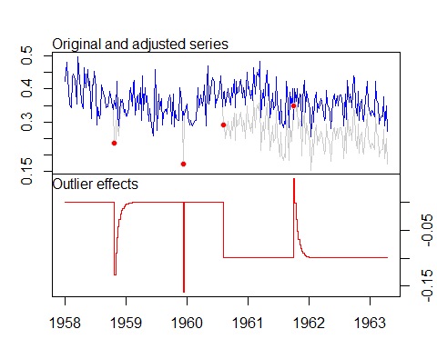

crest_outlier<-tso(xcrest, types = c("TC", "AO", "LS", "IO","SLS"))  
plot(crest_outlier, main="Impulso Crest")

## Warning in par(mar = c(0, 3, 0, 2.1), oma = c(3, 0, 3, 0), mfcol = c(2, :  
## "main" is not a graphical parameter  
  
## Warning in par(mar = c(0, 3, 0, 2.1), oma = c(3, 0, 3, 0), mfcol = c(2, :  
## "main" is not a graphical parameter

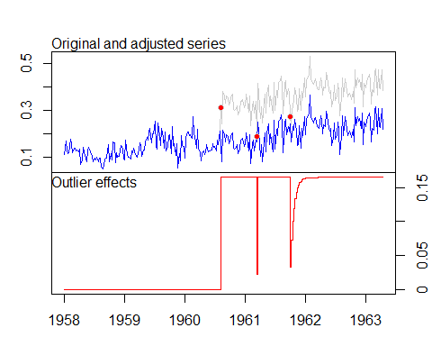

#ARIMAX

colgate.m1<-arimax(oColgate,order=c(0,1,1),method = "ML",  
 xtransf= data.frame(I135=1*(seq(oColgate)==135),  
 I135=1*(seq(oColgate)==135)),  
 transfer=list(c(2,0),c(0,0)))

colgate.m1

##   
## Call:  
## arimax(x = oColgate, order = c(0, 1, 1), method = "ML", xtransf = data.frame(I135 = 1 *   
## (seq(oColgate) == 135), I135 = 1 * (seq(oColgate) == 135)), transfer = list(c(2,   
## 0), c(0, 0)))  
##   
## Coefficients:

## Warning in sqrt(diag(x$var.coef)): Se han producido NaNs

## ma1 I135-AR1 I135-AR2 I135-MA0 I135.1-MA0  
## -0.7587 2e-04 2e-04 0.0014 0.0016  
## s.e. 0.0467 NaN NaN NaN 0.0422  
##   
## sigma^2 estimated as 0.002303: log likelihood = 418.57, aic = -827.14

colgate.m1$coef

## ma1 I135-AR1 I135-AR2 I135-MA0 I135.1-MA0   
## -0.7586976907 0.0002002924 0.0001663622 0.0014322740 0.0015645875

crest.m1<-arimax(oCrest, order=c(0,1,1), method= "ML",  
xtransf= data.frame(I135=1*(seq(oCrest)==135),  
 I135=1*(seq(oCrest)==135)),  
transfer=list(c(2,0),c(0,0)))  
  
crest.m1

##   
## Call:  
## arimax(x = oCrest, order = c(0, 1, 1), method = "ML", xtransf = data.frame(I135 = 1 *   
## (seq(oCrest) == 135), I135 = 1 * (seq(oCrest) == 135)), transfer = list(c(2,   
## 0), c(0, 0)))  
##   
## Coefficients:  
## ma1 I135-AR1 I135-AR2 I135-MA0 I135.1-MA0  
## -0.6448 -0.3597 0.0959 -0.1755 0.1622  
## s.e. 0.0454 0.5730 0.2174 0.2795 0.2816  
##   
## sigma^2 estimated as 0.002011: log likelihood = 436.31, aic = -862.63

crest.m1$coef

## ma1 I135-AR1 I135-AR2 I135-MA0 I135.1-MA0   
## -0.64482696 -0.35967600 0.09591196 -0.17554115 0.16217361

plot(crest.m1$coef[2:5], type = "h")

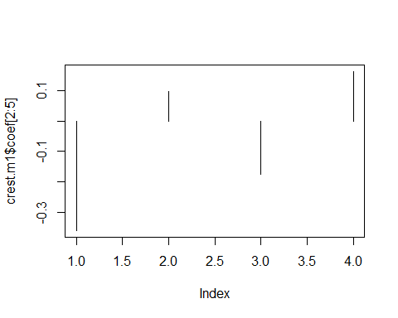

plot(colgate.m1$coef[2:5],type="h")

