Status of This Document

Version History
Ver. No. | Date | Revised By | Description | Filename
0.1 | 2/1/2007 | Twinsen Tsang | Internal Draft | CorvusSFRM.doc

Abstract
The Smart File Reliable Messaging Protocol (SFRM) is an application-level protocol designed for transferring very large business data in the distributed system. Its underlying transmission protocol is based on Hypertext transfer Protocol (HTTP, RFC2616). SFRM is capable transferring unlimited size of business data in segmented, no duplicate, fast, reliable and secure manner. This specification defines the protocol referred as "SFRM 0.1".

Table of Contents
1. Status of This Document 2
1.1. Version History 2
2. Abstract 3
3. Table of Contents 4
4. Table 6
5. Figure 7
6. Introduction 8
6.1. Purpose of the document 8
6.2. Overview of this document 9
6.2.1. Information Packaging Specification 9
6.2.2. Main Features 9
6.2.3. Additional Features 9
6.2.4. SFRM Life Cycle 9
6.3. Definition and Scope of Smart File (SF) 10
6.4. Definition and Scope of Reliable Messaging (RM) 11
6.5. Notational Convention 12
6.6. Intended Audience 13
6.7. Related Documents 13
6.8. Terminology 14
7. Message Packaging 17
7.1. Definition of Message and Segment 17
7.2. Message Packaging Architecture 19
7.2.1. SFRM Input 20
7.2.2. SFIO and SF Data 20
7.2.2.1. PACK / UNPACK Operation 20
7.2.2.2. Archive-Based PACK / UNPACK Operation 21
7.2.2.3. Metadata-Based PACK / UNPACK Operation 22
7.2.2.4. Summary of two typical SFIO Process 22
7.2.3. Segment Packaging and Segment 23
7.2.3.1. SFRM-Version Element 23
7.2.3.2. Message-Id Element 23
7.2.3.3. Conv-Id Element 23
7.2.3.4. Partnership-Id Element 23
7.2.3.5. Total-Size Element 23
7.2.3.6. Total-Segment Element 23
7.2.3.7. Segment-No Element 23
7.2.3.8. Segment-Type Element 23
7.2.3.9. Segment-Offset Element 23
7.2.3.10. Segment-Length Element 23
7.2.3.11. Last-Receipt Element 23

Table
Table 1. Special Terms 11
Table 2. The summary of "Message", "SFRM Message" and "Segment". 17
Table 3. The description of Message Packaging Process / Item. 18
Table 4. Comparison between archive-based and metadata-based SFIO Process. 21

Figure
Figure 1. The SFIO Transformation Process. 9
Figure 2. Show the relationship between SFRM Message and Segment and its corresponding cardinality. The upper triangle is the controller view which it is the SFRM Message (control overall behavior and store critical information) while the lower trapezium is the protocol transmission view (To be responsible for sending and receiving). 16
Figure 3. The overview of Message Packaging architecture. 18
Figure 4. The Archive-Based SFIO Process. 20
Figure 5. The metadata based SFIO Process. 21

Introduction

Purpose of the document
This document is served as the specification of the Smart File Reliable Messaging (SFRM). SFRM is derived owing to the rise in market demand for exchanging very large EDI file, where as AS2 [RFC 4130], EbMS 2.0 [EMBS], SMTP [RFC 821], FTP [RFC 959] are not sufficient when an application-level messaging protocol is required transferring a very large file, For instance, a DVD size file with some reliability and security.
SFRM is binding to HTTP protocol which realizing the capability of exchanging very large amount business data for any enterprises with high reliability, security and resumption power. Business Data in SFRM packaged using standard MIME structures. Signature Verification and data confidentiality are obtained by using Cryptographic Message Syntax with S/MIME security body parts. Authenticated acknowledgements make use of multipart/signed RECEIPT / RECOVERY segments responses to the original HTTP message. This implies legacy electronic business systems which using structured business data (XML, EDI-X12, UN/EDIFACT) can also be benefited by SFRM architecture.

Overview of this document
This document focuses on the definition of message packaging architecture to support SFRM feature. Also, it defines SFRM life-cycle model to realize how the large file can be sent in a Smart File (SF) form. It is organized into four categories and list in the below:

Information Packaging Specification
- Information Transformation - A specification on how the information can be transformed before sent to business partner.
- Information Packaging - A specification on how the information can be packed as SFRM Segments which they are ready to send to business partner.

Main Features
- Reliable Messaging - A specification on how the message can be transferred reliably under two SFRM Systems.
- Security - A specification on how the message can be signed and encrypted in terms of SFRM Segments.
- Error Handling - A specification on how the SFRM system detects and report error, and how it enforces termination on the sending and receiving process.

Additional Features
- On-the-fly sends / receives Module - A description on how the message can be transferred much faster using memory map under two SFRM Systems.
- Caching Module - A description on how the data structure should be cached to prevent large over-head from the persistent storage.

SFRM Life Cycle
- Sender Life Cycle - A life cycle on how the information payload receives at the sender, then how they are packed and transformed, and then send to the receiver.
- Receiver Life Cycle - A life cycle on how the SFRM Segments received transformed back to information payload.

Definition and Scope of Smart File (SF)
Smart File (SF) is defined as an I/O Transformation Process (abbreviate as SFIO) which transforms a pack of file (INPUT) to SFRM-Specific data (OUTPUT) in some smart ways. It defines the following specifications:
- This process MUST be reversible by defining two abstract operations: PACK/UNPACK. PACK is forward operation that transform from INPUT to OUTPUT, while UNPACK is backward operation that transform from OUTPUT to INPUT.
- The output file(s) MUST contain all data content of input file(s) with correctness data integrity. In technical view, input file(s) MUST be a subset of output(s) in term of byte unit.
- Data compression and re-arrangement MAY exist in this process, while process of digital signing and data encryption SHOULD NOT be included.
- The output file(s) MUST preserve the input file(s) structure, meaning that it MUST includes filename of the file(s) including folders. While platform-specific (extended) file attributes are OPTIONAL required in the specifications.

Figure 1 show the abstraction of transformation process, the arrow is the abstract operations and the direction of arrow representing the nature of operation (either forward or backward).

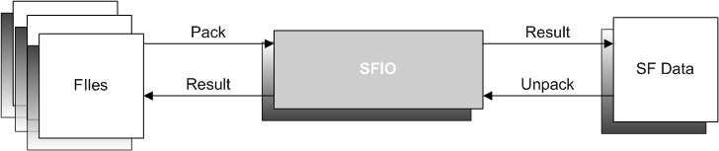
- The SFIO Transformation Process.

Definition and Scope of Reliable Messaging (RM)
Reliable Messaging (RM) is an interoperable protocol based on HTTP such that two SFRM Systems can reliably exchange messages by fulfilling the following specifications:
- MUST Guarantee message delivery, or At-Least-Once delivery semantics.
- MUST Guarantee message error recovery delivery, or At-Least-Once valid delivery semantics.
- MUST Guarantee message duplicate elimination, or At-Most-Once delivery semantics.
- MUST Guarantee message (error recovery) delivery and duplicate elimination, or Exactly-Once valid delivery semantics. [Concluded from pt 1,2,3]
- MUST Guarantee End-End valid delivery. [Concluded from pt 4].

Hence, RM focuses on the inerrable delivery at the end-end system where the intermediates routing and hopping are out of scope in this definition.

Notational Convention
- Terms in Italics: Attributes in the SFRM Semantics.
- Terms in Bold: main keywords of describing term / terminology / item.
- Terms in Bold Italics: TODO
- Starting with prefix
- Starting with prefix "NOTE": Implementation advice.
- Pattern "[SNumber (PTNumber)]": A reference to particular section and particular point. For example, if there is [S6.3 PT1], meaning it is reference to Section 6.3 Point 1.

The keywords MUST, MUST NOT, REQUIRED, SHALL, SHALL NOT, SHOULD, SHOULD NOT, RECOMMENDED, MAY and OPTIONAL, when they appear in this document, are to be interpreted as described in [RFC2119] as quoted here:

Terms | Description
MUST | This word, or the terms "REQUIRED" or "SHALL", means that the definition is an absolute requirement of the specification.
MUST NOT | This phrase, or the phrase "SHALL NOT", means that the definition is an absolute prohibition of the specification.
SHOULD | This word, or the adjective "RECOMMENDED", means that there may exist valid reasons in particular circumstances to ignore a particular item, but the full implications must be understood and carefully weighed before choosing a different course.
SHOULD NOT | This phrase, or the phrase "NOT RECOMMENDED", means that there may has valid reasons in particular circumstances when the particular behavior is acceptable or even useful, but the full implications should be understood and the case carefully weighed before implementing any behavior described with this label.
MAY | This word, or the adjective "OPTIONAL", means that an item is truly optional. One vendor may choose to include the item because a particular marketplace requires it or because the vendor feels that it enhances the product while another vendor may omit the same item. An implementation which does not include a particular option MUST be prepared to interoperate with another implementation which does include the option, though perhaps with reduced functionality. In the same vein an implementation which does include a particular option MUST be prepared to interoperate with another implementation which does not include the option (except, of course, for the feature the option provides).
- Special Terms

.

Intended Audience
The intended audience of this document includes application architects and developers, who intend to implement the SFRM Protocol.

Related Documents
- [RFC2616] HTTP1.1 - http://www.w3.org/Protocols/rfc2616/rfc2616.html
- [RFC1767] EDI Content Type - http://rfc.net/rfc1767.html
- [RFC1847] Security Multipart for MIME – http://rfc.net/rfc1847.html
- [RFC3462] Multipart/Report - http://rfc.net/rfc3462.html
- [RFC2045] The ESP DES-CBC Cipher Algorithm - http://rfc.net/rfc2045.html
- [RFC2046] IP Encapsulating Security Payload (ESP) - http://rfc.net/rfc2046.html
- [RFC2047] The Internet IP Security Domain of Interpretation for ISAKMP - http://rfc.net/rfc2048.html
- [RFC2048] Internet Security Association and Key Management Protocol (ISAKMP) - http://rfc.net/rfc2049.html
- [RFC2049] The Internet Key Exchange (IKE) - http://rfc.net/rfc2049.html
- [RFC3851] Secure/Multipurpose Internet Mail Extensions (S/MIME) Version 3.1 Message Specification - http://rfc.net/rfc3851.html
- [RFC3852] Cryptographic Message Syntax (CMS) - http://rfc.net/rfc3852.html
- [SFRMTA] SFRM Technical Architecture – describe the overall SFRM architectures.
- [SFRMPermT] SFRM Performance Tuning - describe how SFRM should be tuned in order to achieve business demand.
- [SFRMB2BC] SFRM in B2BConnector - describe the implementation architecture in B2B Connector.

Terminology
This specification has used a set of terms referred to the objects which involved in the process of SFRM messaging:

Name | Description
SFRM | An abbreviation of term "Smart File Reliable Messaging".
Sender | A SFRM System which send the SFRM request.
Receiver | A SFRM System which waits for request, process them and replies with different type of Segment.
Partnership | A partnership is a SIMPLEX COMMUNICATION CHANNEL to your business partner.
Payload | A Payload is interpreted as a physical file (or folder) in any storage device or an attachment in the MIME-part in a HTTP Request.
SFRM Input | A set of payload which are going to be carried out the SFRM process.
SF Data | A set of data that can be any format which are transformed though SFIO from SFRM Input.
Network Transmission Unit
Message | A Message is the unit of sending a set of payloads in a time. It stores how and where the message should be sent to Receiver.  For each set of payloads is pushed to the system at the specified location, only one message should be created.
SFRM Message | The alias of Message, used for preventing term ambiguous.
Message ID | A message id is identifiers of message and it is assigned to the message when creating.
Segment | A Segment is the SMALLEST UNIT in SFRM semantics.  It is a data structure including SFRM header fields. Each segment can be identified by its segment type, segment no and message id.  See section
META Segment | A META Segment is a starting segment containing extra preliminary information for handshaking process. (HS).  See section
PAYLOAD Segment | A PAYLOAD Segment is a data segment containing a small chunk of data in the payload by its corresponding data offset position and data length marked. It is used widely in sending payload content to receiver.  See section
RECEIPT Segment | A RECEIPT Segment is a response / ending segment. It occurs only when a PAYLOAD Segment has been received at the Receiver. It contains the receiving status of PAYLOAD Segment.  Each PAYLOAD Segment MUST has NONE or only ONE associated RECEIPT Segment.  It is used for reliable data transferring.  See section
RECOVERY Segment | A RECOVERY Segment is a response-request segment. It occurs only when a PAYLOAD Segment has been received at the Receiver but has kind of error during processing.  It is used for reliable data transferring.  See section
Status | Segments and Messages have its own message status for status tracking and reliability.
SFRM Request | A SFRM Request is a NETWORK TRANSMISSION FORM of Segment. It is a HTTP Request with all fields in the Segment.
SFRM Response | RESERVED.
SFRM Message | An alias of SFRMRequest / SFRMResponse
Sync Response | A Sync Response is equivalent to the HTTP Response.
Async Response | An Async Response is kind of SFRM Request for RECEIPT and RECOVERY segment.  It is interpreted as a Response because both RECEIPT and RECOVERY are passive segment type which occurs only when PAYLOAD segment has been received.
Session | A Session is a caching storage of Message and Segment.  A Session SHOULD create when a Message is being created and delete when this Message is finished transferring.
Repository | A Repository is a particular location of File system which stores the payload.
Inbound / Outbound | Inbound / outbound refer to the SFRM request and SFRM response paths for messages:  Inbound means "Receiving a request from the Sender", and  Outbound means "Sending a request to the Receiver."
HS | Message status – Handshaking. See section
PD | Message status – Pending. See section
PK | Message status – Packaging. See section
PS | Message status – Processed. See section
PR | Message status – Processing. See section
DL | Message status – Delivered. See section
DF | Message status – Delivered Failure. See section
UK | Message status – Un-packaging. See section

Message Packaging
The Smart File Reliable Messaging in this specification defines both common and advanced SFIO method and the set of Segment field which are essential transforming as a part of HTTP header fields for exchanging. (Part of) SFRM Data are attached as the MIME part of HTTP request.

Definition of Message and Segment
In typical messaging protocol, A Message is a logical entity and interpreted as the protocol transmission unit (A.K.A PTU) with a form in combination of header schema and one or more payload(s). While in SFRM semantics, Message is a controller entity, acting as the entire view of the SFRM Input. Each Message MUST be identified by a element called message id (See section). Also it SHOULD store some critical Information for controlling the behaviour of handshaking (See section), security or other implementation-specific operations. To prevent term ambiguous in the rest of specifications, this controller entity is called explicitly as "SFRM Message".
So a new entity is introduced for substituting the term "Message" to be the PTU, where it is called "Segment". It is the smallest unit containing a set of element used for constructing the header schema and then pushed to receiver with the appropriate payload(s). Each segment can be identified by three attributes segment type, segment no and message id (See section).
The relation of Message and Segment can be described as 1 to [1…N] cardinality when Message is 1, and Segment is [1…N]. When N = 1, the Segment is equivalent to the Message.

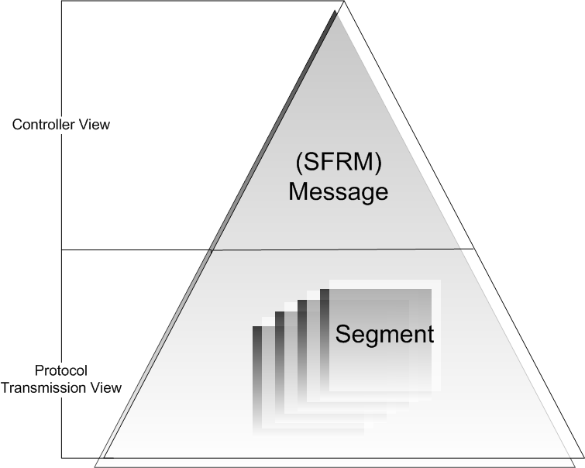
Figure 2 Show the relationship between SFRM Message and Segment and its corresponding cardinality. The upper triangle is the controller view which it is the SFRM Message (control overall behavior and store critical information) while the lower trapezium is the protocol transmission view (To be responsible for sending and receiving).
- The relation of (SFRM) Message and Segment.

 | Message | SFRM Message | Segment
Nature | Protocol Transmission Entity | Controller Entity | Protocol Transmission Entity
Identifiers | A message id element | A message id element | A tuple of  (segment type,  segment no, message id) element
Purpose | Act as the object for communication to the receiver. Usually it is attached with one or more payload(s). | Act as monitor for controlling the global behavior of Segment and store the critical information | Same as Message.
- The summary of Message, SFRM Message and Segment.

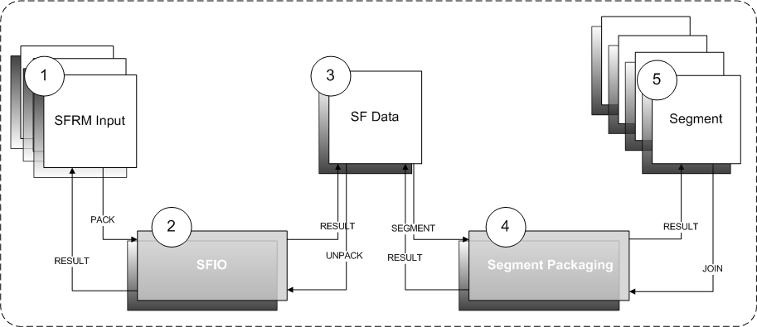
Message Packaging Architecture
- The overview of Message Packaging architecture.
- The description of Message Packaging Process / Item.
Process / Item | Name | Description
1 | SFRM Input | The user input, It should be set of payload which are going to be carried out the SFRM process.
2 | SFIO | An I/O Transformation Process which transforms SFRM Input to SF data in some smart ways.  For details, see Section 6.3
3 | SF Data | A set of data that can be any format which are transformed though SFIO from SFRM Input.
4 | Segment Packaging | A Segmentation algorithm which creates Segment(s) from the SF Data.
5 | Segment | The SMALLEST UNIT in SFRM semantics.  It is a data structure including SFRM header fields. Each segment can be identified by its segment type, segment no and message id.

The message packaging architecture has been defined as a sequence of I/O process. The purpose of packaging architecture is to prepare the SFRM Input for transferring data in a more flexible, resumable and stable behaviors. In the following sections, the specification is going to define all items in Table 3.

NOTE: It is NOT a MUST to have exactly two I/O process in Message Packaging Stage shown on the Figure 3. Implementation satisfying the specification of SFIO (Section 6.3) and Segment Packaging (Section) is considered as conformance to this specification.

SFRM Input
"SFRM Input" is the entry point of the SFRM process. It SHOULD be a set of physical file without file format and size constraint that are required to transfer by SFRM.

NOTE: It is RECOMMENDED that developer SHOULD use file system to store "SFRM Input" as its size may be very large. Using persistent like database to store such large files is definitely impractical because the machine has very high chance becoming unresponsive. Manipulation of "SFRM Input" SHOULD apply "MOVE" operation in file system for avoiding an extra copy, which is very resource-consuming.

SFIO and SF Data
The definition of SFIO has been defined detailed in the [S6.3]. The most important specification is [S6.3 PT2] and [S6.3 PT4]. The purpose of these two is to generate SF Data for transferring to the Receiver. According to the [S6.3 PT4], the file structure is preserved by some ways in SF Data, and then the SF Data are transferred to receiver. It implies that Receiver MUST has enough information restoring the exactly same file content and structure when it has received all Segment.

PACK / UNPACK Operation
The SF Data generation and restoration process in [S7.2.2] is called "PACK" (A.K.A PK) and "UNPACK" (A.K.A UK) correspondingly. They are the abstract operations acting as the entry and exit point accordingly in the SFIO Process.
There are two typical classes can be considered as PACK / UNPACK operation which are Archive-Based Operation and Metadata-Based Operation.

Archive-Based PACK / UNPACK Operation
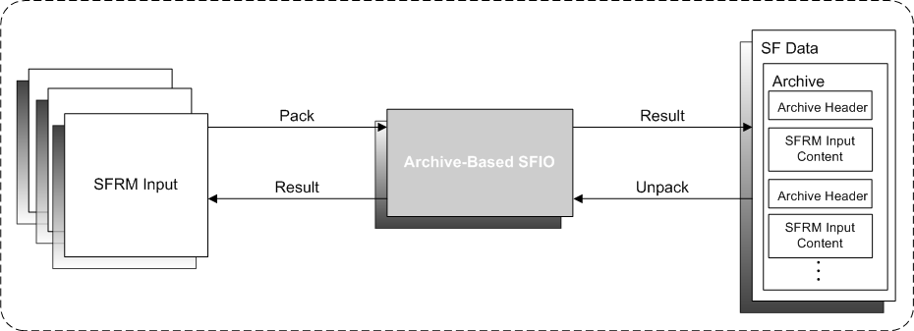
In general, all kind of file archive library possessing Self-Extraction feature can be used as PK / UK operations, or in precisely, the whole SFIO process. File archive process is always a reversible process [S6.3 PT1] that contains all content and folder structures of the input files (i.e. SFRM Input) with correctness integrity ([S6.3 PT2] and [S6.3 PT4]). The absent of Digital Signatures and Encryption in most file archive tool while data compression is always available made them satisfying the last specification [S6.3 PT3]. The pros of using this is that the output "SF Data" has become a single physical file which can be benefited by hardware features like "Read A-head. Also as all file data are kept in the archive, the execution of UK operation can be easier and independent to other component (like a black box) by passing the archive only. While the con is that an extra copy of "SFRM Input", the archived file has been made and this archive generation is disk space and time-consuming when the size of "SFRM Input" is large.
- The Archive-Based SFIO Process.

NOTE: There is some of archive library like ZIP, 7ZIP is designed based on 32bit platform architecture in which the virtual memory addressing space can allow the archived size up to 2³¹ (2GB) only. Implementation requires transferring larger than 2GB is RECOMMENDED to use TAR (tested) or other archive format that support 64-bits architecture or larger than 2GB.

Metadata-Based PACK / UNPACK Operation
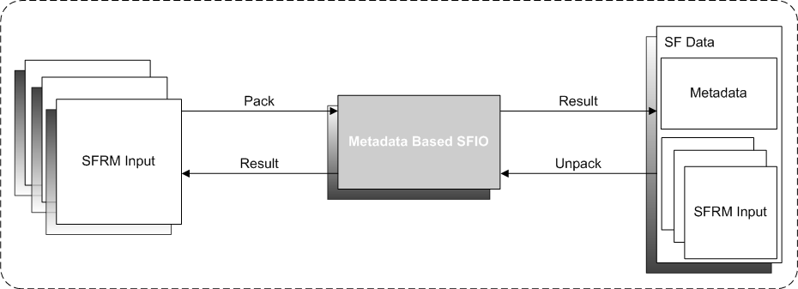
Metadata is a designated data format storing the crucial information in the "SFRM Input". Typical metadata includes the relative path of the file, files’ size and some implementation-specific data. [S6.3 PT4]. The entire "SFRM Input" becomes part of "SF Data" directly without any transformation. [S6.3 PT2]. Reversibility can be achieved by mapping metadata files’ path and received Segment. [S6.3 PT1]. Data compression is dependent upon the underlying implementation and therefore unspecified. [S6.3 PT3]. The pro of using this is the time of metadata generation is insignificant compare to the generation of an archive by [S7.2.2.1] and there is no extra copy of "SFRM Input". The con is that the handling of SFIO Process may be highly coupled to other component like the Receiver System. Also it requires custom handling on mapping metadata path to the received file so that they can preserve the file structures.
- The metadata based SFIO Process.

Summary of SFIO Process
SFIO Process / Behavior | Archive-Based | Metadata-Based
Easy to implement? | Y | N
Support compression? | Y | (Implementation-Specific)
Support read ahead? | Y | N
Time consuming | Y | N
Resource consuming | Y (high disk I/O usage) | N
File size limitation | 2GB for some archiver, Unlimited for TAR (tested) | Unlimited
File format limitation | Unlimited | Unlimited
Has made extra copy? | Y | N
- Comparison between archive-based and metadata-based SFIO Process.

Segment Packaging

SFRM-Version Element

Message-Id Element

Conv-Id Element

Partnership-Id Element

Total-Size Element

Total-Segment Element

Segment-No Element

Segment-Type Element

Segment-Offset Element

Segment-Length Element

Last-Receipt Element

Segment

META Segment

PAYLOAD Segment

RECEIPT Segment

RECOVERY Segment

Transmission Architecture

Extensible Markup Language (XML) is a simple, very flexible text format derived from SGML (ISO 8879). It is designed to meet the challenges of large-scale electronic publishing.
EDI-X12 is an ANSI standard for inter-industry EDI of business transactions.
UN/EDIFACT is stands for ‘Electronic Data Interchange for Administration, Commerce and Transport.’ UN/EDIFACT is the International EDI standard introduced by the United Nations Economic Commission.
Duplicate elimination is a messaging technique to block any message that has received being processed again in the System.
A HTTP request message from a client to a server includes, within the first line of that message, the method to be applied to the resource, the identifier of the resource, and the protocol version in use.
Reading data from local memory before it is needed. First, a block of memory is read from local memory and sent to the microprocessor. Then, the following block in memory is read, anticipating that it will be needed next.
ZIP file format is a popular data compression and archival format. A ZIP file contains one or more files that are compressed or stored.
7-Zip is an open source file archiver predominantly for the Microsoft Windows operating system. It operates either as a command line program or with a graphical user interface. It also features integration with the Windows shell environment.

