POV Cécile E4 – Filière informatique

SUMMARY  
Hierarchical segmentations with graphs : quasi-flat zones, minimum spanning trees and saliency maps

Jean Cousty – Laurent Najman – Yukiko Kenmochi – Silvio Guimarães

# Connected hierarchies of partitions

Let’s consider a finite set $V=\{a, b, c, d, e, f\}$

Partitions of V can be :

$P_{0}=\left\{\left\{a\right\}, \left\{b\right\}, \left\{c\right\},\left\{d\right\},\left\{e\right\},\left\{f\right\},\left\{g\right\},\{h\}\right\}P_{1}=\left\{\left\{a, b\right\},\left\{c\right\},\left\{d, e, f\right\},\left\{g\right\},\{h\}\right\}P_{2}=\{\{a, b, c\},\{d, e, f\}\}P_{3}=\{\{a,b,c,d, e, f\}\}$

Partitions of V cannot be :

* $\left\{\left\{a, b\right\},\left\{c\right\},\left\{d, e, f\right\},∅\right\}$ because it contains an empty set (∅)
* $\{\{a, b, c\},\{d, e, f,c\}\}$ because c is in 2 elements (regions) of the set
* $\left\{\left\{a,b,c,d, e,\right\}\right\}$ because union of all elements is not equal to V.

An element of a partition is called a **region**.

**Analogy with graphs :**

Lets consider the following partitions of a hierarchy $H=(P_{0}, P_{1}, P_{2}, P_{3})$.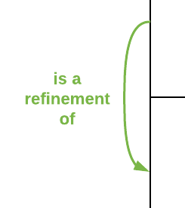

| Partition | Illustration | Set |
| --- | --- | --- |
| P0 | https://documents.lucidchart.com/documents/052eff7e-38f6-453e-9530-926f4e575124/pages/0_0?a=2670&x=439&y=-3&w=462&h=506&store=1&accept=image%2F*&auth=LCA%206a48a3a1aeae7e7d1d30ff5795cf231c42bd4c07-ts%3D1539535636 | P0 = {{1},{2},{3},{4},{5},{6},{7},{8},{9}}  9 connected components |
| P1 | https://documents.lucidchart.com/documents/052eff7e-38f6-453e-9530-926f4e575124/pages/0_0?a=3868&x=-12&y=760&w=484&h=451&store=1&accept=image%2F*&auth=LCA%20f2e95116c0fb6e6559bf267de18c433deb63c6b1-ts%3D1540062138 | P1 = {{1,2},{3,6},{4,5},{7,8},{9}}  5 connected components |
| P2 | https://documents.lucidchart.com/documents/052eff7e-38f6-453e-9530-926f4e575124/pages/0_0?a=3868&x=468&y=790&w=495&h=451&store=1&accept=image%2F*&auth=LCA%208a66901e4fe7f314be0e862c19c5d9ddf228c063-ts%3D1540062138 | P2 = {{1,2},{4,5},{3,6,7,8,9}}  3 connected components |
| P3 | https://documents.lucidchart.com/documents/052eff7e-38f6-453e-9530-926f4e575124/pages/0_0?a=3868&x=180&y=1272&w=440&h=396&store=1&accept=image%2F*&auth=LCA%205eb0ca02840744bd6141ebf90a36554301351949-ts%3D1540062138 | P3 = {{1,2,3,4,5,6,7,8,9}}  1 connected component |

We can represent the **hierarchy** H as a tree, often called a **dendrogram**.

We can see the inclusion relation between regions of the successive partitions. For example, the regions G, I, C in the partition P1 are included in the partition C of P2.

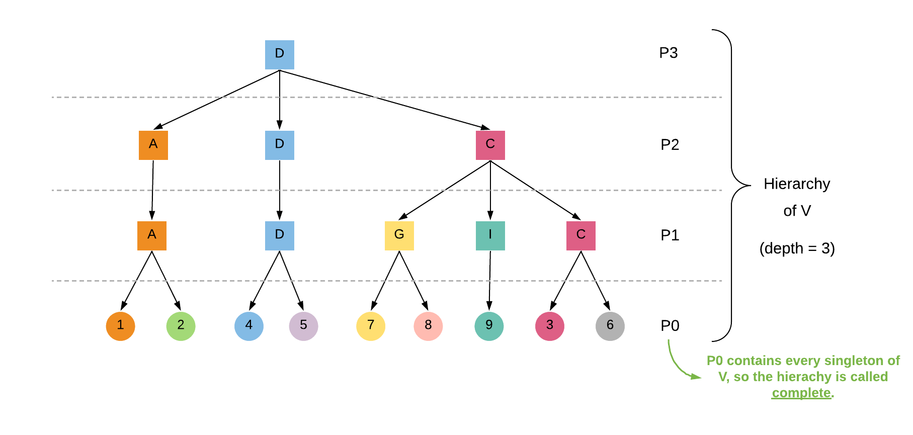

* P0 is called a **refinement** of P1 because any region of P0 is included in a region of P1.
* Given a graph G(V,E), a **partition of V is connected if every of its region is connected**.
* P0, P1, P2 and P3 are called connected partitions for the graph G.

Example of a non-connected partition for G :

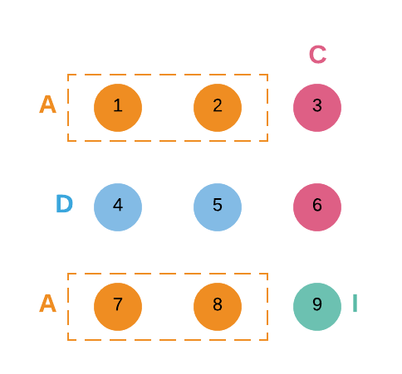

The region A is not connected.

* The previous hierarchy is **connected** because every of its partitions is connected.

# Hierarchy of quasi-flat zones

Let’s consider the following edge-weighted graph G.

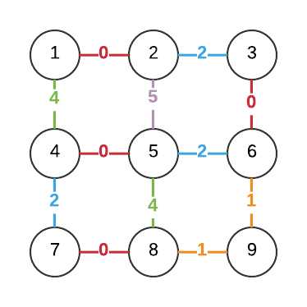

We denote by :

* X a subgraph of G
* ω(u) the weight of the edge u

The **λ-level set** of X is the set of all edges of X whose **weight is less than λ**.  
The **λ-level graph** of X is the subgraph whose edge set is the λ-level set of X and whose vertex set is the one of X.

The connected component partition induced by the λ-level graph of X is called the **λ-level partition of X**.

Lets find the different λ-level partition of the graph G and their associated connected component partitions.

|  | λ-level graph | | Associated λ-level partition of X |
| --- | --- | --- | --- |
| 0-level graph | https://documents.lucidchart.com/documents/052eff7e-38f6-453e-9530-926f4e575124/pages/0_0?a=3961&x=1883&y=423&w=374&h=374&store=1&accept=image%2F*&auth=LCA%20d0291c71c9d5213403380de1eb94ca2f795d0d57-ts%3D1540062138 | https://documents.lucidchart.com/documents/052eff7e-38f6-453e-9530-926f4e575124/pages/0_0?a=2670&x=439&y=-3&w=462&h=506&store=1&accept=image%2F*&auth=LCA%206a48a3a1aeae7e7d1d30ff5795cf231c42bd4c07-ts%3D1539535636 | P0 |
| 1 level-graph | https://documents.lucidchart.com/documents/052eff7e-38f6-453e-9530-926f4e575124/pages/0_0?a=3961&x=1483&y=423&w=374&h=374&store=1&accept=image%2F*&auth=LCA%200bdcbe5af7902d3f1040a699666870bd3901e521-ts%3D1540062138 | https://documents.lucidchart.com/documents/052eff7e-38f6-453e-9530-926f4e575124/pages/0_0?a=2670&x=439&y=500&w=462&h=440&store=1&accept=image%2F*&auth=LCA%2028ffab7bd50173b462d2b79f4f4f3876e3312c6a-ts%3D1539535636 | P1 |
| 2-level graph | https://documents.lucidchart.com/documents/052eff7e-38f6-453e-9530-926f4e575124/pages/0_0?a=3961&x=1483&y=803&w=374&h=374&store=1&accept=image%2F*&auth=LCA%20377b921f07627f5400696070a8453a709164126c-ts%3D1540062138 | https://documents.lucidchart.com/documents/052eff7e-38f6-453e-9530-926f4e575124/pages/0_0?a=2670&x=438&y=954&w=484&h=440&store=1&accept=image%2F*&auth=LCA%20ca83d9c8f39cc64803d0b3bb57faa1dfb8386b9f-ts%3D1539535636 | P2 |
| 3-level graph | https://documents.lucidchart.com/documents/052eff7e-38f6-453e-9530-926f4e575124/pages/0_0?a=3961&x=1483&y=1183&w=374&h=374&store=1&accept=image%2F*&auth=LCA%20847b64803a9b86bd699d6394afe3cb2307ad1faf-ts%3D1540062138 | https://documents.lucidchart.com/documents/052eff7e-38f6-453e-9530-926f4e575124/pages/0_0?a=4063&x=2700&y=914&w=451&h=374&store=1&accept=image%2F*&auth=LCA%20bdb672c1697e3b92f7a930d63995dec19d112021-ts%3D1540062138 | P3 |
| 4-level graph | https://documents.lucidchart.com/documents/052eff7e-38f6-453e-9530-926f4e575124/pages/0_0?a=3962&x=2283&y=803&w=374&h=374&store=1&accept=image%2F*&auth=LCA%20bed146ce32c9552f7452e0ab03c591d31f7f3f6d-ts%3D1540062138 | https://documents.lucidchart.com/documents/052eff7e-38f6-453e-9530-926f4e575124/pages/0_0?a=4064&x=2700&y=1283&w=451&h=374&store=1&accept=image%2F*&auth=LCA%2032cdfc77bc2c915a10c03439e2cc0e2a98c17ddd-ts%3D1540062138 | P3 |
| 5-level graph | https://documents.lucidchart.com/documents/052eff7e-38f6-453e-9530-926f4e575124/pages/0_0?a=3962&x=2223&y=1293&w=374&h=374&store=1&accept=image%2F*&auth=LCA%2018d13725a09a20c6060d4eddb172e1a641052e5e-ts%3D1540062138 | https://documents.lucidchart.com/documents/052eff7e-38f6-453e-9530-926f4e575124/pages/0_0?a=4064&x=3140&y=923&w=451&h=374&store=1&accept=image%2F*&auth=LCA%2091303d1adfbc1a23e618433255fd4008d4d96409-ts%3D1540062138 | P3 |

We can see that the 4-level graph and the 5-level graph are not relevant, because their don’t add a new region : the 3-level graph already has one unique region, so even if we add new vertices in the 4 and 5-level graphs, it doesn’t create any new region.

**The quasi-flat zones hierarchy of G is the hierarchy formed by all the λ-level partitions of G.**  
In our example, the hierarchy has been represented in page 2.

We can see that :

* Any edge of a λn-level graph of G is also an edge of the λn+1-level of X. In fact, if 2 points are connected for the λn-level graph, then they are also connected for the λn+1-level graph.
* The λn-level graph is a refinement of the λn+1-level graph.

Conclusion :   
Any edge-weighted graph induces a connected hierarchy of partitions : the quasi-flat zone hierarchy.

# Correspondance between hierarchies and saliency map

# Minimum spanning trees

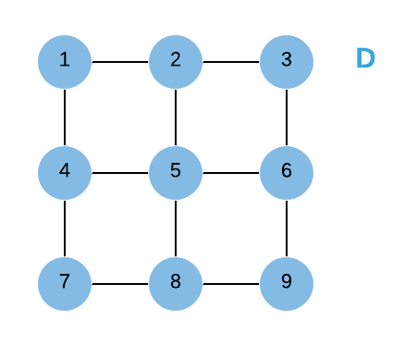

# Illustrations