**Term Website Planning Document Peer Review**

**Site Plan for Final Website Project.**

**Site Purpose:**

Bountiful Foods is small business specializing in organic, locally grown foods. They are physically located in Carlsbad, California, however, they have many food trucks that cover the coastal area from Los Angeles to San Diego. The company sells fruits and produce directly from the farmers in the area, but also uses some national and international suppliers. The owner-operated company caters to walk in traffic at their storefront in Carlsbad and, of course, their food trucks. They deliver and manage those orders on the phone and via the website. The mission is to provide fresh and healthy food options, including organic, made to order, fruit drinks and fruit bags, to the local population and to tourists visiting the coastal areas.

**Target Audience:**

The target audience is any costumer in the area that is interested in buying fresh, locally grown, organic fruits and produce. Bountiful foods also offer fruit drinks and fresh foods in their walk in location in Carlsbad, California and also food trucks that serve customers at strategic locations along the coastal area of southern California. At these costal locations we cater mostly tourists that visit the area year-round.

Persona/Scenarios

Persona A

Carlos has been living in Carlsbad, California for 10 years, since he was diagnosed with diabetes a few years ago, he is determined to eat healthy. He frequently visits Bountiful foods for fresh, organic produce that he consumes at home.

Persona B

Amanda and her family are visiting Coronado Beach for their spring break. They have visited Bountiful Foods food truck by the beach a few times since their stay. They enjoy their refreshing fresh fruit drinks.

**Site Map:**

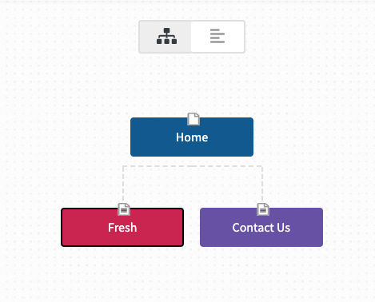

**Color Scheme:**

**Typography:**

**Wireframe Sketches:**

Small view:

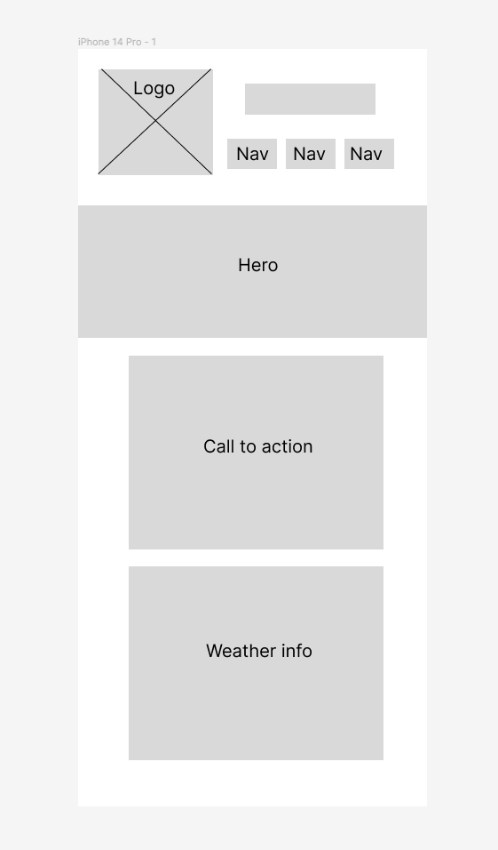

Medium view:

Large view:

