# Istio Getting Started Lab Report

**Student name:Du Xilei**

**Student number:202383930004**

**Date:10.14.2025**

## 1. Objective

The purpose of this lab is to install Istio in a Kubernetes (Minikube) environment, deploy the Bookinfo sample application, and explore Istio's traffic management and observability features.

## 2. Steps and Screenshots

### Step 1: Install Istio

Command: istioctl install --set profile=demo -y  
This installs the Istio control plane, including istiod, ingressgateway, and egressgateway components.

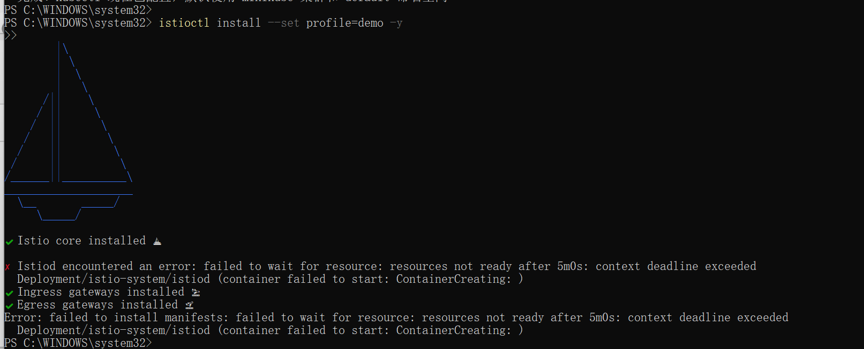

### Step 2: Verify Installation

Command: kubectl get pods -n istio-system  
Verify all pods are in Running status.

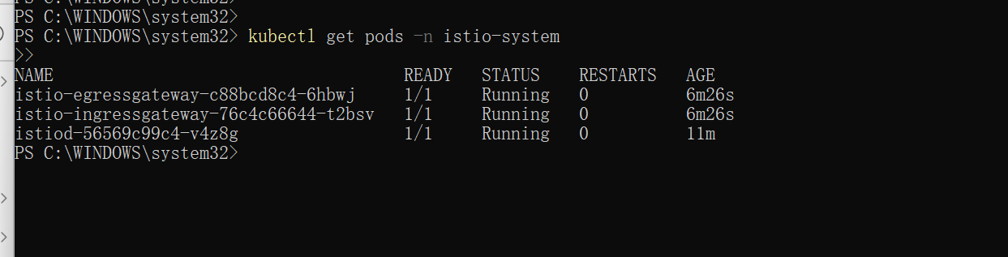

### Step 3: Deploy Bookinfo Application

Command: kubectl apply -f samples/bookinfo/platform/kube/bookinfo.yaml  
This deploys the Bookinfo sample application.

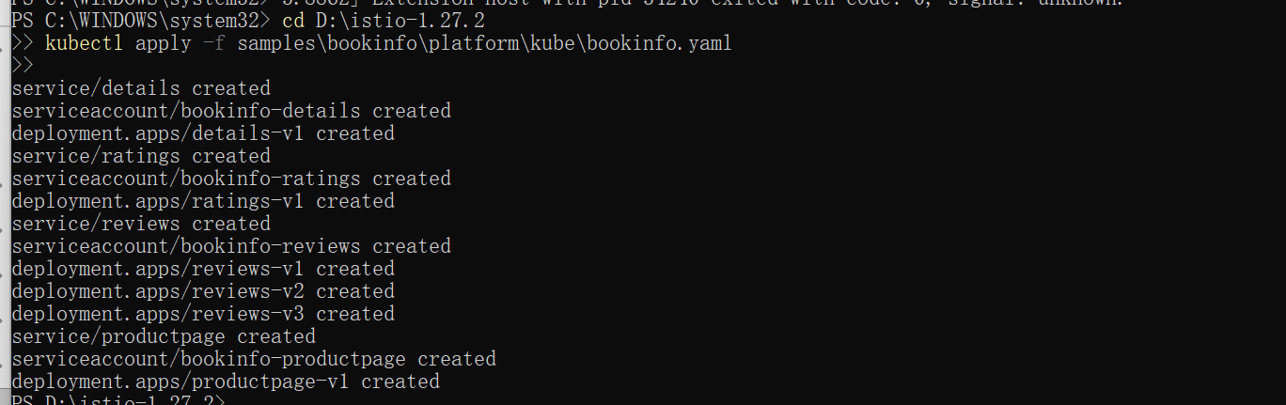

### Step 4: Expose Bookinfo Gateway

Command: kubectl apply -f samples/bookinfo/networking/bookinfo-gateway.yaml  
This creates an Istio Gateway for external access.



### Step 5: Get Access URL

Command: minikube service istio-ingressgateway -n istio-system --url  
Use this URL to access the Bookinfo app from a browser.

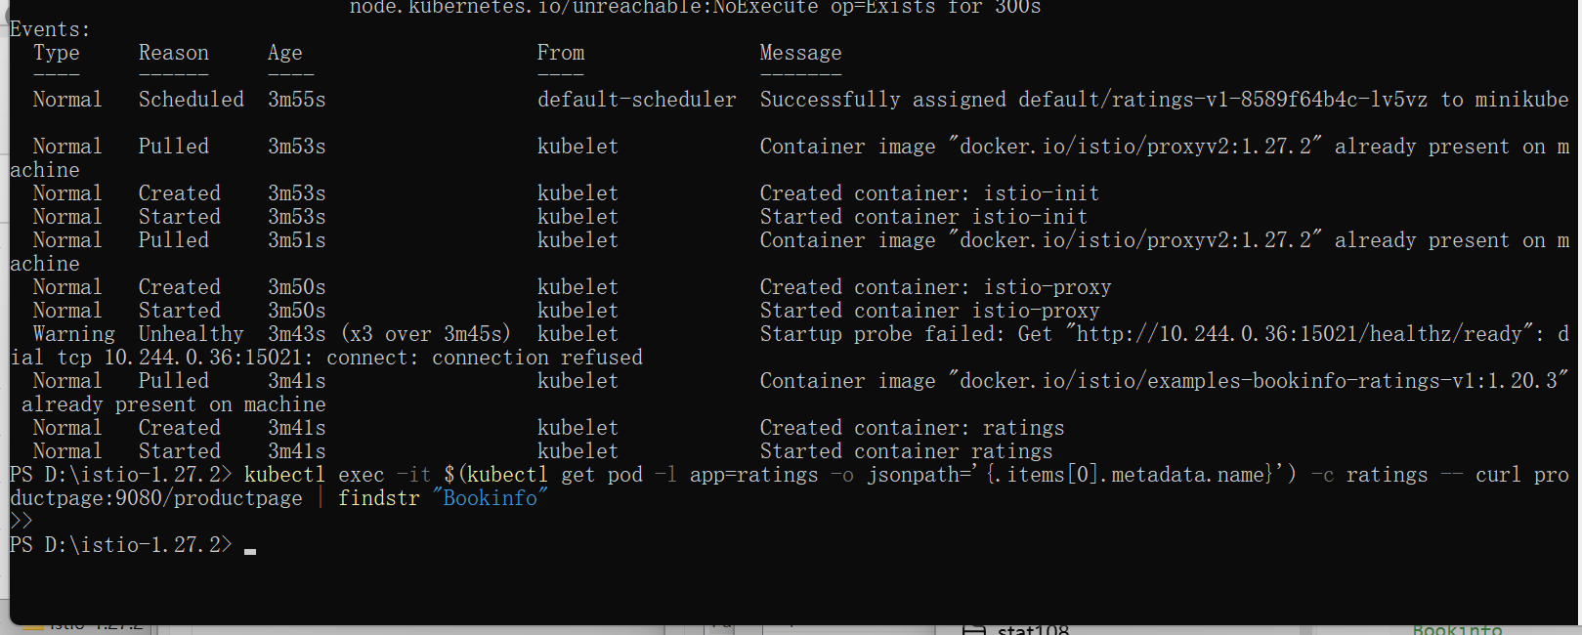

### Step 6: Verify Bookinfo Page

Access the URL in the browser to confirm the app is available.

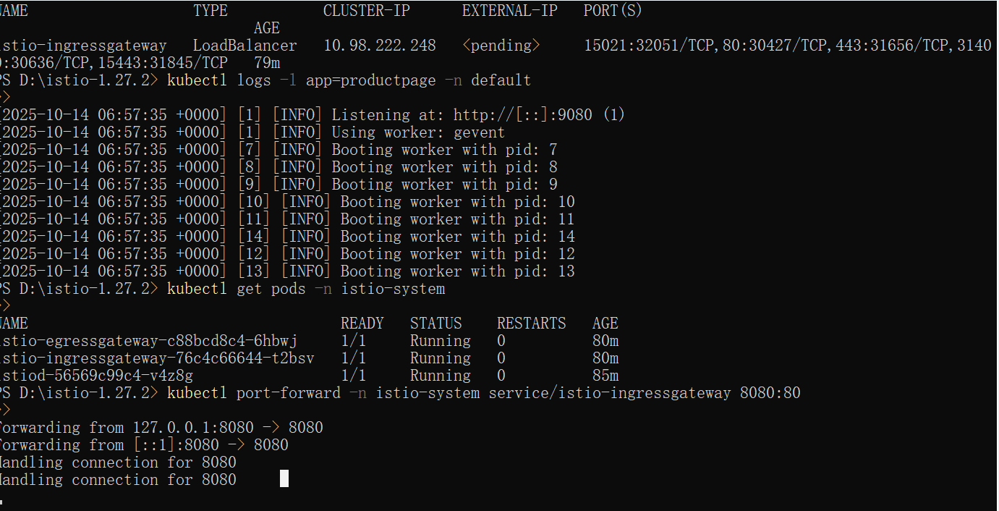

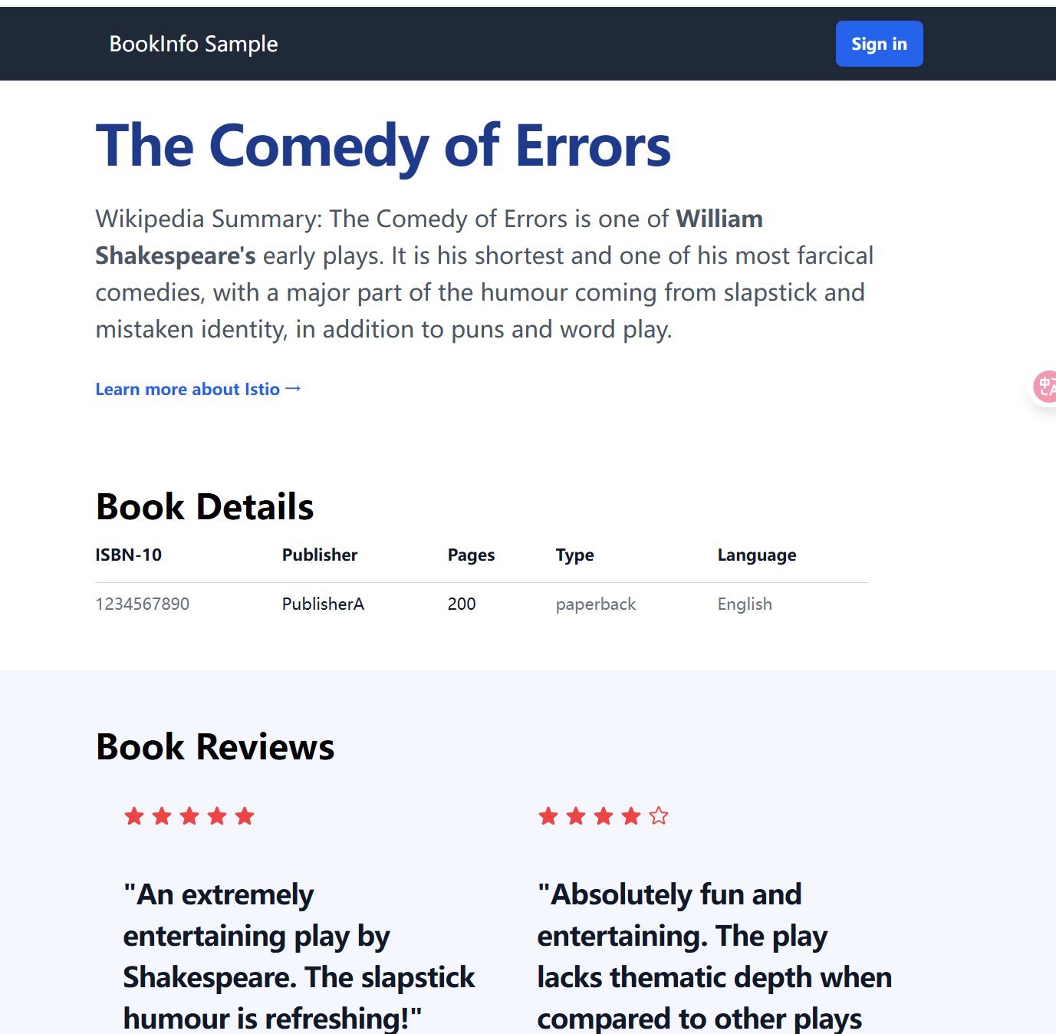

### Step 7: Observe with Kiali

Command: istioctl dashboard kiali  
This opens the Kiali dashboard to visualize Istio service mesh traffic.

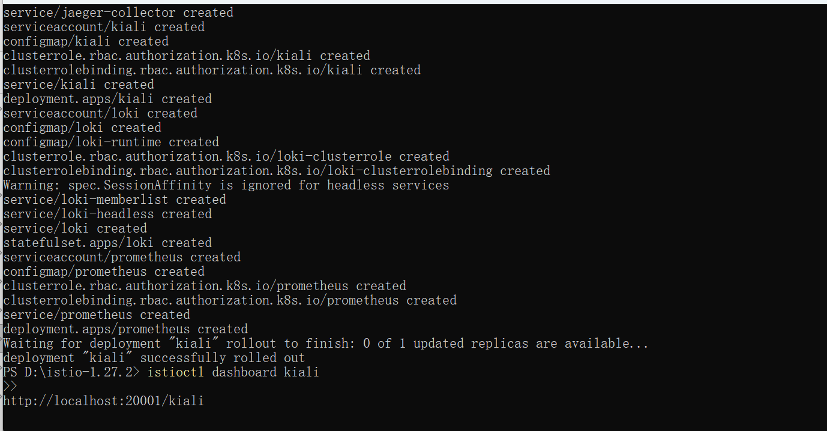

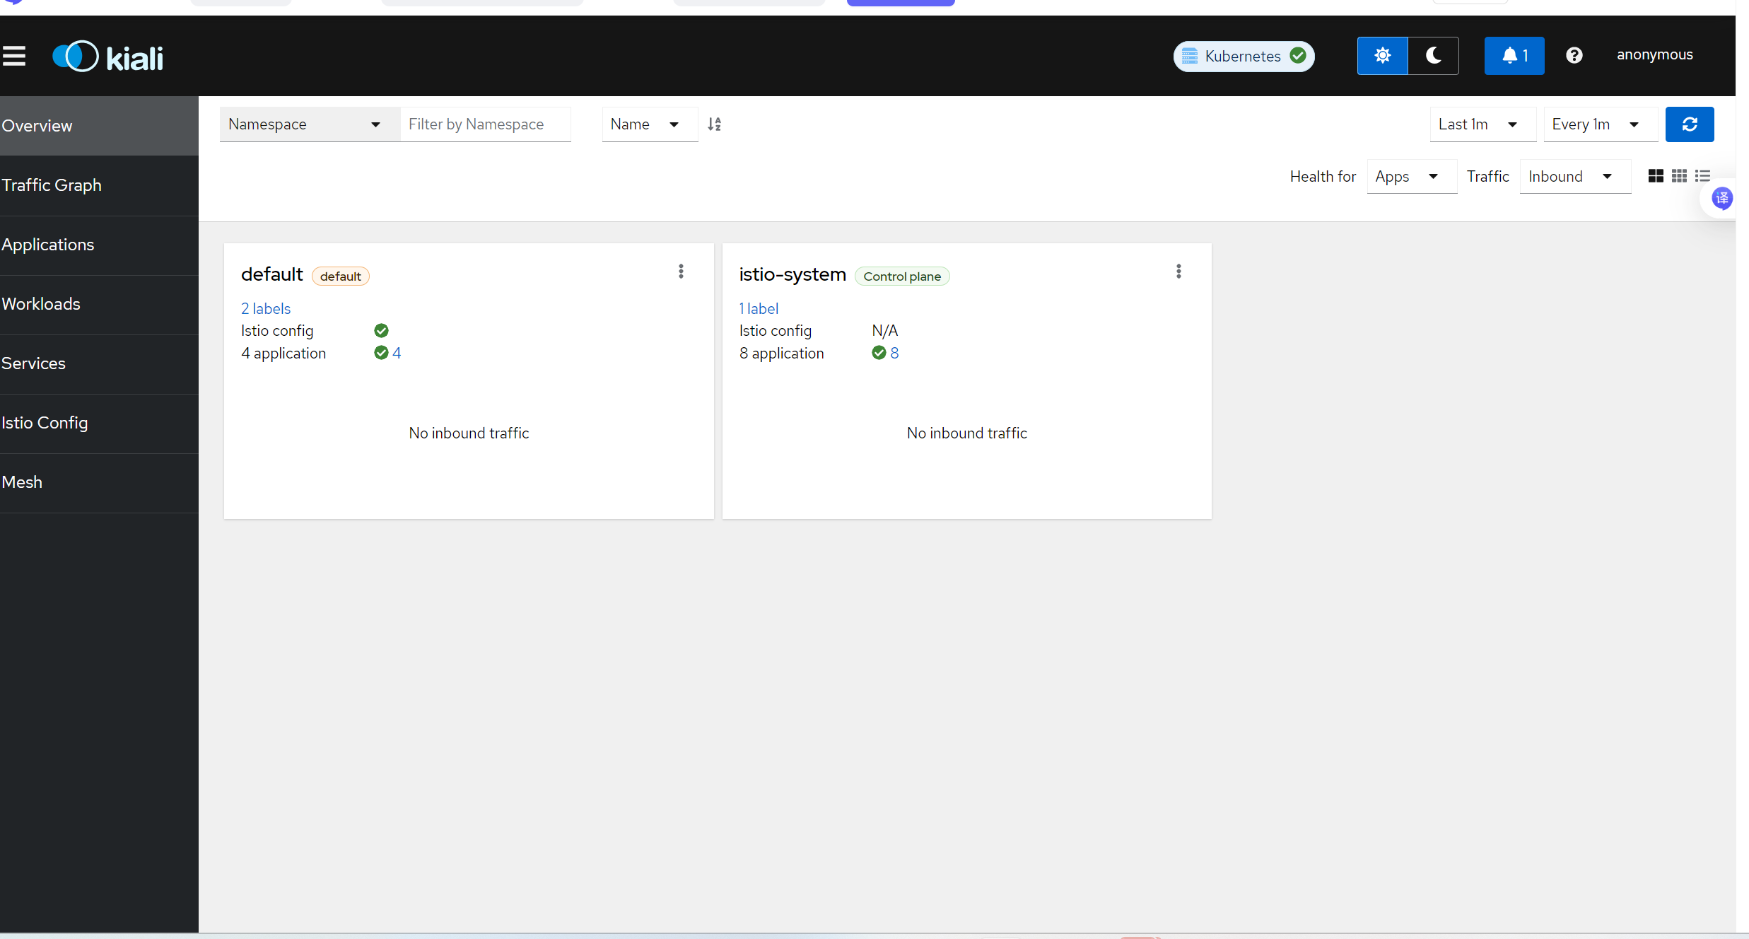

## 3. Observations

All Istio system components were successfully deployed and verified. The Bookinfo application ran properly, and traffic routing was managed via Istio Gateway. Kiali dashboard provided detailed visualization of service-to-service communications.

## 4. Conclusion

This experiment demonstrated how Istio enables advanced service mesh features like traffic management, load balancing, and observability within a Kubernetes environment. The installation and configuration steps were successfully completed using the demo profile.