Cloud Computing Lab Report 6

Name: Xilei Du
ID Number: 202383930004 25 Nov 2025

1 Experiment Overview

The purpose of this lab is to learn the fundamentals of Kubernetes by installing and running a local cluster with Minikube, deploying an application, exploring the cluster, exposing services, scaling the workload, and performing updates. By completing this tutorial, I gained hands-on experience with basic Kubernetes concepts including pods, deployments, services, scaling, and rolling updates.

2 Experiment Tool and Environment
Operating System | Windows 11
Driver | Docker Desktop
Kubernetes Version | v1.34.0
Minikube Version | v1.37.0
Kubectl Version | v1.32.2
Container Image | echoserver:1.10 (Aliyun Mirror)

3 Experimental process

3.1 Install and Start Minikube
Install Docker Desktop and ensure it's running (Docker Engine running). Download and move minikube.exe to System32 or set it in PATH. Verify installations:
- docker version
- kubectl version --client
- minikube version
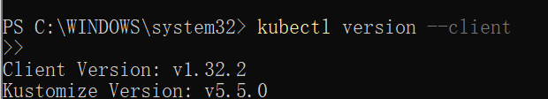
Figure 1: Kubectl version

Start Minikube Cluster
Run the following command to start the local Kubernetes cluster:
- minikube start --driver=docker
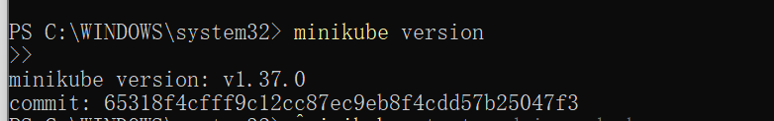
Figure 2: Minikube Version

3.2 Verify Cluster Status
Check the node status:
- kubectl get nodes
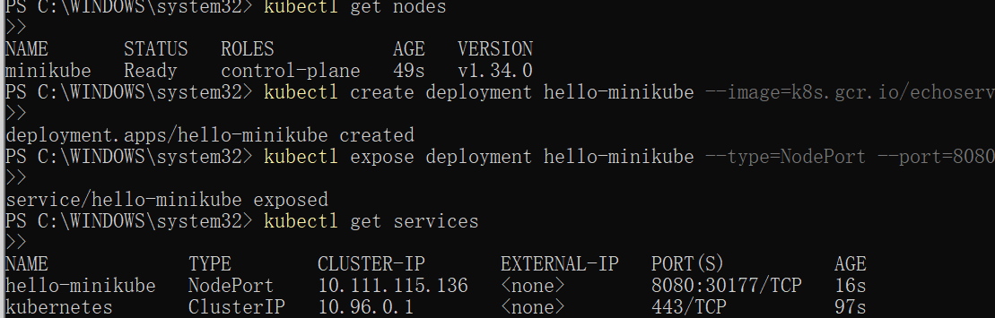
Figure 3: Cluster Status

3.3 Create Deployment
Deploy the application using Aliyun echoserver image:
- kubectl create deployment hello-minikube --image=registry.cn-hangzhou.aliyuncs.com/google_containers/echoserver:1.10

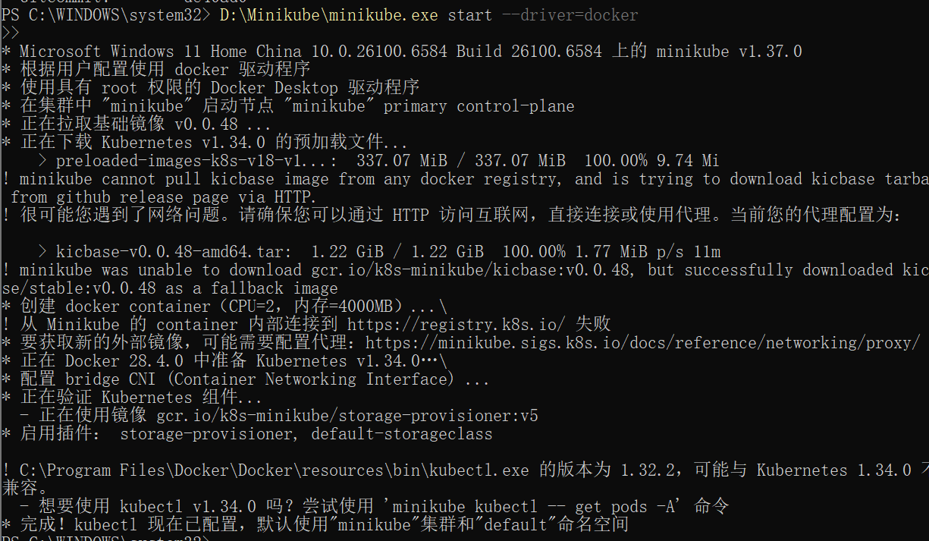
Figure 4: Create Deployment

3.4 Expose Service
Expose the deployment as a NodePort service:
- kubectl expose deployment hello-minikube --type=NodePort --port=8080
Figure 5: Expose Service

3.5 Check Pod Status
Verify if Pod is running:
- kubectl get pods

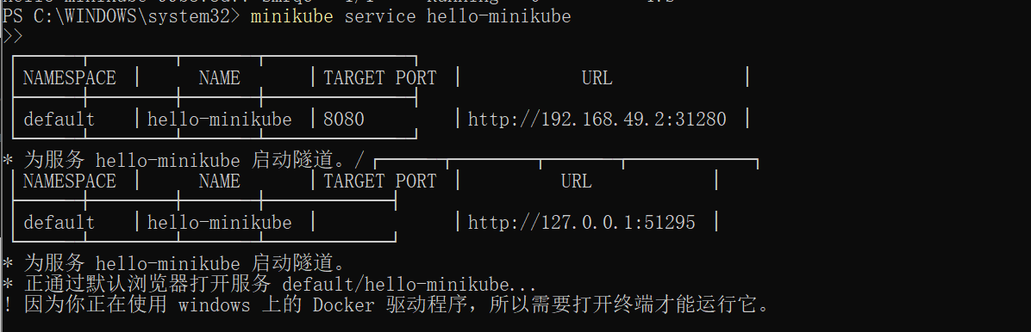
Figure 6: Check Pod Status

3.6 Access Service
Access the service via Minikube tunnel:
- minikube service hello-minikube
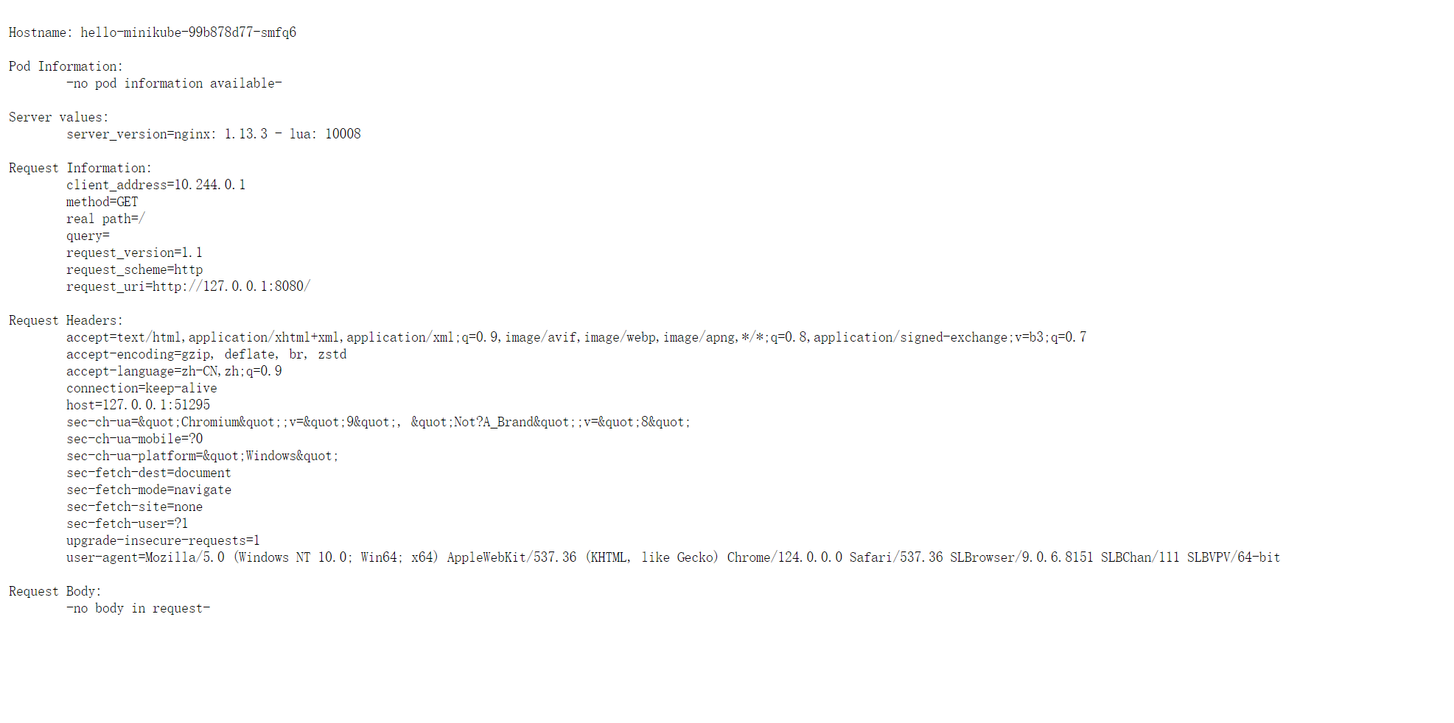
Figure 6: Access the service

4 Summary and takeaways
This experiment demonstrates the full process of deploying and accessing a containerized application on a local Kubernetes cluster using Minikube. The student successfully configured Docker and Minikube, created a deployment, exposed it via a service, and accessed it through a web browser. Common issues like ImagePullBackOff were solved by switching to a domestic mirror repository.

