Cloud Computing Lab Report 3

Name: Xilei Du
ID Number: 202383930004 12 Nov 2025

1 Experiment Overview
The goal of this project is to create my own static personal website and host it on GitHub Pages. By doing so, I will learn the basics of web publishing, how to manage and host a website using GitHub, and build an online presence that can serve as my portfolio, resume, or personal blog.

2 Experimental process

2.1 Create a GitHub Account:
I started by signing up for a GitHub account
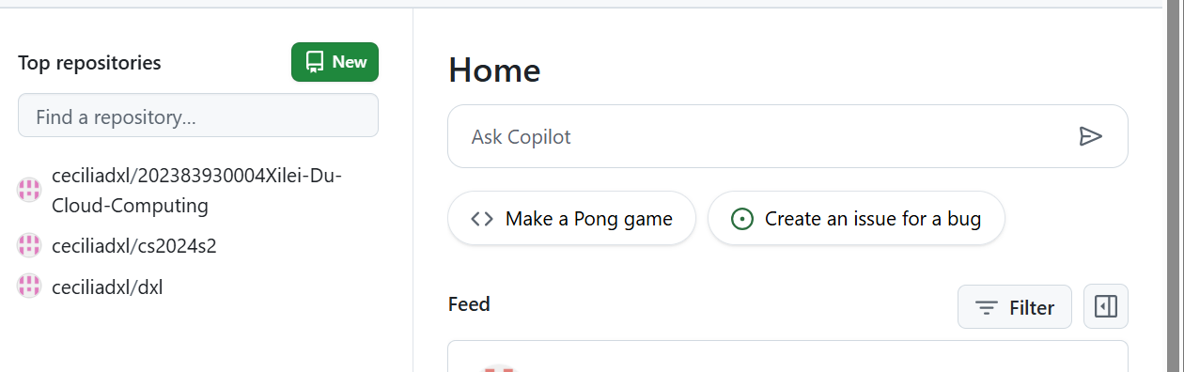

Figure 1: Create a GitHub Account

2.2 Create a New Repository

I created a new GitHub repository with the name username.github.io (where username is my GitHub username). This special name allows GitHub to automatically link it to my personal website.

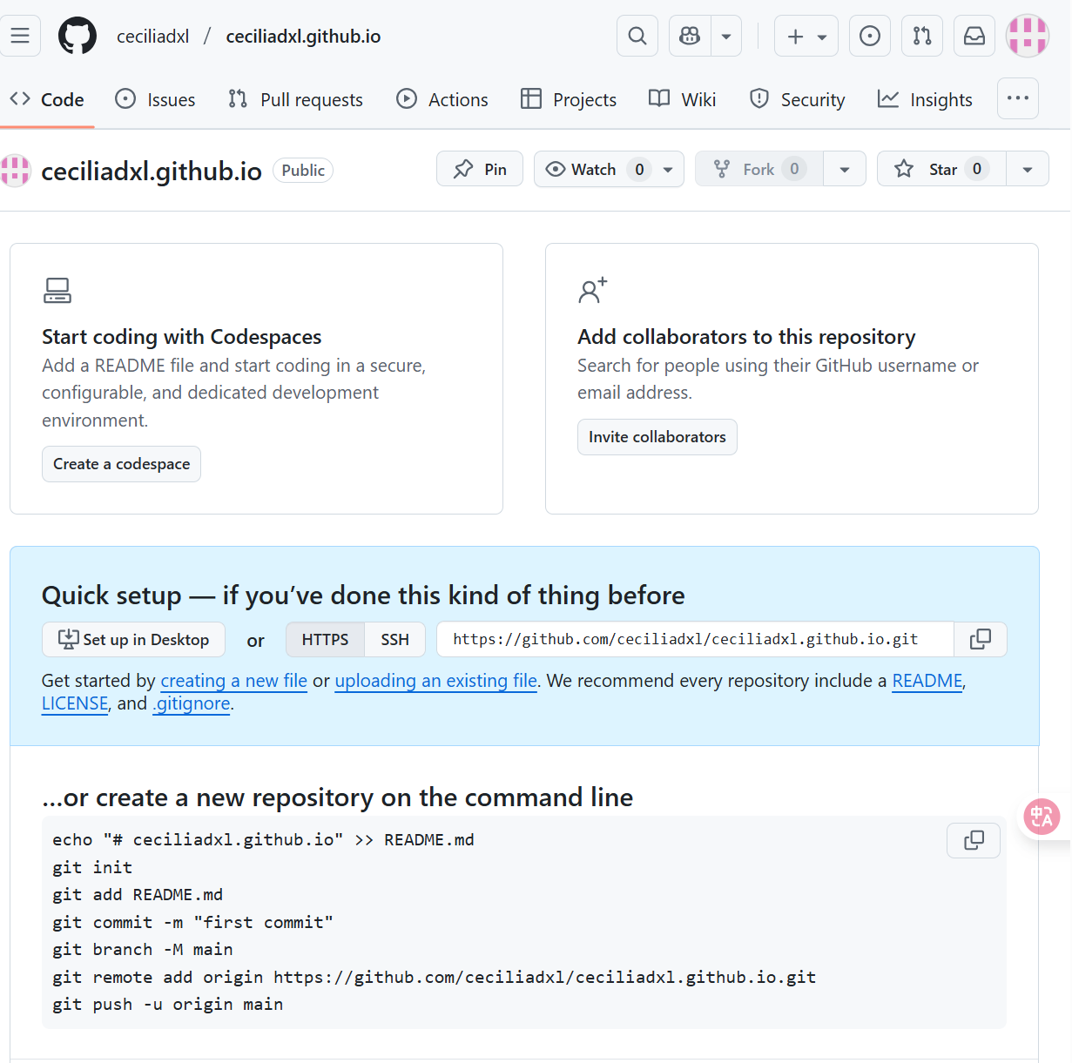

Figure 2: Create a New Repository

2.3 Create My Home Page:

I created an index.html file to serve as my homepage. It includes a brief introduction about me and any other information I want to share.

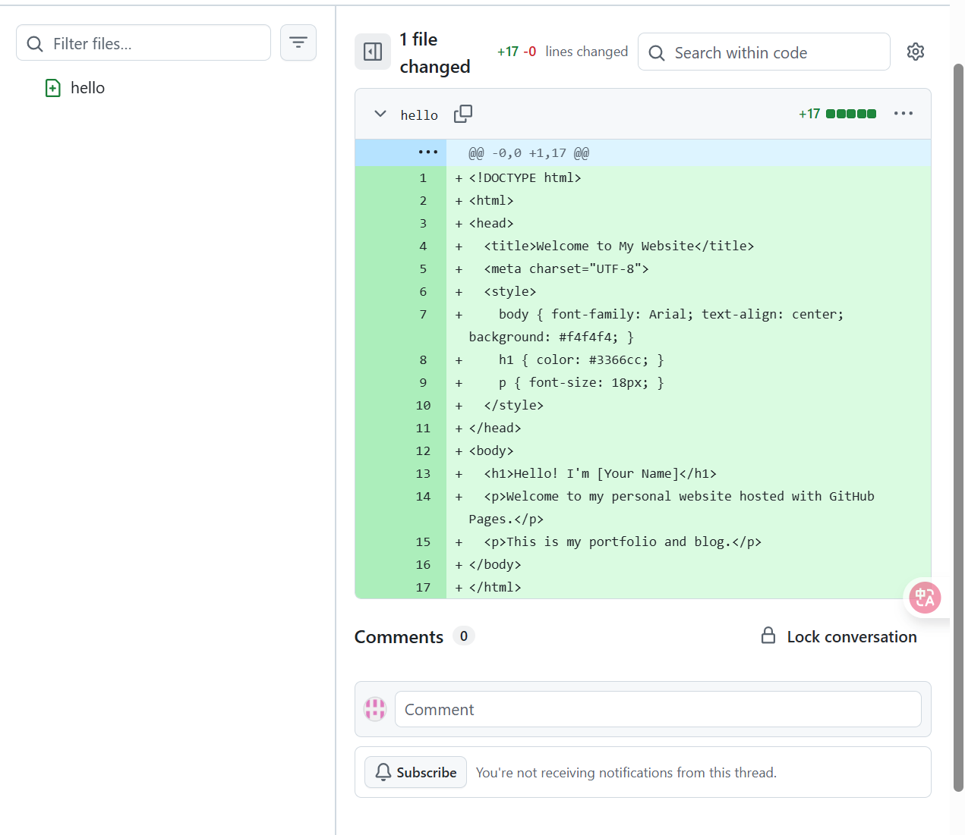
Figure 3: Create My Home Page

2.4 Customize the Website
<html>
<head>
<title>Welcome to My Website</title>
<meta charset='UTF-8'>
<style>
body {font-family: Arial; text-align: center; background: #f4f4f4;}
h1 {color: #3366cc;}
p {font-size: 18px;}
</style>
</head>
<body>
<h1>Hello! I'm [Your Name]</h1>
<p>Welcome to my personal website hosted on GitHub Pages.</p>
<p>This is my portfolio and blog.</p>
</body>
</html>

2.5 Publish the Website:

After setting everything up, I published the website by pushing my changes to GitHub. GitHub Pages automatically generated the website, and I could access it at https://github.com/ceciliadxl/

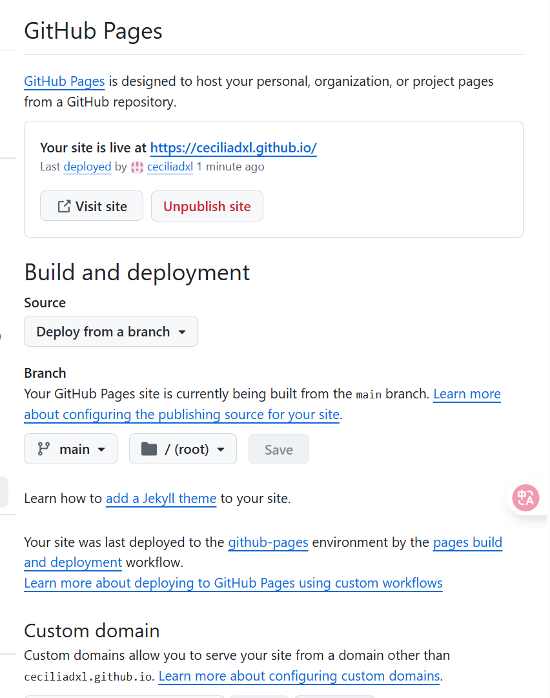
Figure 5: Publish the Website

2.6 View Your Website

After a few minutes, visit your website at:
https://cecliliadxl.github.io
You should see your homepage online.

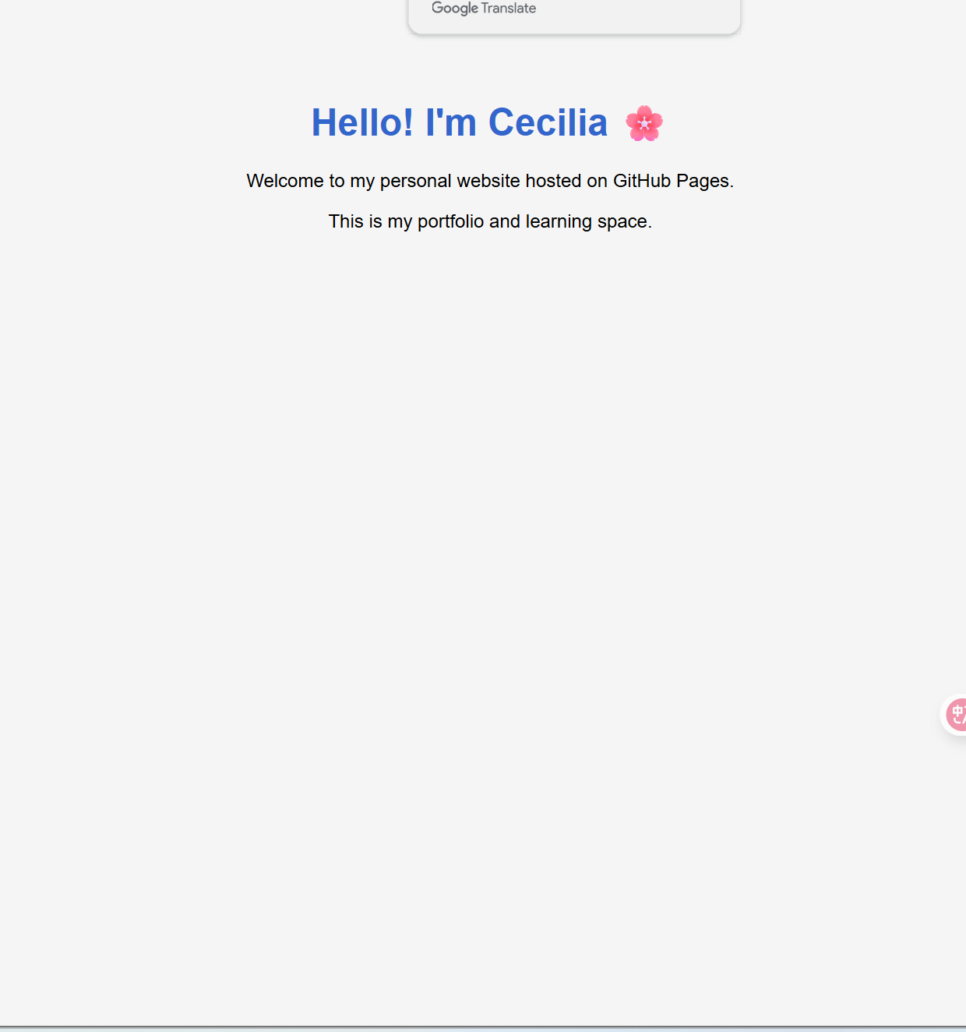
Figure 6: The web page

3 Summary and takeaways
Through this project, I learned how to use GitHub Pages to host a static website without managing any servers. I practiced using GitHub for version control and deployment and understood how static content can be published online easily. This project also helped me build a professional portfolio website that represents my skills and projects.

