Cloud Computing Lab Report 10

Name: Xilei Du
ID Number: 202383930004 14 Dec 2025

1 Experiment Overview

In this lab, I will learn how to deploy a predictive model using KServe on a Minikube Kubernetes cluster. The goal is to install and configure KServe, deploy a predictive model using the InferenceService, monitor the service, and handle inference requests to obtain predictions.

2 Experiment Tool and Environment
Minikube: I will use Minikube to create a local Kubernetes cluster for this experiment. Minikube runs Kubernetes clusters locally and is ideal for testing small applications.
KServe: KServe is a Kubernetes-native platform for deploying and serving machine learning models. I will use it to deploy our predictive model.
Predictive Model: I will choose one predictive model from a machine learning model built with scikit-learn, TensorFlow, or PyTorch.

·

3 Experimental process

3.1 Start Minikube
Expected: Node is in Ready state.
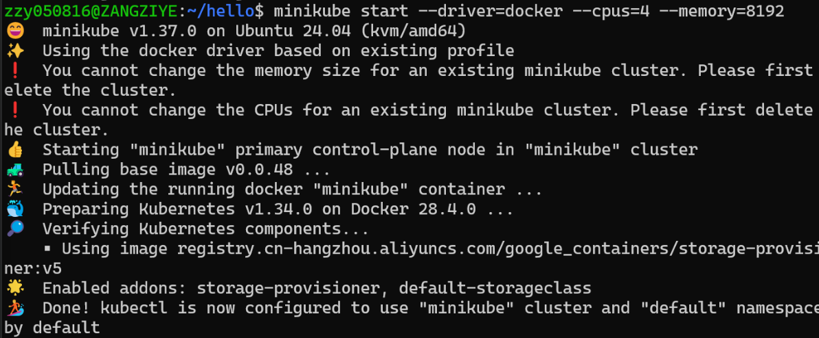
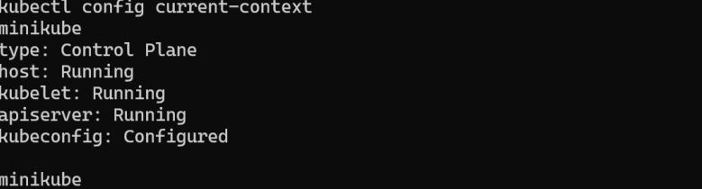
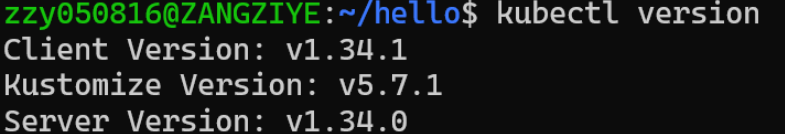

3.2 Install Helm
Expected output includes:

3.3 Install KServe CRDs

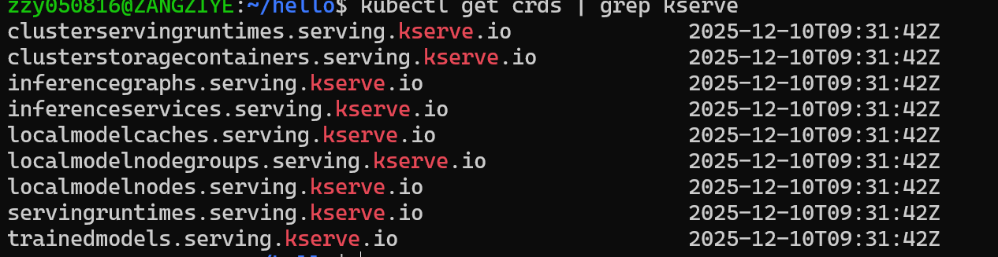

3.4 Install cert-manager (local YAML)
(Installed using local YAML due to WSL network limits)
All cert-manager pods must be Running.

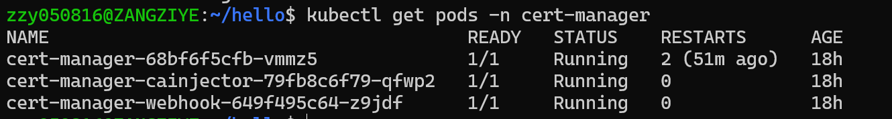

3.5 Install KServe Core Components
kubectl apply --server-side -f kserve.yaml
kubectl apply --server-side -f kserve-cluster-resources.yaml
3.6 Debugging Controller CrashLoopBackOff (Important Part of the Experiment)
Initially, KServe controller failed with:
"error": "invalid deployment mode. Supported modes are Serverless, RawDeployment, ModelMesh"
Fix：kubectl patch configmap/inferenceservice-config -n kserve \
--type=strategic \
-p '{"data":{"deploy":"{\"defaultDeploymentMode\":\"RawDeployment\"}"}}'
kubectl rollout restart deployment kserve-controller-manager -n kserve
Verify:

3.6 Deploy the InferenceService
Create namespace&Deploy the sklearn-iris model

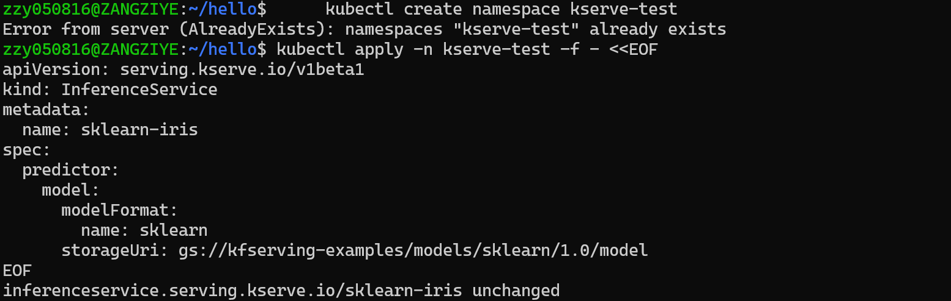
Check status:
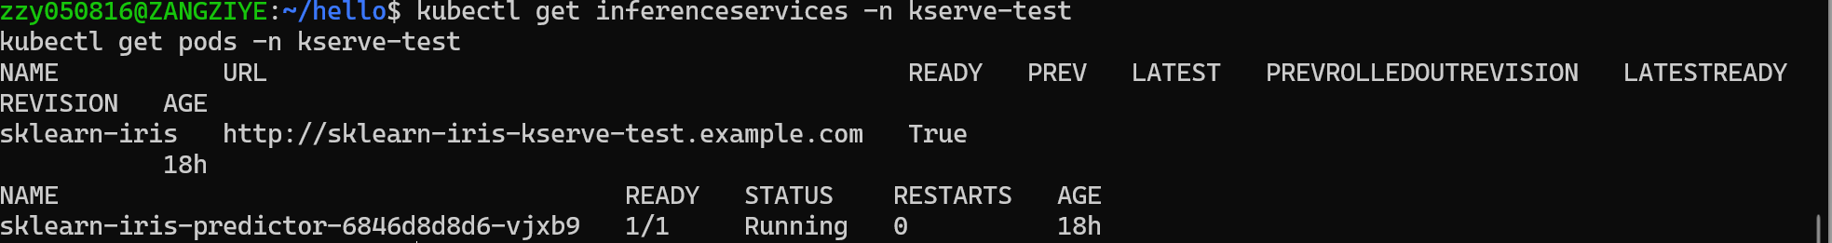

3.7 Access the Model Service (Port Forwarding)
Find the service:
Forward port:

3.8 Send Inference Request
Prepare input:
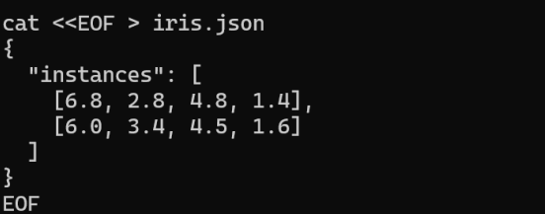
Send request:
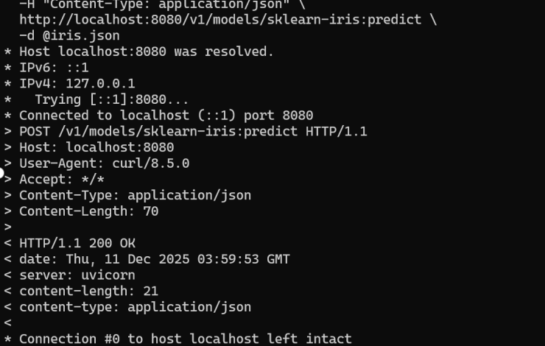

4 Summary and takeaways
Installing KServe on Minikube
A local Kubernetes cluster was deployed and configured using Minikube, and KServe was installed to support inference services for machine learning models.
Debugging Controller Issues (e.g., Deployment Mode, TLS Certificates)
Irregularities related to the controller, such as deployment mode configuration and TLS certificate management, were resolved to ensure KServe functions correctly.
Deploying Models via InferenceService
A machine learning model was successfully deployed via KServe's InferenceService, enabling real-time inference.
Accessing the Inference API from Outside the Cluster
Access to the model inference service from outside the cluster was configured and verified, ensuring that external applications could correctly access the API.
Executing Actual Prediction Requests
An actual prediction request was executed by calling the inference service, and prediction results were successfully obtained.and configuration steps were successfully completed using the demo profile.

