Cloud Computing Lab Report 9

Name: Xilei Du
ID Number: 202383930004 11 Dec 2025

1 Experiment Overview

Through this experiment, I will gain a deep understanding of the fundamental functionalities of Knative, including how to build, deploy, and manage serverless cloud-native applications on Kubernetes. Using Knative, I will learn how to create and manage Knative services, event streams, and how to handle event-driven architectures in cloud-native applications.

Objectives:

Understand the basic concepts of Knative services and event-driven architecture.

Learn how to deploy and manage serverless applications using Knative on Kubernetes.

Master the development and management of cloud-native applications by configuring and using Knative Functions, Knative Serving, and Knative Eventing.

2 Experiment Tool and Environment
Before installing Istio, I ensured the following environment was ready:

Kubernetes cluster running (Minikube / cloud Kubernetes / local cluster)

kubectl configured for the cluster

Cluster admin permissions

3 Experimental process

3.1 Install the local Docker registry

I started a local Docker registry using the following command:

docker run -d -p 5000:5000 --name registry registry:2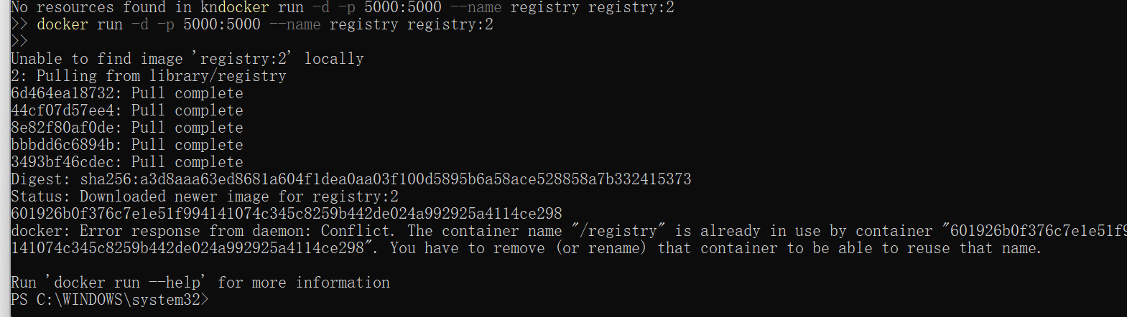
Figure 1: Install the local Docker registry

3.2 Knative Function section
Change the kube\config.yaml
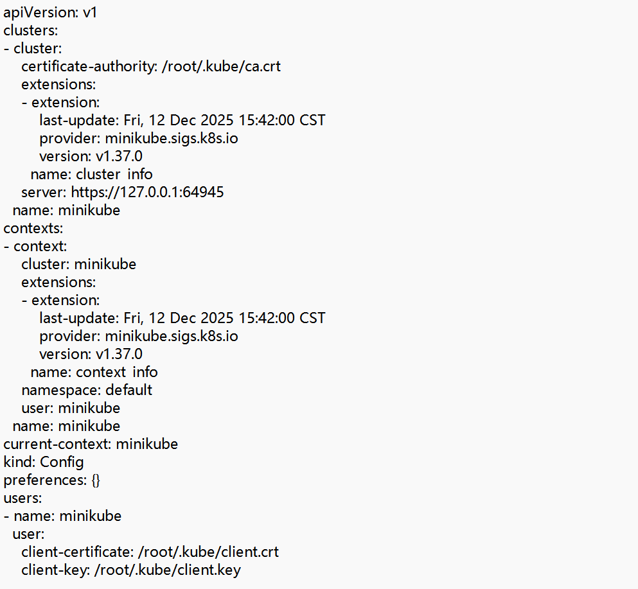
Figure 2: config file

Run docker run --rm -v $HOME\.kube:/root/.kube gcr.io/knative-releases/knative.dev/client/cmd/kn:latest service list

Figure 3: kn install

3.3 Install Knative CRDs
To run Knative services in a Kubernetes cluster, first install Knative's custom resource definitions (CRDs). Use the following command to install:kubectl apply -f https://github.com/knative/serving/releases/download/v0.23.0/serving-crds.yaml
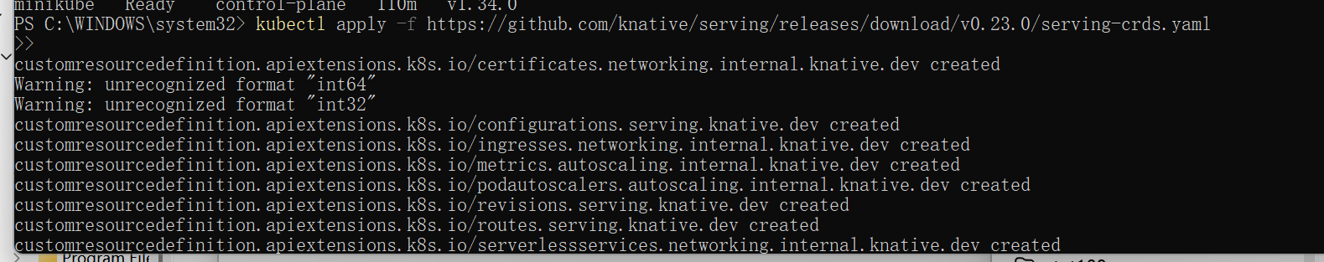
Figure 4: install Knative CRDs

3.4 Install Knative Serving
After installing CRDs, you also need to install Knative Serving, which handles server requests and responses. Use the following command to install Knative Serving:

`kubectl apply -f https://github.com/knative/serving/releases/download/v0.23`
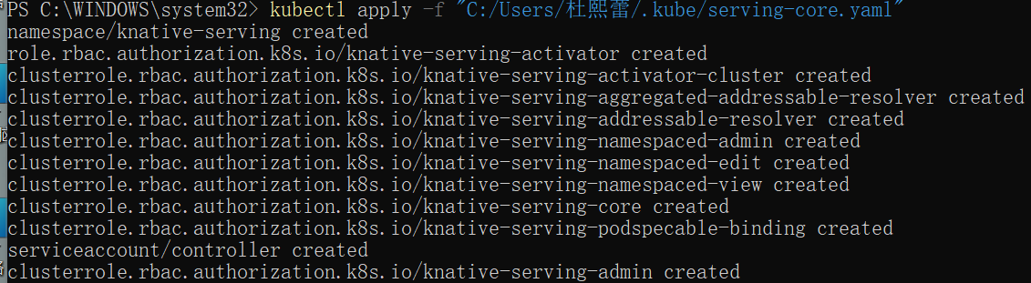
Figure 4: install Knative Serving

Verify if Knative service is installed
Run the following command to check if the Knative service is installed correctly:

kubectl get pods --namespace knative-serving
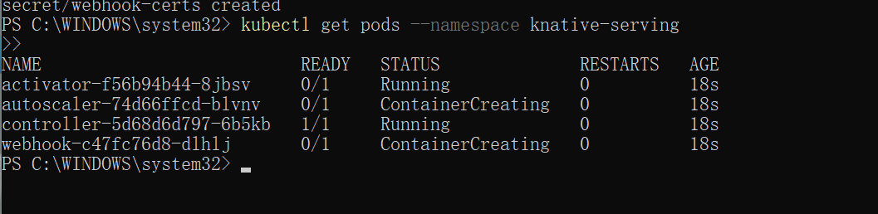
Figure 4: Check Knative Serving

Create a simple Knative service
Create a simple Knative service. For example, create a hello-world service to run a simple Go application.

First, create a YAML file and add the following content:
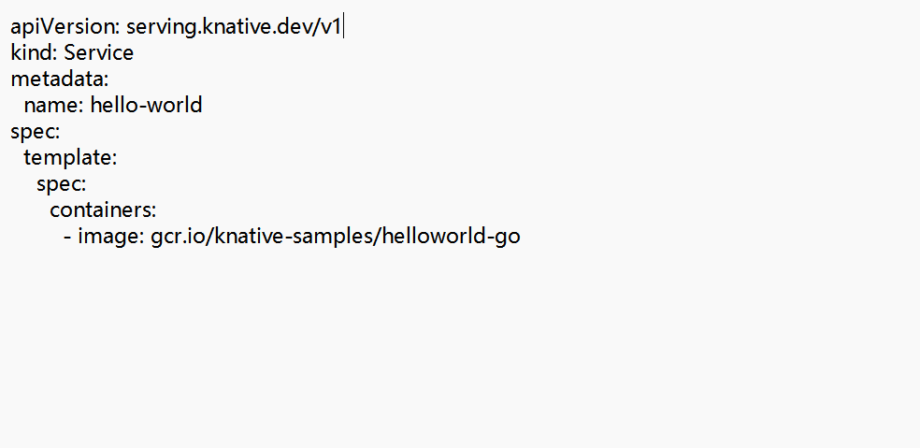
Figure 5: Create a simple Knative service

To deploy hello-world.yaml to your Kubernetes cluster, use the following command:

kubectl apply -f hello-world.yaml

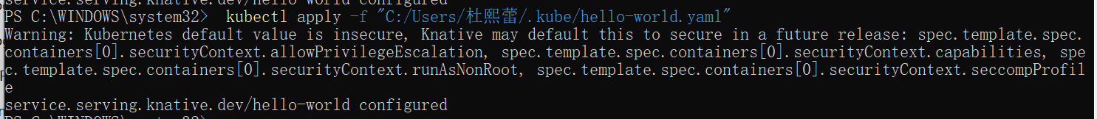
Figure 6: Deployment service

3.5 View Knative services
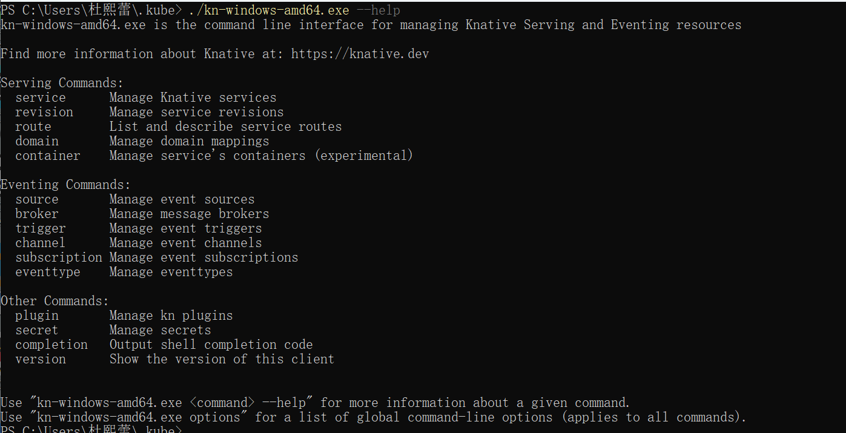
Figure 7: kn-windows-amd64.exe --help

run the following command to create a service:
`kn service create hello-world --image=gcr.io/knative-samples/helloworld-go`
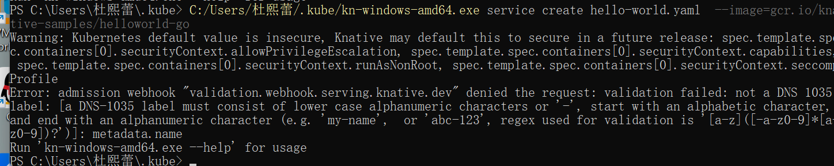
Figure 8: `kn service create hello-world --image=gcr.io/knative-samples/helloworld-go`

To check the status of the services you created, I can run:
kn service list

Figure 9: `kn service list`
Then I enter the URL http://hello-world.default.svc.cluster.local/

traffic stops going to the URL:kubectl get pod -l serving.knative.dev/service=hello -w
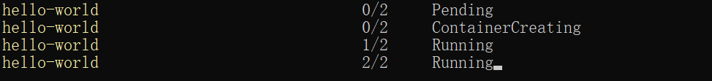Figure 10: Hello World

Use the Knative CLI to perform other administrative tasks, such as modifying or deleting services.

Eg:

Delete the file

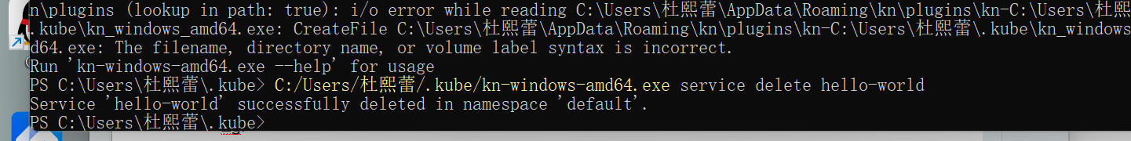
Figure 11: Delete service

3.6 Traffic splitting
Deploy the updated version of your Knative Service by running the command:kn service update hello \--env TARGET=Knative
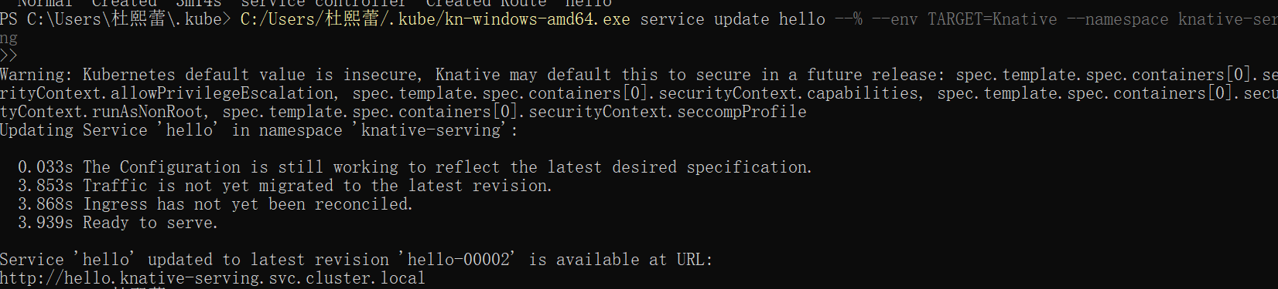Figure 12: hello-00002
Access the Knative Service again on my browser or use curl in your terminal:

Figure 13: hello Knative

View a list of revisions by running the command:kn revisions list
Figure 14: View a list of revisions

3.7 Knative Eventing
Copy the following YAML into a file named cloudevents-player.yaml:
Apply the YAML file by running the command:
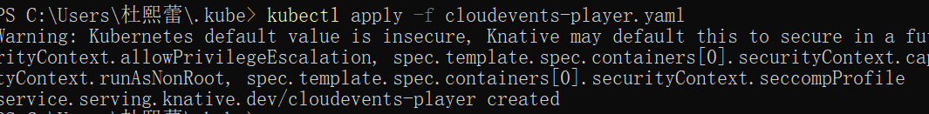
Figure 15: cloudevents-player.yaml
Run the command:
kn service create cloudevents-player \
--image quay.io/ruben/cloudevents-player:latest

Figure 16,17,18: kn service create cloudevents-player
A PingSource was created to generate periodic events and send them
to the event-display service.
Figure 19: A PingSource
The event flow was verified by checking the logs of the event-display pod.
CloudEvents generated by the PingSource were successfully received.
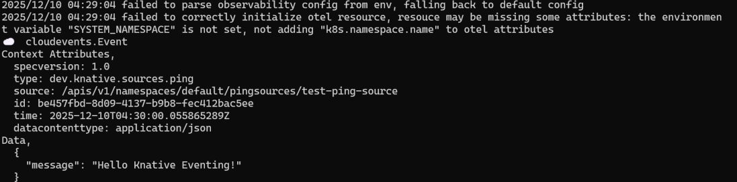
Figure 20: CloudEvents

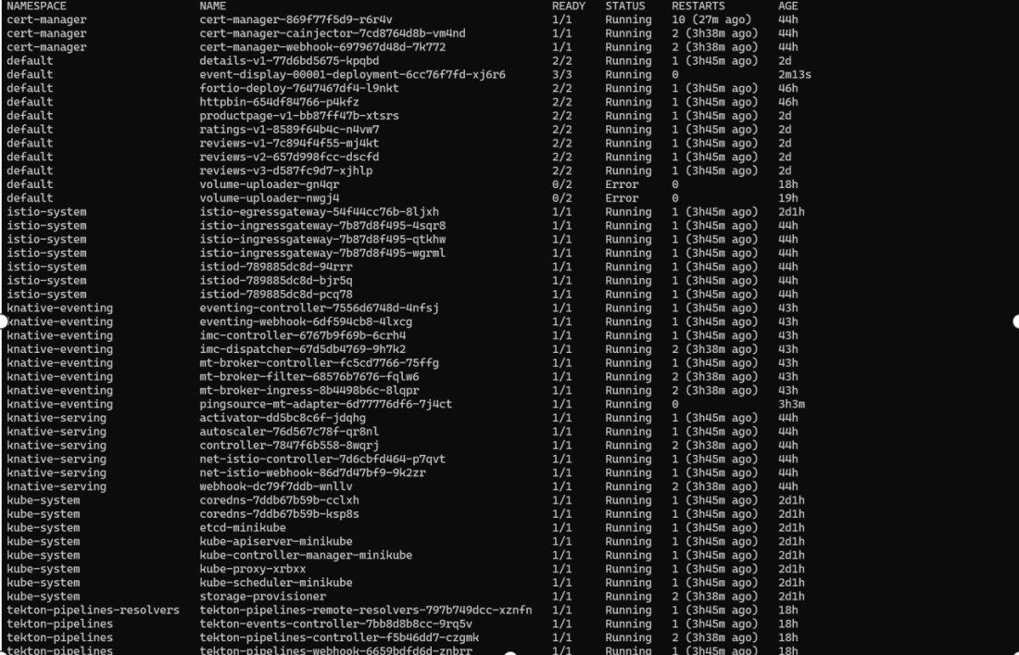

4 Summary and takeaways
In this experiment, I mainly completed the following steps:
Installing Knative Functions: I first configured Knative Functions through the local registry and learned how to deploy and manage serverless functions in Kubernetes. Although I skipped the function deployment part, by configuring and understanding it, I mastered how to work on Knative.
Deploying a Knative Service: Following the documentation, I successfully created a simple Knative service and deployed it on Kubernetes. After checking the service status using the `kubectl` and `kn` commands, I confirmed that the service was running successfully and could be accessed via the specified URL.
Configuring Knative Eventing: I created an event source and a Broker, transmitted events from the event source to the Broker, and then consumed and processed the events using Triggers. This process helped me further understand how to implement an event-driven architecture using Knative Eventing.
Verification and Debugging: By checking the service status, logs, and access URL, I ensured that the Knative service and event stream were working correctly and successfully resolved some minor issues.

Overall, this experiment provided me with a deeper understanding of how Knative works in Kubernetes and enhanced my understanding of event-driven architecture through hands-on practice. During the experiment, I learned how to manage and scale serverless applications and understood how to handle and respond to events using Knative.

