Cloud Computing Lab Report 2

Name: Xilei Du
ID Number: 202383930004 3 Oct 2025

1 Experiment Overview
The purpose of this experiment is to set up a Nebula network to establish connectivity between computers behind NATs (Network Address Translators), with a lighthouse acting as the central point of connection. By utilizing a free Google Cloud virtual machine as the lighthouse, I aim to create a secure private network that allows devices in different network environments to communicate seamlessly, even when they are behind firewalls or NATs.

2 Experimental process

2.1 Set Up Virtual Machine (VM):
I began by creating a free virtual machine on Google Cloud, ensuring it had a public IP address for use as the lighthouse in the network.
2.2 Install Nebula:
After setting up the VM, I installed Nebula on the VM and on all participating machines (behind NATs). I used Homebrew for macOS to install the necessary tools.
2.3 Generate Certificates:
Using the nebula-cert tool, I created the required certificates for the lighthouse and the client machines. These certificates included the root certificate (ca.crt), lighthouse certificate (lighthouse.crt), and private keys (lighthouse.key).
2.4 Configure config.yaml Files:
I configured the lighthouse and client machines with the appropriate config.yaml settings. The lighthouse's configuration included its public IP address and certificate paths. The client configurations pointed to the lighthouse and included their respective certificates and IP addresses.

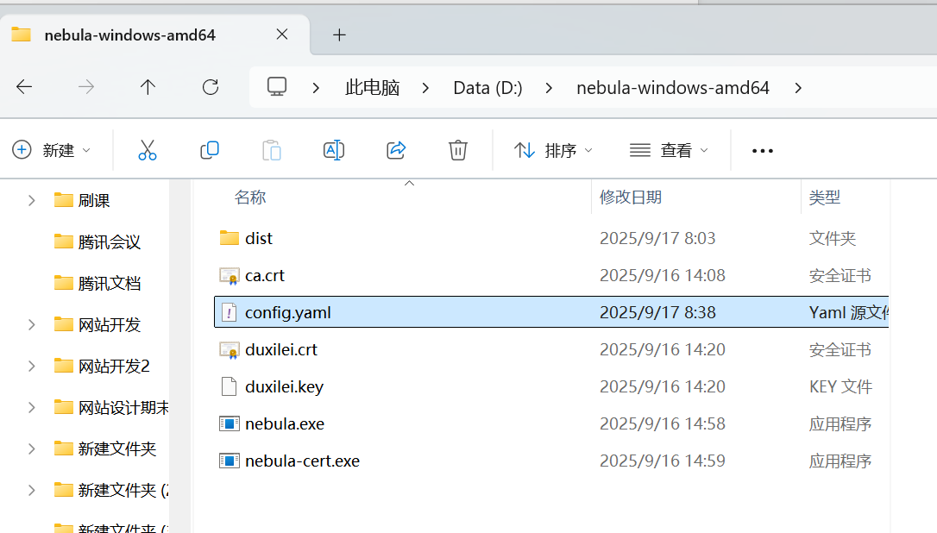
Figure 1: Configure config.yaml Files

2.5 Start Nebula:
Once the configuration files were in place, I started Nebula on both the lighthouse and client machines using:I open the PowerShell as a admin status,enter the nebula file,like this
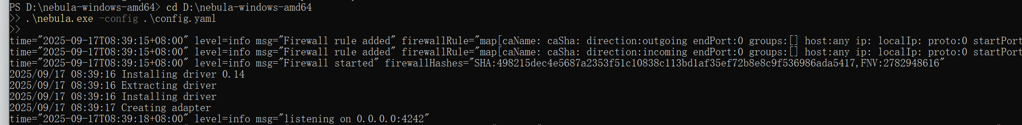
Figure 2: Start Nebula

2.6 Verify Connectivity:
To test the setup, I pinged the IP addresses of the lighthouse and other participating clients to ensure successful communication through the Nebula network.

2.7 Data Comparison:
During the process, I used Meld and Beyond Compare to compare the config.yaml files, ensuring consistency across all configurations. This helped identify any discrepancies and maintain uniformity in the setup.
After Nebula is running on powershell,I open the cmd on my cp.try to ping a ip address:

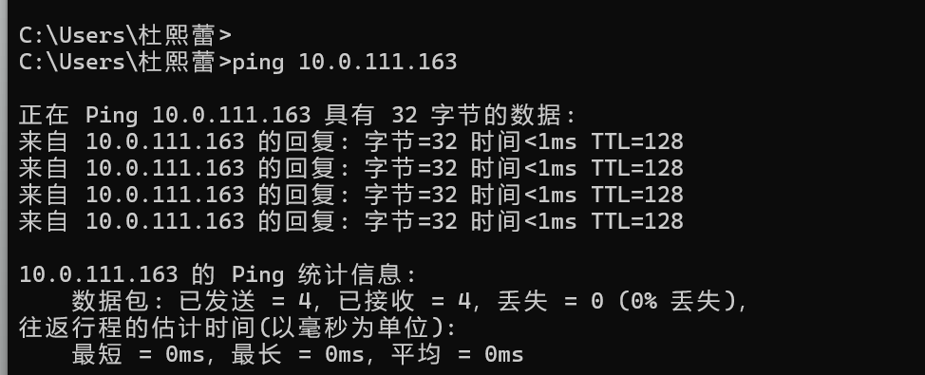
Figure 3: Successful Ping

3 Summary and takeaways
In this experiment, I successfully set up a Nebula network using a Google Cloud virtual machine as the lighthouse. The setup allowed me to connect computers behind NATs securely and efficiently. By generating the required certificates and configuring the necessary files, I was able to ensure all machines in the network could communicate, regardless of their network environment. The process involved configuring the lighthouse and client machines, ensuring proper connectivity through certificate management and network configurations. Finally, by testing the setup and using comparison tools, I verified the correctness and consistency of the configuration files. The experiment demonstrated how to establish a private network that can traverse NATs and firewalls, providing secure communication between devic

