Cloud Computing Lab Report 8

Name: Xilei Du
ID Number: 202383930004 15 Oct 2025

1 Experiment Overview
This experiment aims to provide an in-depth understanding and practical application of Istio’s traf- fic management capabilities. We will learn how to control and manage traffic flow in a microservice architecture and ensure the system’s reliability and resilience in the face of failures by operating four functionalities: Traffic Shifting, Request Routing, Fault Injection, and Circuit Breaking.

2 Experimental process

2.1 Experimental setup
First, start a local Kubernetes cluster. Then,install Istio: Deploy the Bookinfo sample applica- tion.After that,Check service status.

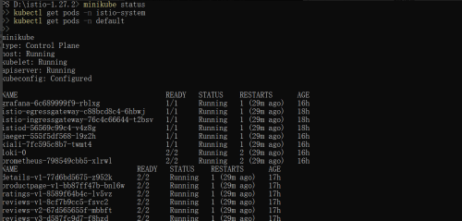

Figuur 1: Setup situation

2.2 Traffic Shifting
This demonstrates how to migrate traffic from an older version of a service to a newer version using Istio.
1. Initial configuration: Direct all traffic to version v1.
kubectl apply -f samples/bookinfo/networking/virtual-service-all-v1.yaml
kubectl apply -f samples/bookinfo/networking/destination-rule-all.yaml.
2. Partial migration: Allocate 50% of traffic to v3 and leave 50% in v1.
kubectl apply -f samples/bookinfo/networking/virtual-service-reviews-50-v3.yaml.

3. Full migration: Switch all traffic to version v3.
kubectl apply -f samples/bookinfo/networking/virtual-service-reviews-v3.yaml

4. Clean up configuration:
kubectl delete -f samples/bookinfo/networking/virtual-service-all-v1.yaml kubectl delete -f samples/bookinfo/networking/destination-rule-all.yaml

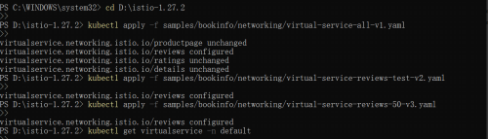

Figuur 2: Traffic Shifting

2.3 Request Routing
To route requests to different versions of a service based on HTTP headers or path conditions.

1. Configure request routing:The end-user header routes requests to either re- views:v2 or reviews:v1.
kubectl apply -f samples/bookinfo/networking/virtual-service-reviews-test-v2.yaml.

2. Test request routing:Use curl to simulate different user requests to verify that the requests are correctly routed to different versions.
curl -H e…nd-user: jason”http://§GATEWAYURL/productpage.

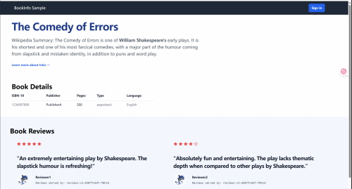

Figuur 3: Request Routing

2.4 Fault Injection
By simulating service delays or errors, verify how the system handles failures and test its resilience.
1. Delayed injection: Adds a delay to the ratings service.
kubectl apply -f samples/bookinfo/networking/virtual-service-ratings-test-delay.yaml.

2. Error injection: Simulate the return of an HTTP 500 error.
kubectl apply -f samples/bookinfo/networking/virtual-service-ratings-test-abort.yaml.

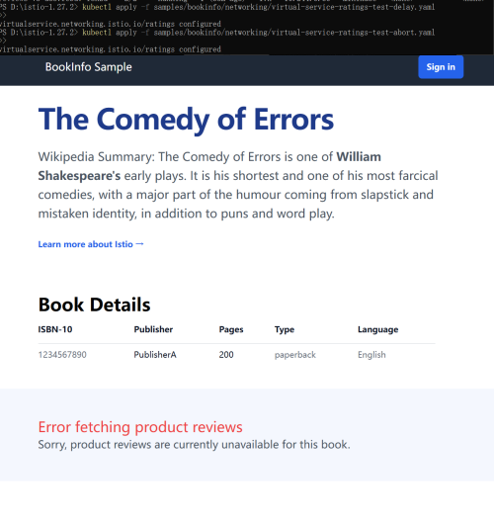

Figuur 4: Fault Injection

2.5 Circuit Breaking
Configure circuit breakers for microservices to prevent the spread of failures and improve system robustness.
1. Configure circuit breakers: Configure connection pooling and exception detec- tion for the reviews service.
kubectl apply -f samples/bookinfo/networking/destination-rule-reviews.yaml
kubectl apply -f samples/bookinfo/networking/virtual-service-reviews-cb.yaml.

2. Simulate failure: Use a load balancer (such as curl) to trigger a request failure and observe the effectiveness of the circuit breaker mechanism.

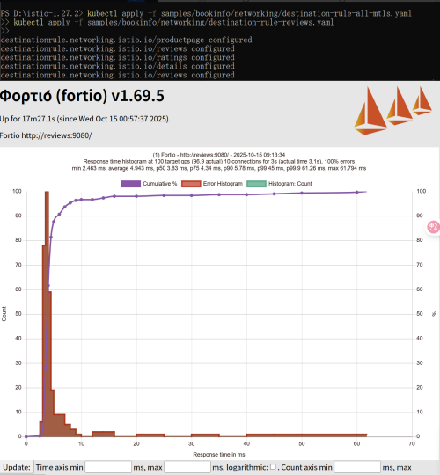

Figuur 5: Circuit Breaking

3 Summary and takeaways
Through this experiment, we learned and practiced Istio’s traffic management capabilities, inclu- ding traffic migration, request routing, fault injection, and circuit breaking. Through step-by-step operation, we learned how to control traffic distribution, how to set routing rules for specific re- quests, how to simulate service failures and verify the system’s fault tolerance, and how to configure circuit breaking mechanisms to protect the system from the impact of escalating failures.

