Cloud Computing Lab Report 5

Name: Xilei Du
ID Number: 202383930004 20 Nov 2025

1 Experiment Overview

The goal of this tutorial is to understand the basic concepts of Docker, including containers, images, Docker Compose, and how to run containers with various configurations. This hands-on exploration will help build a solid understanding of Docker fundamentals, which are essential for containerized application development.

2 Experiment Tool and Environment
Operating System: Windows 11
Docker Desktop: Latest version
WSL 2: Enabled
Tools: Docker CLI, Visual Studio Code, PowerShell/Command Prompt

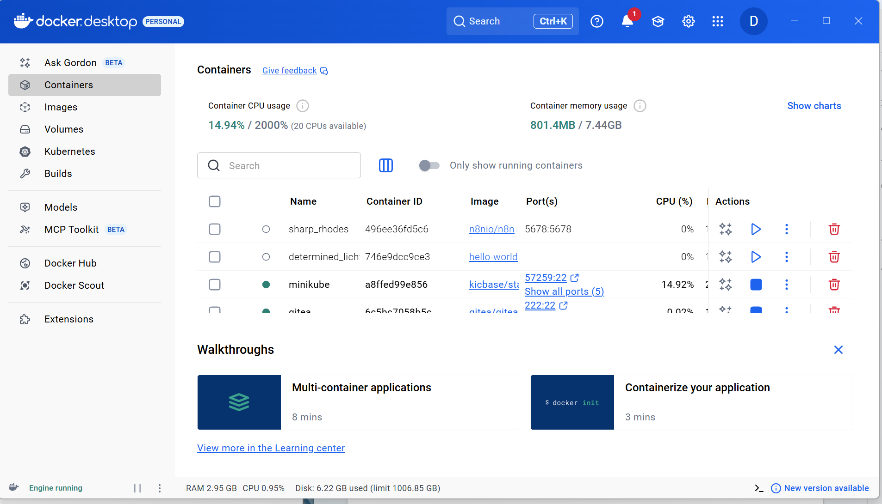

Figure 1: Docker Setup

3 Experimental process

3.1 Containers and Images

Command: docker run hello-world
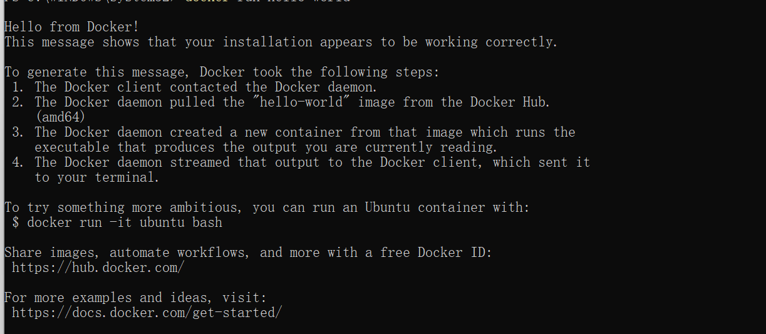
Figure 2: Run Hello-world

Note: Containers are lightweight, isolated environments that package an application and all its dependencies together.

Command: docker pull nginx
docker images
Figure 3:Run docker pull nginx
Note: Images are templates used to create containers.n

3.2 Docker Compose and Port Publishing
1. Pull the Gitea image:
docker-compose.yml:
services:
web:
image: nginx
ports:
- '8080:80'
Command: docker compose up -d
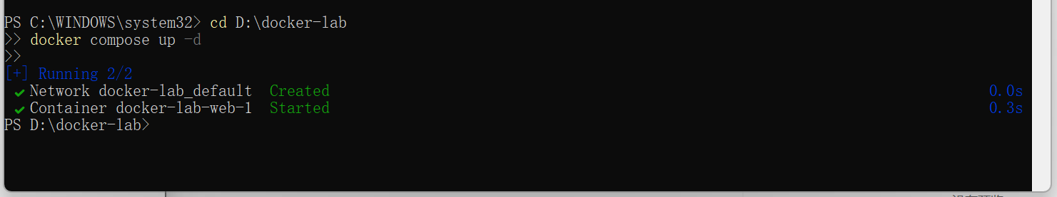
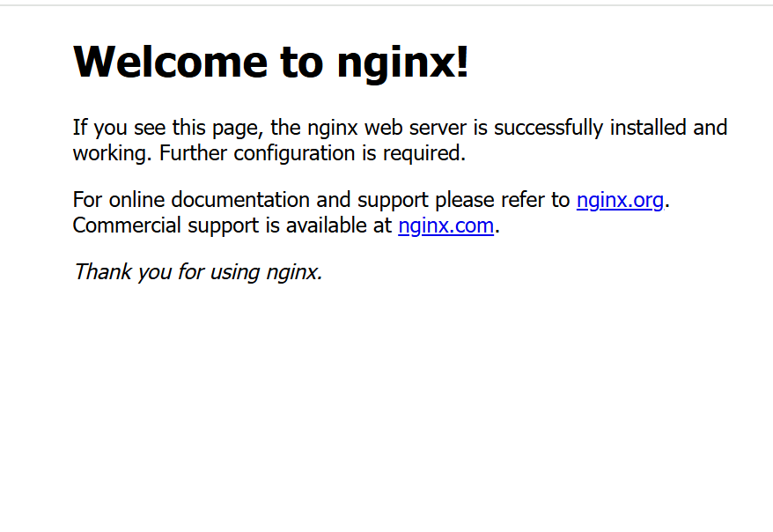

Figure 4:Run docker compose up -d
Note: Docker Compose simplifies running multi-container applications by defining them in a YAML file.

3.3 Persisting and Sharing Data
Command: docker run -d -p 8082:80 -v D:\dockerdata:/usr/share/nginx/html nginx
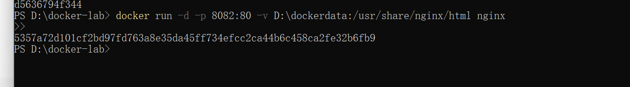
Figure 5 run -d -p 8082:80 -v D:\dockerdata:/usr/share/nginx/html nginx

Command: docker run -it -v %cd%:/app ubuntu bash
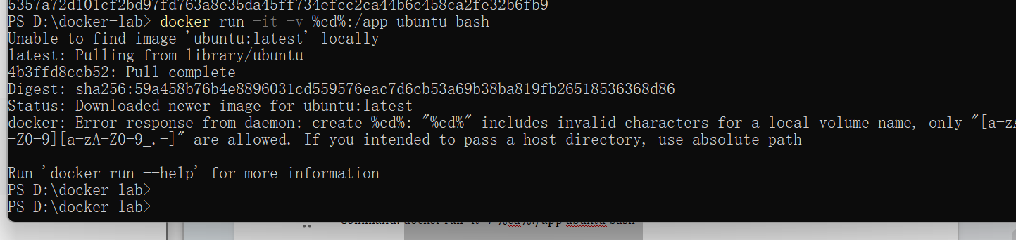
Figure 6:docker run -it -v %cd%:/app ubuntu bash

Note: Volumes and bind mounts allow persistent storage and real-time file sharing between host and container.

3.4 Multi-Container Applications

docker-compose.yml:
services:
web:
image: nginx
ports:
- '8083:80'
db:
image: mysql
environment:
MYSQL_ROOT_PASSWORD: root
Command: docker compose up -d
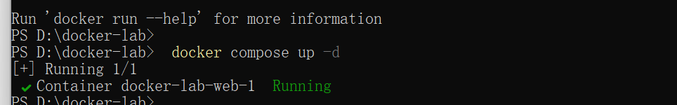
Figure 7:Run docker compose up -d

4 Summary and takeaways
This tutorial helped me understand and apply key Docker concepts such as containers, images, Docker Compose, port publishing, data persistence, and local file sharing. By working with Docker, I now understand how to:
Build and run containers.
Use Docker Compose for multi-container applications.
Persist data and manage containerized applications effectively.
This hands-on experience with Docker significantly improved my skills in containerized application deployment and management. I will now be able to utilize Docker for various development, testing, and production environments.

