Prepare the vps from github the professor share

Then,I open the file and check.

Then I receive and open the cert file from professor,choose my crt,key and ca.crt,as shown:

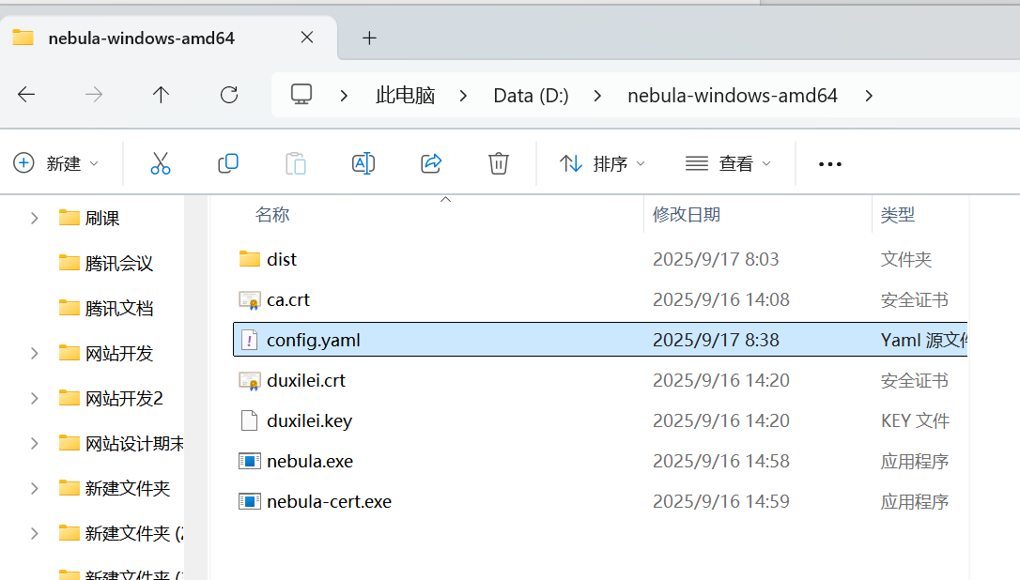

I open the PowerShell as a admin status,enter the nebula file,like this

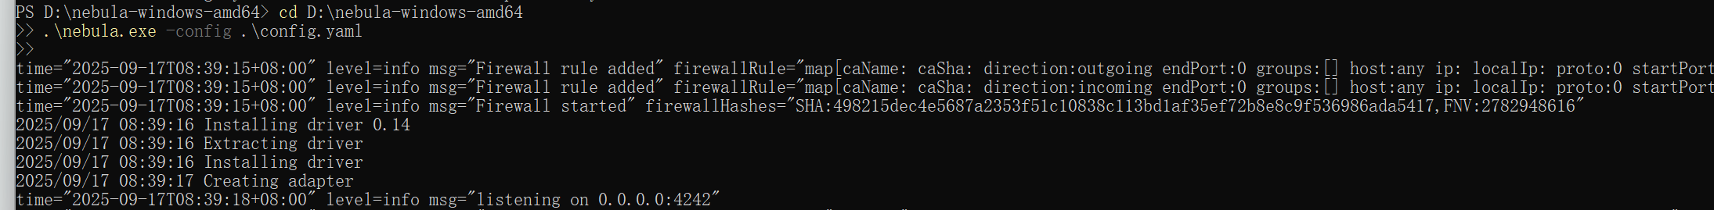

After Nebula is running on powershell,I open the cmd on my cp.try to ping a ip address:

