# Building Your Personal Website with GitHub Pages

Course: Cloud Computing and Web Publishing  
Project: GitHub Pages Website  
Student Name: Du Xilei  
Date: (9.14)

## 1. Objectives

1. Learn the fundamentals of static web publishing using GitHub Pages.  
2. Understand the concept of Platform as a Service (PaaS) for static hosting.  
3. Gain experience with GitHub for version control and deployment.  
4. Build a professional online presence with a personalized website.

## 2. Tools and Environment

|  |  |
| --- | --- |
| Platform | GitHub (https://github.com) |
| Technology | HTML, CSS (optional JavaScript) |
| Editor | Visual Studio Code or GitHub Web Editor |
| OS | Windows / macOS / Linux |
| Browser | Chrome, Edge, or Firefox |

## 3. Experiment Procedure

### Step 1: Create a GitHub Account

### Step 2: Create a New Repository

1. Click the '+' button in the top right → 'New repository'.  
2. Name it exactly as 'username.github.io' (replace username with your GitHub username).  
3. Choose Public and click 'Create repository'.

### Step 3: Create Your Website Homepage

1. Click 'Add file' → 'Create new file'.  
2. Name it 'index.html'.  
3. Enter the following sample HTML code and commit the changes:

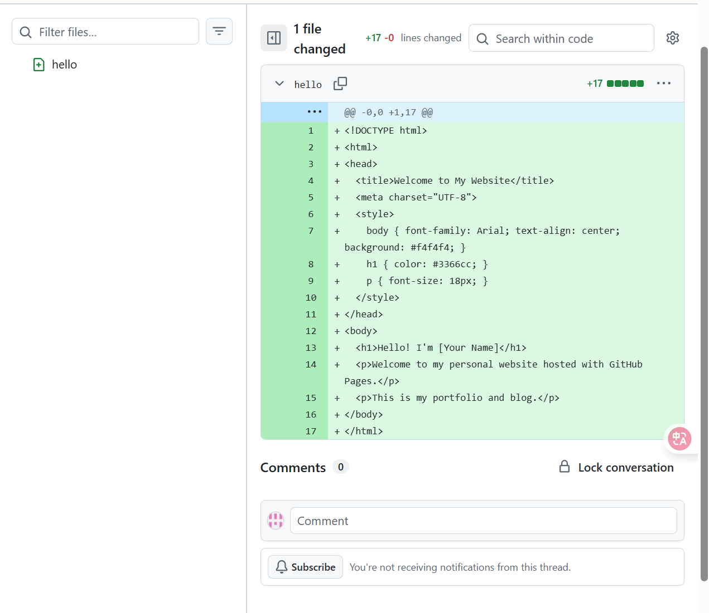<html>  
<head>  
<title>Welcome to My Website</title>  
<meta charset='UTF-8'>  
<style>  
body {font-family: Arial; text-align: center; background: #f4f4f4;}  
h1 {color: #3366cc;}  
p {font-size: 18px;}  
</style>  
</head>  
<body>  
<h1>Hello! I'm [Your Name]</h1>  
<p>Welcome to my personal website hosted on GitHub Pages.</p>  
<p>This is my portfolio and blog.</p>  
</body>  
</html>

### Step 4: Enable GitHub Pages

1. Go to your repository's Settings.  
2. On the left sidebar, click 'Pages'.  
3. Under 'Branch', select 'main' and click 'Save'.

### 

### Step 5: View Your Website

After a few minutes, visit your website at:  
https://cecliliadxl.github.io  
You should see your homepage online.

## 4. Results and Deliverables

Deliverables include:

1. A live, functional website accessible online via GitHub Pages.  
2. The GitHub repository containing your website source code.

## 5. Evaluation Criteria

Your project will be evaluated based on:

|  |  |
| --- | --- |
| Deployment Success | Website is publicly accessible online. |
| Completeness | Home page includes personal introduction. |
| Creativity | Personalized layout and styling. |
| Version Control Usage | Proper GitHub repository and commits. |

## 6. Reflection

Through this project, I learned how to use GitHub Pages to host a static website without managing any servers. I practiced using GitHub for version control and deployment and understood how static content can be published online easily. This project also helped me build a professional portfolio website that represents my skills and projects.