# Lab 4: Installing Docker and Gitea

Course: Cloud Computing and DevOps  
Student Name:Du Xilei  
Date: 2025.9.20

## 1. Objectives

1. Install Docker Desktop on your computer.  
2. Deploy Gitea using Docker and verify LFS support.  
3. Create repositories and push large files.  
4. (Optional) Backup and restore Gitea data.  
5. Install Gitea without Docker using a local database.

## 2. Tools and Environment

|  |  |
| --- | --- |
| Operating System | Windows 10/11 or macOS |
| Software | Docker Desktop, Git, Browser (Chrome/Edge) |
| Image | gitea/gitea:latest |
| Database | SQLite (default), MySQL, or PostgreSQL |

## 3. Installing Docker Desktop

For Windows:  
1. Open PowerShell and run: wsl --install  
2. Download Docker Desktop and install it from https://www.docker.com/products/docker-desktop/.  
3. Register and start Docker Desktop.

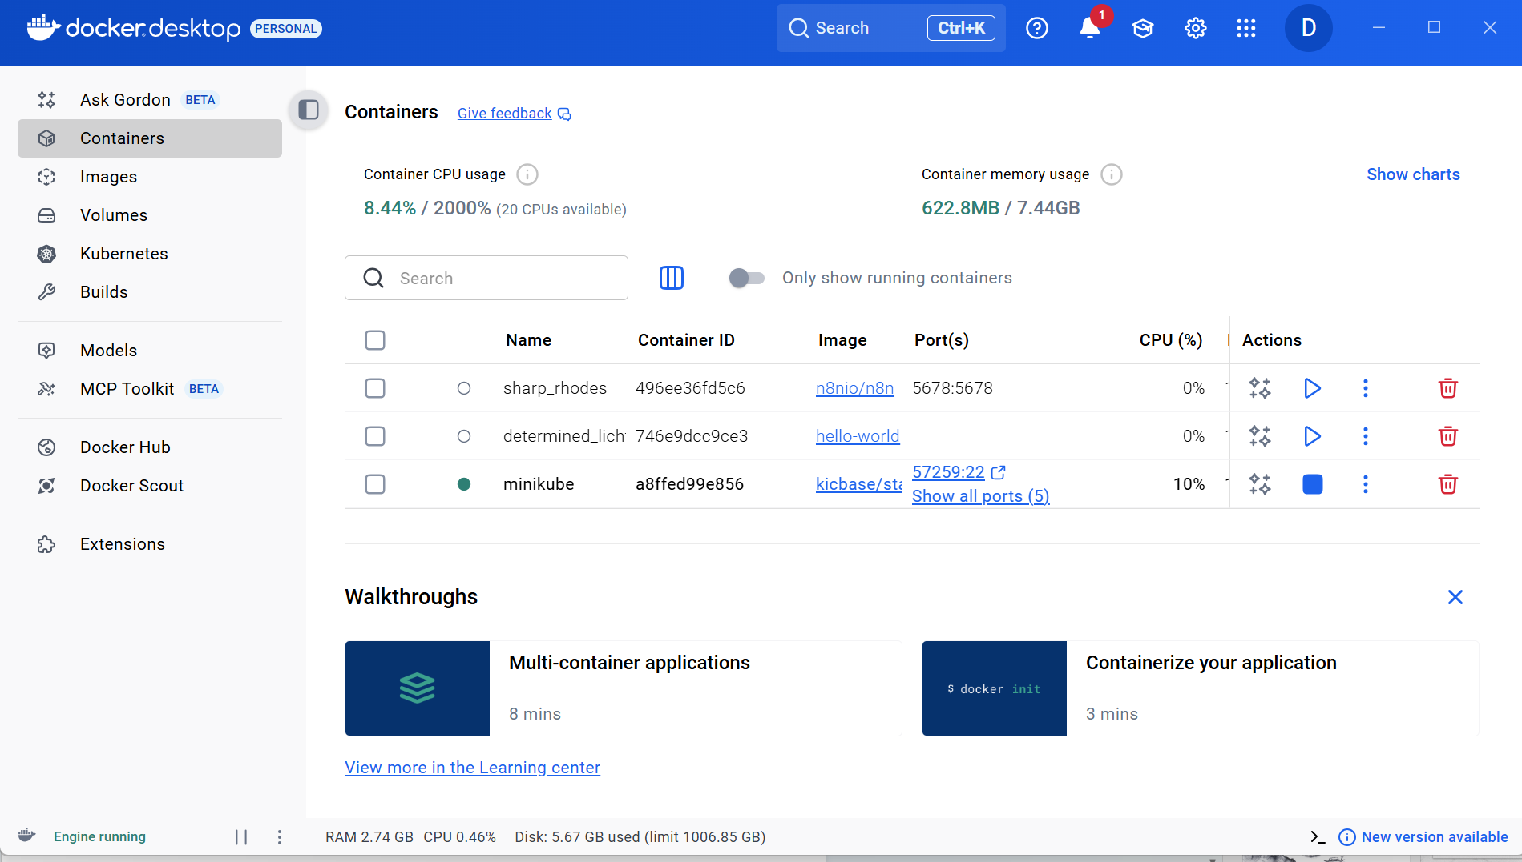Check Docker installation:

* docker version

## 

## 4. Deploying Gitea with Docker

1. Pull the Gitea image:

* docker pull gitea/gitea:latest

2. Create local storage folder and run container:

* docker run -d --name=gitea -p 3000:3000 -p 222:22 -v D:\gitea\data:/data gitea/gitea:latest

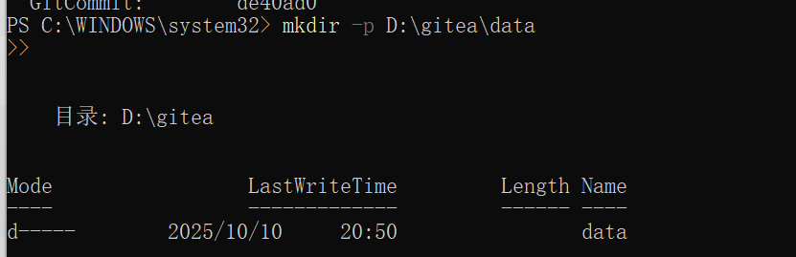

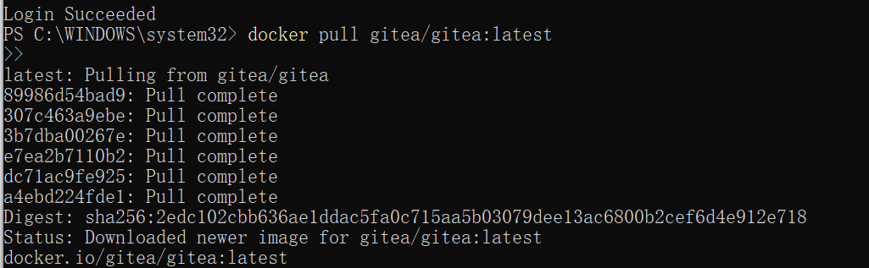

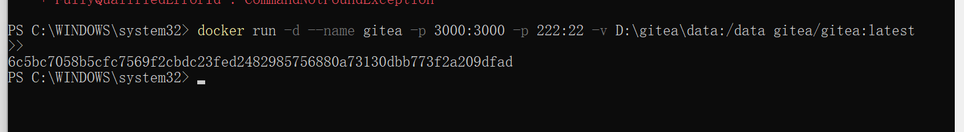3. Access Gitea from browser: http://localhost:3000

## 5. Configuring Gitea and Verifying LFS Support

1. Complete setup using SQLite as database.  
2. Register an admin account.  
3. Navigate to Site Administration → Configuration → LFS Settings.  
4. Confirm that 'Enable LFS' is True.

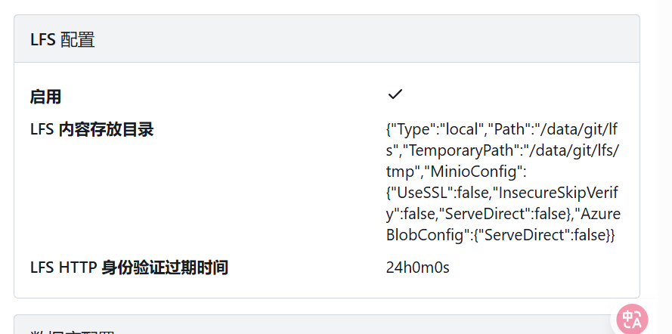Answer: Yes, Gitea supports LFS (Large File Storage).

## 6. Creating a Repository and Uploading Large Files

1. Create a new repo called LargeFileTest.  
2. Clone the repo and enable Git LFS:

* git lfs install  
  git lfs track "*.zip"  
  git add .gitattributes

3. Add a large file (>1GB) and push it:

* git add largefile.zip  
  git commit -m "Add 1GB file"  
  git push origin main

## 7. Creating Repository for Course Work

1. Create another repository named Cloud_Computing_Lab.  
2. Commit your lab work (reports, screenshots, etc.) to this repo.

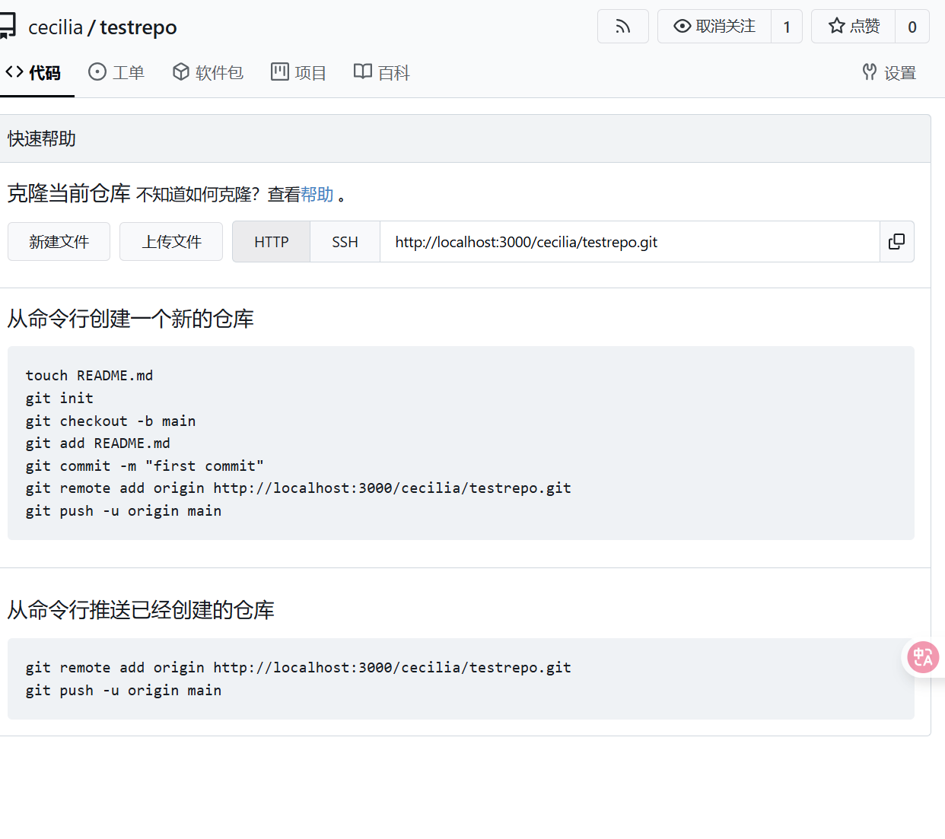

## 8. Reflection

Through this lab, I learned how to install and use Docker Desktop to deploy services in isolated containers. I successfully ran Gitea as a self-hosted Git service and verified that it supports LFS for large files. This experience helped me understand how Docker simplifies deployment and how Gitea can serve as a lightweight alternative to GitHub.

📸 Screenshot 12: Summary or dashboard view of completed setup