**HW4, 19787, chao zhao**

**$ brew install openjdk@11**

**$ echo 'export PATH="/usr/local/opt/openjdk@11/bin:$PATH"' >> ~/.zshrc**

**$ brew install gradle**

**export GRADLE_HOME=/usr/local/Cellar/gradle/gradle-8.3/libexec**

**$ git clone <https://github.com/james-willett/VideoGameDB>**

**$ chmod +x gradlew**

**$ ./gradlew bootRun**

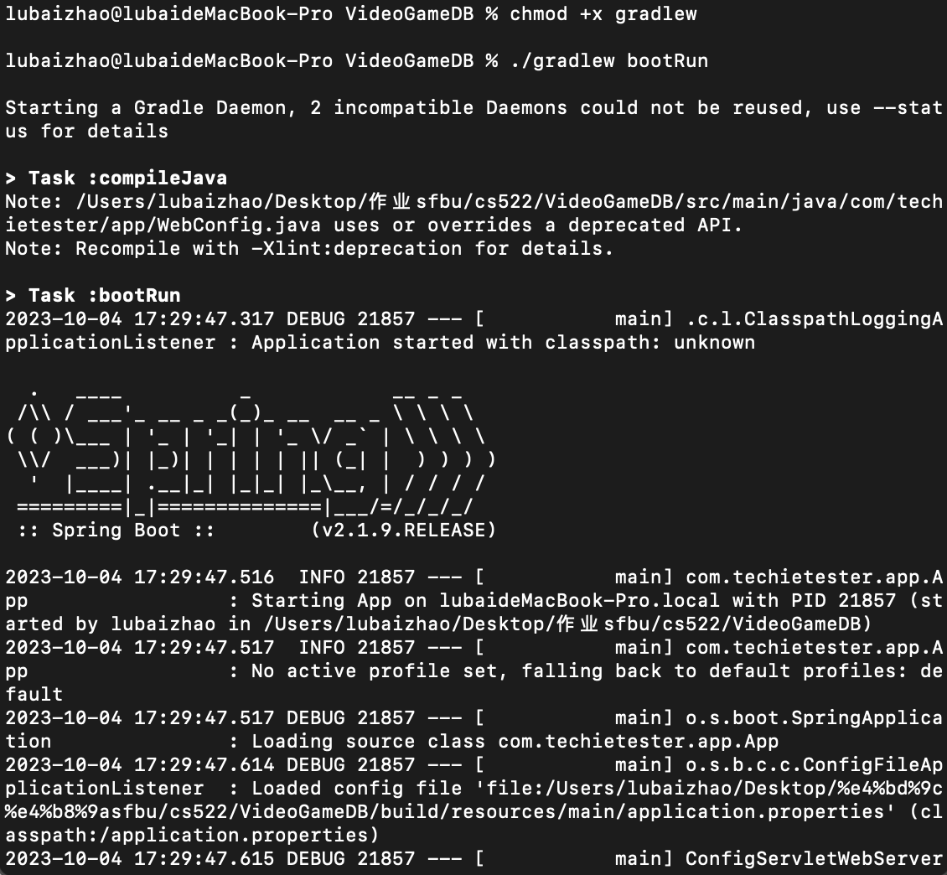

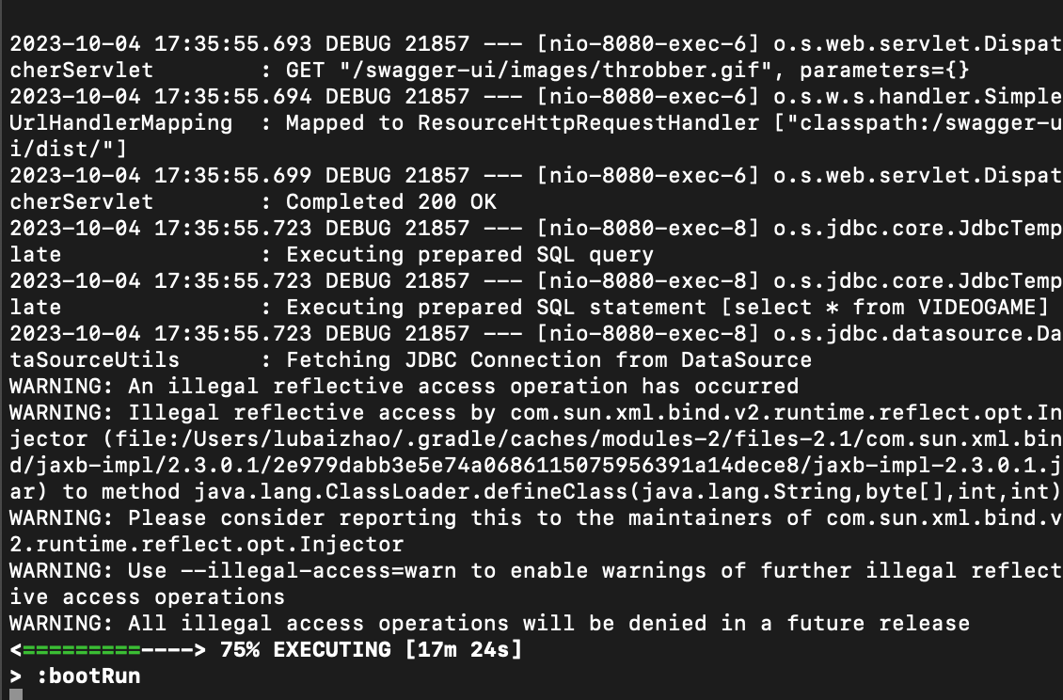

**Get**

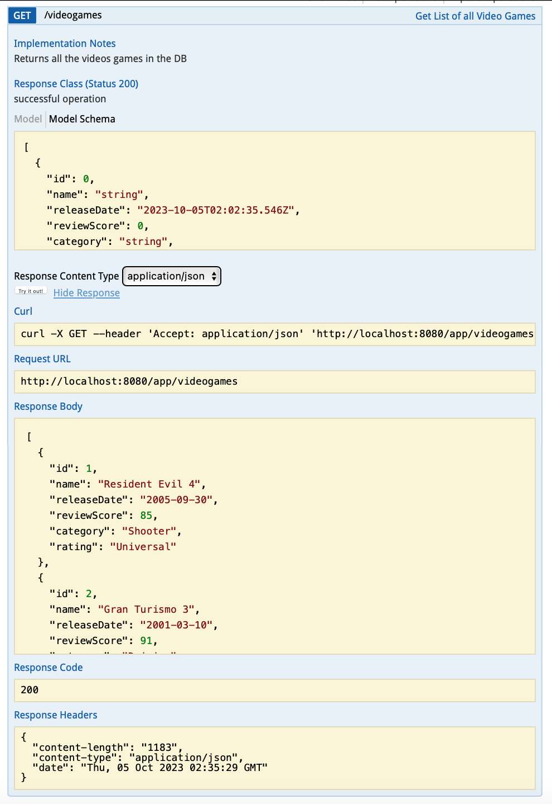

**Post**

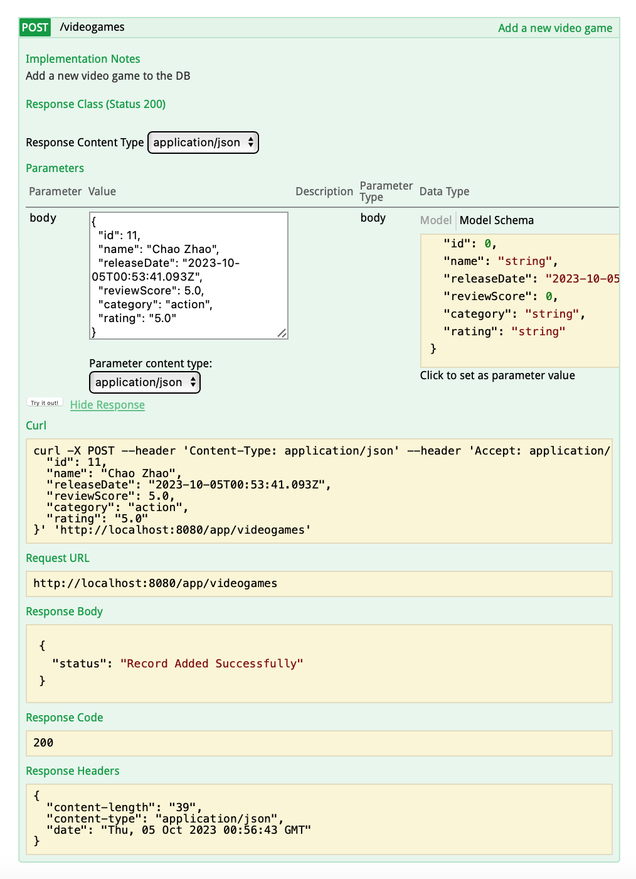

**Delete**

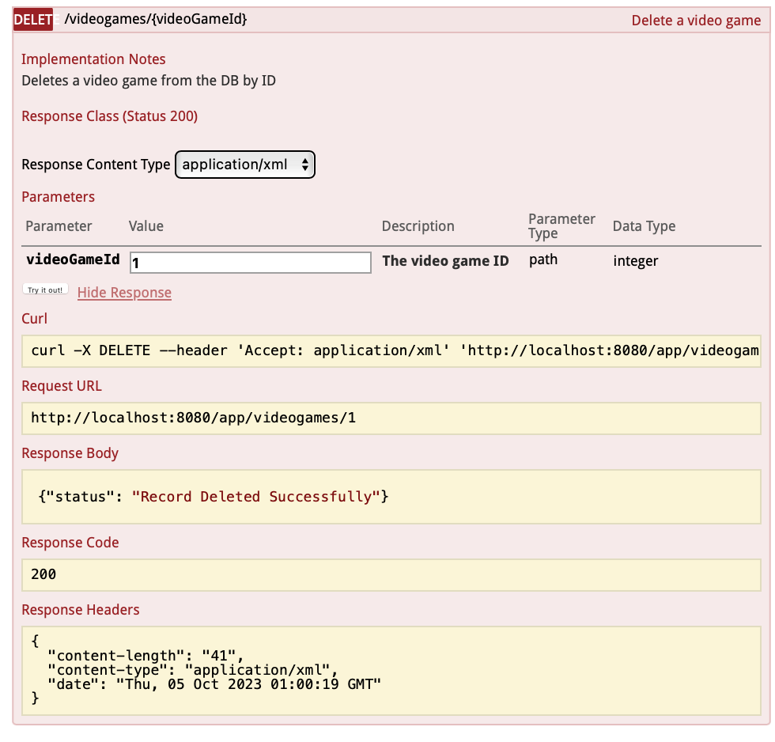

**Get a single videoGame:**

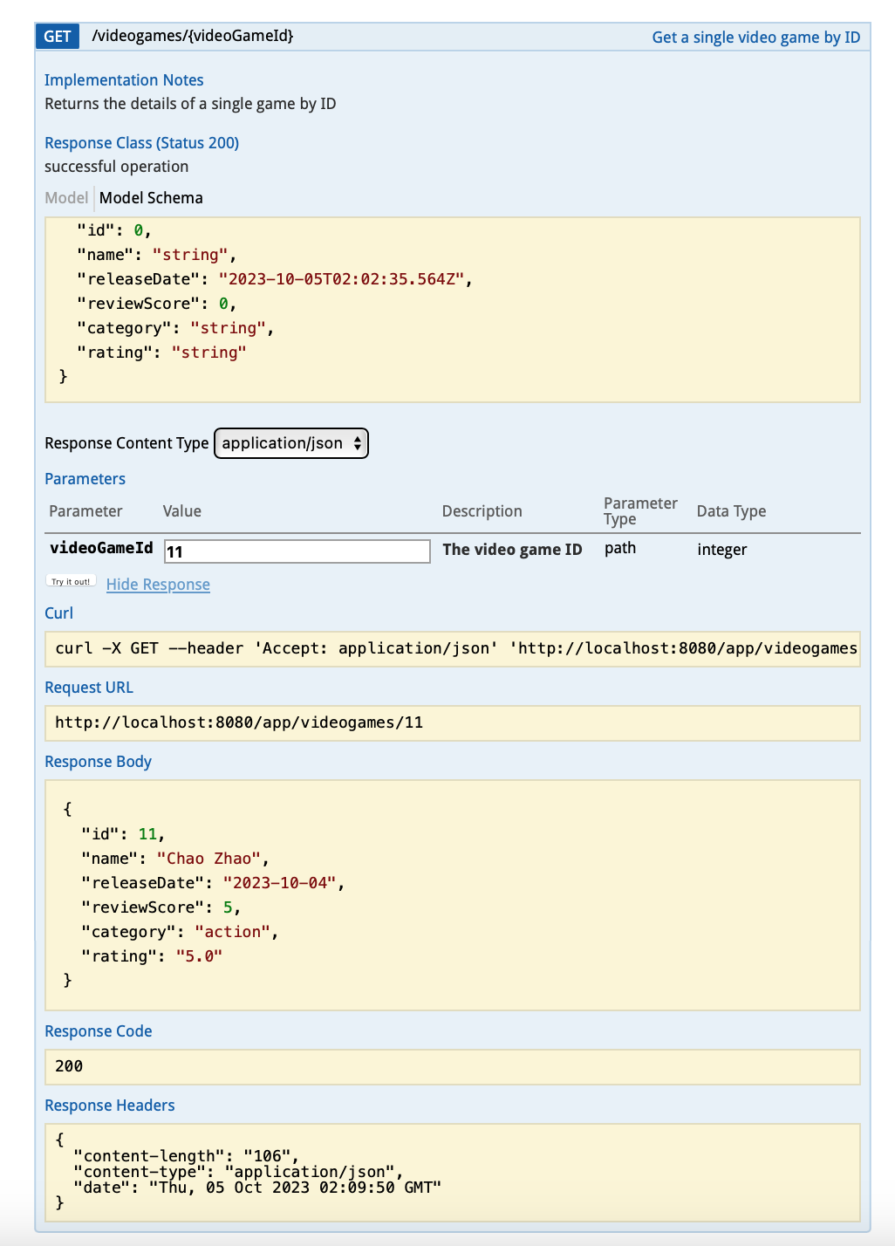

**Put:**

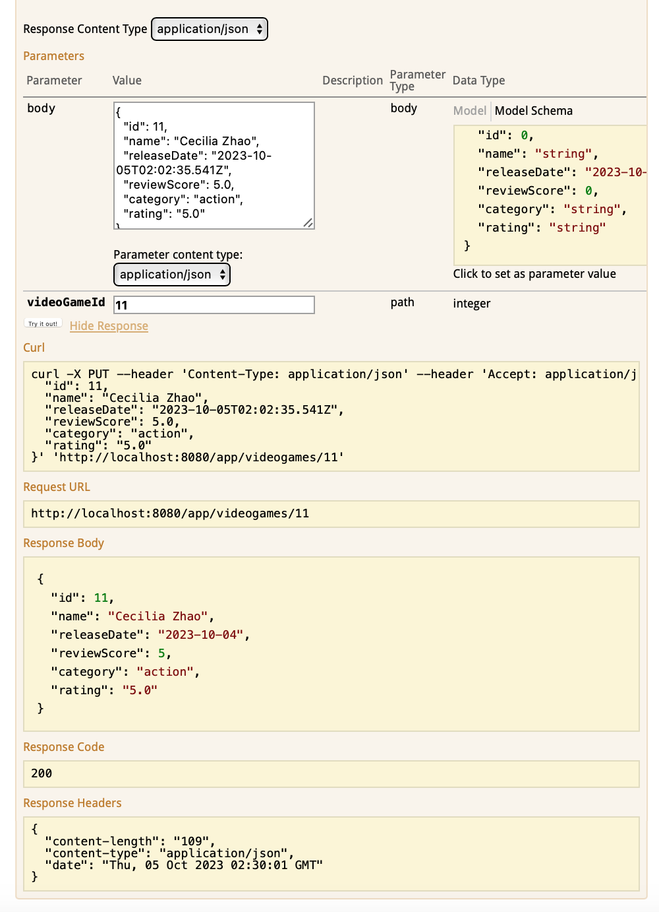

**Using IDE to create a automation script, run it and provide the running results (40%)**

