* Using the color keys we have selected for the raster image that corresponds to the different levels of species richness, we can zone in on the lowest levels of species richness areas in order to identify places that need more conservation actions. When I look at my raster data image, I see that North America needs more conservation actions and so do parts of the lower east of South America. We can also look at the separate layers of the raster data in order to further gauge the places that are the most dire when it comes to species richness for amphibians, mammals, and birds.
* The responses I get from ChatGPT are always weirdly structured. They are vague and noticeably incorrect most of the time when it comes to calculating but the steps in which it gets there seem to be mostly correct.

Below are some of the prompts that I entered in order to find out more about what this LLM model thinks about conservation decisions:

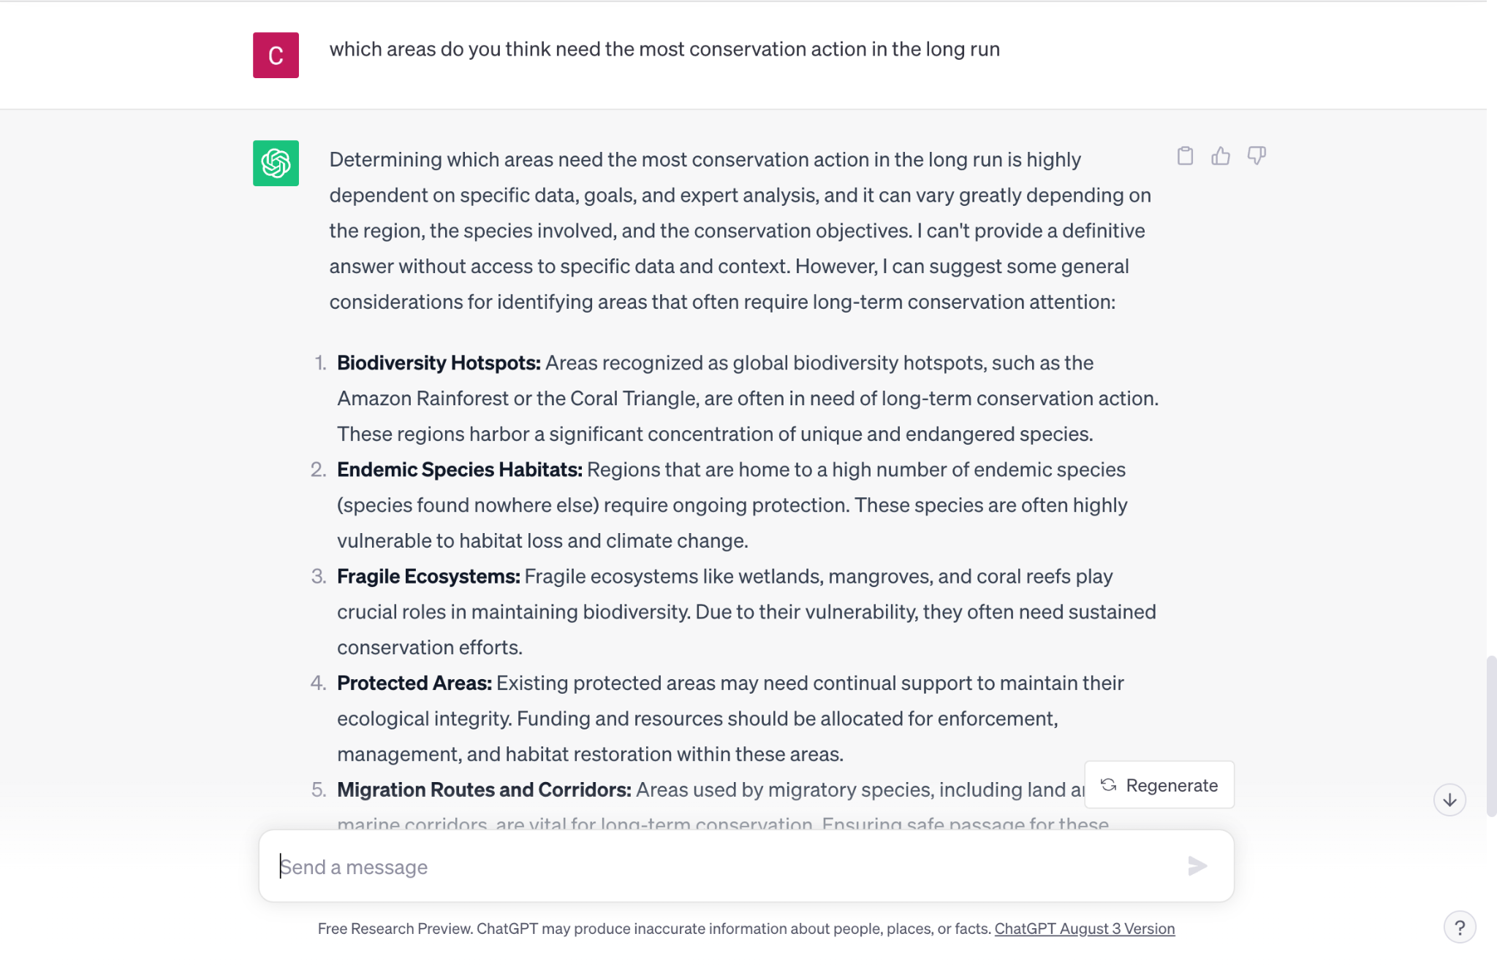

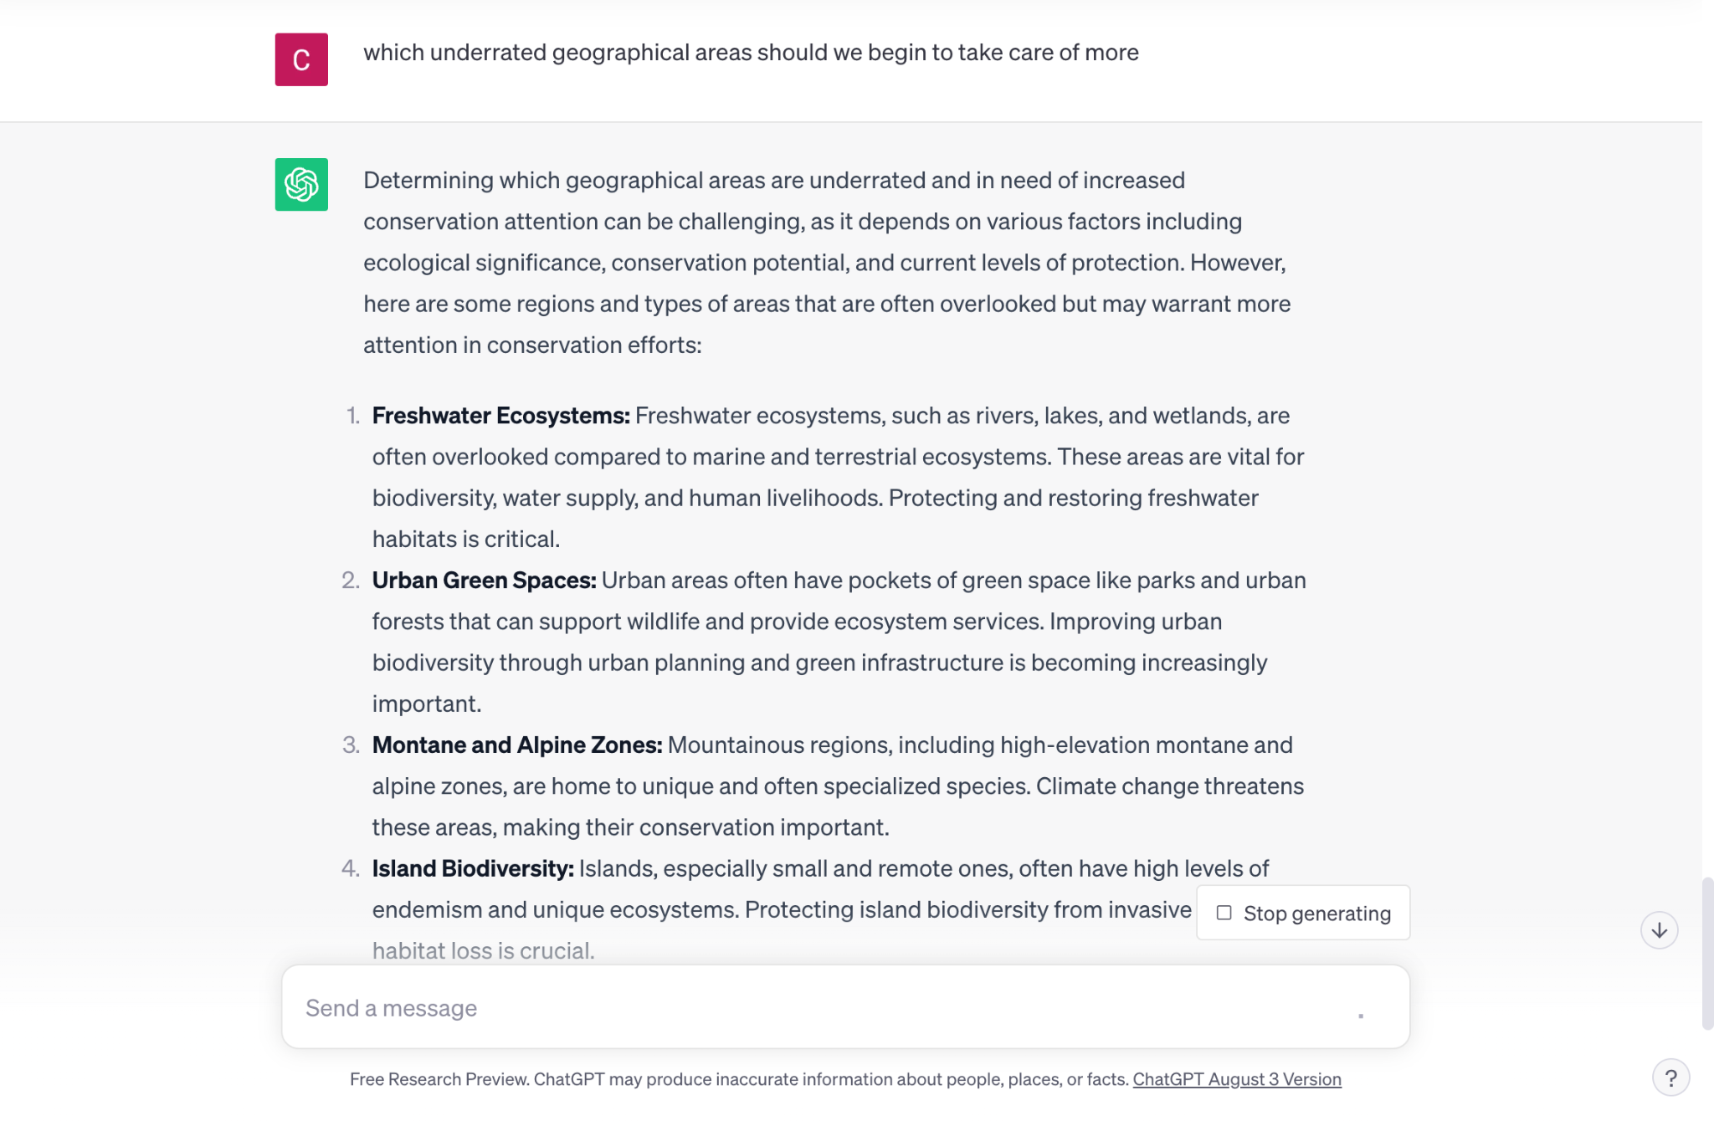

All of these responses make sense. I took a CGS class last semester on ecology and we covered most of these topics and had conversations about how these developed and how we can continue to take care of these places and what species are endangered throughout these most vulnerable sites. I did look up the “Migration routes and corridors” because it is a newer concept that I had not thought about when it comes to conservation action. But, due to my past knowledge, a lot of these terms are not new and are extremely relevant to the conversation around preserving biodiversity. I wish the responses ChatGPT gave included more thoughtful examples and evidence and less of a “google search” type of response.