6/21/12
LED Wiring Schematic
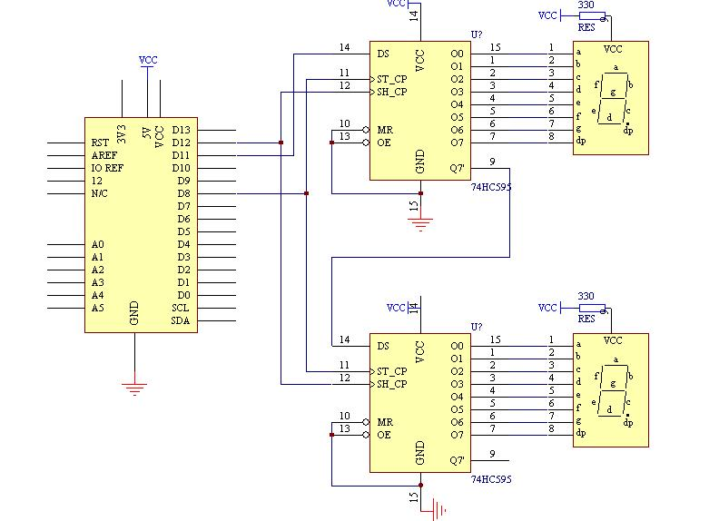

6/22/12
Milestone 1 (Get my LEDs to work as a timer) is now complete.
Notes on milestone: The two LEDs work perfectly, but they are very cumbersome wiring wise. I might want to do something about that, as it is just going to be a huge mess when I have to solder this onto a perf board.

Potentiometer works now (will help with doing the RBG LED later on, which is going to be much more complicated)
Source code:
int potPin = 2; // select the input pin for the potentiometer
int latchpin = 8; // connect to pin 12 on the '595
int clockpin = 12; // connect to pin 11 on the '595
int datapin = 11; // connect to pin 14 on the '595
float b = 0;
int c = 0;
float d = 0;
int e = 0;
int speed = 300; // used to control speed of counting
int segdisp[10] = {
3,159,37,13,153,73,65,27,1,9 };
int val = 0; // variable to store the value coming from the sensor
void setup()
{
pinMode(latchpin, OUTPUT);
pinMode(clockpin, OUTPUT);
pinMode(datapin, OUTPUT);
}
void loop()
{
// Count
val = analogRead(potPin); // read the value from the sensor
int z = val/10;
// digitalWrite(latchpin, LOW);
// shiftOut(datapin, clockpin, LSBFIRST, 0); // clears the right display
// shiftOut(datapin, clockpin, LSBFIRST, 0); // clears the left display
// digitalWrite(latchpin, HIGH);
if (z<10)
{
digitalWrite(latchpin, LOW);
shiftOut(datapin, clockpin, LSBFIRST, segdisp[z]); // sends the digit down the serial path
shiftOut(datapin, clockpin, LSBFIRST, 255); // sends a blank down the serial path to push the digit to the right
digitalWrite(latchpin, HIGH);
}
else if (z>=10 && z<100)
{
d=z%10; // find the remainder of dividing z by 10, this will be the right-hand digit
c=int(d); // make it an integer, c is the right hand digit
b=z/10; // divide z by 10 - the whole number value will be the left-hand digit
e = int(b); // e is the left hand digit
digitalWrite(latchpin, LOW); // send the digits down to the shift registers!
shiftOut(datapin, clockpin, LSBFIRST, segdisp[c]);
shiftOut(datapin, clockpin, LSBFIRST, segdisp[e]);
digitalWrite(latchpin, HIGH);
}
else if (z>=100)
{
c=9;
e=9;
}
}

Milestone 1: Get the LED display to work. COMPLETE (6/21/2012)
Milestone 2: Get the potentiometer to work by counting down the LED display. COMPLETE (6/22/2012)
Milestone 3: Get the photosensor to work (probably by showing how its data is output). COMPLETE (6/25/2012)
Milestone 4: Get the buzzer to work. COMPLETE (6/26/12)
Milestone 5: Learn to use PWM with RBG LED. COMPLETE (6/27/12)
Milestone 6: Combine the code into one program. COMPLETE (6/29/12)
Milestone 7: Complete schematic of box. COMPLETE (7/3/12)
Milestone 8: Build the box itself. IN PROGRESS
Milestone 9: Hook up the potentiometers to RGB LED and have them change its color. COMPLETE (6/27/12)
Milestone 10: Solder in components.IN PROGRESS
Milestone 11: Complete documentation. INCOMPLETE

6/25/2012
Today’s goals:
-Finish up tests on the photocell
-Begin setting up buzzer
Notes:
-Photocell test w/ LED light completed, thus completing Milestone 3.
-Beginning research on how a buzzer works on Arduino
-Thinking about using a briefcase for my puzzle box to make it look more like a Hollywood-esque bomb
For tomorrow:
-Create custom song using buzzer
http://www.instructables.com/id/Play-the-French-Can-Can-Using-an-Arduino-and-Buzze/?ALLSTEPS
http://www.phy.mtu.edu/~suits/notefreqs.html
http://www.flutetunes.com/tunes/the-legend-of-zelda-theme.pdf

6/26

Goals for the day:
-Play a tune other than Can-Can on the buzzer.
-If I complete this and my LED is in, work on integrating potentiometers with that.

Goals achieved:
-Will work on tune at a later date
-Began RBG LED

Lessons learned:
-Remember to look up how to calculate resistor value w/ voltage.
-http://www.kingbrightusa.com/images/catalog/SPEC/WP154A4SUREQBFZGW.pdf
-http://www.instructables.com/id/RGB-LED-Tutorial-using-an-Arduino-RGBL/

6/27/12

Today’s Goals | Goals Achieved | Tomorrow’s Goals
Look up the proper resistor  values values for RBG LED. | RBG LED works  Countdown timer synced w/  buzzer. | Work on implementing p potentiometer and photocell  code into Countdown program

6/28/12

Today’s Goals | Goals Achieved | Tomorrow’s Goals
Continue working on s synthesizing program code. | Second digit now displays on  09-00.  Display blinks when it hits 00.  Lights can be adjusted via  potentiometers w/o problem. | Work on the random number  generator.

6/29/12

Today’s Goals | Goals Achieved | Tomorrow’s Goals
Continue to work on code for  my puzzle box. | The puzzle is now functional. | Play test  Install photocell

6/29 Instructor Meeting

- Most of the hardware is complete, the photocell has to go back in the, the LED has to go back in.
- Right now he is tweaking the code for the case -- it functions, it counts down. He can change the lights without any problem. Once the lights reach a certain color, the timer will stop.
- coding: figuring out which command to use -- delay or something else.
- code is giving him the most problems.
- With his hardware -- it will be tedious to free wire everything to the perf board

7/2/12

Today’s Goals | Goals Achieved | Tomorrow’s Goals
Play test the box.  Reinstall photocell. | First wave of play testing done, tolerance has been modified correctly.  Photocell works. | Continue working on schematic.

7/3/12

Today’s Goals | Goals Achieved | Tomorrow’s Goals
Work on the box’s schematic. | Schematic completed. | Work on perfboard, shorten wires.

7/5 instructor meeting:
-put schematic up on this page
-write blog posts w/ videos on milestones
-come up with improvements (program songs - maybe with wave shield?) 2 different codes - one random, one programmed?)
-Come up with a way to lock the box.
-Complete full documentation before changing the design.

7/5/12

Today’s Goals | Goals Achieved | Tomorrow’s Goals
Work on shortening the wires on the perfboard. | Finished shortening wires. | Continue to solder parts.  Work out how to place components into the suitcase.

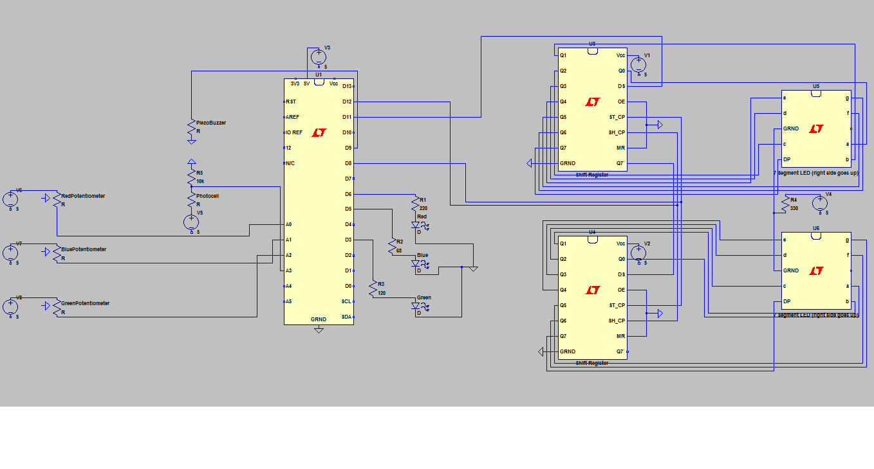
7/6/12

Today’s Goals | Goals Completed | Tomorrow’s Goals
Finish soldering.  Work out how to place components into suitcase. | Finished soldering. | Fix up solder joints.

7/9/12

Today’s Goals | Goals Completed | Tomorrow’s Goals
Fix up solder joints. | Got 1rst stage of soldering done | Solder Arduino wires

7/10/12

Today’s Goals | Goals Completed | Tomorrow’s Goals
Map out parts on box.  Start 2nd stage of soldering. | Finished mapping parts for briefcase. | Solder
7/11/12

Today’s Goals | Goals Completed | Tomorrow’s Goals
Continue soldering | Soldered a few connections | SOLDER

7/12 - instructor meeting:
-Make a milestone post of the unit working on the breadboard for the website.
-Find a solution for the locking mechanism and get the parts on order.
-Needs to complete solder and put it in the box.
-Then complete documentation

7/13/12

Today’s Goals | Goals Completed | Tomorrow’s Goals
Soldering | Soldering completed  Hooked up all components | Troubleshoot why my timer isn’t working  Put components into box

7/16/12

Today’s Goals | Goals Completed | Tomorrow’s Goals
Figure out why the timer isn’t working | Timer is halfway fixed | Completely fix timer  Start mounting onto box

7/17/12

Today’s Goals | Goals Completed | Tomorrow’s Goals
Fix the timer | Diagnosing | Resolder components onto new perfboard

7/18/12

Today’s Goals | Goals Completed | Tomorrow’s Goals
Resolder onto perf board | Use github for documentation | Continue soldering

7/19/12

Today’s Goals | Goals Completed | Tomorrow’s Goals
Solder | Timer works  Buzzer works | Solder RBG LED, potentiometers, and photocell

7/20/12

Today’s Goals | Goals Completed | Tomorrow’s Goals
Continue soldering | Lots of soldering | Solder photocell  Mount onto box

Instructor meeting 7/20:

Next step:
Get the LED in and test the potentiometers
Comment all the lines in the code
Start on the box by the end of today and locking mechanism
Figure out a battery connection

Problems:
Soldering -- general mechanics.

What can be done at home:
Commenting on the code
Sketch

7/23/12

Today’s Goals | Goals Achieved | Tomorrow’s Goals
Finish soldering  Mount the parts onto box | Finished soldering  Battery installed | Begin mounting

7/24/12

Today’s Goals | Goals Achieved | Tomorrow’s Goals
Mount parts onto box | Parts have been mounted | Finish up documentation  Add servo arm (if time allows it)
7/25/12

Today’s Goals | Goals Achieved | Tomorrow’s Goals
Finish documentation | Documentation completed | See if I can’t put on a servo

