Mechanical Engineering Portfolio Website
Team Members: Caitlyn Caldwell

Description of project: A responsive portfolio website that showcases a mechanical engineering candidate’s project, skills, and contact information through an engaging and visually interactive experience.

Section 1:

Introduction: The purpose of this project is to create a modern portfolio website that effectively presents a mechanical engineering candidate’s work and accomplishments. Rather than functioning as a simple online resume, the website will serve as an interactive showcase that highlights technical projects through engaging visuals and detailed descriptions, making it easier for visitors to explore the candidate’s experience.

Purpose: The project will provide a professional website where visitors can learn about the candidate, browse engineering projects, view technical details and images, and access contact information. The website will emphasize usability while incorporating creative animations and visual effects to create a memorable experience.

Scope: The project will include multiple pages such as a home page, project pages, and a contact page. It will allow users to browse projects and view detailed information for each one while maintaining a responsive design for desktop and mobile devices. The project will not include user accounts, online purchasing, social networking features, or backend content management systems. Content updates will be managed by the developer.

Technologies Used: HTML, CSS, JavaScript, Netlify/GitHub Pages for deployment, Git/GitHub for version control
Section 2a:
- The application shall provide a responsive homepage introducing the portfolio owner.
- The application shall display a dedicated project page containing multiple engineering projects.
- The application shall allow users to open an individual project page containing detailed information.
- The application shall provide an About page describing the portfolio owner.
- The application shall provide a Contact page describing the portfolio owner.
- The application shall include consistent navigation between all major sections.
- The application shall include animations and interactive visual effects.

Section 2b:
Stretch Requirements:
- The application may allow projects to be filtered by category or technology.
- The application may include an interactive project gallery with multiple images.
- The application may include downloadable resume functionality.
- The application may include 3D models or interactive CAD viewers.
- The application may include a blog section.

Section 2c:
Weekly schedule:
Week | Requirement | Description | Acceptance Criteria
8 | Contact Page & Professional Resources | Develop a contact page containing methods for communication and professional resources | The user can navigate to the Contact page and successfully view all contact methods and access the linked professional resources.
9 | About Page & Responsive Layout | Develop an About page that introduces the portfolio owner and ensure the website is fully responsive across different devices | The About page displays the biography, skills, and experience correctly, and the layout adapts properly on desktop, tablet, and mobile screens.
10 | Homepage & Navigation | Create the homepage and implement a consistent navigation system connecting all major sections of the website. | The website loads to the homepage, and users can successfully navigate between Home, About, Projects, and Contact pages without broken links.
11 | Projects Gallery/Page(s) | Develop a projects section that showcases multiple engineering projects with images and summaries. | The user can view a gallery containing at least six projects, each displaying a title, image, and brief description, and can browse all projects.
12 | Creative Animations & Visual Effects | Implement animations, transitions, and interactive visual effects that enhance the user experience while maintaining usability | Users experience smooth animations and interactive effects throughout the website without negatively affecting navigation or responsiveness.
13 | Stretch Goal: Downloadable Resume | Add functionality that allows visitors to download the portfolio owner’s resume directly from the website. | The user can click a resume button or link and successfully download the resume file.
14 | Stretch Goal: Individual Project Pages that offer additional detail | Create dedicated pages or modal views for each project containing expanded descriptions, images, and technical details. | Selecting a project opens a detailed view with additional information, images, and project-specific content, and users can return to the projects gallery.

Section 3: Design Overview of the Product.
Workflow:
- User visits the homepage.
- User learns about the portfolio owner through introductory content.
- User navigates to the Projects page.
- User selects a project to view detailed information, images, and descriptions.
- User may continue exploring additional projects or navigate to the About page.
- User accesses the contact page to find professional contact information or download a resume.

Resources:
The application will function as a client-side web application, with all pages delivered through modern web browser.
- HTML, CSS, and JavaScript
- GitHub for version control
- Hosting platform such as Netlify
- Images and project documentation provided by the portfolio owner
- Animation libraries if needed

Data at Rest: The website will primarily store static project information, images, and contact details within the application files. No user accounts or personal user data will be stored. If project information is separated into JSON files, those files will serve as the application’s data source.

Data on the Wire: When a visitor accesses the website, the browser will download the HTML, CSS, JavaScript, images, and other assets from the hosting server over HTTPS. No sensitive user information will be transmitted since the website does not require authentication or user submissions.

Data State:
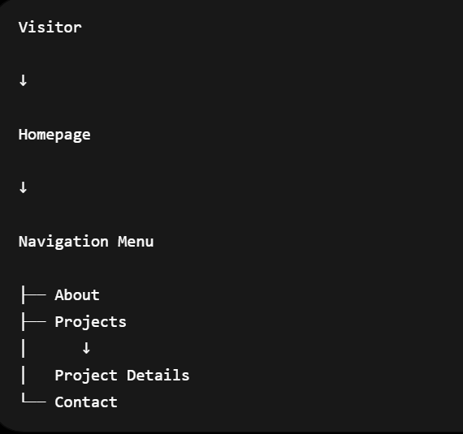

HMI/HCI/GUI:
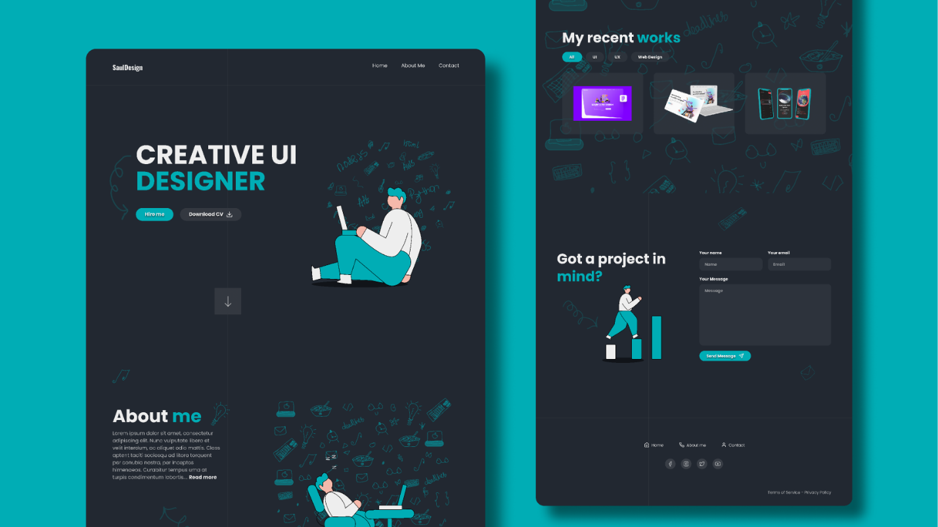
Section 4: Verification:
Demo: The project will be demonstrated by navigation through the website and showing that all required functionality operates correctly. The demonstration will include:
- Loading the homepage
- Navigating between pages
- Viewing project details
- Displaying animations and responsive layouts
- Accessing contact information
- Downloading the resume

Testing:
Requirement | Verification Method
Homepage displays correctly | Open the website on desktop and mobile devices and verify the layout
Project page works | Navigate to Projects and verify all projects display
Project details open | Select a project and confirm detailed information appears
Contact page works | Navigate to Contact and verify all information is displayed
Navigation functions | Test every navigation link for correct routing
Responsive design | Resize browser and test on multiple screens

Sources/Citation/Resources Links:

https://www.figma.com/community/file/1175755450846438274/portfolio-website-design
https://reactbits.dev/
https://wireframe.cc/
https://developer.mozilla.org/en-US/docs/Web/HTML
https://developer.mozilla.org/en-US/docs/Web/JavaScript
https://www.w3schools.com/CSSref/index.php
https://brodinplett.com/
https://redbarrelsgames.com/games/the-outlast-trials/
https://landonorris.com/
https://porterrobinson.com/

