|  |  |
| --- | --- |
| **ELECTRONIC ASSIGNMENT COVERSHEET** | Murdoch_land_RGB |

|  |  |
| --- | --- |
| **Student Number:** | 34445873 |
| Surname: | Chew |
| Given name: | Jian Yue |
| Email: | cjianyue@gmail.com |
|  |  |
| **Unit Code:** | ICT601 |
| Unit name: | Business Analytics |
| Enrolment mode: | External |
| Date: | 19 Feb 2023 |
| Assignment number: | 1 |
| Assignment name: | Assignment 1 |
| Tutor: | Mr. Koh Choon Chye |

|  |
| --- |
| **Student's Declaration:**   * Except where indicated, the work I am submitting in this assignment is my own work and has not been submitted for assessment in another unit. * This submission complies with Murdoch University's academic integrity commitments. I am aware that information about plagiarism and associated penalties can be found at <http://our.murdoch.edu.au/Educational-technologies/Academic-integrity/>. If I have any doubts or queries about this, I am further aware that I can contact my Unit Coordinator prior to submitting the assignment. * I acknowledge that the assessor of this assignment may, for the purpose of assessing this assignment:   + reproduce this assignment and provide a copy to another academic staff member; and/or   + submit a copy of this assignment to a plagiarism-checking service. This web-based service may retain a copy of this work for the sole purpose of subsequent plagiarism checking, but has a legal agreement with the University that it will not share or reproduce it in any form. * I have retained a copy of this assignment. * I will retain a copy of the notification of receipt of this assignment. If you have not received a receipt within three days, please check with your Unit Coordinator. |

|  |
| --- |
| I am aware that I am making this declaration by submitting this document electronically and by using my Murdoch ID and password it is deemed equivalent to executing this declaration with my written signature. |
| **Optional Comments to Tutor:**  *e.g. If this is a group assignment, list group members here* |

*If you can, please insert this completed form into the body of* ***each*** *assignment you submit. Follow the instructions in the Unit Information and Learning Guide about how to submit your file(s) and how to name them, so the Unit Coordinator knows whose work it is.*

***Start your assignment on the next page.***

ICT601 - ASSIGNMENT 1

CHEW JIAN YUE, 34445873, CT0363382

CONTENTS

[I. PART A 6](#_Toc128261609)

[Introduction to the dataset 6](#_Toc128261610)

[1. Top 10 localities by number of properties listed 7](#_Toc128261611)

[a. Visualisation(s) 7](#_Toc128261612)

[b. Textual explanation 8](#_Toc128261613)

[c. Explanation of process 8](#_Toc128261614)

[2. Overall nights booked between October and end of 2020 and how they change from week to week 12](#_Toc128261615)

[a. Visualisation(s) 12](#_Toc128261616)

[b. Textual explanation 12](#_Toc128261617)

[c. Explanation of process 13](#_Toc128261618)

[3. Comparison of Metropolitan and Regional nights booked between October and end of 2020 and how it changes from week to week 15](#_Toc128261619)

[a. Visualisation(s) 15](#_Toc128261620)

[b. Textual explanation 15](#_Toc128261621)

[c. Explanation of process 16](#_Toc128261622)

[4. Map showing bookings in postal codes where at least 100 nights booked 17](#_Toc128261623)

[a. Visualisation(s) 17](#_Toc128261624)

[b. Textual explanation 17](#_Toc128261625)

[c. Explanation of process 18](#_Toc128261626)

[5. Overall nights booked between October and end of 2020 and how they change from week to week 19](#_Toc128261627)

[a. Visualisation(s) 19](#_Toc128261628)

[b. Textual explanation 19](#_Toc128261629)

[c. Explanation of process 20](#_Toc128261630)

[II. PART B - Report on Business Analytics Platform 21](#_Toc128261631)

[Capabilities and detailed description of platform 21](#_Toc128261632)

[1) Visualisation through infographic-Style Dossiers 21](#_Toc128261633)

[a. Self-service reporting 21](#_Toc128261634)

[b. Extensible visualisations 22](#_Toc128261635)

[c. Data discovery 22](#_Toc128261636)

[2) Object-oriented architecture 23](#_Toc128261637)

[3) Reporting 24](#_Toc128261638)

[a. Decision making 24](#_Toc128261639)

[b. Performance measurement 24](#_Toc128261640)

[4) Mobile Analytics (MicroStrategy Mobility) 24](#_Toc128261641)

[a. HyperIntelligence 25](#_Toc128261642)

[b. Custom applications 25](#_Toc128261643)

[c. Scalable, Secure, Predictive caching, Offline support 25](#_Toc128261644)

[5) (Advanced) Predictive Analytics 25](#_Toc128261645)

[Platform limitations, other possible problems 26](#_Toc128261646)

[1) Easy to create bad visualisations 26](#_Toc128261647)

[2) Steep learning curve 26](#_Toc128261648)

[3) Unstructured data 26](#_Toc128261649)

[4) Machine learning 26](#_Toc128261650)

[5) Real-time data 27](#_Toc128261651)

[6) Industry specific 27](#_Toc128261652)

[Conclusion 27](#_Toc128261653)

[III. References 28](#_Toc128261654)

# PART A

## Introduction to the dataset

Notably, the variable or feature “Post Code” in the dataset contains three missing values. In Tableau, they are represented in *null.*

I have represented the three values with missing Post Code here, possibly there is some methods to infer or retrieve their postal code with other data in the row, such as Latitude or Longitudinal data.

|  |  |  |  |  |  |  |  |
| --- | --- | --- | --- | --- | --- | --- | --- |
| property id (Properties) | Post Code | Locality | Latitude | Longitude | Room Type | price (Properties) | Metro/Regional |
| 311393 | *null* | AUGUSTA-MARGARET RIVER | -33.9856 | 114.9947 | Entire home/apt | 130 | Regional |
| 678944 | *null* | MANJIMUP | -34.3153 | 116.1775 | Entire home/apt | 114 | Regional |
| 756766 | *null* | BAYSWATER | -31.9275 | 115.8931 | Entire home/apt | 70 | Regional |

It is possible to infer the post code from the *latitude* and *longitude* data (approximately equal), and most importantly, the *locality*. However, the effect on the answers are minimal as we are primarily using available Latitude and Longitude data instead of inferring or generating *Lat* and *Long* data from Post Code.

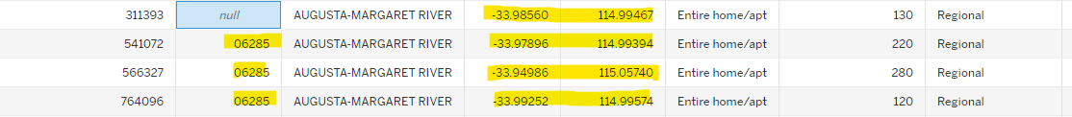

Data relationships is made between the two tables with similarity column: property id.

The Tourism Commission wishes to know

## Top 10 localities by number of properties listed

### Visualisation(s)

### Textual explanation

From the visualisation, the top 10 localities are:

Busselton (1399), Augusta-Margaret River (828), Stirling (824), Perth (729), Fremantle (66), Mandurah (446), Joondalup (386), Vincent (373), Albany (328), Belmont (325).

### Explanation of process

Firstly, I scanned through the available properties and measures available and automatically generated by Tableau on the left *Data* pane.

Hovering over *Properties (Count)* which provides a tooltip that tells us that it is an automatically generated field that counts the number of records in the Properties table. Properties count is the measure needed to understand the number of properties for each locality (dimension). The locality dimension is dragged to *Rows* so I can figure out the

I dragged this to the *Columns*.

Next, I clicked on the buttons shown below to sort by descending order, to show the localities with highest number of properties. Since, my boss is only interested in only the top 10 localities, I have included a filter to only show the top 10 localities. If my boss is also interested in viewing the other localities and their comparisons with the top 10 localities, I would consider colour coding the top 10 localities and leaving the rest of the localities in the bar chart visualisation instead of using filtering.

Tabular format is included for easier viewing.

## Overall nights booked between October and end of 2020 and how they change from week to week

## Visualisation(s)

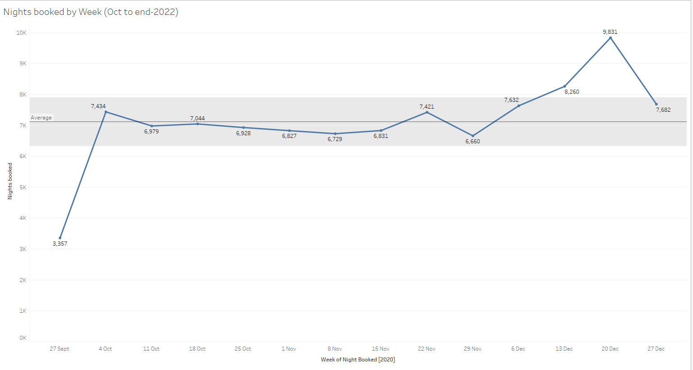

## Textual explanation

From the visualisation, the lowest night book is on the week of 27 September. This is possibly because the data we have filtered starts on 1 Oct as required by the question and the data given does not necessarily start from 27 September. Hence, some parts of the week’s data is not included in this visualisation analysis, although “forecasting” backwards may be done, but I have chosen to rely on actual data. For most of the weeks throughout the last quarter of the year, the nights booked are relatively stable at around 7000, and is within the confidence interval of the average line. However, in the week of 13 Dec and 20 Dec, there is a spike in nights book. I suspect that this is because people are on vacation mode (travellers from various countries) and clearing their annual leaves at the end of the year to relax. Most rooms booked are entire apartment, although there is not more information about this, but investigation can be carried out to understand possibly these types of rooms are more popular because of family travellers.

## Explanation of process

The highlighted are the variables being used to generate the visualisation as we are interested in the nights booked throughout the various weeks.

I have selected “Week Number” so our data is focused on the nights booked in the various weeks.

Filter is applied to ensure the accurate date range required by the question.

## Comparison of Metropolitan and Regional nights booked between October and end of 2020 and how it changes from week to week

## Visualisation(s)

## Textual explanation

Generally the metropolitan bookings are higher than regional bookings, but the direction generally are the same for both metro/regional bookings, except for the week 22 Nov, the Regional bookings went up sharply which is not reciprocated by changes in metropolitan bookings.

## Explanation of process

Similar to question 2, I have duplicated the visualisation but added Metro/Regional to colour to separate between Metro/Regional bookings for analysis. To generate the table format, I have used “Duplicate as crosstabs”. Possibly the difference between them can also be tabulated in a new row.

## Map showing bookings in postal codes where at least 100 nights booked

## Visualisation(s)

## Textual explanation

The map shows the regions with at least 100 bookings. Although it could be unclear with many overlaps.

## Explanation of process

Long and Lat is dragged in and the map visualisation selected. Then, a filter is added on bookings to only show data that has bookings count on minimum of 100 bookings.

I have chosen to use another map layout to make the map clearer to my boss.

The background map as street view provides better visual representation of the Australia regions.

Colours are used instead of text to show booking counts.

## Overall nights booked between October and end of 2020 and how they change from week to week

## Visualisation(s)

## Textual explanation

Total income = $180082+$189395 = $369,477. Using the prices given in the two postal codes.

The assumption is the Broome area is used and using select tool to select regions relatively close to Broome. Price in bookings is the most reliable measure as they are the actual price being charged in bookings, instead of prices in properties.

## Explanation of process

Broome is selected as the region and any surrounding Post Code using the select tool are filtered.

# PART B - Report on Business Analytics Platform

Platform: MicroStrategy, provider of business intelligence provides software for 15,456 organisations (2.18% market share) to analyse internal/external data to formulate business decisions.

## Capabilities and detailed description of platform

Leader in enterprise analytics solutions and offers governed, personalized data to each member of the organisation. Handles big data in fast and automated manner and creates customised data visualisations out-of-the-box (MicroStrategy, n.d.-a).

### Visualisation through infographic-Style Dossiers

Modern interactive dashboard tool accepts dynamic and centralised data.

Super-users create and own master dossiers on grid report, removing grid report from end-users’ view.

* 1. Self-service reporting

Enabling end-users to self-generate reports, reducing reliance on CITS[[1]](#footnote-2), leverages on skills in various teams to ensure data accuracy delivered to end-users (Natarajan, 2018).

Figure - Summary of Dossier capability

Advantages:

* Saving time, costs
* Increased work efficiency

Limitation(s):

* Super-user determination of available data in Master Dossier based on flawed business knowledge results in reduced critical insights.
  1. Extensible visualisations

Out-of-the-box data visualisations (graphs, charts, grids, maps) and hundreds of custom visualisations available open-source from D3 (Tutorialspoint, n.d.) and “Solution Gallery” to speed up analyst’s project turn-around time.

Figure - Visualisations

Available tools like visualisation builder and coding with SK to build visualisations from scratch.

* 1. Data discovery

Connectivity, interoperability and ability to blend with multitudes of data sources including relational databases, files, cloud big data, social media platforms (Tutorialspoint, n.d.) using relational OLAP architecture through dynamic MDX/SQL or freeform SQL engines.

Figure - Data Sources

Figure - Dossier

### Object-oriented architecture

Centralised metadata repository[[2]](#footnote-3) with developer definable objects which can be reused across BI project. Schema and report objects combined to create higher-level objects (e.g., attributes/metrics generating reports and documents), hence changes to lower-level objects automatically proliferates change to higher-level objects (Tutorialspoint, n.d.).

MicroStrategy Architect models multiple sources to single source (unified metadata). Public objects can be shared across the organisation, providing benefits like consistency and internationalisation.

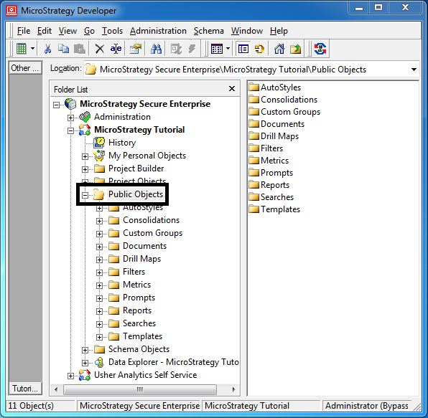

### Reporting

* 1. Decision making

Provide different views in real-time on retail industry from product category by division, department, people to assess supplier delivery performance (Bradley, 2020) for predictive analytics (blacklist vendors) and employee-supplier interaction transparency to management.

### Performance measurement

Inform stakeholders through story dashboard to communicate contributions of financials and accountability.

Generation of KPI and scorecard reports at various hierarchies provide summary of vendor performance through self-service BI.

### Mobile Analytics (MicroStrategy Mobility)

Integrates analytics and transactional workflows into native applications (iOS/Android) into professionals’ mobile devices. For example, analytics and database writes from scanning of product barcodes (MicroStrategy, n.d.-d). Software available on MacOS and Windows.

Allows for collaboration, real-time GPS integration (data filtered on location) on responsive dashboards (automatically resized for varying aspect ratio devices).

### HyperIntelligence

Pro-actively solves data needs by delivering insights through cards in emails, websites and CRM on mouse-hover without code (Kastelic, 2022; MicroStrategy, n.d.-c). Companies such as Tata and Orange benefitted through increased sales and improved customer satisfaction.

### Custom applications

Full APIs available for white-labelling, branding and integrating to existing workflows (MicroStrategy, n.d.-b).

### Scalable, Secure, Predictive caching, Offline support

Offline transactional data available on-device.

### (Advanced) Predictive Analytics

Prediction of future trends is organisation’s quintessential to identify opportunities and threats. Transactional, CRM, economic, demographic, marketing data fed to predictive models help create forecast and assist strategic decision-making in semiconductor industry.

Users import PMML[[3]](#footnote-4) from data-mining tools to create predictive reports on MicroStrategy.

Able to integrate with R, Python and Google Analytics by disparate data blending with 300 native analytics functions satisfy needs of descriptive, diagnostic and prescriptive analytics (*Predictive Modeling*, n.d.). Example: Corporate Express used logistic regression model built-in to predict customer churn (Eckerson, 2007).

## Platform limitations, other possible problems

### Easy to create bad visualisations

Due to difficulty navigating unfamiliar and complex UI, easy for inexperienced business analyst to create poor visualisations (bad colours, many confusing lines). Sometimes, accidentally placing wrong dimensions/measures may result in software crashing – excessive RAM usage.

In contrast, Tableau algorithm automatically optimises and selects visualisations based on number of dimensions and datatype of measures, MicroStrategy lacks this feature.

### Steep learning curve

With higher skill ceiling, draws higher usage barrier-to-entry. Relatively lesser resources and learning materials online compared to more popular BI platforms. There is lower demand for MicroStrategy skilled professionals compared to other BI tools inferred from its lower market share.

Figure - MicroStrategy Udemy courses

Figure - Tableau Udemy courses

### Unstructured data

MicroStrategy is poised to handle structured data with definable schema, challenges arise when fed with picture/text data from social media, although it markets to provide solutions for “entire workflow”.

### Machine learning

MicroStrategy has advanced analytics but many organisations still rely on more robust, well-designed, open-source frameworks like TensorFlow or SciKitLearn for artificial intelligence.

Example: image processing of lungs from pneumonia patients

### Real-time data

Other tools like Apache Kafka are more popular and robust in handling big data processing and streaming in the pipeline.

### Industry specific

Difficulty to suit needs of all industries’ specific needs.

For example, MicroStrategy is not suited for currency trading where fast data pipelines and advanced algorithms are used to make instantaneous decisions, rarely with much human intervention. Although MicroStrategy can be integrated to Salesforce, Salesforce has built-in analytics with CRM. There are other software tools better designed for specific tasks.

## Conclusion

There are numerous case-studies of companies from various industries utilising MicroStrategy such as:

* Banking/Finance/Fintech
* Insurance
* Retail/Sales
* Transportation/Logistics
* Pharmaceuticals

MicroStrategy suite is feature-rich compared to “mainstream”/well-known BA/BI applications such as Tableau, providing solutions for entire data pipeline and workflows. However, because of many complicated components, training could be costly and daunts/deters companies which have existing infrastructure from switching to MicroStrategy’s solutions due to many reasons (including vendor lock-in). However, its openness (platform agnostic) and scalability are strong advantages. MicroStrategy has introduced courses to build skills, but more could be done to convince companies to adopt their technologies given the competitive market.

# References

Bradley, P. (2020). *The masters blog: MicroStrategy in the retail industry*. https://community.microstrategy.com/s/article/The-Masters-Blog-MicroStrategy-in-the-Retail-Industry?language=en\_US

Eckerson, W. W. (2007). Predictive analytics. *Extending the Value of Your Data Warehousing Investment. TDWI Best Practices Report*, *1*, 1–36.

Kastelic, S. (2022, March 3). *HyperIntelligence from MicroStrategy Makes You Smarter*. https://www.crmt.com/resources/blog/how-to-be-smarter-with-hyperintelligence-from-microstrategy/

MicroStrategy. (n.d.-a). *Data visualization: What it is and why we use it*. MicroStrategy. Retrieved 24 February 2023, from https://www.microstrategy.com/en/resources/introductory-guides/data-visualization-what-it-is-and-why-we-use-it

MicroStrategy. (n.d.-b). *Enterprise Analytics*. MicroStrategy. Retrieved 25 February 2023, from https://www.microstrategy.com/en/enterprise-analytics

MicroStrategy. (n.d.-c). *HyperIntelligence*. MicroStrategy. Retrieved 25 February 2023, from https://www.microstrategy.com/en/hyperintelligence

MicroStrategy. (n.d.-d). *Overview of MicroStrategy Mobile*. MicroStrategy. Retrieved 25 February 2023, from https://www.microstrategy.com/en/business-intelligence/video/overview-of-microstrategy-mobile

MicroStrategy. (2020). *Metadata repository*. https://www2.microstrategy.com/producthelp/2020/Oracle19c/en-us/Content/Oracle19c/oracle19c\_Metadata\_Repository.htm

Natarajan, B. (2018, June 12). Why MicroStrategy is a great BI tool for governed self-service model. *Medium*. https://bnatarajan.medium.com/why-microstrategy-is-a-great-bi-tool-for-governed-self-service-model-1307285a0784

*Predictive Modeling: The Only Guide You’ll Need*. (n.d.). MicroStrategy. Retrieved 25 February 2023, from https://www.microstrategy.com/en/resources/introductory-guides/predictive-modeling--the-only-guide-you-ll-need

Tutorialspoint. (n.d.). *MicroStrategy—Quick guide*. Retrieved 25 February 2023, from https://www.tutorialspoint.com/microstrategy/microstrategy\_quick\_guide.htm

1. Company Information Technology Services (CITS) [↑](#footnote-ref-2)
2. The metadata repository is a collection of tables that contain definitions for all MicroStrategy objects - server definitions, database logins, database instances and connections, reports, metrics, facts, and more (MicroStrategy, 2020). [↑](#footnote-ref-3)
3. Predictive Model Markup Language [↑](#footnote-ref-4)