EIDC feedback on v1 DataMAD demonstrated 0n 06/04/2020

# General:

Given the API is now a possibility this may affect how we work and therefore may influence the priority of some of the functionality and possibly even need re-evaluation of our requirements e.g. we push updated info to DataMAD which may make the edit function in records obsolete.

So it would be useful to explore the API in addition to the web interface.

We see the EIDC potentially using it like this:

* We create an EIDC service that calls the API to:
  + Extract DataMAD data to update existing Jira issues (per grant)
  + Extract EIDC Jira data to update DataMAD (e.g. date DMP agreed)
* This service would run automatically on a schedule (e.g. daily).

So, apart from "claiming" grants we may not need to use the interface much. However, it depends on the capabilities of the DataMAD API. More information would be useful.

Initially though, here are some additional data we would like the API to include right from the start:

• Date claimed: This would be the date on which the grant was assigned to a particular data centre. It would be useful so you can quickly find grants that have been assigned since the last time checked. If this field isn't present we would have to do a lot of data processing to find the ones that are new vs ones that have previously been claimed and are already in Jira

• Date last updated: This field would be the date on which the record was last changed (similar to above)

• Claimed by: This would be the person (the logged in user) who clicked the CLAIM button. I don't think this is recorded at the moment. It would be useful for integration with Jira (and also as we have multiple staff working on the activity).

## General web interface

The interface looks great but we have a few suggestions:

In order to display more information on each row you could add a toggle button which opens a panel containing more information on the grant (see below)

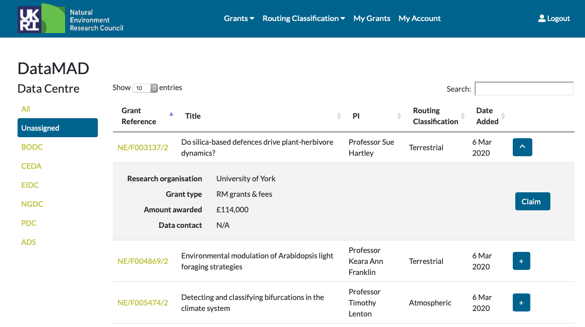

Toggle info panel button

Expanded info panel

*(I am not suggesting that you add the actual fields shown in the example above - they have just been added at random as an illustration)*

The Routing classification should be in words, not graphics which are open to (mis)interpretation.

When you click the CLAIM button, there should be an "are you sure" prompt. At the moment it's far too easy to claim a grant accidentally.

Continued…….

## Specific functionality requirements and feedback based on v1

|  |  |  |  |
| --- | --- | --- | --- |
| **Function / Area** | **ref** | **Requirement** | **Version 06/04/2020 comments** |
| Unassigned view | 1.1 | view details including ODMP & CFS for unassigned grants | ODMP&CFS not visible and need to be |
| Unassigned view | 1.2 | be able to sort and order based on information in any column | Can sort on any column in view. But you cannot filter |
| Unassigned view | 1.3 | record the fact that a data centre has reviewed a grant and concluded its not theirs (cumulative content) | Not delivered |
| Unassigned view | 1.4 | when claiming a grant, extract/send key details to Jira (or othe via API) | OK this can be done from the actual record view ('Create Jira issue' button) (RS) |
| Unassigned view | 1.5 | key columns are Grant reference, Title, PI, Routing classification, Date added, Start date | Need ‘Start date’ column. 'Claim status' is pointless at the list level - they are all clearly not claimed and in order to decide if we should claim it you need to go into the record to read more and view the ODMP so just claim it there. |
| List view | 2.1 | able to sort and order based on information in any column | OK can sort on any column in view |
| List view | 2.2 | Too many columns - needs to fit on screen so key columns only (see 2.5) are necessary to view (but optionally can be searched/added to the view) | can't add and search on optional columns |
| List view | 2.3 | DC list - needs clarity on lead / sub grants, split awards, standalone, etc | Not delivered |
| List view | 2.4 | Accessible option to move on or back a page, maybe at top left and bottom left of the list | Delivered (bottom of list (usually where needed?)) |
| List view | 2.5 | key columns are Grant reference, Title, PI, Routing classification, Date added, Start date | Start date missing. 'Claim status' is pointless at the list level - they are all clearly EIDC and in order to decide if we should unclaim/assign it you need to go into the record to read more and view the ODMP |
| List view | 2.6 | Could there be a link from each grant to the corresponding info on Grants on the Web? | Would like |
| Searches | 3.1 | Users should be able to create and save / share their own filters, giving more options on which fields appear in the list view | Not delivered |
| Searches | 3.2 | Search output needs to have meaningful output in the results list - e.g. we need to see the grant reference, not just the title | Delivered - Returns the same fields as in EIDC listing so ok |
| Searches | 3.3 | Should be able to search on less specific Science Area information, e.g. ALL terrestrial, rather than Terrestrial 100% OR Terrestrial 80%, etc | Not delivered (RS). Can search on majority classification only. |
| Searches | 3.4 | Also to search for a Created Date range (this field only appears on Unassigned grants but would be useful elsewhere) | covered by 1.5 & 2.5 |
| Searches | 3.5 | the 'Search documents' search option brings up ALL grants and related documents for the reference input. We need that - it's good! | No function to search for related documents e.g. ODMP and CfS |
| Searches | 3.6 | Faceted search/advanced search required, to remove undesirable search results if the user knows they are searching specific field only | Would be useful |
| Searches | 3.7 | Search filter needs to clear itself when navigating away from the page | doesn't clear |
| Menus | 4.1 | Rather than a long list showing all the options, hide the options for each section until it's clicked on - e.g. show 'Data Centres on the main menu but then reveal the DCs on a dropdown when the header is clicked | Delivered in menu at top. Why need to repeat menu at side as this takes up useful space? |
| Record view | 5.1 | View all grant information | Delivered (but see 5.4) |
| Record view | 5.2 | Minmise Abstract / Objectives text (maybe truncate to 2 or 3 lines) but allow the option to expand to full content within the record view, if wanted | Delivered by expanded view. |
| Record view | 5.3 | widen view of grant info panel | Delivered |
| Record view | 5.4 | view ODMP & CfS for each grant | Not delivered. ODMP&CFS not visible and need to be (RS) |
| Record view | 5.5 | Edit key info e.g. DMP Agreed date | Delivered. (For info, as data centres need to revisit and potentially edit the required info but the functionality remains the same. However, if we were to have carefully designed/planned fields they could be used to trigger stages in the workflow (which could also be integrated into Jira). |
| Record view | 5.6 | Replace 'Date first contact with PI' to 'Agreed DMP date' | See 5.5. comment above |
| Record view | 5.7 | Better way of identifying / displaying extended and renewed grants (especially where there's a /1, /2, etc suffix) | Not delivered |
| Record View |  | (this is duplicated in 2.6) Could there be a link from each grant to the corresponding info on Grants on the Web? | Would like |
| EIDC view | 6.1 | view list of grants assigned to EIDC and search these on any column | Delivered |
| EIDC view | 6.2 | need to be able to create custom views based on any column e.g. show all grants with end date in 2020 | Not delivered (RS) |