Reconstruction of Ground Surface Temperature History from Borehole Temperature Profiles

Henry N. Pollack, Department of Geological Sciences, University of Michigan, Ann Arbor, Michigan 48109-1005 USA

The reconstruction of past climate on the Earth has been an important endeavor in climate change studies because such reconstructions provide a record of the variability of the climate system under an array of natural and anthropogenic influences. Subsurface temperatures in the upper few hundred meters of the Earth’s crust, as measured in small diameter boreholes, provide an archive of temperature changes that have occurred at the surface of the continents in earlier times.

The principle that enables this archive to exist can be illustrated with a simple analogy: consider a rock placed next to a campfire in the evening. The interior of the rock gradually warms because of the radiant energy absorbed from the campfire. Even after the campfire has gone out, the interior of the rock is still warm, and provides testimony to the fact that there had been a campfire the previous evening. With proper analysis, the interior temperatures of the rock could reveal for how long and how brightly the fire had been burning – i.e. the ‘climatic’ history of the rock’s surface over the previous several hours could be reconstructed.

To reconstruct the surface temperature history of a much bigger rock, i.e. the Earth, and over a much longer time interval, say centuries, requires observations of the temperature over a much greater range of depth below the surface, on the order of a few hundred meters. Temperatures beneath the Earth’s surface are observed by lowering a sensitive thermometer into a narrow diameter borehole, and making a sequence of measurements at different depths to obtain a log of temperature vs. depth, otherwise known as a borehole temperature profile. This profile will vary from place to place depending on the amount of heat flowing toward the surface, and on the particular temperature history experienced at the surface at that location. Because the thermometers yield direct measurements of temperature, there is no need for an empirical calibration as required by many temperature proxies, e.g. tree ring thicknesses, in which variations in ring width must be related to known variations in temperature.

Two principal processes govern the temperature field in the outer few hundred meters of the Earth’s crust: the outward flow of heat from the interior of the planet, and temperature perturbations at the surface which travel downward into the interior. The latter typically vary on time scales of years, decades, centuries, and millennia, whereas the former reflects deep-seated geological processes which vary on time scales of millions of years. Thus, the downward-propagating short-term perturbations are imprinted on an apparently steady-state background of the outward-propagating heat from the interior. In the simple setting of a homogeneous rock medium, the temperature signature of the outward-flowing heat is a linear increase of temperature with depth below the surface. The rate of increase of temperature with depth is known as the geothermal gradient (see Figure 1). The gradient depends both on the amount of heat being transferred and the thermal properties of the rock in which it is traveling. The geothermal gradient lies in the range of 10-50 ◦C per kilometer of depth in most regions of the continents.

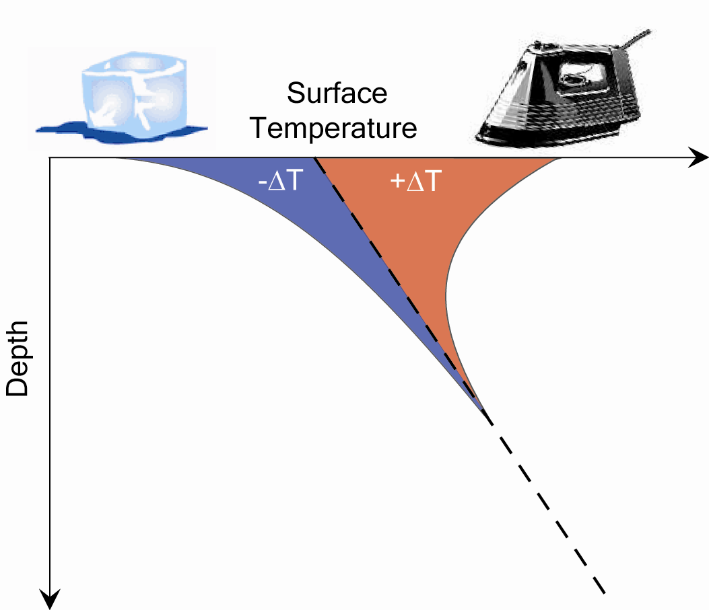

Figure 1. Schematic graph of temperature vs. depth. Dashed line represents the geothermal gradient; curved lines represent perturbations to subsurface temperatures caused by warming (+ΔT) or cooling (–ΔT) of the surface

The geothermal gradient describes the progressive increase of temperature with depth, starting out from the local surface temperature at a given site. Even in the absence of climatic perturbations, the local temperature at the surface varies with latitude because of the decreasing fraction of the solar flux interecepted by the planetary surface from equator to pole. Additionally, there are departures from that simple latitudinal cooling that arise from the differences in reflectivity (albedo) between land, sea and ice, and by atmospheric and ocean circulation that redistributes heat over the global surface. The topography, vegetation, wind, precipitation and many other factors also imprint their signature on the local surface (and subsurface) temperature field, and their effects must be accounted for in the analysis of the subsurface temperature profile in terms of climate perturbations.

Temperature perturbations propagating downward from the surface become smaller with depth (see Figure 1), and the rate of attenuation depends on the time scale of the surface disturbance. Short period perturbations disappear at shallow depths, whereas longer period perturbations attenuate less rapidly at depth, and therefore can be seen at greater depths. Seasonal variations of temperature are confined to about the upper 20 meters, decadal variations to the upper 60 meters, centennial variations to the upper 150 meters, and millennial variations to the upper 500 meters. The rate at which heat travels (diffuses) through rock is such that all changes that have taken place in the last millennium are effectively confined to the upper 500 meters of the Earth’s crust.

The analysis and interpretation of borehole temperature profiles to yield a reconstruction of the ground surface temperature history is essentially an attempt to answer the following question: What temperature history at the surface would produce the present-day temperature profile observed in the borehole? Because the geothermal gradient changes only over millions of years, it can be considered a constant in the analysis, and can be separated from the profile. The remaining (‘residual’) temperature variations are then analyzed to extract a ground surface temperature history.
The approaches to this problem fall into two broad categories: forward and inverse modeling. In a forward model, a provisional history is assumed and its subsurface expression is calculated. The differences between the calculated and observed temperatures are an indication of how well the provisional model accounts for the residual subsurface temperature profile. Many models can be tested for their compatibility with the observations, and models with a minimum of mismatch are judged ‘acceptable’. Modern computers are able to generate and test a great many provisional histories, and determine what the general characteristics of an acceptable ground surface temperature history must be.

Inverse modeling is a mathematical technique in which the observations play an active rather than passive role in the determination of an acceptable ground surface temperature history. Inverse models generally allow more flexibility in addressing the form of the history to be reconstructed, in suppressing non-climatologic ‘noise’ (e.g. temperature perturbations arising from topography, vegetation or slow groundwater movements) and in assessing the uncertainty and resolution of the final result. Methods exist to invert several different borehole profiles simultaneously, in order to isolate a common climatologic signal immersed in local noise. Averaging of several reconstructions from a number of boreholes in a geographic region effectively isolates the regional climatologic history from other site-specific non-climatologic factors.

What have we learned about climate change from the analysis of borehole temperatures? Because of the attenuation of short period signals as they propagate downward, the subsurface temperature profile is best suited to the recovery of long-term trends in the climate history. The database of borehole temperatures has yielded (as of 2004) reconstructions at more than 800 sites on six continents. Taken as a global ensemble, the borehole data indicate a temperature increase over the past five centuries of about 1 Celsius degree, half of which occurred in the 20th century alone (see Figure 2). This estimate of 20th century warming is similar to the record of surface warming determined by meteorological stations. The estimate of colder temperatures five centuries ago is consistent with the putative Little Ice Age determined from a host of other observations.

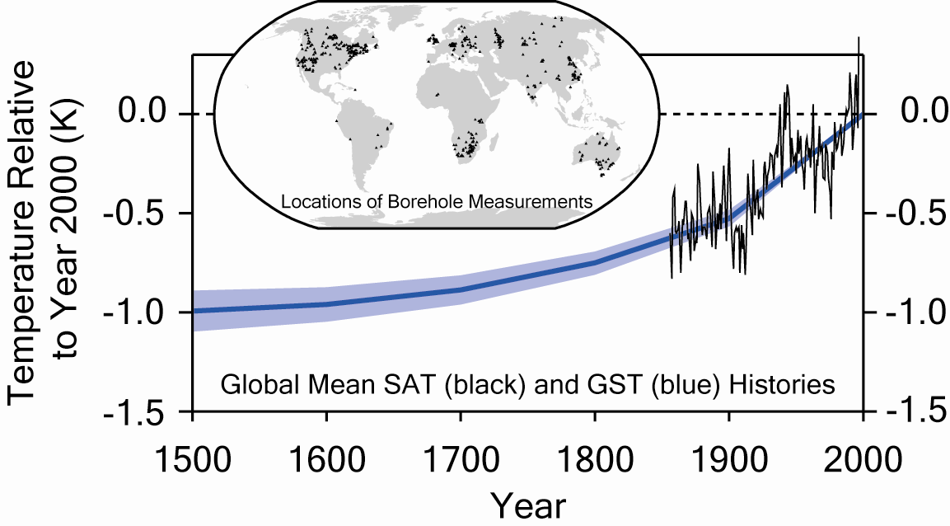

Figure 2. Reconstructed ground surface temperature (GST) history over the past five centuries. The shading represents the uncertainty of the reconstruction. Also shown for comparison is the global average instrumental record of surface air temperature (SAT) since 1860.

