The Documentary Data
Rudolf Brázdil

On a local or regional scale, many meteorological instrumental series from individual stations exist, some of them reaching back as far as the 17th century or the early 18th century. Prior to these periods and prior to the establishment of national meteorological networks, however, information on past climates necessarily must be drawn from non-instrumental man-made sources or from proxy evidence obtained from natural archives. A man-made source on climate is a document, i.e. a unit of information such as a manuscript, a piece of printed matter, a picture or an artefact which refers to weather patterns or impacts of climate. The concept of documentary evidence includes all kinds of man-made sources.
Documentary evidence is the basic data source in historical climatology, the science dealing with reconstructing temporal and spatial patterns of weather and climate as well as climate related natural disasters for the period prior to the creation of national meteorological networks (i.e. mainly for the last millennium). Reconstructions based on documentary data play an important role in the enhanced greenhouse debate.
Documentary data are the only kind of palaeoclimatic data that are based on direct observations of meteorological parameters (temperature, precipitation, cloudiness, etc.) in terms of narrative descriptions and/or early instrumental measurements. Important usages of documentary data are the verification of extreme values in natural proxies such as tree rings and for detailed descriptions of past weather conditions, e.g. after major volcanic eruptions. Most importantly they are the only evidence that is directly related to the socio-economic impacts of rare but significant disasters in the period prior to the organisation of instrumental network observations.
Data sources. The documentary data can be broadly categorised as being either direct or indirect data. The direct data can be thought of as descriptive documentary data (e.g. narrative descriptions of weather patterns, early instrumental observations). Indirect (proxy) documentary data rather reflects the impact of weather on the environment (e.g. the freezing of waterways or the beginning/end of grain or wine harvest). In contrast to descriptive documentary data which are limited by the activity of the observer, some kinds of documentary proxy data, inasmuch they have been produced by administrative routine, are available over periods of several centuries.
Descriptive documentary evidence is an exceptionally rich source, including written reports from annals, memoirs and chronicles, daily weather reports, personal and official correspondence, travel diaries, economic records, pictures, leaflet newspapers, early journalism, epigraphic records etc. The geographical range of documentary data depends on:
- The sedentary presence of literate individuals. This excludes the high latitudes in early centuries and also the high altitudes.
- An appropriate institutional and cultural framework (e.g. the existence of conventions and of local elites in towns).
- A tradition of keeping chronicles of extraordinary events based on eyewitness observations.
In Western and Central Europe the density and quality of information increases over the past millennium:
- Prior to AD 1300: Reports of socio-economically significant anomalies and natural disasters.
- 1300 to 1500: More or less continuous reports on characteristics of summers and winters (partly also of spring and autumn) including reference to “normal” conditions.
- 1500 to 1800: Almost complete description of monthly weather, to some extent also of daily weather. Growing number and diversity of continuous series of documentary proxy data produced by the early modern local, regional and state bureaucracies.
- 1650 to 1850: Instrumental measurements made by isolated individuals. First short-lived international network observations.
- From 1850: Instrumental observations in the framework of national and international meteorological networks.
The list needs to be understood in a cumulative way, i.e. climatic information from the older kinds of documentary evidence is not replaced but superposed by more recent ones. In sum, the quality of the data improves, their density and their time resolution increases and their spatial coverage extends over time.
Outside the Byzantine empire the conditions mentioned above were met first in the reign of Charlemagne (9th century AD) that includes most of the territory of contemporary Germany and France, Belgium and the Netherlands, Switzerland and Northern Italy, as well as in Ireland and to some extent in England. From about AD 1050 the tradition of keeping chronicles spread to the territories of contemporary Catalonia (Spain), the Czech Republic, Denmark, Hungary, Iceland, Poland, Slovakia, and later on also to the Baltic countries, Russia and the territory of contemporary Finland. Records from south-eastern Europe are scanty until the 18th century.
Critical evaluation of sources and data. The documentary evidence may contain either sporadic or continuously recorded climatic information. In all cases it needs to be assessed whether a source is contemporary, i.e. whether authors witnessed the events they describe or whether these events at least occurred during their life-time. Observations that were copied from other documents or compilations, often contain transcription errors in the dates of observations.
To obtain a correct dating can be a difficult problem. In 1582 the new Gregorian calendar replaced the old Julian one (with a time difference of ten days). Dates prior to this year need to be corrected accordingly. Gregory’s reform, however, was only adopted piecemeal, even in the catholic world. Thus, it must be assessed for every territory whether the ‘old’ or the ‘new’ style was used. Most Medieval sources are tacit with respect to the dating which they used. For events in ‘winter’, it must be derived from the context or from other sources whether the ‘old’ or the ‘new’ year is meant. Suspicion should be thrown on compilations of climatic events (including recent ones), for which it is not assured that sources were critically evaluated.
When interpreting Medieval documents the particular conditions under which the documents were created need to be considered. Before the art of printing was invented in the 15th century, books had to be copied by hand. During the Early and High Middle Ages this was done in the scriptoria of monasteries. The philological work of critical text edition attempts to assess which is the oldest manuscript (the archetype) and to establish its relationship with the more recent copies that may today exist in different libraries or private collections.
Uncritical use of documentary data can be found in more recent publications of authors who are not so familiar with documentary evidence. Questionable reconstructions of climate from documentary data should not be blamed on the chroniclers without justification, but to an improper interpretation of data by the researcher.
Temperature reconstruction. Using a time series of some documentary proxy data (e.g. wine harvest dates) a climate signal can in many cases be extracted. As a rule, the climatic information obtained relates to air temperature data with a time resolution of months or longer. For calibration and verification of the temperature signal, it is necessary that some overlapping instrumental data exist.
Time series of documentary proxy data are mostly drawn from administrative records. Such series are often long, continuous and quasi-homogeneous so that they can be calibrated against instrumental measurements. Documentary proxy data may reflect the beginning of agricultural activities (e.g. the grain or the vine harvest) and production (e.g. yield of vineyards), the time of freezing and opening up of sea-ports or inland waterways, or that of religious ceremonies such as rogations (standardised liturgical actions to cope with situations resulting from climatic stress). For example, French records of grape-harvest dates in Burgundy have been used to reconstruct spring-summer temperatures using a process-based phenology model developed for the Pinot Noir grape (Fig. 1).
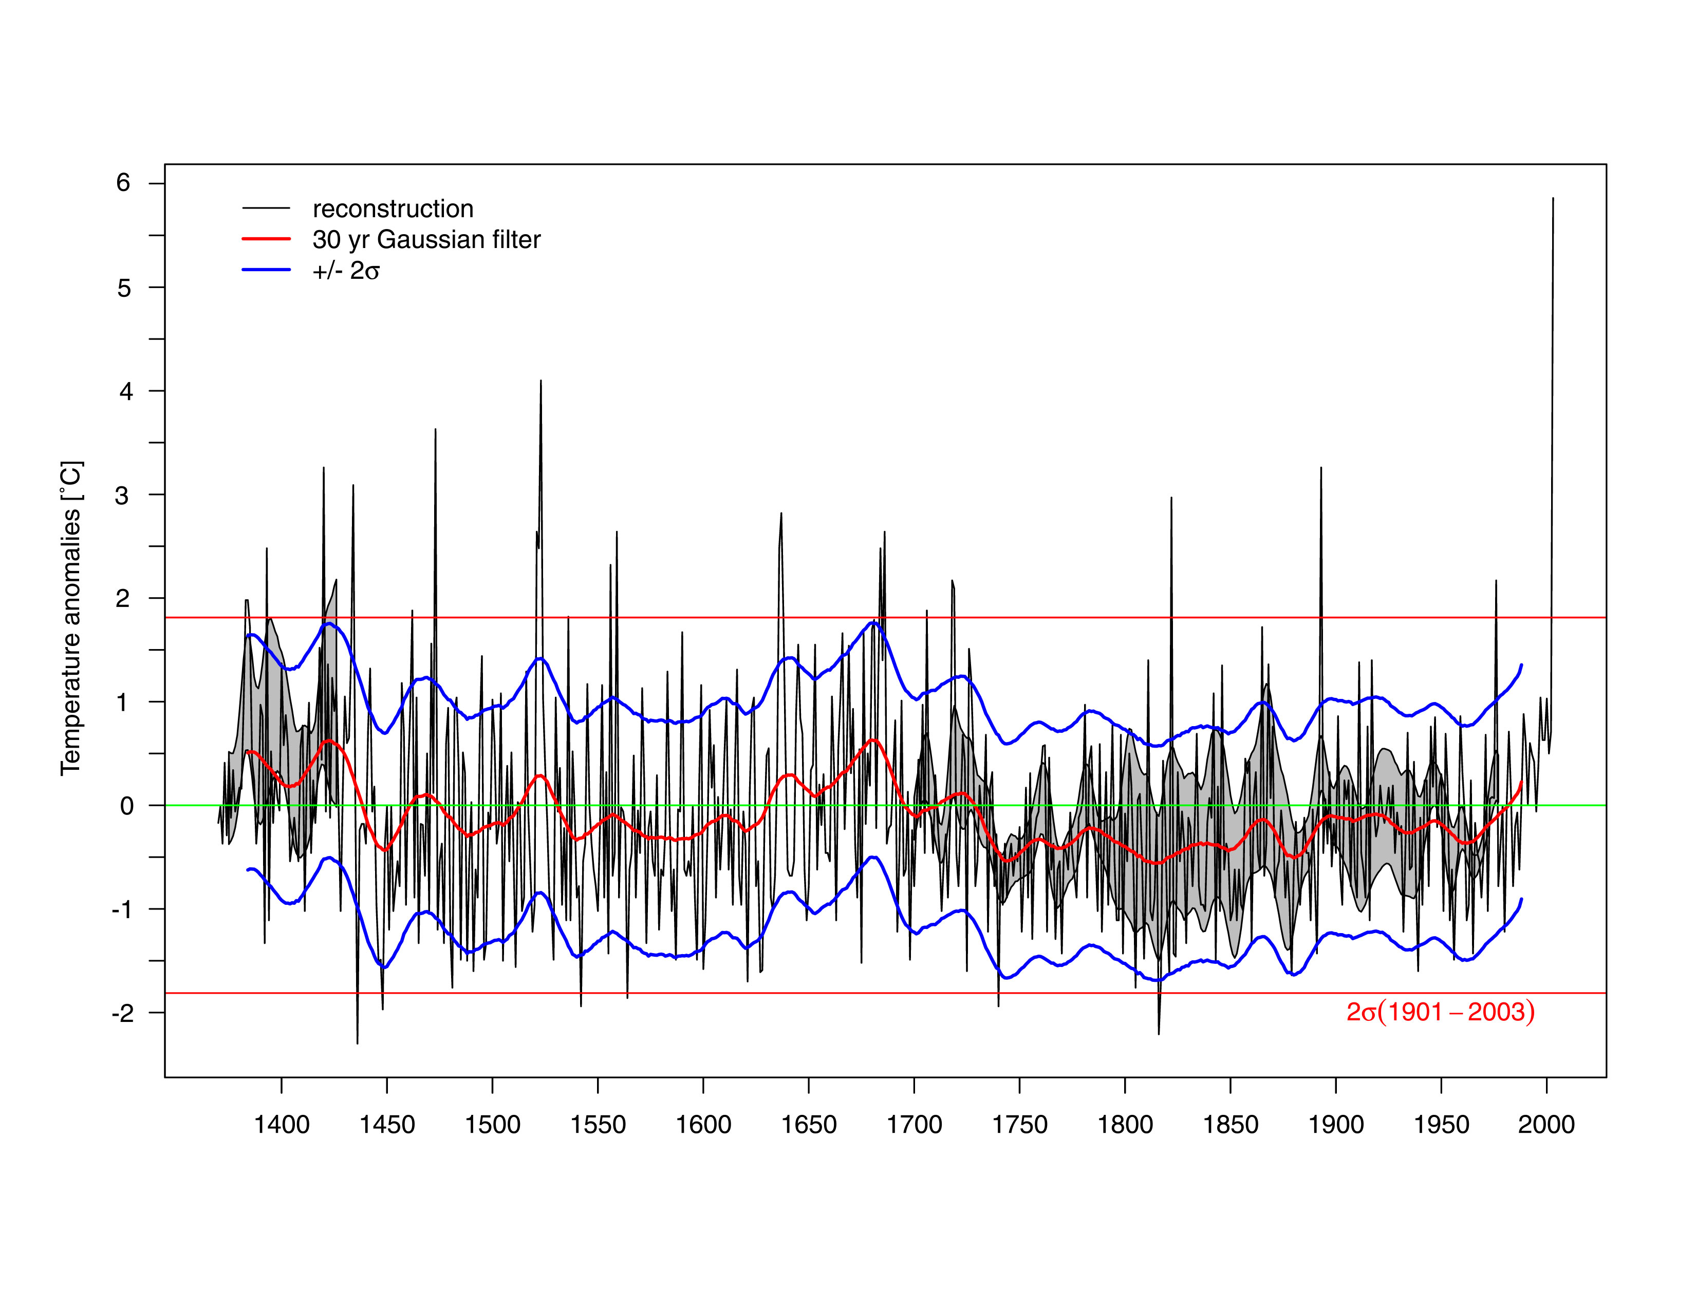Fig. 1. Fluctuations of April-August temperature anomalies in Burgundy as reconstructed from grape-harvest dates in the period 1370–2003. Smoothed by 30-year Gaussian filter, σ – standard deviation

Descriptive documentary data has the following advantages in relation to natural proxy data:
- Good dating control and high temporal resolution.
- Clear distinguishment of meteorological elements in the narrative reports (e.g. temperature, precipitation, snow cover, wind).
- Focus on anomalies and natural disasters.
- Taken together they cover all months and seasons.
The following drawbacks should be mentioned:
- Discontinuous structure of the records (due to the life-length of observers).
- Bias by the selective perceptions of observers.
- Extremely time consuming work related to extracting the climatic information from different documentary sources.
The reconstruction methodology. The procedure of temperature reconstruction usually starts with the search of suitable documentary data that are able to explain a high amount of temperature variability (Fig. 2). The first step includes a consideration of critical analysis of sources, author and/or institutional framework, calibration of documentary proxy data, etc. The comparison and cross-checking of data from different documentary sources, both direct and indirect, should allow assessment of an unequivocal climatic tendency, within a given temporal and spatial domain.
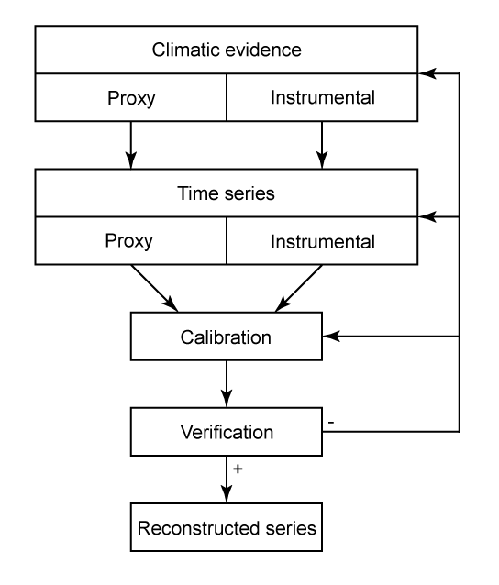
Fig. 2. The process of temperature reconstruction based on documentary data

The proxies are then transformed into a time series with a clearly defined temporal resolution. The statistical transformation of the proxy data into ordinal data in the form of a time series of temperature indices is a great challenge requiring both a broad statistical and dynamical understanding.
The climatic tendency is generally expressed in the form of an intensity index for temperature, which is attributed to the month or season under investigation. The index series may consist, for example, of weighted monthly temperature indices using a seven-term classification (3 extremely warm, 2 very warm, 1 warm, 0 normal, –1 cold, –2 very cold, –3 extremely cold). Seasonal or annual indices may be obtained by summation of monthly values (i.e. the seasonal values can fluctuate from –9 to 9). Other scaling into ordinal numbers can also be used, depending on the density and quality of the basic information, and is to some extent affected by the subjectivity of the researcher.
The series of intensity indices can be calibrated and verified against instrumental observations for a period of overlapping data. The aim of the calibration is to determine the relation (transfer function) between the temperature indices and the real air temperatures. Direct calibration is, however, only possible for a few cases and very distinct periods.
A reason for this limitation is that, in most cases, the qualitatively best observers switched from non-instrumental records in diaries to instrumental observation when meteorological instruments became available at reasonable prices by about the mid-18th century. This means that overlapping local instrumental and proxy data do often not exist. Nevertheless, it has been shown that subjectively registered values often have strong correlations with measured parameters.
Prior to being used for a reconstruction, the transfer functions need to be verified for an independent time period, or at least a cross-validation procedure has to be carried out if the data series is rather short. The relationship obtained for a calibration period is thus applied to a verification period, for which the temperature values are estimated from the documentary data. These estimations are then compared with the measured values and evaluated using different statistical measures. If the transfer function obtained expresses the variability of air temperature under consideration with satisfactory precision, the chronology of the proxy can be used for temperature reconstruction. An example of a twelve century long reconstruction of both winter and summer temperatures for the Low Countries is shown in Fig. 3.
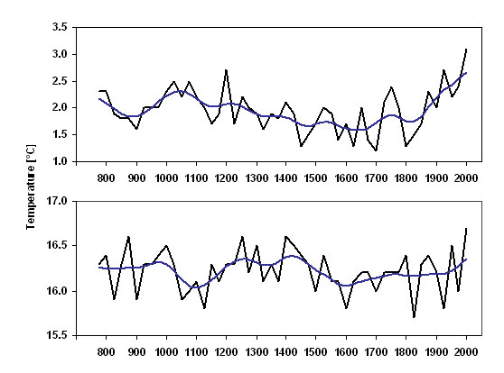
Fig. 3. Fluctuations of winter and summer temperatures for the Low Countries (De Bilt) – 25-year means. Smoothed by a Gaussian filter for 10 items

The transfer functions, usually derived from relatively modern periods, may however be non-stationary (e.g. when the phenological series were affected by changes in the crop mix, the introduction of new varieties of crops or by the introduction of harvest technology). This problem can be ameliorated by considering a sufficiently long calibration period.
The potential for reconstructions in different regions. Some potential of reconstructing climate from different kinds of documentary evidence exists more or less in every European country, but only some have been used hitherto for temperature investigations (in particular in the Czech Republic, Germany, England, Hungary, Italy, the Netherlands, Norway, Poland and Switzerland). Further studies from other European countries are needed to help resolve finer spatial and temporal scales of past temperature variability.
There exists great scientific and data potentials in eastern Asia (particularly in China, but also in Japan and Korea), but also in other parts of the world (such as Latin America and potentially the Islamic World). A main limiting factor for further extension of documentary data, however, is the generally missing or very small funding for the extremely time consuming work related to extracting the basic information from corresponding data in different documentary sources.

Reference for further reading
Brázdil, R., Pfister, C., Wanner, H., von Storch, H., Luterbacher, J. (2005): Historical climatology in Europe – the state of the art. Climatic Change, 70, 3, 363–430.
Glaser, R. (2001): Klimageschichte Mitteleuropa. 1000 Jahre Wetter, Klima, Katastrophen. Primus Verlag, Darmstadt, 227 pp.
Pfister, C. (1999): Wetternachhersage. 500 Jahre Klimavariationen und Naturkatastrophen (1496–1995). Verlag Paul Haupt, Bern, Stuttgart, Wien, 304 pp.
Pfister, C., Brázdil, R., Glaser, R., eds. (1999a): Climatic Variability in Sixteenth-Century Europe and its Social Dimension. Kluwer Academic Publishers, Dordrecht, Boston, London, 351 pp.
Van Engelen, A.F.V., Buisman, J., IJnsen, F. (2001): A millennium of weather, winds and water in the Low Countries. In: Jones, P.D. et al., eds.: History and Climate: Memories of the Future? Kluwer Academic/Plenum Publishers, New York, Boston, Dordrecht, London, Moscow, pp. 101–124.

