The early instrumental data
Reinhard Böhm

The instrumental period refers to the period of comprehensive global coverage, prior to this there were still substantial quantities of instrumental data. These early instrumental data are the basis for proxy-based climate reconstructions in the pre-instrumental period - providing the data for calibration and verification. Climate time series usually show a strong short-term (high frequent) variability and a relatively small long-term (low frequent) evolution. Therefore, the longer the calibration period is, the greater is the chance to obtain statistically well proved and stable algorithms to fit proxy information to directly measured climate. Fig.1 illustrates the respective three basic facts on climate variability:
- the mentioned high short-term variability
- the decrease in variability of spatial means with increasing area
- the longer early instrumental period available at regional (European) compared to hemisperic to global scale
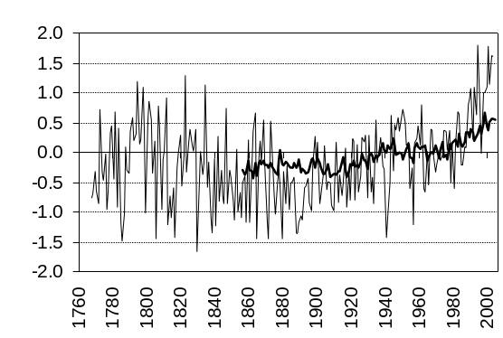
Fig.1. A regional and a hemispheric mean instrumental temperature time series
thin: data from Central Europe (HISTALP), bold: data for the northern hemisphere (CRUTEM2), both are annual anomalies to the 1901-2000 averages

Also the current debate on a human influence on climate (anthropogenic greenhouse effect) makes a further extension of the instrumental period into “pre-industrial” times highly desirable. This helps to avoid possible errors or biases when extrapolating interrelations derived from a calibration sample under “greenhouse conditions” (essentially the 20th century) to any (usually much longer) application period in the world of “natural climate”.
The theoretical and practical potential of instrumental data is outlined in Figure 2. The major dates and activities in relation to temperature measuring are arranged in the graph around the respective development of a Central European database (HISTALP) of long-term climate time series. There is no sharp definition of an early instrumental period. After Galileo Galilei had first proposed and constructed a thermometer based on the modern understanding of a physical instrument, it took some time until systematic, well described measurements started. Three milestones stand out before others. The Accademia del Cimento’s first network in the mid 17th century (Italian centred but with some corresponding sites elsewhere in Europe) and the late 18th century Palatina activity (of full European scale already) both decayed after not much more then a decade. But some of the Palatina sites survived as single activities (maintained by astronomical observatories in most cases) and build the backbone of the early instrumental period in climatology. After 1851 the first national meteorological services started their activities. One of their major objectives was the systematic maintainance of meteorological networks. This caused the sudden increase of the data coverage curve in Figure 2. It reached the modern network density near 1900. 1873, the founding year of the International Meteorological Organisation, may serve as a benchmark for a fully developed “instrumental period” maintained by internationally coordinated meteorological services and under common quality definitions – which were formulated in a series of “Directors’ Conferences of the Meteorological Services” In the late 19th century.
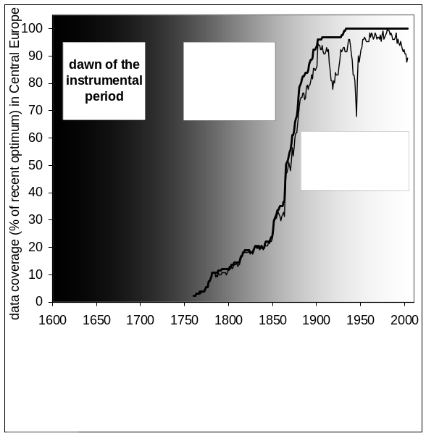
Fig.2. Outline of the transition from the proxy to the instrumental period
bold line: coverage with long-term and quality improved instrumental temperature series in Central Europe (HISTALP), thin line: series for the respective original data)

Proceeding back in time again, roughly from 1850 to 1750, instrumental time series become scarce and there are increasing difficulties to adjust for inhomogeneities (details later). However, climate elements like air temperature and air pressure - with slow spatial decorrelation - still provide a station density in these 100 years sufficient to catch major parts of the total spatial variance of decadal scale variability. But the process of calibration of proxies against instrumental data increasingly looses its onesidedness. In these 100 years of the classical “early instrumental period” both data sorts can “learn from each other”. Not only the proxies should be fitted to the instrumental data – the aim of any analysis should be to strive for an optimised consistency between the different sorts of data. If consistency is not achievable, such cases should at least make us aware of shortcomings of our data or our methods. Two respective cases are described at the end of this article. Further back, into the “dawn of instrumental data” (1650 to 1750), the few existing really early instrumental series (the Paris-Montsouris series, the Central England temperature series and a few others) cannot be satisfyingly checked for their quality and homogeneity within the world of instrumental series due to the lack of independent comparative series in similar climatic regime. Therefore the existing oldest instrumental data may be regarded as one among other data sources for climate reconstruction – being nearest to the so called “documentary sources” from historic written archives (compare the respective chapter).
From all regions of the globe Europe stands out through the best coverage of early instrumental series. A survey done a few years ago demonstrates the respective potential of pre-1850 measuring sites shown in Figure 3. On other continents only a few additional series extend beyond 1850. North America’s record holder is the Boston series (Blue Hill compound, starting in 1831). For Asia, Madras (1792) or Nagasaki (1818) may be mentioned. Africa, South America and Australia seem not to have contiguous temperature series starting before 1850.

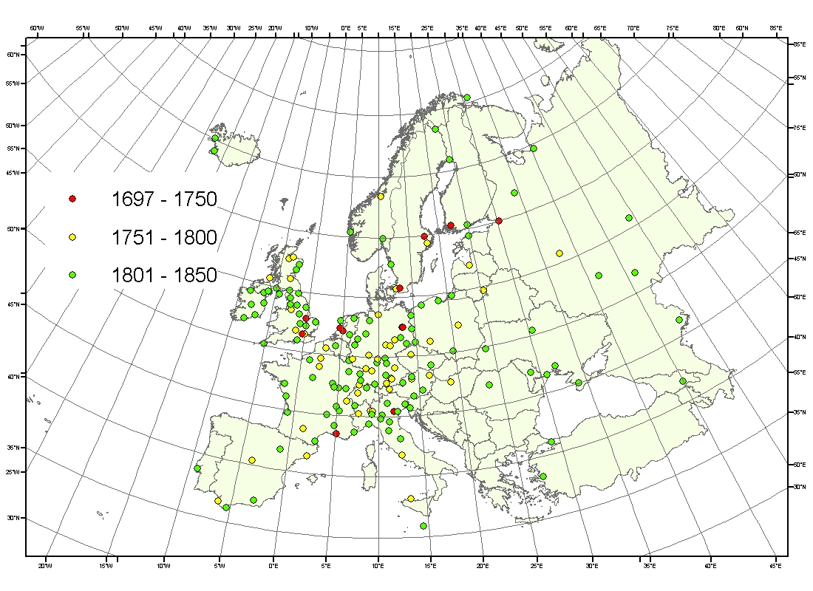
Fig.3. Sites in Europe with early instrumental and still existing time-series

Unfortunately, we have to admit that this potential has not been fully exploited so far. Even for the leading climate element - temperature, and for a region like Central Europe - a recent data processing activity managed to increase the hitherto (before 2003) available 1760-1850 network density by 23%. This example indicates that there may still be yet undiscovered (more precisely: not digitised) valuable early instrumental information hidden in the archives and libraries of weather services, universities and other research institutes.
Before applying instrumental data in proxy climate reconstructions it should be considered to what extent they reflect real climate (the question of homogeneity), to what extent the comparative instrumental series are representative for the proxy sites (the question of spatial representation) and if the chosen/available sample matches the needs defined by temporal variability (the questions of temporal stability, trend significance,…). The latter two basics have been argued aready and both underline the value of the early instrumental period. The first issue (homogeneity) is a sometimes under-underestimated absolute criterion “sine qua non” in general, but one of special delicacy in the early instrumental period.
At first sight it may be astonishing why a series of measurements with physical instruments should not contain the measured element (in our case air temperature) alone and thus providing a quick and easy overview on what has happened in the measuring period. In fact it is never possible over a longer period of time to keep all factors constant, which influence the measurements. It is factors like relocations, changes of the surroundings (from tree-growth or -cutting to large scale urbanisation), technological progress (better instruments, automation), observing practices (time of obervation, height above ground) and others which sometimes have an influence on the measured data comparable or even greater than the long-term evolution of the measured element itself.
From the theoretical point of view, the problem of how to remove the “non climatic noise” from climate time series is solved. There are a number of methods which do a good job. The best potential to detect and remove inhomogeneities is in methods relying on two major inputs: from “metadata” (station history archives describing how the data were produced) on the one hand and the results of mathematical tests on the other (the best are the so called “relative homogeneity tests”). Relative homogeneity tests rely on the basic assumption that the climatic content of neighbouring series (in mathematical terms “highly correlated” series) should be very similar in the course of time. Any jumps or trends in differences (or ratios) between neighbouring series can be regarded as caused by non-climatic disturbances -> inhomogeneities.
The time consuming homogenising work is increasingly well done for several regions, for several climate elements and for different time periods. But we are yet far from having reached the ideal goal of having a global coverage of satisfying resolution (in space and time) of well homogenised climate information matching the respective potential of existing instrumentally measured data.
Anyway, temperature (the main subject of this article) is the most well developed climate element. Figure 4 and Table 1 mediate a feeling about the impact and the size of the homogeneity problem. The table tells that us that climate time series, in fact, contain a plenty of inhomogeneities (and outliers but there is not the place here to adequately discuss this aspect which has serious consequences on any study dealing with climate extremes). We see that the typical homogeneous sub-period of a climate series (of a sample of more than 500 series of an average length near 140 years) is not much longer than 20 years.

Tab.1. Data availability and quality statistics of the Central European HISTALP dataset
(5-element subset for air pressure, temperature, precipitation, sunshine duration and cloudiness)
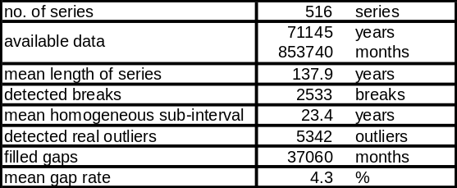

For the climate element air temperature, all homogeneity adjustments (and outlier correction) applied on the 131 series of the dataset have been condensed to the “HOM minus ORI”-series of Figure 4. We see that even the mean over a large number of original series (the bold line) may be signficantly biased – in our case by 0.5 deg. This is large compared to the real climate trends in the region which are of the order of 1 deg per 100 years. The much broader range of single adjustments (minus 4 to +3 deg for annual means) clearly demonstrates that non homogenised single series may show trend errors much stronger than the real trends themselves.
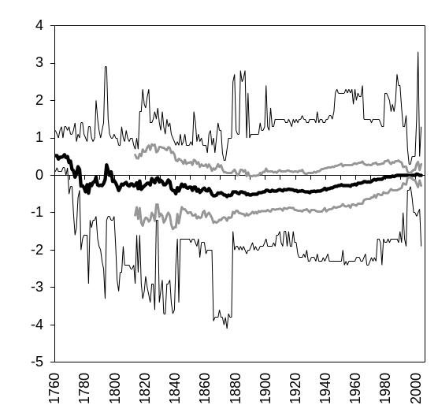
Fig.4. Difference series between homogenised and original instrumental temperature data in Central Europe (annual means)
1: mean over a sample of 131 series, 2: 67% range 3: total range of all adjustments

This brings us right to the leading poblem in regard to the early instrumental period. As already argued, network density does not meet the necessities defined by spatial de-correlation in many regions. One way to overcome this problem is an increased effort to search for and to implement metadata into the process of homogenising. This helps to reduce the problem and has lead to some well founded solutions of the early instrumental homogenising problem. But there remain always some open questions – and they become more and more serious the further a series reaches back into the 18th century.
Therefore, another path should increasingly be followed and would make us aware at least about the credibility of what we know about climate in the early instrumental period. It is the concept of abandoning the usually assumed priority of “measured data” versus proxies, by replacing this priority with a search for consistencies (or inconsistencies) in a multi-proxy analysis where early instrumental data are regarded as questionable themselves (and not as the “ground truth” beyond any discussion).
A few respective studies have been performed so far or are currently being done. Here we mention,two which deal with a prominent and interesting feature of many early temperature series – a high temperature-level in a warm period near 1800 (e.g. in Central Europe) and an even warmer one before (e.g. in Sweden). So far the respective “consistency approaches” have not brought clear and quantitative results. The Central European case has produced several arguments contra the instrumental evidence (from tree-ring and glacier data and from some metadata about sheltering problems…) and some pro (physical consistency with air pressure series, some documentary evidence, single findings from lake deposits, not yet fully understood ice core evidence…). The Swedish case (Stockholm and Uppsala) used instrumental air pressure and cloudiness information together with intensive station history research and some documentary evidence on harvest dates in the region. It also ended with a formulation of doubts about a too high measured temperature level and with a pleading for increased respective data and research activities in the early instrumental period.
After the predominantly critical passages above, a concluding example shall indicate that carefully deduced early instrumental data can indeed be used to study interesting features of climate variability having happened in those roughly 100 years. The legendary “year without a summer” (1816) for example is documented in regions like Central Europe by more than 20 instrumental series. They quantitatively confirm this summer to having been the coldest on record not only in America (where the expression was first used). But it allows also for setting this single summer in relation to the extraordinary decade of the 1810s in general which brought one of the most pronounced sudden climate drops ever recorded. Paleo-runs with climate models have provided a coherent explanation (enhanced volcanism together with reduced solar activity at the end of the so called “Dalton Minimum”) for the cooling. The fact that the sudden temperature drop happened already some years before 1815 makes it advisable to prefer the expression “volcanic years” to the often heard arguing with the Tambora eruption alone (April 1815). Anyway the 1810s initiated also the last major glacier advances which culminated in the 1820s and in the mid 19th century in one of the most advanced glacier stages of the post-glacial period (compare the respective chapter).

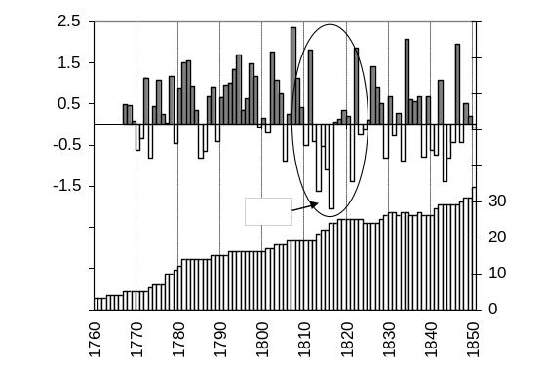
Fig.5. Early instrumental summer-temperature series averaged over 5 (1767) to 34 (1850) single station series in Central Europe.
top: JJA-temperature anomalies (relative to the 1901-2000 average)
bottom: network evolution

References fur further reading:
Böhm R, Auer I, Brunetti M, Maugeri M, Nanni T, Schöner W. 2001. Regional temperature variability in the European Alps 1760-1998 from homogenized instrumental time series. International Journal of Climatology. 21: 1779-1801.
Lamb HH. 1995 (2nd ed.). Climate, History and the Modern World. Ruthledge, 433 pages
Harington CR, ed., 1992: The year without a summer? World climate in 1816. 40 contributions on 576 pages published by the Canadian Museum of Nature, Ottawa (Cat.No. NM95-20/1 1991-E)
Moberg A, H Alexandersson, H Bergström, PD Jones. 2003. Were southern Swedish temperatures before 1860 as warm as measured? International Journal of Climatology. 23: 1495-1521
v.Rudloff H. 1967. Die Schwankungen des Klimas in Europa seit Beginn der regelmäßigen Instrumentenbeobachtungen. Vieweg, Braunschweig

web-information (used also for his article):
http://www.cru.uea.ac.uk, (global) http://www.zamg.ac.at/ALP-IMP (Central European)

Correspondence to:
Reinhard Böhm
Central Institute for Meteorology and Geodynamics, Hohe Warte 38, A-1190 Vienna, Austria
Tel. +43 1 36026 2203
FAX: +43 1 36026 72
e-mail: reinhard.boehm@zamg.ac.at

