Temperature reconstruction using ice cores

Elisabeth Schlosser, Institute of Meteorology and Geophysics,
University of Innsbruck, Austria

Ice cores are one of the most successful tools in paleoclimatology. The huge ice sheets of Greenland and Antarctica provide a climate archive that meanwhile goes back 800,000 years into the past. The physical and chemical properties of the ice yield valuable information about former air temperatures, the chemical composition of the past atmosphere, volcanic activity and even about the strength and frequency of storms in former climates.
Glacier ice develops from snow that is compressed under its own weight until its density is so high that it becomes ice. Still, its density is lower than that of normal water ice, which we would get if we put a box with water into the freezer. Therefore, glacier ice contains little air bubbles, that can be investigated to get information about the composition of the atmosphere of the past.
Ice cores of Greenland and Antarctica yield the oldest ice, since the ice sheets are several kilometers thick (the largest ice thickness found in Antarctica is about 4.5km), but of course, ice cores can be drilled also in smaller ice caps or glaciers, as long as the ice is “cold”, which by definition means that no melting of the snow and ice occurs in summer. Melt water would penetrate the upper layers of the ice sheet, so that the properties we measure at the core are blurred.
The first ice core was drilled in Greenland (Camp Century) in the 1960s by Americans, and it was analyzed by Danish scientists. Big coring augers are used to get a cylinder of ice, about 10 cm in diameter and several meters long. By repeating the coring procedure one finally gets a whole ice core of several kilometres length.
For temperature reconstruction, the best method is the measurement of the so-called stable isotope ratio of water. To understand this, we have to remember our school chemistry: We have learned that each atom consists of a nucleus made of protons (with a positive charge) and neutrons (with no charge), surrounded by a cloud of electrons (with negative charge). Whereas the number of protons and electrons is the same in all atoms of one particular element, the number of neutrons can differ, e.g. the element oxygen has eight protons and eight electrons, but can have eight, nine or ten neutrons. This means that there are three different “types” of oxygen, or three different isotopes. The term “stable” isotopes is used, because there are also isotopes that are radioactive and decay. The “normal” oxygen (O) has eight neutrons, which leads to an atomic weight of 16. Therefore it is written as ¹⁶O. Analogously we speak of ¹⁷O and ¹⁸O. Hydrogen also has two different isotopes, the normal H with only one proton and the heavier one that has one proton and one neutron, the so-called deuterium. So water molecules, which consist of one oxygen atom and two hydrogen atoms, can have different molecular weights, depending on which types of isotopes they are made of.
The important thing is that the heavier water molecules tend to evaporate a bit slower and condense faster than the lighter ones. Thus the ratio of the heavy isotopes to the light isotopes is not constant, but changes during condensation and evaporation processes. In ice cores, usually the ratio of ¹⁸O to ¹⁶O is measured. Since relative concentrations can be measured more easily than absolute ones, normally this ratio is given in the so-called δ-notation:

δ¹⁸O =
(¹⁸O/¹⁶O)_{sample} – (¹⁸O/¹⁶O)_{SMOW}
(¹⁸O/¹⁶O)_{SMOW}
where SMOW refers to “Standard Mean Ocean Water”.It is important to have a "standard" water, which is easily reproducible and to which other waters can be compared. Fortunately, ocean water can provide such a standard. The isotopic composition of deep offshore ocean water is remarkably uniform across the Earth. This has been used to create the so-called Standard Mean Ocean Water (SMOW). Later, a new standard, the VSMOW (Vienna Standard Mean Ocean Water) was defined by the IAEA (International Atomic Energy Agency)), which is currently used. During ice ages, the oceans had a higher stable isotope ratio than today (between one and two permille for δ¹⁸O), because additional water depleted in ¹⁸O was contained in the ice sheets. This has to be taken into account for ice core interpretation. However, for one climate period it may be assumed to be constant. So, how can we derive the temperature from the δ¹⁸O profile of an ice core? On expeditions that led from the coast of Greenland or Antarctica to the interior of the continent, the mean annual air temperature and the δ¹⁸O of the snow were measured. Since the altitude of the ice sheets increases towards the interior, the air temperature and the δ¹⁸O decrease. It was found that there is a simple linear relationship between the two variables. Why is this so? To understand this, we have to follow the path of the precipitation from the beginning to the final snowfall. This is shown in Fig. 1: During the first evaporation from the ocean, the heavier isotopes are slower to evaporate than the lighter ones, thus the first water vapour is relatively light compared to the ocean water. The air and thus the water vapour is raised and cooled until the first condensation takes place and clouds are formed. Now the heavier molecules condensate earlier than the light ones, thus the process is reversed and the first raindrops in the cloud have again the same isotope ratio as the ocean water. Now the air mass and thus the cloud is moved, let’s say, in case of Antarctica, southward, which means the air is cooled and further condensation takes place. Again,
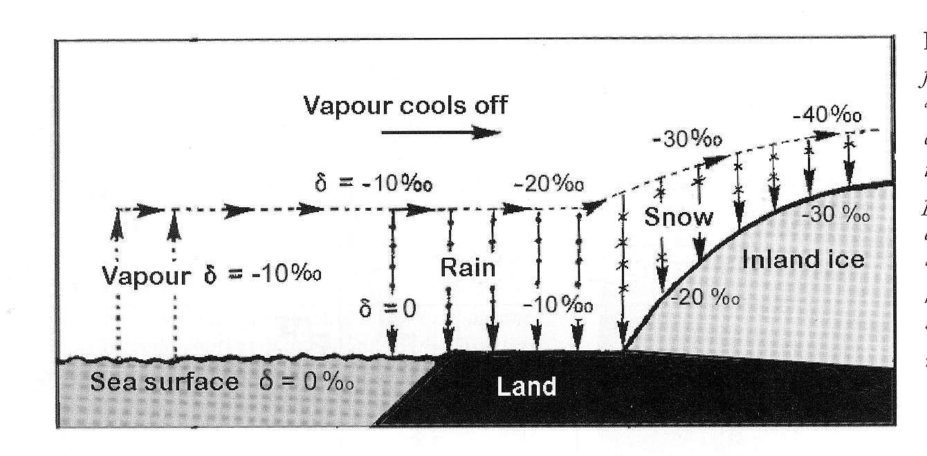
Fig. 1: Changes in δ¹⁸O from the first evaporation to the final snow fall (after Dansgaard, 2004)

the heavier isotopes condense earlier, thus the rain or snowfall contains heavier water, whereas the remaining moisture in the cloud gets lighter and lighter. At the edge of the continent, the air is raised due to the increasing altitude of the ice sheet surface, and thus cooled even stronger. (The air temperature decreases with altitude and with latitude.) The farther inland the snow falls, the lower is the isotope ratio, since most of the heavier isotopes have fallen out already at lower latitudes. Thus we get a relationship between the stable isotope ratio and the temperature the air had when the precipitation was formed. Fig. 2 shows the δ¹⁸O profile of a “shallow” core that has been drilled close to the German Antarctic wintering base “Neumayer”. We can see that the δ¹⁸O oscillates: we find high values in summer and low values in winter. Thus we can find the annual layers in the core. The red lines mark the borders between two annual layers. By counting the annual layers we can determine the age of the ice. This method works only until a certain depth, because, as mentioned above, the ice is compressed under its own weight, and at some point the annual layers become so thin that it is impossible to distinguish single annual layers. Other dating methods are used for these parts of ice cores, for example:

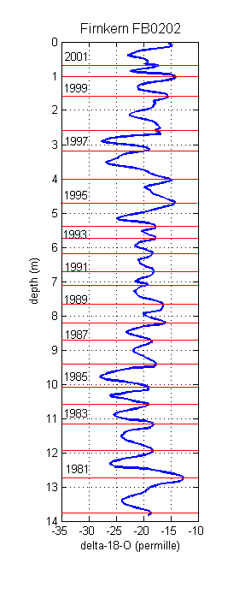
Fig. 2: δ¹⁸O profile from a shallow firn core drilled at Neumayer Station, Antarctica

- identifying horizons of known age, such as acid layers from dated volcano eruptions,
- matching features of the δ¹⁸O record with another dated climatic record, such as ocean or lake sediments, or
- radiocarbon dating of CO₂ extracted from air bubbles in the ice.
Although it is clear, that there is a strong relationship between temperature and isotope ratio, the quantitative conversion of δ¹⁸O to air temperature is a problem. Willi Dansgaard, one of the pioneers in the isotope and ice core business, has always stressed, that only the changes in δ¹⁸O should be shown in the diagrams, never the change in temperature. Even today, after almost 40 years of ice core research, the problem remains unsolved.
There are many different reasons for the persistent uncertainty. The δ¹⁸O is influenced by many other factors apart from air temperature, such as the original isotope ratio of the ocean water (which was different from today during ice ages), the origin of precipitation and the seasonal distribution of snowfall events. Additionally to these meteorological factors, there are glaciological influences. It has to be taken into account, that the ice flows and thus the ice in the core might come from areas of higher altitude, which are cooler than the drilling site. Also, during glacial periods the altitude of the ice sheet was higher than today, thus the ice in the core might originate from a cooler area than today. Scientists have also measured today’s temperature in the bore holes of the ice cores. Although the signal is considerably attenuated, one can still find the colder ice ages and warmer interglacials in the cores, and by using physical laws, the scientists can calculate the original temperature profiles (this is discussed further in another article), which, especially for Greenland, yielded results different from the ones retrieved by measuring stable isotope ratios. So the discussion about this is still going on at present.
However, the signal is clear enough to distinguish between ice ages and warmer climate periods, and, for example, to see the so-called “Little Ice Age” in high resolution ice cores. Compared to other climate proxies like lake and ocean sediments, the ice cores have the big advantage of relatively high resolution, which is sub-annual for many regions, at least in the upper parts of the cores. Thus they are a most valuable tool for investigating the climate of the past.
The currently observed phenomenon of “Global Warming” is a widely discussed issue today, and the media love to present as extreme as possible future climate “scenarios”, if not “predictions”. However, as long as we have not completely understood the mechanisms that led to climatic change in the past, we cannot “predict” the climate of the future. We have made large progress with help of the ice cores, but still there are many problems unsolved.

Further reading:

Dansgaard, W., 2004: Frozen Annals, Narayana Press, Odder, Denmark, 122 pp.

Alley, R., The Two-Mile Time Machine, 2000: Ice Cores, Abrupt Climate Change, and Our Future. Princeton University Press, 240 pp.

Mayewski, P.A., F. White, L. Margulis, 2002: The Ice Chronicles: The Quest to Understand Climate Change. University Press of New England, 264 pp.

Reconstruction of Ground Surface Temperature History from Borehole Temperature Profiles, Henry N. Pollack.

