Marine Sediment Proxy Records

Why Study Ocean Water Temperature?
The oceans cover over 70% of the Earth’s surface and influence climate on a global scale. Heat exchange between the ocean’s surface and the atmosphere is crucial to both oceanic and atmospheric circulation patterns. All ocean basins are connected, and ocean waters flow from basin to basin in a continuous, closed fashion driven by differences in water temperature and salinity (and hence density). This is often called the thermohaline ‘conveyer belt’. Heat is released to the atmosphere at high latitudes in the North and South Atlantic, where cooling surface waters sink down to form cold, deep water that flows from the Atlantic into the Indian and Pacific Oceans. These deep flows surface again in the northern Indian and Pacific Oceans, to travel back to the Atlantic as warmer, shallow water currents. Thermohaline circulation influences climate on millennial to multi-centennial time-scales, for example, changes in the mode and rate of deep water formation have been postulated to explain colder climate during the Little Ice Age (ca. 1700 to 1900 A.D.).
On shorter, interannual to decadal timescales, global sea surface temperatures are strongly influenced by atmospheric variability. Prominent climatic phenomena include the North Atlantic Oscillation (NAO) and El Niño Southern Oscillation (ENSO). The first refers to shifts in the gradient of atmospheric sea-level pressure between the Arctic/Icelandic region and the subtropical region near the Azores, which either strengthens or weakens the Westerlies blowing over the Atlantic. This phenomenon is strongly reflected in European climate patterns. The Southern Oscillation refers to the quasi-cyclic behaviour of the interaction between the atmosphere and the equatorial Pacific. An El Niño event is reflected by an anomalous warming of surface ocean waters in the eastern tropical Pacific, lasting three or more seasons, due to diminished strength of westward blowing trade winds in connection to shifting atmospheric pressure anomalies over Darwin (Australia) and Tahiti (South Pacific). This leads to a drastic decrease in fish populations along the coasts of Ecuador and Peru. On neighbouring continents it is linked to extreme weather patterns such as droughts, heavy rainfall and floods. Seasonally, sea surface temperatures vary mainly due to changes in the duration and intensity of sunlight (long summer vs. short winter days) as well as storm activity.

Hazards of Heating the Oceans
Seawater retains heat much better than air, leading to the supposition that most heat related to global warming would be expected to be incorporated into the oceans. Interactions between the atmosphere and the oceans, and thus global climate patterns, are likely to change under the influence of increased surface ocean temperatures. Ocean water temperatures strongly influence the abundance and distribution of marine animals and plants, of crucial importance to fisheries. Warming of sea surface waters can cause marine ecologies to shift their habitat and/or to be disrupted from stability. El Niño events are prime examples of such (regional) disruptions.

How do we reconstruct past seawater temperatures?
Reliable seawater temperature estimates are crucial to any reconstruction and modeling of past ocean salinity and density, water column stratification, thermohaline circulation, and ice volume. A number of proxies are available for this purpose; the main and most commonly used methods are
discussed in the sections below. Ongoing research will likely provide more detailed insights to existing proxies, the development of new ones, as well as improved measurement techniques.
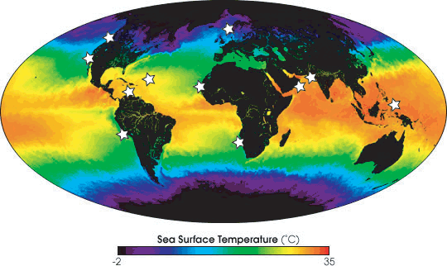
Figure 1: Global sea surface temperature as measured by moderate-resolution imaging spectroradiometer (MODIS; one month composite of May 2001). Star symbols indicate locations from where marine sediments with interannual to centennial resolution have been recovered.

MODIS image courtesy of NASA (modis.gsfc.nasa.gov).

I. Faunal and floral assemblages
Temperature calculations based on faunal and floral microfossil assemblages have been widely applied, using various well-established statistical techniques and regional or global calibration datasets. This methodology builds on the fact that the abundances and geographic distribution of different marine plankton species are tightly linked to sea surface temperature (SST), and that the percentages of different species contained in a fossil assemblage also reflect the sea surface temperatures they originally lived in. The main marine microfossil groups studied include planktonic foraminifera (calcareous unicellular zooplankton), radiolaria (siliceous unicellular zooplankton), and diatoms (siliceous unicellular phytoplankton).
The transfer technique is based on grouping species within an assemblage by Q-mode factor analysis, which is subsequently related to SST by multiple linear regression in the calibration process. An alternative approach, the modern analog technique (MAT), statistically compares fossil assemblages to modern assemblages that are tagged with the overlying modern SST. Both methods are dependent on extensive reference data sets that must be calibrated to present-day SST. Overall, there seems to be little difference in results between the two methods, as long as the fossil group and calibration sets are the same. The accuracy of SST estimates varies per calibration, but is typically 1-2ºC. An improvement of the paleotemperature determinations mainly depends on the improvement of the reference data set, by adding more core-top samples and applying uniform taxonomy. One major limitation is posed by the degree of preservation of the fossil assemblages used. Typically, dissolution will preferentially affect fragile, thinly walled species, which commonly are indicators of warmer SST, thereby introducing a bias towards cooler SST reconstructions.

II. Foraminifer shell chemistry
A primary measure of (past) ocean water temperatures lies in the chemical analysis of calcite shells of marine organisms called foraminifera. Foraminifera are single-celled protists that secrete calcium carbonate shells around their cells. The chemistry of these calcite shells provides information about the chemical and physical conditions in which they grew. Two main types of foraminifera are distinguished, both comprising numerous different species. Planktonic foraminifera live in the upper few hundred meters of the water column, whereas benthonic foraminifera live on, or within, the seafloor. Foraminifer shells are abundantly found as fossils in marine sediments and thus serve to reconstruct past ocean conditions, particularly surface and deep-sea water temperatures.
Box 1: Generic paleotemperature equation
Where T is temperature, a, b and c empirically derived constants, 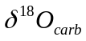 the oxygen isotopic composition of the solid carbonate, 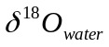 the oxygen isotopic composition of the water in which the carbonate precipitated. The quadratic fit is based on theoretical predictions of the nature of isotopic fractionation at low vs. high temperatures. However, linear (c=0) and quadratic (c≠0) fits have proven to fit experimental data equally well at warm oceanic temperatures, within a precision of 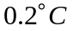.

Note that the following geochemical methods are also extensively used in tracking seawater temperature variability in other biogenic carbonates, such as corals and bivalves.

II(a) Stable oxygen isotope composition
The oxygen isotope composition of foraminiferal calcite (δ¹⁸O_{carb}) depends on the ambient water temperature at the time of calcification. The other most important factor is the isotopic composition of the seawater, correlated to local salinity, which varies through time and from place to place. In the longer term (millennial scale), seawater is affected by whole-ocean shifts in oxygen isotopic composition reflecting storage of lighter oxygen isotopes in continental ice sheets. Thus, temperature estimates have to be corrected for seawater composition (see Box 1).
The reconstruction of temperatures is further complicated by a strong linear correlation between δ¹⁸O_{carb} and the carbonate chemistry (pH and/or carbonate ion concentration) of the ambient water as well as species-specific differences in δ¹⁸O_{carb} (caused by so-called ‘vital effects’), as demonstrated in laboratory cultures of living foraminifera.
The ratio of the heavy isotope ¹⁸O to the lighter ¹⁶O measured in a given carbonate shell is reported as a deviation from the same ratio measured in a standard, in permil (‰). One permil corresponds to an apparent change in temperature of about 5ºC. Standard errors of various paleotemperature equations are estimated to be ±0.4-0.7ºC.

II(b) Mg/Ca values
The elemental ratio of Mg to Ca (Mg/Ca, in mmol/mol) of foraminiferal calcite increases exponentially with temperature. This relationship is thermodynamic in origin, but substantial deviations between different foraminifer species are attributed to physiological factors (‘vital effects’). These deviations are empirically calibrated with the help of laboratory culturing experiments. The accuracy of temperature estimates from Mg/Ca in foraminifera is about 1 to 1.6ºC.
Calcite dissolution, which increases with water depth, affects Mg/Ca ratios in foraminiferal shells by preferential removal of Mg. This preservation bias leads to an underestimation of water mass temperatures. However, as long as the sediment core position is at least 100m above the calcite saturation depth (the lysocline), this bias is minimized.
This method of paleothermometry is widely used and has proven very useful because it allows for more accurate estimates of paleo-
δ¹⁸O_{water} values (affected by changes in salinity and ice-volume, see above) from the
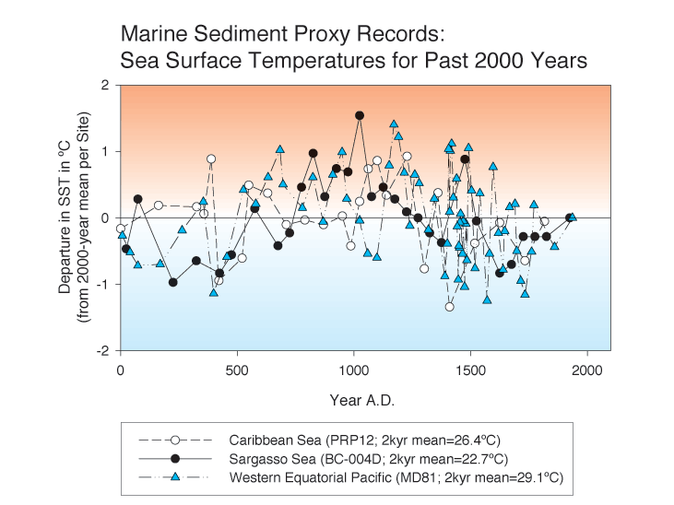
Figure 2: Mean sea surface temperature (SST) proxy records for the past 2000 years. SST reconstructions from the Caribbean and Sargasso Seas are derived from stable oxygen isotopes in planktonic foraminifera, whereas the record from the western Equatorial Pacific is based on foraminiferal Mg/Ca ratios. To facilitate comparison, each record was normalised by its 2000 years (=2kyr) mean value to depict the departure in SST, in ºC. Data adapted from Nyberg et al. (2002), Keigwin (1996), and Stott et al. (2004).

oxygen isotope composition of the same calcite, using the oxygen isotope paleotemperature equation. Surface ocean salinity depends primarily on the balance between precipitation and evaporation, thus strongly reflecting atmospheric and climatic variability.

III. Alkenone unsaturation index
Another widely applied proxy, that offers sea surface temperature (SST) estimates independently from those derived from foraminiferal shell chemistry and microfossil assemblage studies, is based on the organic molecules produced by phytoplankton; namely single-celled, marine algae called coccolithophores. Only a few species, Emiliania huxleyi and Gephyrocapsa oceanica, have been identified to produce long-chain, unsaturated methyl and ethyl ketones (alkenones). These alkenones have various chain lengths (C₃₇, C₃₈, and C₃₉) and two or three double bonds. The ratio of di- and tri-unsaturated C₃₇ alkenones changes linearly with the ambient temperature in which they are produced, as empirically determined by numerous laboratory culture experiments. This ratio appears to be stable after incorporation into marine sediments, and thus offers reconstruction of past sea surface temperatures. The precision (±1 std) of the temperature determination is better than 0.3ºC.

A global calibration of the alkenone unsaturation index in surface sediment samples to annual mean SST has shown that seasonality of primary production and variations in growth rate of the algae seem to have no strong effect on the linear relationship that was established from culture experiments. The standard error of the SST estimate using the surface sediment calibration is about 1 to 1.5ºC. In some cases, the method may be limited due to the lack of sufficient organic material contained in the sediments.

Multi-proxy approach
The use of more than one paleotemperature proxy within one and the same marine sediment record is recommendable. This allows to separate the SST from the salinity signal (in case of the foraminiferal Mg/Ca and δ¹⁸O_{carb} values), to assess and resolve seasonal SST signals (δ¹⁸O_{carb} of various planktonic foraminifer species; alkenone vs. foraminifer-based proxies) as well as to verify the consistency of results between different methods. Ultimately, paleotemperature variability and trends reconstructed from marine sediments should be correlated to other marine proxy records (such as corals and bivalves) and span the bridge towards terrestrial proxy records (such as lake sediments and ice cores) at comparable time resolution.

Temporal Resolution of Marine Sediments
Work on decadal to centennial timescales demands a very tight age control and precise correlation between proxy records if robust conclusions are to be made about rapid changes or events of short duration. Radiocarbon dating is the most common technique used to date marine sediments, usually carried out on biogenic carbonate (for example planktonic foraminifera) or organic matter. Carbon contained in ocean surface waters is older than the carbon in the atmosphere, the so-called reservoir effect. Therefore, an additional correction needs to be made to convert marine radiocarbon dates to calendar years to enable adequate correlation between various marine records as well as with terrestrial proxy records. In addition, special coring techniques are required to minimize the disturbance of the uppermost centimeters of sediment, which are poorly compacted and therefore easily lost in the coring process.
In recent years, studies of marine sediments have extended to higher temporal resolution. Temporal resolution of marine sediment records (i.e. how much time is contained within and in what detail) varies greatly due to large regional differences in sedimentation rates and bioturbation. Bioturbation is the mixing of sediments by the burrowing activity of organisms that live at the seafloor, thus averaging out the climatic signals (such as temperature) originally contained in seasonal and annual deposits. Annual and decadal resolution is only acquired in select areas, with rapid, continuous deposition and/or limited bioturbation. Rapid deposition is typically found in highly productive areas, such as upwelling regions off north- and southwest Africa, western South America and the Arabian Peninsula, but bioturbation affects the record. The restriction of deep-water circulation or depletion of oxygen in bottom waters (in so-called ‘oxygen minimum zones’) promotes the undisturbed sedimentation of particles by minimizing bioturbation, resulting in annually laminated (also called varved) sediments that may contain seasonally distinct features. Examples of such high-resolution marine sediment records have been recovered from the Saanich Inlet (British Columbia), Santa Barbara Basin (Californian Margin), Norwegian fjords, and Arabian Sea (Pakistan Margin). More typically, centennial to millennial resolution is found in the open marine environment from which we can gain invaluable information on longer-term climate variability, in which the oceans play a crucial and large role.

Sources and Selected References
Bemis, B.E., Spero, H.J., Bijma, J., and Lea, D.W., 1998. Reevaluation of the oxygen isotopic composition of planktonic foraminifera: Experimental results and revised paleotemperature equations. Paleoceanography 13(2), 150-160.

Broecker, W.S., 2000. Was a change in thermohaline circulation responsible for the Little Ice Age? PNAS 97(4), 1339-1342.

Burroughs, W.J., 2001. Climate Change – A Multidisciplinary Approach. Cambridge University Press, Cambridge, UK, 293 pp.

Fisher, G., and Wefer, G. (Editors), 1999. Use of Proxies in Paleoceanography – Examples from the South Atlantic. Springer-Verlag, Heidelberg Berlin, Germany, 735 pp.

High(er) Resolution Proxy Records:
Keigwin, L. D., 1996. The Little Ice Age and Medieval warm period in the Sargasso Sea. Science 274, 1504-1508.

Nyberg, J., Malmgren, B. A., Kuijpers, A., and Winter, A., 2002. A centennial-scale variability of tropical North Atlantic surface hydrography during the late Holocene. Palaeogeogr. Palaeoclimatol. Palaeoecol. 183, 25-41.

Stott, L., Cannariato, K., Thunell, R., Haug, G.H., Koutavas, A., and Lund, S., 2004. Decline of surface temperature and salinity in the western tropical Pacific Ocean in the Holocene epoch. Nature 431, 56-59.

Zhao, M., Eglinton, G., Read, G., and Schimmelmann, A., 2000. An alkenone (U^{K’}₃₇) quasi-annual sea surface temperature record (A.D. 1440 to 1940) using varved sediments from the Santa Barbara Basin. Organic Geochemistry 31, 903-917.

Jorijntje Henderiks,
Department of Geology and Geochemistry, Stockholm University

