DAY 1:
- What is the standard structure of a springboot application?
A Spring Boot application is organized into distinct layers, each with a clear responsibility. Understanding this structure is the single most important thing before writing any code — once it clicks, everything else falls into place naturally.
Here are the two things to understand first: the folder/package structure (where files live on disk), and the layer architecture (how those files communicate at runtime).

Package structure
Every Spring Boot project follows this convention, rooted under your base package (e.g. com.upstart.hotel):
src/
└── main/
├── java/
│ └── com/upstart/hotel/
│ ├── HotelApplication.java ← entry point
│ ├── config/ ← security, beans, CORS config
│ ├── controller/ ← REST endpoints
│ ├── service/ ← business logic
│ ├── repository/ ← database access
│ ├── model/ ← JPA entities (DB tables)
│ ├── dto/ ← request/response objects
│ ├── exception/ ← custom exceptions + handler
│ └── security/ ← JWT filters, UserDetails
└── resources/
├── application.properties ← DB URL, JWT secret, etc.
├── static/ ← (only if serving HTML)
└── templates/ ← (only if serving HTML)

The layer architecture
The key mental model is a strict top-down call chain. A request enters at the top and data flows down to the database, then back up:
HTTP Request
↓
Controller (receives the request, validates input, calls service)
↓
Service (all business logic lives here, calls repository)
↓
Repository (speaks to the database, returns entities)
↓
Database (MySQL)
Each layer only talks to the one directly below it. Your controller never touches the repository directly, and your repository never contains business logic. This separation is what makes the codebase maintainable.
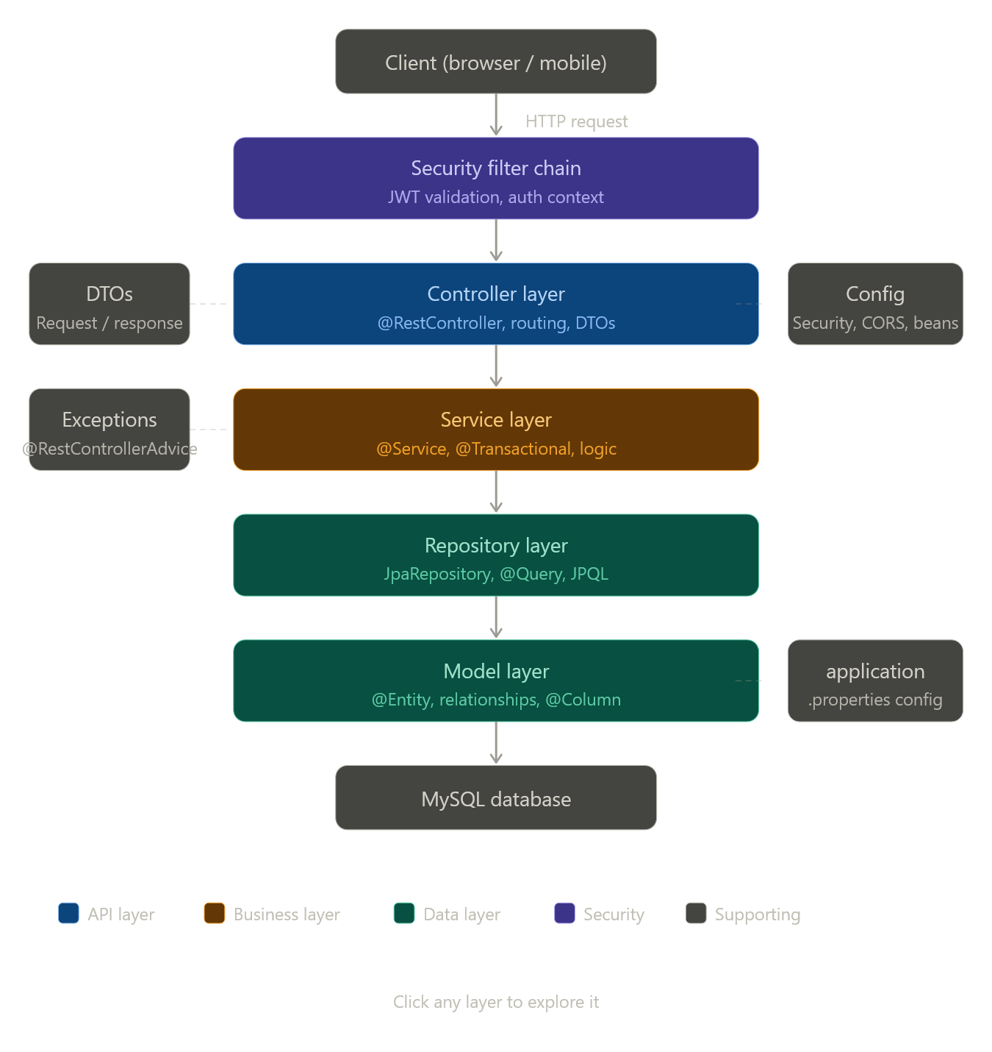
Here's how each piece looks in code:---
What each layer does in plain terms
The Controller is the door — it receives HTTP requests, extracts data from them (path variables, request body, params), hands the work off to the service, and returns the result as JSON. It should contain almost zero logic.
The Service is the brain — it holds all your business rules. For a hotel system, this is where "is the room available for these dates?", "apply the discount for loyalty members", and "cancel the booking and trigger a refund" all live. It's annotated with @Service and @Transactional where needed.
The Repository is the hands — it talks to the database. You mostly just define an interface extending JpaRepository<Room, Long> and Spring generates the SQL for you. For complex queries you add @Query with JPQL.
The Model is the blueprint of your data — each class maps to a database table. Room, Booking, Guest, Payment would all be model classes annotated with @Entity.
The DTO (Data Transfer Object) is the envelope — you never expose your raw entity classes directly to the client. A BookingResponseDto might include room name and guest email without exposing internal fields like database IDs or audit timestamps.
The Config package holds beans and framework configuration — your SecurityFilterChain, CORS settings, and any custom Spring beans you need.
The Exception package holds your custom exception classes (RoomNotAvailableException) and a single @RestControllerAdvice class that catches them and returns clean JSON error responses.

- Is this a standard that is recommended or it’s a must to code my application that way?

Great question — and it's worth being precise about this.
It is not a must. Spring Boot itself imposes almost no structure on you. You could technically write your entire application in a single file and it would compile and run. Spring only requires that your main class with @SpringBootApplication exists and that your components are in a package it can scan.
What the layered structure is, then, is a strong community convention — not a framework rule. It's the pattern the entire Java ecosystem has converged on over decades, documented in official Spring guides, taught in every course, and used in virtually every professional codebase. When another developer opens your project, they expect to find controller/, service/, repository/ — and if they don't, they'll be confused.
So the more useful way to think about it is this: you can break the rules, but each rule you break has a real cost.
What breaks when you skip layers
If you put database queries directly in your controller, that controller becomes impossible to unit test — you can't test your logic without also spinning up a database. If you put business logic in your repository, two different features that share that data access code will start fighting over it. If you expose JPA entities directly as API responses, your database schema and your API contract become the same thing — change one, you break the other.
The structure isn't bureaucracy for its own sake. Each boundary solves a specific problem you will eventually run into if you ignore it.
What is actually flexible
The package names themselves are just convention — you could call it web/ instead of controller/ and nothing breaks. Small projects sometimes merge the DTO and model layers. Some teams skip the service layer for very simple CRUD endpoints where there's genuinely no business logic. These are legitimate choices.
What isn't really flexible for a serious project is the concept of separation — keeping HTTP concerns out of database code, keeping business logic out of framework wiring. The exact folder names matter far less than that.
The bottom line for you
Since you're building Upstart Cameroun as a real platform and not just a learning exercise, I'd recommend following the standard structure closely. Not because Spring forces it, but because when you come back to the codebase in three months, or when a collaborator joins, the structure will pay for itself immediately. The discipline of "controllers don't touch repositories" will also catch design mistakes early, before they become hard to untangle.

DAY 2:
- What happens at the start.spring.io website when creating a springboot application? What is the standard?

Good question. What start.spring.io does is generate a project skeleton for you — it's essentially a code generator that saves you from manually setting up build files, folder structure, and dependency configuration from scratch.
Here's exactly what happens and what each choice means:

The choices you make on the page
Project — Maven or Gradle. This is your build tool. Maven uses pom.xml, Gradle uses build.gradle. Maven is the more common choice in enterprise Java, and it's what most Spring Boot tutorials use. Stick with Maven unless you have a reason not to.
Language — Java, Kotlin, or Groovy. You're using Java.
Spring Boot version — pick the latest stable release (not a SNAPSHOT, not a Release Candidate). At the time of writing that's 3.x.
Project Metadata — this is important:
- Group is your organisation's reverse domain, e.g. com.upstart. This becomes the root of your Java package structure.
- Artifact is your project name, e.g. hotel. This becomes the folder name and the JAR filename.
- Name is the display name — usually same as Artifact.
- Package name is auto-filled as com.upstart.hotel — this is the base package all your code lives under.
- Packaging — choose Jar. This bundles everything including the embedded Tomcat server into one runnable file.
- Java version — pick 21 (the current LTS) or 17 if your environment requires it.
Dependencies — this is the most important part. You're telling Spring what your app needs, and it adds the right entries to your pom.xml. For a hotel booking system the standard set would be:
- Spring Web — enables REST controllers and the embedded Tomcat server
- Spring Data JPA — enables repositories and ORM via Hibernate
- MySQL Driver — JDBC driver so your app can talk to MySQL
- Spring Security — authentication and authorization framework
- Lombok — reduces boilerplate (getters, setters, constructors via annotations) — though based on your past experience you may prefer to skip this and write manually
- Validation — enables @NotNull, @Email, @Size on your DTOs
- Spring Boot DevTools — auto-restarts the app when you save changes during development

What you actually download
When you click Generate, you get a .zip file. Inside it is a complete, ready-to-import project with:
hotel/
├── pom.xml ← all your dependencies declared here
├── src/
│ ├── main/
│ │ ├── java/
│ │ │ └── com/upstart/hotel/
│ │ │ └── HotelApplication.java ← the entry point
│ │ └── resources/
│ │ └── application.properties ← empty config file
│ └── test/
│ └── java/
│ └── com/upstart/hotel/
│ └── HotelApplicationTests.java
That's it. No controllers, no services, no entities — just the skeleton. Everything else you build yourself by creating packages and classes inside com/upstart/hotel/.

The one file that matters most at this stage
pom.xml is what Spring Initializr really generates for you. Here's what the relevant section looks like for the dependencies above:
<dependencies>
<dependency>
<groupId>org.springframework.boot</groupId>
<artifactId>spring-boot-starter-web</artifactId>
</dependency>
<dependency>
<groupId>org.springframework.boot</groupId>
<artifactId>spring-boot-starter-data-jpa</artifactId>
</dependency>
<dependency>
<groupId>com.mysql</groupId>
<artifactId>mysql-connector-j</artifactId>
<scope>runtime</scope>
</dependency>
<dependency>
<groupId>org.springframework.boot</groupId>
<artifactId>spring-boot-starter-security</artifactId>
</dependency>
<dependency>
<groupId>org.springframework.boot</groupId>
<artifactId>spring-boot-starter-validation</artifactId>
</dependency>
</dependencies>
Notice the naming pattern — almost everything is a spring-boot-starter-*. A starter is a pre-packaged bundle of related libraries. spring-boot-starter-web for example pulls in Spring MVC, Jackson (for JSON), and Tomcat all at once. You don't have to find and wire each library individually.

What HotelApplication.java looks like
package com.upstart.hotel;

import org.springframework.boot.SpringApplication;
import org.springframework.boot.autoconfigure.SpringBootApplication;

@SpringBootApplication
public class HotelApplication {
public static void main(String[] args) {
SpringApplication.run(HotelApplication.class, args);
}
}
@SpringBootApplication is actually three annotations in one: it enables auto-configuration, component scanning (so Spring finds all your @RestController, @Service, @Repository classes), and configuration support. This one class is the only thing Spring Initializr writes for you in Java — the rest is yours to build.

The workflow in one sentence
Start.spring.io writes your pom.xml and folder skeleton so you can open IntelliJ, import the project, and immediately start creating your own packages and classes without any manual setup.

- Now that we have the general overview of what a springboot application looks like, let’s dive a little deeper. For each of the layers in the project folder give me an example of the type of code that can be found inside.

Perfect timing to go deeper. Let's walk through each layer with a concrete example, all tied to the hotel booking system so it's consistent. I'll go top to bottom, the same way a request flows through the app.

1. Model layer — model/Room.java
This is where you start, because everything else depends on knowing what your data looks like. A model class maps directly to a database table.
package com.upstart.hotel.model;

import jakarta.persistence.*;

@Entity
@Table(name = "rooms")
public class Room {

@Id
@GeneratedValue(strategy = GenerationType.IDENTITY)
private Long id;

@Column(nullable = false)
private String roomNumber;

@Column(nullable = false)
private String type; // SINGLE, DOUBLE, SUITE

@Column(nullable = false)
private Double pricePerNight;

private boolean available;

// constructors, getters, setters
}
@Entity tells Hibernate "this class is a database table." @Table(name = "rooms") tells it what to name the table. @Id and @GeneratedValue handle the primary key. Nothing else in the app knows or cares about SQL — Hibernate translates this class into table operations for you.

2. Repository layer — repository/RoomRepository.java
This is just an interface. You don't write the implementation — Spring generates it at runtime.
package com.upstart.hotel.repository;

import com.upstart.hotel.model.Room;
import org.springframework.data.jpa.repository.JpaRepository;
import org.springframework.data.jpa.repository.Query;
import org.springframework.data.repository.query.Param;

import java.time.LocalDate;
import java.util.List;

public interface RoomRepository extends JpaRepository<Room, Long> {

List<Room> findByAvailableTrue();

List<Room> findByType(String type);

@Query("SELECT r FROM Room r WHERE r.type = :type AND r.pricePerNight <= :maxPrice")
List<Room> findAffordableRoomsByType(@Param("type") String type,
@Param("maxPrice") Double maxPrice);
}
JpaRepository<Room, Long> gives you save(), findById(), findAll(), deleteById() for free. The methods like findByAvailableTrue() and findByType() are derived queries — Spring reads the method name and generates the SQL automatically. The @Query method lets you write your own JPQL when the naming convention isn't enough.

3. DTO layer — dto/RoomResponseDto.java and dto/BookingRequestDto.java
DTOs are plain Java classes with no annotations. They define what data enters and leaves your API — completely separate from your database entities.
package com.upstart.hotel.dto;

// What the API sends back to the client
public class RoomResponseDto {
private Long id;
private String roomNumber;
private String type;
private Double pricePerNight;
private boolean available;

// constructors, getters, setters
}
package com.upstart.hotel.dto;

import jakarta.validation.constraints.*;
import java.time.LocalDate;

// What the client sends when making a booking
public class BookingRequestDto {

@NotNull(message = "Room ID is required")
private Long roomId;

@NotNull(message = "Check-in date is required")
@Future(message = "Check-in must be a future date")
private LocalDate checkInDate;

@NotNull(message = "Check-out date is required")
private LocalDate checkOutDate;

@NotBlank(message = "Guest name is required")
private String guestName;

@Email(message = "Provide a valid email")
private String guestEmail;

// constructors, getters, setters
}
The validation annotations (@NotNull, @Future, @Email) only fire when you put @Valid on the controller method parameter. The entity Room never has these — validation is an API concern, not a database concern.

4. Service layer — service/BookingService.java
This is where the real work happens. All business decisions live here.
package com.upstart.hotel.service;

import com.upstart.hotel.dto.BookingRequestDto;
import com.upstart.hotel.exception.RoomNotAvailableException;
import com.upstart.hotel.exception.ResourceNotFoundException;
import com.upstart.hotel.model.Booking;
import com.upstart.hotel.model.Room;
import com.upstart.hotel.repository.BookingRepository;
import com.upstart.hotel.repository.RoomRepository;
import org.springframework.stereotype.Service;
import org.springframework.transaction.annotation.Transactional;

@Service
public class BookingService {

private final BookingRepository bookingRepository;
private final RoomRepository roomRepository;

public BookingService(BookingRepository bookingRepository,
RoomRepository roomRepository) {
this.bookingRepository = bookingRepository;
this.roomRepository = roomRepository;
}

@Transactional
public Booking createBooking(BookingRequestDto request) {

// 1. Does the room exist?
Room room = roomRepository.findById(request.getRoomId())
.orElseThrow(() -> new ResourceNotFoundException("Room not found"));

// 2. Is the room available?
if (!room.isAvailable()) {
throw new RoomNotAvailableException("Room " + room.getRoomNumber() + " is not available");
}

// 3. Calculate total price
long nights = ChronoUnit.DAYS.between(request.getCheckInDate(), request.getCheckOutDate());
double totalPrice = nights * room.getPricePerNight();

// 4. Create the booking
Booking booking = new Booking();
booking.setRoom(room);
booking.setGuestName(request.getGuestName());
booking.setGuestEmail(request.getGuestEmail());
booking.setCheckInDate(request.getCheckInDate());
booking.setCheckOutDate(request.getCheckOutDate());
booking.setTotalPrice(totalPrice);

// 5. Mark room as unavailable
room.setAvailable(false);
roomRepository.save(room);

return bookingRepository.save(booking);
}
}
Notice @Transactional — this means if anything fails midway (say saving the booking throws an error), the room's availability change also gets rolled back. The database stays consistent. This is business logic — it belongs here, not in the controller and not in the repository.

5. Controller layer — controller/BookingController.java
The controller is deliberately thin. It receives the request, delegates to the service, and returns the response.
package com.upstart.hotel.controller;

import com.upstart.hotel.dto.BookingRequestDto;
import com.upstart.hotel.model.Booking;
import com.upstart.hotel.service.BookingService;
import jakarta.validation.Valid;
import org.springframework.http.HttpStatus;
import org.springframework.http.ResponseEntity;
import org.springframework.web.bind.annotation.*;

@RestController
@RequestMapping("/api/bookings")
public class BookingController {

private final BookingService bookingService;

public BookingController(BookingService bookingService) {
this.bookingService = bookingService;
}

@PostMapping
public ResponseEntity<Booking> createBooking(@Valid @RequestBody BookingRequestDto request) {
Booking booking = bookingService.createBooking(request);
return ResponseEntity.status(HttpStatus.CREATED).body(booking);
}

@GetMapping("/{id}")
public ResponseEntity<Booking> getBooking(@PathVariable Long id) {
Booking booking = bookingService.getBookingById(id);
return ResponseEntity.ok(booking);
}

@DeleteMapping("/{id}")
public ResponseEntity<Void> cancelBooking(@PathVariable Long id) {
bookingService.cancelBooking(id);
return ResponseEntity.noContent().build();
}
}
@RestController means every method returns JSON automatically. @RequestMapping("/api/bookings") is the base URL for this controller. @Valid on the parameter is what triggers the DTO validation annotations. The controller has zero business logic — it just routes and delegates.

6. Exception layer — exception/RoomNotAvailableException.java and exception/GlobalExceptionHandler.java
First the custom exception itself — just a class that extends RuntimeException:
package com.upstart.hotel.exception;

public class RoomNotAvailableException extends RuntimeException {
public RoomNotAvailableException(String message) {
super(message);
}
}
Then the global handler that catches it:
package com.upstart.hotel.exception;

import org.springframework.http.HttpStatus;
import org.springframework.http.ResponseEntity;
import org.springframework.web.bind.annotation.ExceptionHandler;
import org.springframework.web.bind.annotation.RestControllerAdvice;

import java.time.LocalDateTime;
import java.util.Map;

@RestControllerAdvice
public class GlobalExceptionHandler {

@ExceptionHandler(RoomNotAvailableException.class)
public ResponseEntity<Map<String, Object>> handleRoomNotAvailable(RoomNotAvailableException ex) {
return ResponseEntity.status(HttpStatus.CONFLICT).body(Map.of(
"timestamp", LocalDateTime.now(),
"status", 409,
"error", ex.getMessage()
));
}

@ExceptionHandler(ResourceNotFoundException.class)
public ResponseEntity<Map<String, Object>> handleNotFound(ResourceNotFoundException ex) {
return ResponseEntity.status(HttpStatus.NOT_FOUND).body(Map.of(
"timestamp", LocalDateTime.now(),
"status", 404,
"error", ex.getMessage()
));
}
}
@RestControllerAdvice means this class watches all controllers. When any controller throws RoomNotAvailableException, execution jumps here instead of crashing with a 500 error. The client gets a clean, structured JSON error response with the right HTTP status code.

7. Config layer — config/SecurityConfig.java
This is where you wire Spring Security — which endpoints are public, which require authentication, and how JWT filters plug in.
package com.upstart.hotel.config;

import org.springframework.context.annotation.Bean;
import org.springframework.context.annotation.Configuration;
import org.springframework.security.config.annotation.web.builders.HttpSecurity;
import org.springframework.security.web.SecurityFilterChain;

@Configuration
public class SecurityConfig {

@Bean
public SecurityFilterChain filterChain(HttpSecurity http) throws Exception {
http
.csrf(csrf -> csrf.disable())
.authorizeHttpRequests(auth -> auth
.requestMatchers("/api/auth/**").permitAll() // login/register: public
.requestMatchers("/api/rooms").permitAll() // browsing rooms: public
.anyRequest().authenticated() // everything else: must be logged in
);
return http.build();
}
}
This is pure framework wiring — no business logic, no database access. That's exactly why it lives in config/ and not anywhere else.

How it all connects
When a POST /api/bookings request arrives, here is the exact path it travels:
Request arrives
→ SecurityFilterChain checks the JWT token
→ BookingController.createBooking() receives the body
→ @Valid triggers BookingRequestDto validation
→ BookingService.createBooking() runs the business logic
→ RoomRepository and BookingRepository talk to MySQL
→ Booking is returned up through the layers as JSON
Each layer does one job and hands off to the next. That's the entire architecture.

