國立臺北大學資訊工程學系
Department of Computer Science & Information Engineering
National Taipei University

碩士論文
Master Thesis

指導教授：陳裕賢 博士
Advisor：Dr. Yuh-Shyan Chen
低軌道多波束衛星網路之節能型換手決策：基於角度感知多鯰魚式多目標強化學習
Energy-Efficient Handover Decision for LEO Multi-Beam Satellite Networks Based on Angle-Aware Multi-Catfish MODQN

研究生：吳柏宏
Student：Bo-Hung, Wu

中華民國 115 年 7 月
July, 2026

Abstract
Low Earth Orbit (LEO) satellite networks offer wide coverage and low latency, but the high speed of the satellites causes rapidly changing beam coverage, so handovers are frequent and hard to decide. The existing Multi-Objective Deep Q-Learning Network (MODQN) models this problem with three reward terms — throughput, handover cost, and load balancing — yet the throughput reward reflects little of how beam off-axis angle and interference affect energy efficiency. Each user also takes its own arg max without seeing the choices of others, so users tend to point at the same beam and over-concentrate, users on one beam share its bandwidth, so concentration directly lowers each of their rates, while the learning side never sees what the other users choose at that step. This baseline is extended into a Multi-Catfish Reinforcement Learning (MCRL) framework. On the reward side, throughput is replaced with angle-aware energy efficiency, and transmit power is determined directly by link angle gain: each uninterrupted served physical-link segment starts at the segment-start power $p^{0}$, and only consecutive service of the same physical link uses the previous-step power and angle-gain recurrence. When off-axis angle reduces beam gain, the recurrence can raise RF power within a continuing segment, while realized SINR, throughput, and system consumption jointly determine energy efficiency, handover, outage, unserved steps, re-entry, and episode reset restart the segment. At training time, the main side and the catfish side are each a three-objective MODQN: their three Q-networks map one-to-one to energy efficiency, handover, and load balancing, while the three catfish-side networks share one environment trajectory and one replay buffer. Experience shaping uses energy-efficiency stratification, asymmetric discounting, and periodic mixed-batch intervention, reward shaping adds a paired competitive term only to the catfish-side energy-efficiency reward. Both operate only during training, the deployment rule is unchanged.
Keywords: Low Earth Orbit Satellite, Multi-Beam Network, Handover Decision, Multi-Objective Reinforcement Learning, MODQN, Multi-Catfish, Load Balancing, Energy Efficiency

1. Introduction
In recent years, mobile communications have advanced toward sixth-generation systems and non-terrestrial networks. Low Earth Orbit (LEO) satellites provide broad coverage and low propagation delay, and can serve remote areas, maritime regions, and airspace where ground infrastructure is difficult to deploy, which is why they have drawn attention. However, LEO satellites orbit at high speed, causing the available satellites and beams to change continuously, making connection maintenance and handover decisions more difficult.
In multi-beam LEO satellite systems, a single satellite serves different geographic regions using multiple beams, and users may require handover between beams or satellites due to satellite movement, coverage boundary changes, or degrading service quality. Using signal strength alone for beam selection may cause excessive load on certain beams, prioritizing handover reduction may leave users on progressively degrading connections, focusing on load balancing may sacrifice transmission quality for some users. Therefore, multi-beam LEO handover should not rely on a single metric but must simultaneously consider multiple objectives such as throughput, handover cost, and load balancing.
To address this type of dynamic decision problem, existing studies have approached LEO satellite handover through deep reinforcement learning and multi-objective learning, respectively emphasizing access delay and collisions, and throughput and handover cost [1], [2]. Among them, Sun et al. formulated multi-beam LEO satellite handover as a multi-objective deep-reinforcement-learning problem using a Multi-Objective Deep Q-Learning Network (MODQN) [2].
Energy-aware, beam-gain, and spectrum-coexistence studies further show that link geometry, power cost, and interference affect handover and energy evaluation [3], [4], [5]. Handover work under dynamic propagation emphasizes channel state and load [6], while beam management under stochastic traffic and time-varying topology highlights the tradeoff among service quality, load, and system resources [7]. These studies, however, mostly address individual parts of the problem, a framework that jointly connects off-axis angle, transmit power determined directly by angle gain, and MODQN-based multi-objective training for multi-beam LEO satellite handover remains absent.
This study therefore extends the MODQN baseline into Multi-Catfish Reinforcement Learning (MCRL), modifying the reward and the training procedure to address energy efficiency and beam concentration. The main contributions are as follows:
- MCRL retains MODQN’s multi-objective reinforcement-learning architecture and replaces the first reward term with angle-aware energy efficiency. Each uninterrupted served physical-link segment starts at the segment-start power $p^{0}$, and consecutive service of the same link applies the previous-step power and angle-gain recurrence, the same realized power then determines interference, throughput, and system power consumption, with no cap, clip, or projection in the physical formula.
- MCRL retains the deployment rule in which each user independently selects its maximum-valued action. Training adds experience shaping and reward shaping, and both act only during training, the input representation and the selection rule at deployment are the same as in MODQN.
The remaining chapters are organized as follows. Chapter 2 reviews related work on LEO satellite handover, multi-beam resource management, energy efficiency, and reinforcement learning. Chapter 3 describes the system model and problem formulation. Chapter 4 introduces the MCRL method. Chapter 5 describes the simulation settings and evaluation procedure. Chapter 6 summarizes the study and discusses limitations and future directions.

2. Background
This chapter reviews LEO satellite handover, multi-objective reinforcement learning, catfish competitive learning, and capacity-constrained decisions, then positions the problem addressed in this study.

2.1 Related Work
LEO satellite handover involves high-speed satellite motion, changing beam coverage, user connection quality, and system load. Existing studies have applied deep reinforcement learning directly to handover decisions. Lee et al. [1] learned handover protocols that reduce access delay and collisions. Learning through interaction with the environment helps these methods adapt to time-varying communication conditions.
As energy costs receive attention, handover decisions have also begun incorporating energy considerations. Ntabeni et al. [3] proposed energy-aware Q-learning that jointly considers signal quality, handover frequency, and energy efficiency. Chen et al. [4] proposed a joint LEO handover and fast beam switching (HOBS) algorithm that uses historical signal-quality and beam-index information to narrow the search range and reduce beam-training latency, it also accounts for signal-to-interference-plus-noise ratio, beam transmit power, beam gain, beam switching, and both intra-satellite and inter-satellite interference. Mendonça et al. [5] considered off-axis antenna loss and interference management in spectrum-coexistence handover, showing that beam angle and interference affect handover decisions. Liu et al. [6] used multi-agent deep reinforcement learning with a three-state Markov model of dynamic propagation conditions, allowing decisions to consider channel state, load, and handover performance. The channel, interference, and power models in Chapter 3 draw on these treatments of signal quality and beam power.
Multi-objective reinforcement learning addresses the trade-offs among transmission performance, handover cost, and load distribution. Sun et al. [2] formulated LEO multi-beam handover as a multi-objective deep-reinforcement-learning problem in MODQN, using throughput, handover cost, and load balancing as three reward terms and learning their action values with three parallel Q-networks. Because it addresses the same handover setting and objectives, MODQN is the primary baseline for this study. Song et al. [8] also incorporated throughput, handover frequency, and load balancing into multi-objective handover. Tajmajer [9] used decision values for modular scalarization, whereas Basaklar et al. [10] processed the objectives separately during learning rather than combining them into a single scalar at the outset. MCRL retains MODQN’s three objective networks and linear scalarization, while changing the first reward and the training procedure.
The MODQN baseline backbone used in this study is shown in Fig. 2-1. Three Q-networks estimate action values for energy efficiency, handover, and load balancing, which are scalarized by weights $Ω$ and selected with $ϵ$-greedy exploration. The environment returns a three-dimensional reward and the next state, after transitions enter replay, target networks construct temporal-difference targets for updating the three online networks. The first objective in the figure uses the angle-aware energy efficiency defined in this study, the additional MCRL training mechanisms are described in Chapter 4.
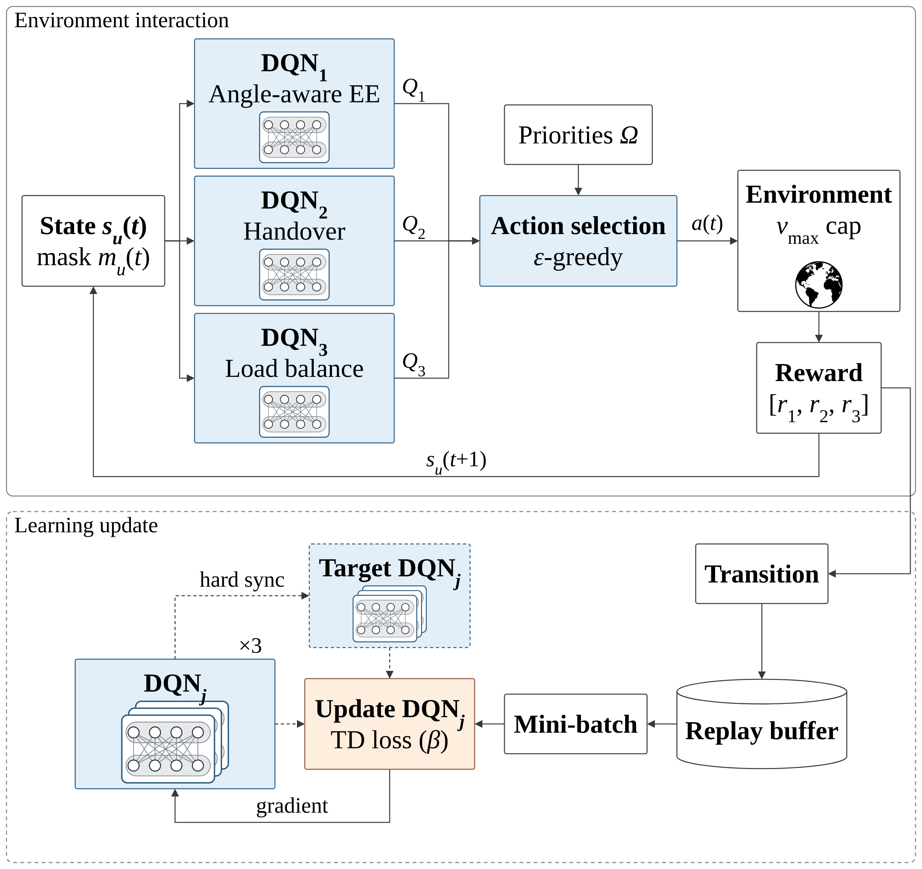
Fig. 2-1 MODQN baseline used in this study
Fig. 2-1: MODQN baseline backbone used in this study. The three objective Q-networks share state input and a feasible-action mask, then scalarize with weights $Ω$ to select actions. Environment transitions enter replay, and the three online/target network pairs update with their respective objective rewards. The first objective shows the angle-aware energy efficiency adopted here, which differs from the original MODQN throughput objective, no additional MCRL training-time shaping is included.
The selection and use of training experience also influence the learned policy. Schaul et al. [11] proposed prioritized experience replay, adjusting sampling probabilities from temporal-difference errors so that more informative transitions are used more often. Ke [12] proposed Catfish Deep Reinforcement Learning (CDRL), which introduces a catfish role during training to promote exploration and experience use without directly producing deployment decisions. CDRL was originally applied to energy-efficient control in RIS-aided communications. This study extends that auxiliary-training approach to multi-objective handover: both the main and catfish agents are three-objective MODQNs, and the three networks within each agent correspond to the three objectives. In entity-based multi-agent reinforcement learning, a user, satellite, or beam is chosen as the agent unit and multiple agents make decisions jointly. The two MCRL agents instead serve as training roles for the same handover problem, neither controls one particular network entity. The catfish agent supplies additional experience and competitive signals during training, while the main agent continues to learn from its own experience. Chapter 4 describes these mechanisms.
Capacity and resource constraints are another important issue in multi-beam systems. Zhu et al. [7] studied beam management under stochastic traffic arrivals and time-varying topology, balancing service quality, beam load, and system resources. For reinforcement-learning problems with constraints, Calvo-Fullana et al. [13] added constraint information to the state, and Agorio et al. [14] applied the same approach to multi-agent assignment. Holder et al. [15] used reinforcement learning for satellite assignment under limited resources, while Ye et al. [16] studied load-aware user association in cellular networks. The training-shaping strategies in Chapter 4 draw on these approaches.

2.2 Motivation
Taken together, the studies reviewed in Section 2.1 reveal three issues that have not been addressed jointly. First, the first reward in existing multi-objective handover methods is often still throughput-centered, while energy-aware work less often connects angle gain, off-axis-induced power changes, interference, realized throughput, and system energy consumption in a single energy-efficiency chain. Second, MODQN’s three objectives generally use the same learning workflow, while prior catfish-style auxiliary learning has mainly been studied in single-objective problems, objective-wise auxiliary training has not yet been defined. Third, independent per-user selection cannot directly see the other users’ choices or the resulting beam congestion at the same time step. Existing constraint approaches often change the deployment-time assignment procedure or add constraint information to the state, fewer address it while retaining the original deployment rule.
MCRL addresses these problems through two design choices. First, it replaces the first reward with each user’s additive contribution to angle-aware system energy efficiency, so that the link-quality and power costs caused by off-axis angle enter the same objective. Second, in Multi-Catfish training, both the main and catfish sides use three-objective MODQNs, whose three Q-networks correspond to energy efficiency, handover, and load balancing. The training process includes experience shaping and reward shaping: experience shaping uses energy-efficiency stratification, asymmetric discounting, and periodic mixed-batch intervention to change the experiences used during training, reward shaping adds a same-state competitive comparison only to the catfish side’s first objective, thereby aligning the auxiliary training with the corresponding objectives. The two shaping strategies act only during training. At deployment, only the main agent is retained and each user still takes its own argmax.
A larger off-axis angle reduces beam gain and can lower the received signal power, SINR, and throughput. Within a continuing served segment, a lower current gain than the previous gain can raise RF power under the previous-step recurrence and may increase power-amplifier consumption. A new segment does not retain inactive-link power and instead restarts at $p^{0}$, the recurrence has no power cap, clip, or projection. Section 3.1.3 gives the complete model, and Section 3.2 defines the formal reward.

3. Preliminaries
This chapter first explains how a user selects a service beam from the visible beams. It then introduces the signal quality, throughput, and power consumption of the selected link. Finally, these quantities are organized into the three objectives of energy efficiency, handover cost, and load balancing.

3.1 System Model

3.1.1 Network Model
Consider a downlink multi-beam LEO satellite communication system. Because the satellites keep moving, the satellites and beams visible to each user change over time. Time is discretized into successive steps of length $Δt$, and the system selects one available service beam for each user at every step, the value of $Δt$ is given in Section 5.1. The overall scenario is shown in Fig. 3-1.
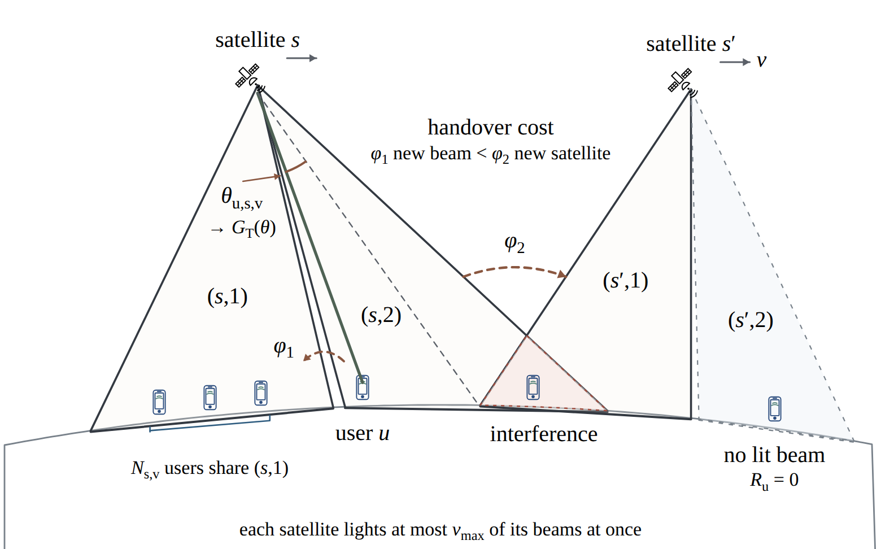
Fig. 3-1 LEO multi-beam satellite system model
Fig. 3-1: System model of a multi-beam LEO satellite network. Each user selects a service beam from the candidates provided by visible satellites. Beam direction affects signal quality, and users selecting the same beam share its resources. The system must also account for beam interference and handover cost, a beam that no user selects is not activated.

Users, Satellites, and Beams
Let $U=\{1,…,U\}$, $S=\{1,…,S\}$, and $V=\{1,…,V\}$ denote the user, satellite, and beam-index sets, respectively. The symbols $u$, $s$, $v$, and $t$ denote user, satellite, beam, and time-step indices.
Let $x_{u,s,v}(t)$ represent the realized connection. When $x_{u,s,v}(t)=1$, user $u$ is served by beam $v$ of satellite $s$, otherwise it is 0. Each user can connect to at most one beam, so
xu,s,v(t)∈{0,1}, s∈S​v∈V​xu,s,v(t)≤1.(3.1)
Let $z_{s,v}(t)$ indicate whether beam $(s,v)$ is active. For every $u∈U$, $s∈S$, and $v∈V$, a user can connect only to an active beam, so
$$\begin{matrix} & z_{s,v}(t)∈\{0,1\}, x_{u,s,v}(t)≤z_{s,v}(t). & & \text{(3.2)}\end{matrix}$$

Beam Activation and Load
The number of users actually served by beam $(s,v)$ is
Us,v(t)=u∈U​xu,s,v(t).(3.3)
This study activates only beams with connected users, so beam activation follows directly from the connection result:
$$\begin{matrix} & z_{s,v}(t)=\left\{\begin{matrix}1, & U_{s,v}(t)>0, \\ 0, & U_{s,v}(t)=0,\end{matrix}\right. ∀s∈S, v∈V. & & \text{(3.4)}\end{matrix}$$
A beam with no users transmits no power and creates no interference. This study sets no separate upper bound on how many beams one satellite may activate at the same time.

3.1.2 Geometry and Channel Model
In LEO satellite communications, geometry determines both the distance between a user and a satellite and the user’s direction relative to a beam center. Following non-terrestrial network channel models and LEO satellite research [17], [18], the slant range between user $u$ and satellite $s$ is defined as in (3.5):
$$\begin{matrix} & d_{u,s,v}(t)=\sqrt{R_{E}^{2}\sin^{2}α_{u,s}(t)+h_{s}^{2}+2R_{E}h_{s}}−R_{E}sinα_{u,s}(t). & & \text{(3.5)}\end{matrix}$$
Here, $α_{u,s}(t)$ is the elevation angle of the user relative to the satellite, $R_{E}$ is the Earth’s radius, and $h_{s}$ is the satellite altitude. The index $v$ records the slant range at the candidate-link level, its value may be identical across beams on the same satellite. The slant range is one component of the linear link-power factor used below, which does not directly carry the wanted-link angular pattern.
The off-axis angle describes the angular difference between the user’s direction and the beam-center direction. A multibeam LEO model defines this angle through the arccosine of two direction vectors [19, Eq. (5)], so the off-axis angle of user $u$ relative to beam $(s,v)$ is defined as in (3.6):
$$\begin{matrix} & θ_{u,s,v}(t)=arccos\left(\frac{v_{u,s,v}(t)⋅r_{u,s,v}(t)}{∥v_{u,s,v}(t)∥∥r_{u,s,v}(t)∥}\right). & & \text{(3.6)}\end{matrix}$$
Here, $v_{u,s,v}(t)$ is the beam-center direction recorded for candidate link $(u,s,v)$, and $r_{u,s,v}(t)$ is the satellite-to-user direction recorded for the same link. The three indices mark link-level data ownership. $v$ may have the same value across users of one beam, and $r$ may have the same value across beams of one user-satellite pair. The off-axis angle is the point at which geometric information enters the energy-efficiency chain.
Following the angular pattern commonly used for multi-beam satellites and adopted in HOBS [4], [20], the transmit gain is retained only as a function of the off-axis angle:
$$\begin{matrix} & G^{T}​\left(θ,θ_{3dB}\right), G^{T}​\left(0,θ_{3dB}\right)=G_{0}. & & \text{(3.7)}\end{matrix}$$
Here, $G_{0}$ is the beam-center gain. To keep the tunable antenna parameters traceable to the simulator, the main text uses a one-layer normalized-pattern expansion:
$$\begin{matrix} & G^{T}​\left(θ,θ_{3dB}\right)=G_{0}F​\left(θ,θ_{3dB}\right), G^{T}​\left(0,θ_{3dB}\right)=G_{0}, F​\left(0,θ_{3dB}\right)=1. & & \text{(3.8)}\end{matrix}$$
The angular pattern adopts the $J_{1}/J_{3}$ pattern of HOBS Eq. (3) [4], the angle argument and pattern are
$$\begin{matrix} & μ​\left(θ,θ_{3dB}\right)=2.07123\frac{sinθ}{sin\left(θ_{3dB}/2\right)}, F​\left(θ,θ_{3dB}\right)={\left[\frac{J_{1}​\left(μ​\left(θ,θ_{3dB}\right)\right)}{2μ​\left(θ,θ_{3dB}\right)}+\frac{36J_{3}​\left(μ​\left(θ,θ_{3dB}\right)\right)}{{\left[μ​\left(θ,θ_{3dB}\right)\right]}^{3}}\right]}^{2}. & & \text{(3.9)}\end{matrix}$$
Here $J_{1}(⋅)$ and $J_{3}(⋅)$ are the Bessel functions of the first kind of orders 1 and 3, and $2.07123$ is that equation’s fixed angle argument, the same value that appears in other multibeam-satellite work. $F$ is naturally unity at $θ=0$ ($1/4+3/4$), so no extra boresight normalization constant is required, however $J_{1}(μ)/(2μ)$ and $36J_{3}(μ)/μ^{3}$ are $0/0$ at $μ=0$, so the limit is taken directly whenever $|μ|<ϵ_{μ}$, with $ϵ_{μ}$ given in Section 5.1. $θ_{3dB}$ is a fixed antenna parameter, but it appears on the right-hand side of the definition of $μ$ and, through $μ$, sets the shape of $F$ and $G^{T}$, it is therefore listed as an argument of all three, so that the left-hand side of every definition covers the quantities that appear on its right. $G_{0}$ is different: it is a multiplicative scale constant that does not change the shape of the pattern and is therefore not an argument. From Eq. (3.10) onward the same function is applied at a specific link’s off-axis angle, so it is written with the fixed parameter explicitly as $G^{T}(θ_{u,s,v},θ_{3dB})$. This layer does not introduce a three-index gain variable and does not add a pattern selector.
This study does not adopt the $G_{0}=40$ dBi of Table I of HOBS [4]. The aperture $10c/f_{c}$, the gain of 40 dBi and the beamwidth listed there are mutually inconsistent: under either dimensionally valid reading, 40 dBi requires an aperture efficiency of $η=2.53$ (radius reading) or $η=10.13$ (diameter reading), both greater than one. The aperture is therefore re-derived from the beamwidth, $D=1.0275λ/θ_{3dB}=17.7λ$, with the Ka-band aperture efficiencies of $0.639$–$0.645$ back-derived from 3GPP TR 38.821 [22], this gives $G_{0}=2000$ ($33.0$ dBi). The value is listed in Section 5.1. Throughout this thesis $θ_{3dB}$ denotes the full half-power beamwidth, consistent with the cell radius $R_{b}=h_{s}tan(θ_{3dB}/2)$ in Section 5.1, whereas HOBS Eq. (3) normalizes by the one-sided half-power angle, Eq. (3.9) therefore substitutes $θ_{3dB}/2$. The constant $2.07123$ is calibrated to exactly that point: $F=1/2$ at $μ=2.07123$.
Let $H_{u,s,v}(t)$ denote the linear link-power factor that does not directly carry the wanted-link angular pattern. To trace it to the channel implementation, expand H as
$$\begin{matrix} & H_{u,s,v}(t)={10}^{−\frac{L_{u,s,v}(t)}{10}}G_{u,s,v}^{R}(t), & & \text{(3.10a)}\end{matrix}$$
where
$$\begin{matrix} & L_{u,s,v}(t)=L_{f}​\left(d_{u,s,v}(t),f_{c}\right)+L_{g}​\left(α_{u,s}(t)\right)+L_{c}​\left(α_{u,s}(t)\right)+L_{s}​\left(α_{u,s}(t)\right). & & \text{(3.10b)}\end{matrix}$$
The four losses correspond to $L=L_{fs}+L_{g}+L_{sc}+L_{sf}$ of HOBS Eq. (1), this thesis writes them as $L=L_{f}+L_{g}+L_{c}+L_{s}$ to keep subscripts single-lettered: $L_{f}$ is the free-space path loss, $L_{g}$ the atmospheric gaseous absorption, $L_{c}$ the scintillation and $L_{s}$ the shadow fading, the last three vary with elevation, and their models and values are given in Section 5.1, all four are dB terms converted to a common linear scale before entering H, and $G_{u,s,v}^{R}(t)$ is the linear receive gain. These four terms are exactly the loss set of HOBS Eq. (1), the public expansion adds nothing below them. Scan loss, NLoS clutter, and other implementation-layer channel corrections are absorbed into $H_{u,s,v}(t)$, take no public symbol, and are not tunable parameters.
$G_{u,s,v}^{R}(t)$ is written as a boresight gain minus an off-axis loss. Let $θ_{u,s}^{R}(t)$ be the angle in degrees between the user’s receive-antenna pointing direction and the direction of satellite $s$. Then
$$\begin{matrix} & G_{u,s,v}^{R}(t)=min​\left\{max​\left\{A_{R}−B_{R}\log_{10}θ_{u,s}^{R}(t), G_{R,min}\right\}, G_{R,max}\right\}. & & \text{(3.10c)}\end{matrix}$$
$A_{R}$, $B_{R}$, and the floor $G_{R,min}$ are taken from the ITU-R S.465-6 earth-station reference radiation pattern [21], whose stated range of 2 to 31 GHz covers the $f_{c}$ used here. The three are not independent settings: the recommendation gives $A_{R}−B_{R}\log_{10}θ^{R}$ for $θ_{min}^{R}≤θ^{R}<{48}^{∘}$ and $G_{R,min}$ for ${48}^{∘}≤θ^{R}≤{180}^{∘}$, and the two branches join continuously at ${48}^{∘}$. The boresight gain $G_{R,max}$ is the derated value adopted for a comparable 0.6 m user terminal in an LEO handover setting [5], about 4.7 dB below the ideal gain of that aperture. The recommendation defines the envelope only for $θ^{R}≥θ_{min}^{R}$ (here $θ_{min}^{R}≈{2.498}^{∘}$ at $f_{c}$), this work extends the same envelope into $θ^{R}<θ_{min}^{R}$ up to the $G_{R,max}$ cap, which is a modelling simplification outside the scope of the recommendation.
The two wanted-link linear power-gain factors are still used directly as
$$\begin{matrix} & H_{u,s,v}(t)G^{T}​\left(θ_{u,s,v},θ_{3dB}\right). & & \text{(3.10)}\end{matrix}$$
Here, $G^{T}$ directly carries the off-axis-angle dependence, while $H_{u,s,v}(t)$ preserves the physical meaning of the remaining channel factors — the four losses of Eq. (3.10b), the receive gain, and Rician small-scale fading, whose $K$-factor $K_{R}$ is a scenario calibration listed in Section 5.1. Both are linear power-scale factors, not complex channel amplitudes. The thesis, the simplified symbol table, and the / legacy simulator frontend share this one public expansion layer that maps to simulator controls and runtime fields, only layout may differ, not formulas, symbols, or editable parameters. The public expansion is capped at the depth the source paper itself shows: the four loss terms of HOBS Eq. (1) and a single $J_{1}/J_{3}$ angular-pattern layer whose two-term structure follows HOBS Eq. (3). Deeper antenna measurement, Bessel-approximation, and channel-calibration details are outside the public formula layer. No intermediate channel symbol distinguished only by letter case is introduced. Note also that the MODQN $G_{i,l,v}$ is a channel gain whose role corresponds to $H_{u,s,v}$ here, semantically different from the antenna gains $G^{T}$ and $G^{R}$, the two same-letter symbols are not merged.

3.1.3 Power, SINR and Throughput Model
The following keeps only actual quantities for each user–satellite–beam link. $p_{u,s,v}$ denotes actual RF transmit power, it is not obtained by inverting a target SINR, minimum rate, or lagged interference. If the implementation needs measured, predicted, or cached provenance, that information belongs in field metadata rather than in a second physical SINR.
Let $τ_{u,s,v}$ be the start time of the current uninterrupted served physical-link $(u,s,v)$ segment. Episode reset, handover, outage, an unserved step, and re-entry all break continuity, a new segment does not retain inactive-link power and starts at $p^{0}$. Only consecutive service of the same physical link uses the previous-step recurrence:
This is an angle-aware power rule defined by this study, not an equation from the original MODQN paper. The modelling condition is to keep the product of transmit power and transmit gain constant within one continuous served segment: $p_{u,s,v}(t,θ_{u,s,v}(t),θ_{3dB})G^{T}(θ_{u,s,v}(t),θ_{3dB})=p_{u,s,v}(t−1,θ_{u,s,v}(t−1),θ_{3dB})G^{T}(θ_{u,s,v}(t−1),θ_{3dB})$. Solving for the current power gives the equation below. It compensates only the transmit-side angular gain, it does not claim that the full SINR or throughput remains constant.
$$\begin{matrix} & p_{u,s,v}​\left(t,θ_{u,s,v}(t),θ_{3dB}\right)=p_{u,s,v}​\left(t−1,θ_{u,s,v}(t−1),θ_{3dB}\right)\frac{G^{T}​\left(θ_{u,s,v}(t−1),θ_{3dB}\right)}{G^{T}​\left(θ_{u,s,v}(t),θ_{3dB}\right)}, x_{u,s,v}(t−1)=x_{u,s,v}(t)=1, G^{T}​\left(θ_{u,s,v}(t),θ_{3dB}\right)>0, & & \text{(3.11)}\end{matrix}$$
The segment-start condition and its within-segment closed form are:
$$\begin{matrix} & p_{u,s,v}​\left(τ_{u,s,v},θ_{u,s,v}(τ_{u,s,v}),θ_{3dB}\right)=p^{0}, p_{u,s,v}​\left(t,θ_{u,s,v}(t),θ_{3dB}\right)=p^{0} \frac{G^{T}​\left(θ_{u,s,v}(τ_{u,s,v}),θ_{3dB}\right)}{G^{T}​\left(θ_{u,s,v}(t),θ_{3dB}\right)}. & & \text{(3.12)}\end{matrix}$$
Equation (3.12) is valid only when every step from $τ_{u,s,v}$ through $t$ remains the same served physical link with positive gain, it is the telescoped identity of Eq. (3.11), not runtime state across an event. The recurrence expresses the previous-step angle-gain effect on link RF power and introduces no target SINR, no required-power inversion, no beam/satellite cap, no PA clamp, and no min/max projection.
Define the system angle state $θ(t)$ as the collection of off-axis angles $θ_{u,s,v}(t)$ over every $u∈U, s∈S, v∈V$, and let $I_{u,s,v}(t,θ_{u,s,v},θ_{3dB})$ denote the total co-channel interference relative to the wanted link.
The beams use three-colour frequency reuse. Let $c_{s,v}∈\{0,1,2\}$ be the frequency colour of beam $(s,v)$, assigned from the axial coordinates $(q_{s,v},r_{s,v})$ of its ground cell on the hexagonal lattice as $c_{s,v}=(q_{s,v}−r_{s,v}) mod 3$. The rule guarantees that any two adjacent cells carry different colours: beams of the same colour share one sub-band, and beams of different colours are orthogonal. The bandwidth available to one beam is therefore $B^{w}=B_{sys}/3$, and interference arrives only from activated beams of the same colour as the serving beam. The cell layout and the axial coordinates are environment settings, given in Section 5.1.
An activated beam radiates at a single power regardless of how many users it carries. Following the aggregation convention of the runtime, let $p_{s,v}​\left(t,θ,θ_{3dB}\right)=\max_{u∈U: x_{u,s,v}(t)=1}p_{u,s,v}​\left(t,θ_{u,s,v}(t),θ_{3dB}\right)$ be that beam’s transmit power. The left-hand side retains the system angle state and the fixed beamwidth because the right-hand side takes a maximum across all served links. Following HOBS and the multi-beam LEO satellite system model [4], [20], the interference splits into same-satellite and cross-satellite terms, given in Eq. (3.12a) and Eq. (3.12b):
Iu,s,vintra(t,θu,s,v,θ3dB)=v′∈V, v′≠vcs,v′=cs,v​zs,v′(t) ps,v′​t,θ,θ3dB GT​θu,s,v′(t),θ3dBHu,s,v′(t),(3.12a)
Iu,s,vinter(t,θu,s,v,θ3dB)=s′∈S, s′≠s​ v′∈Vcs′,v′=cs,v​zs′,v′(t) ps′,v′​t,θ,θ3dB GT​θu,s′,v′(t),θ3dBHu,s′,v′(t),(3.12b)
so that $I_{u,s,v}(t,θ_{u,s,v},θ_{3dB})=I_{u,s,v}^{intra}(t,θ_{u,s,v},θ_{3dB})+I_{u,s,v}^{inter}(t,θ_{u,s,v},θ_{3dB})$. Every term uses the interfering beam’s own off-axis angle and linear link factor, because different beams reach the same user through different path losses and gains, the sums are gated by the activation indicator $z$ and are not weighted by how many users a beam carries.
The noise power is $σ^{2}=k_{B}TB^{w}$, where $k_{B}$ is the Boltzmann constant and $T=T_{a}+T_{0}\left({10}^{NF/10}−1\right)$ is the receiver system temperature. The antenna temperature $T_{a}$, the receiver noise figure $NF$ and the noise-figure reference temperature $T_{0}$ take the VSAT values of 3GPP TR 38.821 [22] and are listed in Section 5.1. The noise integrates over the whole beam bandwidth and therefore does not scale with the beam’s load. The unique link SINR is
$$\begin{matrix} & γ_{u,s,v}​\left(t,θ_{u,s,v},θ_{3dB}\right)=\frac{p_{u,s,v}​\left(t,θ_{u,s,v},θ_{3dB}\right)H_{u,s,v}(t)G^{T}​\left(θ_{u,s,v},θ_{3dB}\right)}{I_{u,s,v}​\left(t,θ_{u,s,v},θ_{3dB}\right)+σ^{2}}, & & \text{(3.13)}\end{matrix}$$
with $I_{u,s,v}(t,θ_{u,s,v},θ_{3dB})+σ^{2}>0$. This symbol is used for both baseline-link calculation and angle-aware power substitution, no estimated, required, target, or serving-index-nested SINR is introduced.
Multiplexing within a beam is time division. The $U_{s,v}(t)$ users on a beam take turns using the available bandwidth. The link throughput is [2], [4]
$$\begin{matrix} & R_{u,s,v}​\left(t,θ_{u,s,v},θ_{3dB}\right)=\frac{B^{w}}{U_{s,v}(t)}\log_{2}​\left(1+γ_{u,s,v}​\left(t,θ_{u,s,v},θ_{3dB}\right)\right), U_{s,v}(t)>0. & & \text{(3.14)}\end{matrix}$$
$B^{w}$ is the available bandwidth of one beam, for a single-user illustration, set $U_{s,v}=1$ without creating a second rate or SINR formula. The connection variable $x_{u,s,v}(t)$ selects the active service link and does not create a user-level SINR or throughput alias.
A beam is driven by a single power amplifier, so supply-side power is a per-beam quantity rather than a per-link one. Let $ξ_{s,v}​\left(t,θ,θ_{3dB}\right)>0$ be that beam’s effective conversion efficiency from RF power to supply-side consumption. Then
$$\begin{matrix} & P_{s,v}^{p}​\left(t,θ,θ_{3dB}\right)=\frac{p_{s,v}​\left(t,θ,θ_{3dB}\right)}{ξ_{s,v}​\left(t,θ,θ_{3dB}\right)}. & & \text{(3.15)}\end{matrix}$$
Radiated power is not the power actually consumed. A beam’s RF signal is produced by a power amplifier, and the ratio of its RF output to the DC power it draws is the $ξ$ of Eq. (3.15). An amplifier is more efficient near saturation but less linear there, so it is operated a fixed distance below saturation, that distance is the output back-off $BO$, expressed in dB, and the saturated power is $p_{sat}=p_{max}{10}^{BO/10}$, where $p_{max}$ is the per-beam operating limit after back-off. Following the power-efficiency relation of the classical class-B amplifier [23], the back-off region is approximated by a load-dependent square-root curve, this is an engineering approximation for system-level analysis, not a full circuit model:
$$\begin{matrix} & ξ_{s,v}​\left(t,θ,θ_{3dB}\right)=min​\left\{ξ_{max}, ξ_{max}\sqrt{\frac{p_{s,v}​\left(t,θ,θ_{3dB}\right)}{p_{sat}}}\right\}. & & \text{(3.15a)}\end{matrix}$$
The square root follows from the ideal class-B approximation: with $V_{o}$ the output voltage amplitude at fixed supply voltage and load, the RF output power satisfies $P_{RF}∝V_{o}^{2}$ while the average DC input satisfies $P_{DC}∝V_{o}$, so $ξ=P_{RF}/P_{DC}∝\sqrt{P_{RF}}$. At one quarter of the saturated output the efficiency is $ξ_{max}/2$, not $ξ_{max}/4$. The values of $ξ_{max}$ and $BO$ are listed in Section 5.1, a Ka-band satellite-downlink GaN Doherty MMIC reports a saturated power-added efficiency of 23–31%, and about 20% at 6 dB output back-off [24], which is of the same order as this model without being the same measurement point. Morello and Mignone’s two-carrier DVB-DSNG example uses 5.5 dB of output back-off per carrier [25], showing that multi-carrier operation needs a larger back-off to stay quasi-linear, that statement does not generalize to all multi-carrier systems and is cited here only as corroboration of the back-off magnitude.
This shape has one consequence that matters for this thesis: because efficiency is poorer at low output, lowering the transmit power does not lower the consumed power proportionally. What actually governs energy efficiency is how much throughput a given amount of power buys, and that is why Section 3.2 takes energy efficiency, rather than transmit power alone, as the first objective.
Let $P^{f}(t)$ aggregate all fixed/circuit overhead that is not directly controlled by off-axis angle. With Nsact(t)=v∈V​zs,v(t) the number of active beams on satellite $s$, and with one active beam mapped to one RF chain in this study,
Pf(t)=s∈S​Nsact(t) Pcir+1​Nsact(t)>0PBB.(3.16a)
The baseband power is shared by all active beams of that satellite and is therefore counted once per satellite, never twice. The values of $P_{cir}$ and $P_{BB}$ are taken from Table II of You et al. [26] and are listed in Section 5.1. The one-beam-to-one-RF-chain mapping is this study’s own, not a conclusion about satellite architecture from that work, that work also includes local-oscillator and phase-shifter power, which this study does not adopt, so Eq. (3.16a) is a partial payload-power model rather than a complete satellite power model. The total system power is
PN​t,θ,θ3dB=Pf(t)+s′∈S​v′∈V​zs′,v′(t) Ps′,v′p​t,θ,θ3dB.(3.16)
The sum runs over $(s,v)$ rather than over $(u,s,v)$: an active beam has a single amplifier, and its supply-side power is not counted once per user it carries, which is consistent with the $p_{s,v}$ aggregation of Eq. (3.12a). A per-link sum would add a spurious term s,v​(Us,v(t)−1)Ps,vp​t,θ,θ3dB that grows with occupancy and would make the first objective duplicate the work of the third.
Finally, the displayed EE for a fixed link $(u,s,v)$ is
$$\begin{matrix} & η_{u,s,v}​\left(t,θ_{u,s,v},θ_{3dB}\right)=\frac{R_{u,s,v}​\left(t,θ_{u,s,v},θ_{3dB}\right)}{P^{N}​\left(t,θ,θ_{3dB}\right)}, P^{N}​\left(t,θ,θ_{3dB}\right)>0. & & \text{(3.17)}\end{matrix}$$
The three subscripts fix the numerator’s UE-link. The denominator remains shared system power, so $η_{u,s,v}$ is a displayed single-link contribution to system EE, not true private-power per-user EE.
The multi-objective deep Q-network (MODQN) baseline used in this study trains one Q-network for each of the three objectives, throughput was originally its first reward term [2]. This study defines the first reward as the sum of the selected-link EE contributions, so that transmission volume, beam angle, and power consumption are considered together.

3.2 Problem Formulation
This study considers energy efficiency, handover cost, and load balancing jointly. Let $L_{w}$ be the number of visible satellites included at each step. Using the realized connection $x_{u,s,v}(t)$ as the decision outcome, the long-term objectives are [2]
P1:& maxt​u∈U​r1,u​t,θ,θ3dB,P2:& mint​u∈U​Ψu(t),P3:& mint​s∈S​v∈V​Us,v(t)2,s.t.:& xu,s,v(t)∈{0,1}, s∈S​v∈V​xu,s,v(t)≤1.(3.24)
P1 seeks to deliver more data for the consumed power, P2 reduces handovers, and P3 drives the per-beam user counts toward an even split: with the served total fixed, the sum of squares is smallest when beam occupancies differ by at most one. The three objectives are defined below.

3.2.1 Angle-Aware Energy Efficiency
Equations (3.15)–(3.17) define link-side consumption, shared system power, and the displayed EE for a fixed link. The first reward sums the EE contributions of the links selected by each user:
r1,u​t,θ,θ3dB&=s∈S​v∈V​xu,s,v(t)ηu,s,v​t,θu,s,v,θ3dB&=s∈S​v∈V​xu,s,v(t)Ru,s,v​t,θu,s,v,θ3dBPN​t,θ,θ3dB, PN​t,θ,θ3dB>0.(3.25)
The unit of $r_{1,u}​\left(t,θ,θ_{3dB}\right)$ is bit/J. It is the additive contribution of user $u$ to instantaneous system energy efficiency. Equation (3.25) is defined when shared system power is positive, unselected links are excluded by $x_{u,s,v}(t)=0$. No user-level SINR or user-level throughput symbol is introduced here.
The off-axis angle therefore enters $G^{T}$ directly, while the wanted-link numerator in Eq. (3.13) uses $p_{u,s,v}H_{u,s,v}G^{T}(θ_{u,s,v},θ_{3dB})$, Eqs. (3.11)–(3.12) use the segment-start power $p^{0}$ and the previous-step recurrence to determine angle-aware link RF power. The same $p$ also enters the total-interference system state and the power/EE relations in Eqs. (3.15)–(3.17). The physical formula needs neither target-SINR inversion nor a protective power cap.

3.2.2 Handover Cost
Using the serving pair $(ρ_{u}(t),δ_{u}(t))$ defined above, the cost of switching beams within one satellite is $φ_{1}$, while the cost of switching satellites is $φ_{2}$, with $0<φ_{1}<φ_{2}$. The second reward is
$$\begin{matrix} & r_{2,u}(t)=−Ψ_{u}(t), Ψ_{u}(t)=\left\{\begin{matrix}0, & (ρ_{u}(t),δ_{u}(t))=(ρ_{u}(t−1),δ_{u}(t−1)), \\ φ_{1}, & ρ_{u}(t)=ρ_{u}(t−1), δ_{u}(t)≠δ_{u}(t−1), \\ φ_{2}, & ρ_{u}(t)≠ρ_{u}(t−1).\end{matrix}\right. & & \text{(3.27)}\end{matrix}$$
Keeping the current connection has no cost, an intra-satellite beam switch has the smaller cost, and an inter-satellite handover has the larger cost.

3.2.3 Load Balancing
The third reward is the negative occupancy of the beam the user selected, where that occupancy is the $U_{s,v}(t)$ of Eq. (3.3):
$$\begin{matrix} & r_{3,u}(t)=−U_{b_{u}(t)}(t). & & \text{(3.28)}\end{matrix}$$
Here $b_{u}(t)$ is the beam user $u$ selects at that step and $U_{b_{u}(t)}(t)$ is the number of users that beam serves at that step, from (3.28). A more crowded selected beam gives a smaller reward. This reward is decomposable per user: since u∈U​Ubu(t)(t)=s,v​Us,v(t)2, the sum over users is exactly the negative of the P3 objective, so each user’s reward is an exact decomposition of the global objective rather than one system-level scalar shared by every user.

3.2.4 Reward Vector and Evaluation Metric
MODQN retains the three-dimensional reward vector [2]:
$$\begin{matrix} & {\vec{R}}_{u}​\left(t,θ,θ_{3dB}\right)=\left[r_{1,u}​\left(t,θ,θ_{3dB}\right), r_{2,u}(t), r_{3,u}(t)\right]. & & \text{(3.29)}\end{matrix}$$
The three components do not take the same arguments: $r_{1,u}$ depends on the whole set of off-axis angles and beamwidth parameter through $η_{u,s,v}$ and $P^{N}$ and therefore carries $θ,θ_{3dB}$, whereas $r_{2,u}$ is fixed by the change of serving satellite and beam and $r_{3,u}$ by the occupancy alone, so neither involves an angle. The vector carries $θ,θ_{3dB}$ because its first component does. The generic $r_{j,u}$ and ${\overset{‾}{r}}_{j,u}$ of Chapter 4 do not spell the arguments out component by component, each component keeps the definition given here.
Training uses stepwise rewards. Cross-time total-bits/total-energy evaluation belongs to the experimental procedure in Chapter 5, this section does not introduce a second physical EE symbol. Chapter 5 specifies the evaluation interval, service quality, coverage, and handover metrics separately from the per-step link EE in Eq. (3.17).
MODQN lets each user independently select the feasible beam with the largest weighted Q-value. Users with similar states may concentrate on the same few beams. By Eq. (3.14), users on one beam share its bandwidth, so concentration directly lowers each user’s rate and worsens the P3 objective in Eq. (3.24). Chapter 4 addresses this issue through two training-shaping strategies.

4. Multi-Catfish Reinforcement Learning (MCRL)

4.1 Method Overview
Chapter 3 used the realized connection $x_{u,s,v}(t)$ to describe the physical system. This chapter organizes the selectable beams into a fixed action space for the neural network and explains how MODQN and MCRL use this information.
The physical beams available to a user change as the satellites move, but the output length of the neural network must remain fixed. Each user therefore uses a fixed-length candidate table. It retains $L_{w}$ visible satellites and $J_{w}$ candidate beams from each satellite, giving $C=L_{w}J_{w}$ positions. Let $C=\{1,…,C\}$ be the candidate-index set, where $c∈C$ denotes one table position.
The table contents change over time. The mapping $b_{u}(c,t)∈S×V$ gives the physical satellite and beam represented by position $c$ for user $u$ at time $t$. The network selects a candidate index, and $b_{u}(c,t)$ maps that choice back to the physical indices used in Chapter 3.
This candidate table is a thesis-side fixed-output representation. The original MODQN paper writes its state and access action over the full $L×V$ beam-position grid, this thesis restricts each moving visibility window to $L_{w}×J_{w}$ candidates.
The user state contains four types of information: the previous connection, a link-level signal-quality value for each candidate, the off-axis angle of each candidate, and the number of users who selected each beam at the previous step. In candidate-table order, the state is
$$\begin{matrix} & \begin{aligned}s_{u}(t)&=concat​\left(x_{u}(t−1), (γ_{u,s,v}​\left(t,θ_{u,s,v},θ_{3dB}\right))_{\begin{matrix}(s,v)=b_{u}(c,t) \\ c∈C\end{matrix}}, (θ_{u,s,v}(t))_{\begin{matrix}(s,v)=b_{u}(c,t) \\ c∈C\end{matrix}}, N_{u}(t−1)\right).\end{aligned} & & \text{(4.1)}\end{matrix}$$
Here, $x_{u}(t−1)=(x_{u,b_{u}(c,t)}(t−1))_{c∈C}$ records the previous connection. The two parenthesized sequences list the three-index link SINR and off-axis-angle elements in candidate order, and $concat$ joins the four blocks into one state vector. The SINR reuses the single physical definition of $γ_{u,s,v}$ from Chapter 3. These values are available to the environment before the current action. If the implementation uses cached or predicted provenance, that label belongs in field metadata and does not create another physical symbol. The candidate table at step $t$ must be ordered so that the beam that actually served the user at the previous step remains identifiable: if user $u$ was served at $t−1$, its serving beam $(ρ_{u}(t−1),δ_{u}(t−1))$ must still occupy one candidate position, so that $x_{u}(t−1)$ recovers the previous physical association required by Eq. (3.27), if that beam has left the candidate table, every position selected at this step constitutes a handover.
Let $n_{s,v}(t−1)$ denote the demand directed to beam $(s,v)$ at the previous step. The vector $N_{u}(t−1)=[n_{b_{u}(c,t)}(t−1)]_{c∈C}$ follows the candidate order, whereas $U_{s,v}(t)$ in Eq. (3.3) is the realized served load.
Equation (4.1) uses only information available before the current action is selected. The connection, load, SINR, and throughput produced by that action determine the current reward and the next state.
The candidate-table length is fixed, but some positions may be unavailable. Let $m_{u}(t)$ denote the feasible-action mask:
$$\begin{matrix} & m_{u}(t)=\left(m_{u,1}(t),m_{u,2}(t),…,m_{u,C}(t)\right), m_{u,c}(t)∈\{0,1\}, & & \text{(4.2)}\end{matrix}$$
$$\begin{matrix} & A_{u}(t)=\left\{c∈C∣m_{u,c}(t)=1\right\}. & & \text{(4.3)}\end{matrix}$$
Here, $m_{u,c}(t)=1$ means that candidate $c$ is selectable and 0 means that it is not. The set $A_{u}(t)$ collects all selectable candidate indices. The policy returns the scalar candidate index $a_{u}(t)$, the environment uses its one-hot encoding $a_{u,c}(t)$ when it applies the action to candidate $c$.
Let the scalar $a_{u}(t)$ denote the candidate selected by user $u$. The environment expands it into the one-hot indicator $a_{u,c}(t)$, which is 1 only for the selected candidate:
$$\begin{matrix} & a_{u}(t)∈A_{u}(t), a_{u,c}(t)=1​\left\{c=a_{u}(t)\right\}, c∈C. & & \text{(4.4)}\end{matrix}$$
When the feasible-action set is non-empty, each user selects one candidate at each time step, when it is empty, no candidate can be selected, so
c∈C​au,c(t)=1,Au(t)≠⌀,0,Au(t)=⌀, au,c(t)∈{0,1}.(4.5)
When $A_{u}(t)=⌀$, the condition $a_{u}(t)∈A_{u}(t)$ of Eq. (4.4) has no solution and no candidate is executed at that step: user $u$ is unserved, all its $x_{u,s,v}(t)$ are zero, and the transition of that step does not enter the replay buffer. This setting does not claim that the mask is always non-empty, because candidate-cell coverage and link feasibility can together rule out every candidate at the same step.
The decision-time mask $m_{u,c}(t)$ and the physical-beam activation $z_{s,v}(t)$ have different roles: the first determines what a user may select, while the second follows the activation rule of Eq. (3.4) and states whether that physical beam radiates. The realized connection is therefore
$$\begin{matrix} & x_{u,b_{u}(c,t)}(t)=a_{u,c}(t) z_{b_{u}(c,t)}(t). & & \text{(4.5a)}\end{matrix}$$
Thus, a user is connected only when the candidate was selected and the corresponding beam radiates. The link must then also be feasible: a link whose required power exceeds the per-beam limit is declared infeasible, and that user is in outage for the step. The selections of all users form the joint action:
$$\begin{matrix} & a(t)=\left(a_{1}(t),a_{2}(t),…,a_{U}(t)\right). & & \text{(4.6)}\end{matrix}$$
Valid selections determine beam activation, whose state follows Eq. (3.4). Equation (4.5a) then gives the realized connections, from which the next state and the three rewards are calculated.
Together, the state, action, reward vector, environment transition, and discount factor form a multi-objective Markov decision process.
The original MODQN builds one Q-network for each objective, giving $\vec{Q}(s_{u},a)=[Q_{1}(s_{u},a),Q_{2}(s_{u},a),Q_{3}(s_{u},a)]$ [2]. The three Q-values are combined with weights $Ω=[ω_{1},ω_{2},ω_{3}]$, and each user selects the action with the largest combined value from $A_{u}(t)$, $ϵ$-greedy exploration is added during training. Each Q-network is updated by temporal-difference learning using its own objective reward. The concrete weights are reported in Section 5.1.
MCRL retains MODQN’s three objective Q-networks and per-user independent $argmax$ selection. Experience shaping and reward shaping act only during training, modifying the training experiences and the catfish agent’s first reward respectively, the input representation and the selection rule at deployment are the same as in MODQN.
Figure 4-1 locates these mechanisms in data collection and parameter updating.
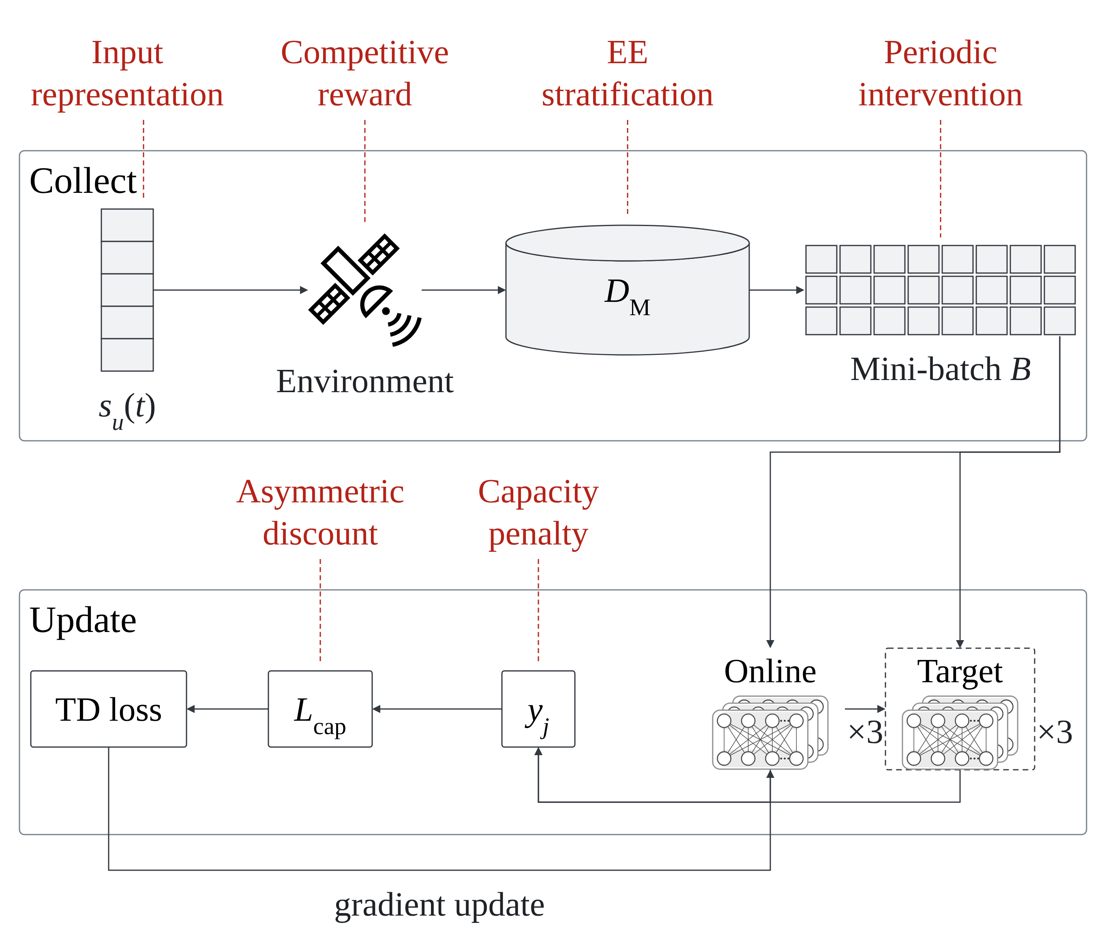
Fig. 4-1 Intervention points in the MODQN update
Fig. 4-1: Intervention points of MCRL in the MODQN update. Energy-efficiency stratification and competitive reward process catfish experiences, periodic intervention supplies a mixed batch for the main agent, asymmetric discounting distinguishes the two within-episode weightings.
Figure 4-2 presents the correspondence between the main and catfish agents at the objective-network level.
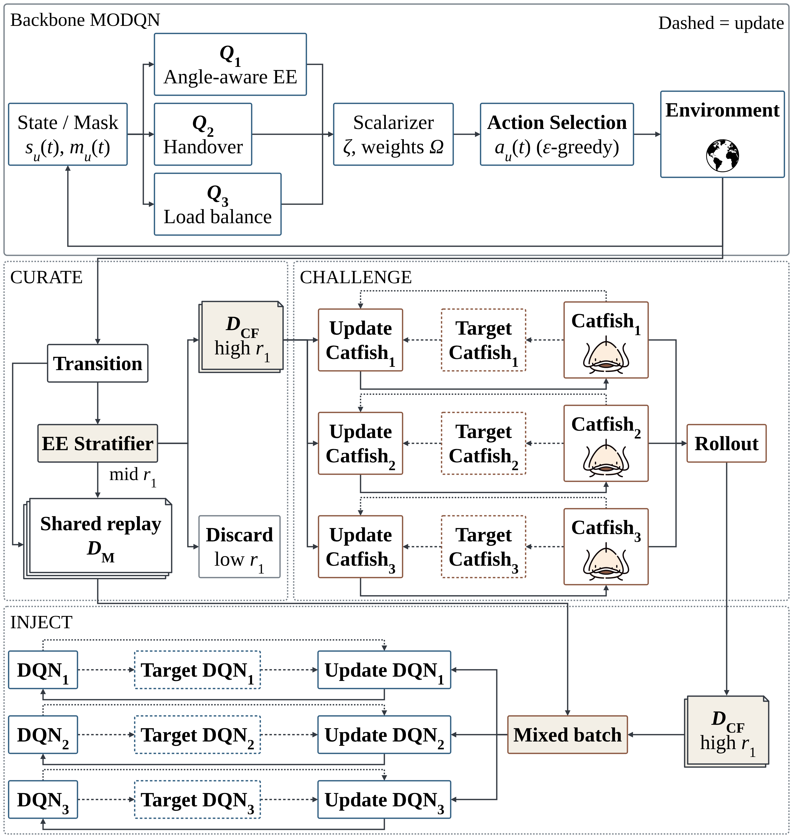
Fig. 4-2 Objective-network view of MCRL
Fig. 4-2: Objective-network view of MCRL. The main and catfish sides each contain three objective Q-networks, with the one-to-one correspondence $Q_{j}^{M}↔Q_{j}^{F}↔r_{j}$. Each side scalarizes its three Q-values using the common weights $Ω$ and selects one action.
Figure 4-3 shows the trajectories, replay buffers, and periodic intervention from the agent-and-data-flow perspective.
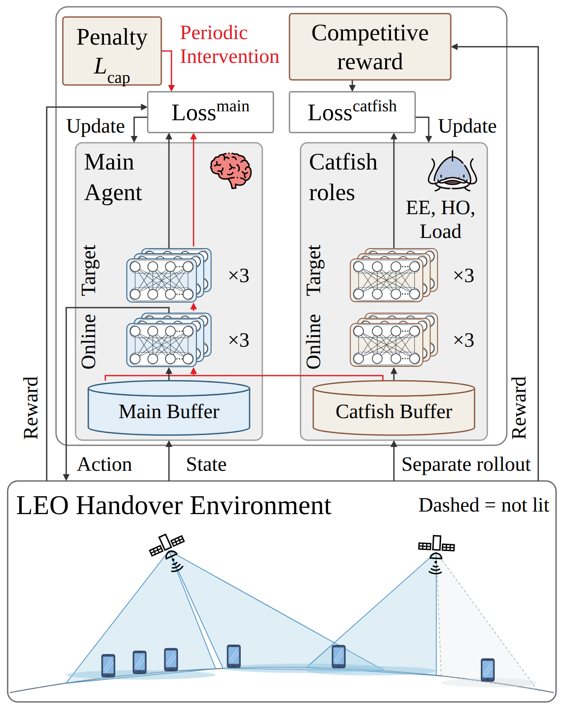
Fig. 4-3 Role-level MCRL training architecture
Fig. 4-3: Agent-and-data-flow view of MCRL. The main and catfish agents each generate a training trajectory and maintain a replay buffer. Catfish transitions are routed by their first-objective score, and periodic intervention uses a mixed batch to update the main agent, only the main agent is deployed after training.

4.3 Experience Shaping with the Catfish Agent
This section explains how MCRL uses an auxiliary catfish role in the three-objective handover problem.
The main agent and the catfish agent are each a three-objective MODQN. Both sides contain three online Q-networks and three target networks. $Q_{j}^{M}$ and $Q_{j}^{F}$ correspond to the same objective $r_{j}$, where $j=1,2,3$ denote energy efficiency, handover, and load balancing. Within each side, the three objective networks follow the deep Q-network training procedure [27] and use the same states, actions, transitions, and replay buffer, while each reads the $j$th component of the reward vector. Training therefore has two MODQN agents, after training, only the main agent is retained.
The three rewards have different units and scales. After the environment produces a reward and before it enters a replay buffer, component $j$ is divided by a fixed positive constant $c_{j}$, so that ${\overset{‾}{r}}_{j,u}^{d}=r_{j,u}^{d}/c_{j}$, the complete update expression is given in Eq. (4.13). The term “unshaped reward” denotes this calibrated reward before the competitive term in Eq. (4.11) is added.
The main-side buffer $D_{M}$ stores the unshaped, calibrated three-dimensional reward. The catfish-side buffer $D_{F}$ retains both unshaped and competitively shaped calibrated views: catfish TD updates use the shaped view, whereas catfish samples used by periodic intervention use the unshaped view. Only the energy-efficiency stratification threshold directly uses the first objective before calibration. Both buffers operate on complete time-step transitions containing all users.
Experience shaping has three components. Energy-efficiency stratification selects catfish experiences, asymmetric discounting changes how the catfish agent weights returns across steps within an episode, and periodic intervention uses part of the catfish experience for an additional main-agent update.
The first component is energy-efficiency stratification. At each step, the catfish side produces one complete transition bundle containing all users and the three-dimensional reward, denoted $τ_{t}^{F}$. Define its stratification score as the mean unshaped additive contribution to the first objective before calibration: gF​t,θ,θ3dB=U−1u∈U​r1,uF​t,θ,θ3dB. This score is then compared with the empirical distribution $F_{W}$ of the scores from the most recent $W$ bundles. It is used only for training-time stratification and is not an evaluation metric. For $q∈(0,1)$, $F_{W}^{−1}(q)$ is the $q$-quantile of the empirical distribution, meaning that approximately a proportion $q$ of recent scores are no greater than this threshold. Let $q_{1}$ and $q_{2}$ satisfy $0<q_{1}<q_{2}<1$. The routing rule is:
$$\begin{matrix} & routing​\left(τ_{t}^{F}\right)=\left\{\begin{matrix}D_{F}, & g^{F}​\left(t,θ,θ_{3dB}\right)≥F_{W}^{−1}(q_{2}), \\ D_{M}, & F_{W}^{−1}(q_{1})≤g^{F}​\left(t,θ,θ_{3dB}\right)<F_{W}^{−1}(q_{2}), \\ ⌀, & g^{F}​\left(t,θ,θ_{3dB}\right)<F_{W}^{−1}(q_{1}).\end{matrix}\right. & & \text{(4.7)}\end{matrix}$$
High-scoring bundles enter $D_{F}$, middle-scoring bundles are also sent to $D_{M}$, and low-scoring bundles are discarded. Although routing uses only the first objective before calibration, the retained item is the complete three-objective transition, the replay buffer then uses the calibrated view described above.
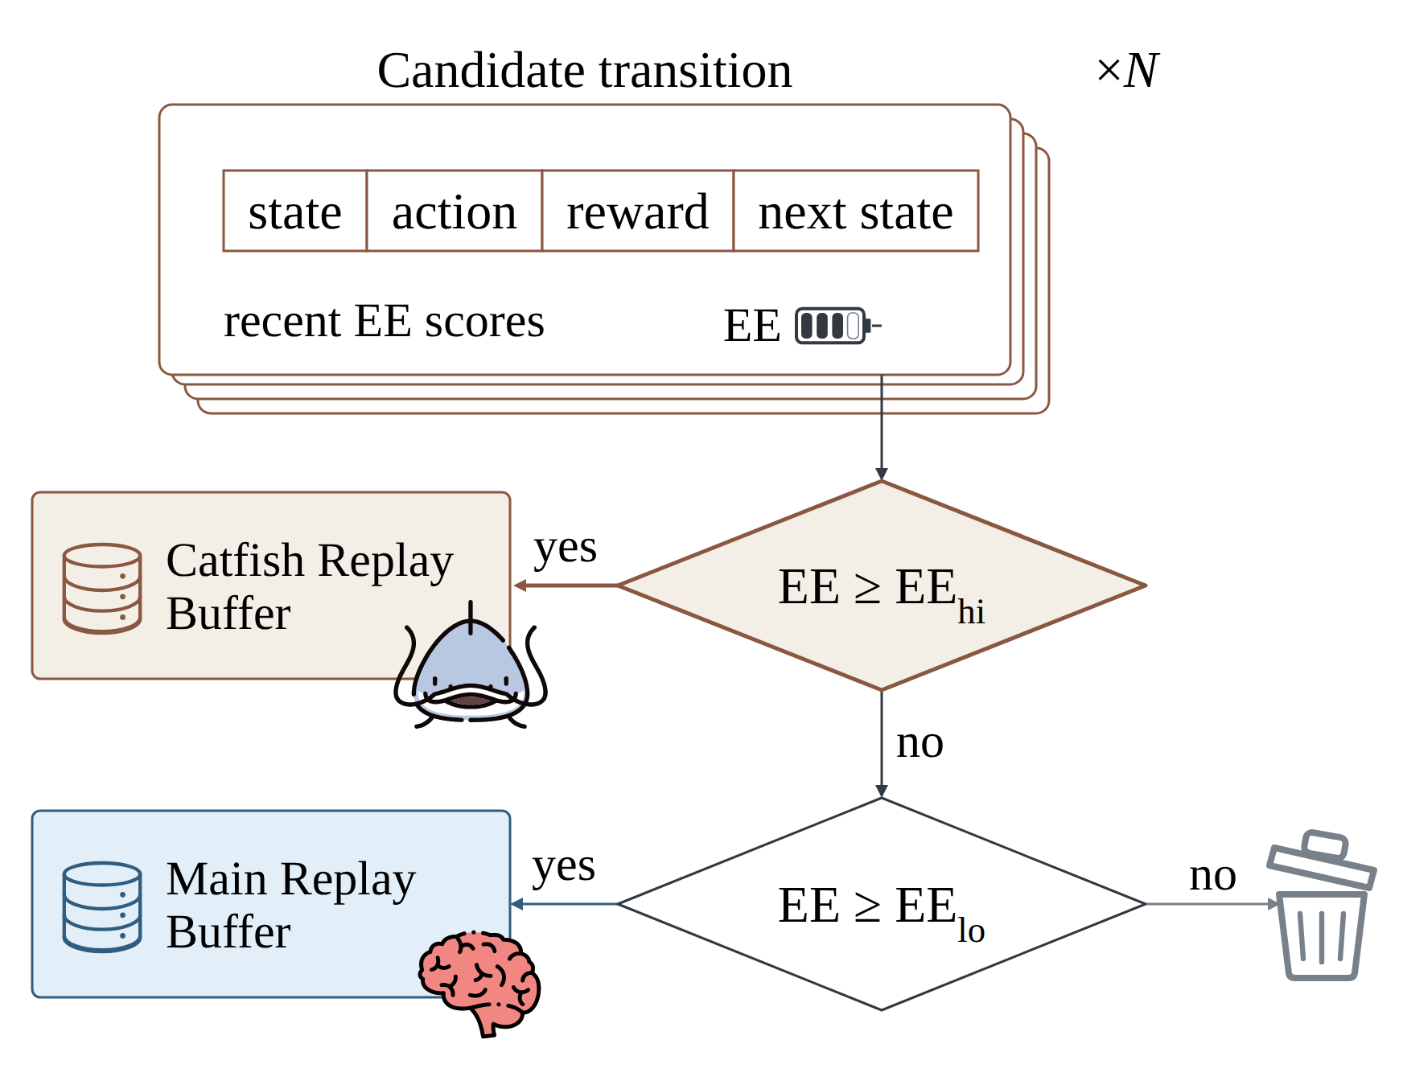
Fig. 4-4 Energy-efficiency stratification
Fig. 4-4: Energy-efficiency stratification. The catfish-side transition bundle $τ_{t}^{F}$ is scored by its mean unshaped first-objective contribution $g^{F}​\left(t,θ,θ_{3dB}\right)$ before calibration and compared with the recent distribution $F_{W}$. High-scoring bundles enter $D_{F}$, middle-scoring bundles are also sent to $D_{M}$, and low-scoring bundles are discarded (Eq. (4.7)), each retained buffer then uses its corresponding calibrated reward view.
The second component is asymmetric discounting. The three main-side objectives share $β_{M}$, while the three catfish-side objectives share the larger $β_{F}$:
$$\begin{matrix} & β_{M}<β_{F}, β_{j}^{M}≡β_{M}, β_{j}^{F}≡β_{F}, j=1,2,3. & & \text{(4.8)}\end{matrix}$$
A larger discount factor keeps more of the return from later steps within an episode. At the episode length $H=10$ used here, both effective horizons are at least the episode itself ($1/(1−β_{M})=10$), so the difference appears as how weight is distributed across steps within an episode: the main side emphasizes nearer-term returns, while the catfish side counts the whole episode almost uniformly. The episode length matches the effective horizon of $β_{M}$ at ten steps, which is the setting of Table I in the source paper and therefore not a deviation.
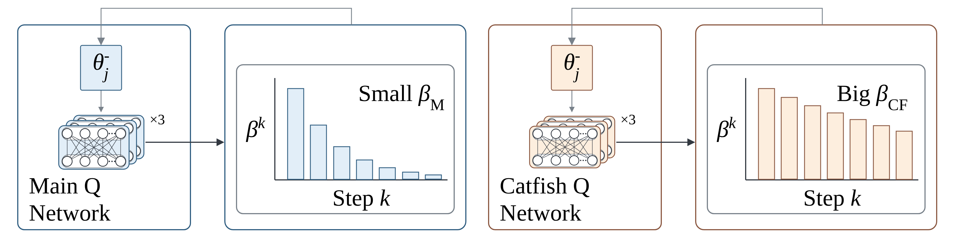
Fig. 4-5 Asymmetric discounting
Fig. 4-5: Asymmetric discounting. The three main-side objective networks use $β_{M}$, and the three catfish-side objective networks use the larger $β_{F}$ (Eq. (4.8)). The relative weight of a return $n$ steps ahead is $β^{n}$, the bars only illustrate this decay.
The third component is periodic intervention. Each interval $T$ is sampled uniformly from the integer range $[T_{1},T_{2}]$. When the interval expires, a mixed batch $B_{I}$ is formed from a proportion $ρ_{I}$ of $D_{F}$ and the remainder from $D_{M}$:
$$\begin{matrix} & \begin{aligned}n_{F}&=round​\left(ρ_{I}B\right), \\ n_{M}&=B−n_{F}.\end{aligned} & & \text{(4.9)}\end{matrix}$$
Here, $B$ is the batch size and $round(⋅)$ denotes rounding to the nearest integer. Drawing $n_{M}$ samples from $D_{M}$ and $n_{F}$ samples from $D_{F}$ forms the mixed batch $B_{I}$, both kinds of samples use the unshaped, calibrated three-dimensional reward. The three main-side networks use the same $B_{I}$ and perform one additional update with $β_{M}$, a new $T$ is drawn after an intervention.
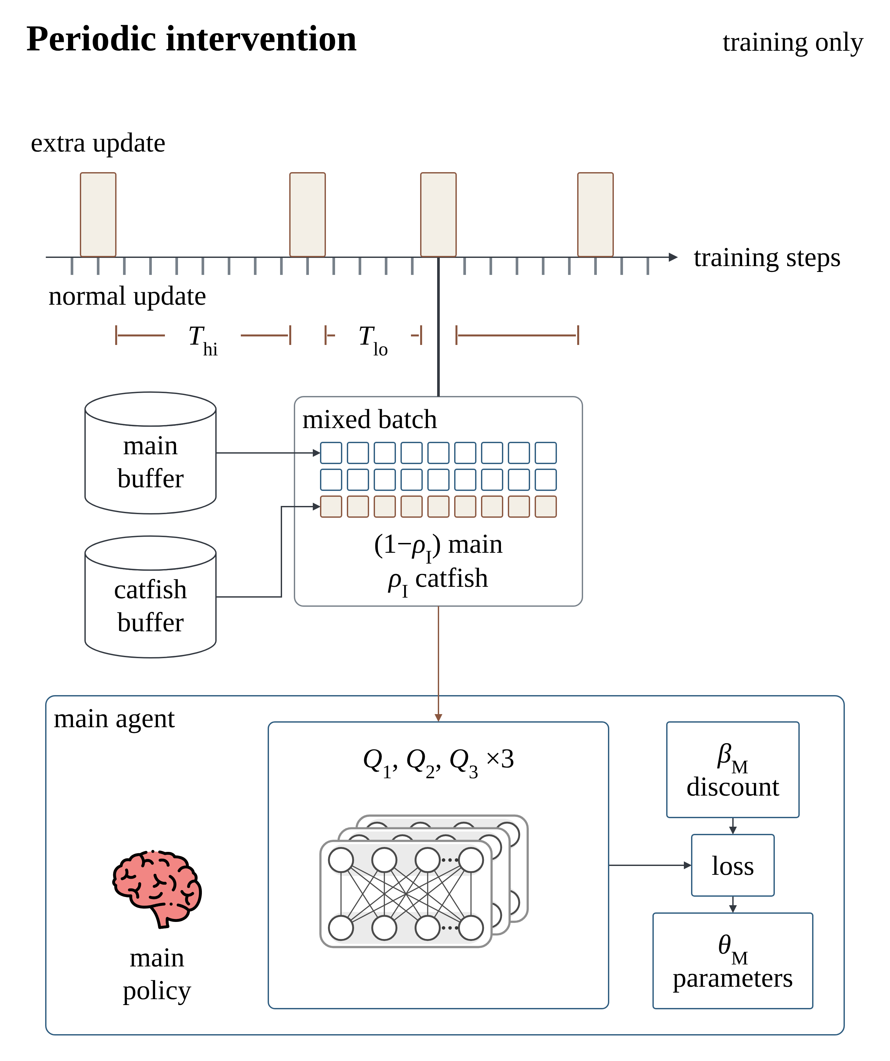
Fig. 4-6 Periodic intervention
Fig. 4-6: Periodic intervention. $n_{M}$ main-side samples and $n_{F}$ catfish-side samples form $B_{I}$ (Eq. (4.9)), both use unshaped, calibrated rewards. The same batch then updates $Q_{1}^{M}$, $Q_{2}^{M}$, and $Q_{3}^{M}$.
Together, the three components perform experience shaping, and they change only training, deployment still selects actions with the main agent.
The two sides use the same action-selection rule. Let $d∈\{M,F\}$ denote the main or catfish side, and let $A_{u}^{d}(t)$ be the feasible action set for user $u$ on that side. Each side combines its three Q-values with the common weights $Ω=[ω_{1},ω_{2},ω_{3}]$ from Section 3.2 and selects from this set. During training, each side also uses its own $ϵ$-greedy exploration:
$$\begin{matrix} & V_{u}^{d}(a,t)=\sum_{j=1}^{3}{ω_{j}}Q_{j}^{d}\left(s_{u}^{d}(t),a\right), a_{u}^{d}(t)=arg\max_{a∈A_{u}^{d}(t)}V_{u}^{d}(a,t), d∈\{M,F\}. & & \text{(4.10)}\end{matrix}$$
Equation (4.13) shows the one-to-one correspondence between the two MODQNs. $Q_{j}^{M}$ and $Q_{j}^{F}$ estimate the same objective, and both sides combine their three objective values into the scalarized value $V_{u}^{d}(a,t)$. Because the two sides learn independently, they may select different actions. The three networks within one side share its selected action but keep separate network parameters. These Q-networks are trained with calibrated rewards, so the effective trade-off weight in the original units is $ω_{j}/c_{j}$.

4.4 Reward Shaping: the Competitive Reward Mechanism
This section defines the first reward used by the catfish side. The competitive reward mechanism (ACRM) compares the catfish and main agents on the energy-efficiency objective. Handover and load balancing receive no competitive term, but they are still calibrated by the same $c_{j}$ before entering a replay buffer.
ACRM compares two complete joint actions under the same pre-action state and stochastic conditions. The catfish agent uses Eq. (4.10) to produce $a_{F}(t)$, while the main agent produces the exploration-free greedy action $a_{M∣F}(t)$. The two simulations therefore differ only in their joint action. Their first objectives are both computed by Eq. (3.25). Let the raw rewards be $r_{1,u}^{F}​\left(t,θ,θ_{3dB}\right)$ and $r_{1,u}^{M∣F}​\left(t,θ,θ_{3dB}\right)$, after which the difference and shaped reward are defined as:
$$\begin{matrix} & r_{1,u}^{S}​\left(t,θ,θ_{3dB}\right)=r_{1,u}^{F}​\left(t,θ,θ_{3dB}\right)−r_{1,u}^{M∣F}​\left(t,θ,θ_{3dB}\right), r_{1,u}^{C}​\left(t,θ,θ_{3dB}\right)=r_{1,u}^{F}​\left(t,θ,θ_{3dB}\right)+η_{w} r_{1,u}^{S}​\left(t,θ,θ_{3dB}\right). & & \text{(4.11)}\end{matrix}$$
Here, $η_{w}≥0$ is the competitive weight. Both raw $r_{1}$ values are calculated by Eq. (3.25) before the difference is formed. $r_{1,u}^{S}>0$ means that the catfish rollout has higher energy efficiency under the same conditions, whereas $r_{1,u}^{S}<0$ means the opposite. When $η_{w}=0$, $r_{1,u}^{C}=r_{1,u}^{F}$.
The catfish-side shaped vector is $[r_{1,u}^{C},r_{2,u}^{F},r_{3,u}^{F}]$. ACRM first forms $r_{1,u}^{C}$ in the original units and then calibrates the entire vector. Energy-efficiency stratification still scores the uncalibrated $r_{1,u}^{F}$, samples sent to $D_{M}$ and the intervention batch $B_{I}$ use the unshaped calibrated view, catfish TD updates use the shaped calibrated view. The competitive term therefore affects only $Q_{1}^{F}$.
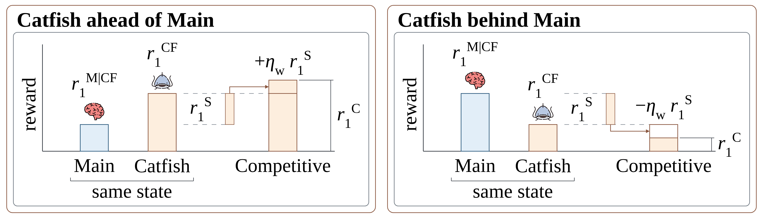
Fig. 4-7 Competitive reward mechanism
Fig. 4-7: Competitive reward on the energy-efficiency axis. Under the same pre-action state and stochastic conditions, only the complete joint action changes. Both simulations compute the first objective with Eq. (3.25), then form $r_{1,u}^{S}$ and $r_{1,u}^{C}$ (Eq. (4.11)). Both shaped and unshaped vectors are then calibrated by Eq. (4.13), and only $Q_{1}^{F}$ uses the competitively shaped value.

4.5 Overall Training Procedure
The main and catfish agents generate separate training trajectories. The competitive reward compares the two sides using the main-agent value before the update, and experience routed at that step is available to later parameter updates.
Pseudocode 4-1 summarizes the complete order. $E$ and $H$ are the number of training episodes and the maximum steps per episode, $B$ is the TD batch size, and $K$ is the target-network synchronization period. The interval $T$ is sampled from the range specified for Eq. (4.9).
# | Pseudocode 4-1: MCRL Training
 | Input: Two MODQNs and the training settings required by Eqs. (4.7)–(4.16). Output: the trained main agent $Q^{M}$.
1 | Initialize the online and target networks, replay buffers $D_{M},D_{F}$, and the first intervention interval $T$.
2 | for $e=1,…,E$ do: initialize separate main-agent and catfish-agent training trajectories.
3 | &nbsp,&nbsp,for $t=1,…,H$ do: construct the two inputs using Eqs. (4.7)–(4.9).
4 | &nbsp,&nbsp,&nbsp,&nbsp,Select the two joint actions independently using Eq. (4.10) and $ϵ$-greedy exploration.
5 | &nbsp,&nbsp,&nbsp,&nbsp,Execute the main-agent action to obtain $τ_{t}^{M}$, calibrate its unshaped reward, and store the complete transition in $D_{M}$.
6 | &nbsp,&nbsp,&nbsp,&nbsp,Execute the catfish-agent action to obtain $τ_{t}^{F}$, evaluate the main-agent greedy action from the same pre-action state and form the competitive reward using Eq. (4.11).
7 | &nbsp,&nbsp,&nbsp,&nbsp,Route $τ_{t}^{F}$ using its uncalibrated first objective in Eq. (4.7). Samples sent to $D_{M}$ use the unshaped calibrated view, catfish TD updates use the shaped calibrated view.
8 | &nbsp,&nbsp,&nbsp,&nbsp,When enough experience is available, update the main and catfish agents using $β_{M}$ and $β_{F}$, respectively.
9 | &nbsp,&nbsp,&nbsp,&nbsp,When the intervention interval expires, form $B_{I}$ using Eq. (4.9), apply one additional main-agent update, and sample a new $T$.
10 | &nbsp,&nbsp,&nbsp,&nbsp,If the episode terminates, leave the time-step loop.
11 | &nbsp,&nbsp,Synchronize both target networks every $K$ episodes.
12 | return $Q^{M}$.
The main-side TD update reads the unshaped calibrated vector. The catfish-side TD update reads the calibrated form of $[r_{1,u}^{C},r_{2,u}^{F},r_{3,u}^{F}]$. Let $d∈\{M,F\}$ denote the main or catfish side, and let $β_{d}$ be its discount factor. Both sides keep the form of Eq. (16) of the source paper, with each objective taking its own maximum over its own target network:
$$\begin{matrix} & y_{j,u}^{d}=\left\{\begin{matrix}{\overset{‾}{r}}_{j,u}^{d}(t), & s_{u}^{d}(t+1) \text{is a terminal state}, \\ {\overset{‾}{r}}_{j,u}^{d}(t)+β_{d}\max_{a^{′}∈A_{u}^{d}(t+1)}Q_{j}^{d}\left(s_{u}^{d}(t+1),a^{′},θ_{j}^{d,−}\right), & \text{otherwise},\end{matrix}\right. d∈\{M,F\}, j=1,2,3. & & \text{(4.12)}\end{matrix}$$
If the next state is terminal the TD target is the step reward alone, otherwise the discounted target-network value is added, and each objective takes its own maximum over its own target network. The main and catfish sides each perform one TD update, periodic intervention performs one additional main-side update with $B_{I}$.
Taking a separate maximum per objective during training is distinct from the deployment rule of (4.13), which scalarizes with $Ω$ before the $argmax$. This is the design of the source paper and is retained unchanged.
The three rewards have different units and magnitudes: bit/J, handover cost, and a beam-occupancy count. The following calibration is a thesis-defined training contract, not a formula stated in the original MODQN paper. The original paper stores the raw reward components and directly scalarizes the learned Q-values with $Ω$, it does not introduce $c_{j}$. This thesis adds $c_{j}$ so that the three objectives enter training on fixed, declared scales. Before a sample enters a replay buffer, each reward is divided by the fixed calibration constant $c_{j}$:
$$\begin{matrix} & {\overset{‾}{r}}_{j,u}^{d}(t)=\frac{r_{j,u}^{d}(t)}{c_{j}}, c_{j}>0, j∈\{1,2,3\}, & & \text{(4.13)}\end{matrix}$$
Here, $r_{j,u}^{d}(t)$ is the $j$th update reward on side $d$ before calibration and ${\overset{‾}{r}}_{j,u}^{d}(t)$ is the calibrated value. Before training starts, the constants $c_{j}$ are fixed and then shared by the training procedures. Consequently, the scalarization in Eq. (4.10) and the TD target in Eq. (4.12) use the same scale. In the original units, the effective trade-off weight is $ω_{j}/c_{j}$.
Deployment retains the three main-agent objective networks. Each user computes the scalarized value in Eq. (4.10) and uses $argmax$ to select a service beam.

5. Experimental Results

5.1 Simulation Settings
This chapter specifies the simulation environment, index domains, channel and energy-consumption model, and the settings used for training and evaluation. Chapter 3 defines the single active EE contract; this chapter supplies numerical scenarios and evaluation scope without redefining SINR, throughput, or EE.
Table 5-1 gives the numerical settings of the environment and index domains. The symbol $v$ in Chapter 3 denotes one beam index, while $V$ denotes the number of beam positions on each satellite; this study sets $V=39$. The symbols $U$, $S$, $V$, and $C$ correspond to the element counts of the respective sets.
Table 5-1. Environment and index-domain settings
Category | Symbol or relation | Setting in this study
Satellite constellation | $S$​ | Real Starlink ephemerides (TLE with SGP4), 373 daily files covering 2025-07-27 to 2026-08-20; inclination about 53 degrees
Satellite altitude | $h_{s}$​ | Determined by the ephemerides rather than set. The daily median altitude over the corpus is 483.0 km, and those daily medians range from 470.7 to 539.7 km; the instantaneous altitudes of individual satellites spread wider than that range
Visible-satellite window | $L_{w}$​ | 4
Ground users | $U$​ | 100
Beam-pointing locations per satellite | $V$​ | 39. Coverage is measured directly on the cell lattice at $h_{s}=483$ km, where 39 cells cover 95.2% of the service area. The lattice takes $R_{b}$ as the circumradius of the hexagonal cell, so the centre spacing is $\sqrt{3}R_{b}=24.24$ km and one cell covers 509.0 km$​^{2}$; each cell is then inscribed in its own 3 dB contour and no coverage hole is left. The same area ratio gives $18000×0.95/509.0=33.6$ cells, below the measured value, because it ignores the edge spill when the lattice is clipped to the rectangular service area; the measurement governs
Local candidate ranks per window satellite | $J_{w}$​ | 7 (the beam location nearest the user and its six adjacent locations)
Candidate action domain | $C=L_{w}J_{w}$​ | $4×7=28$​
Pointing combinations in the window | $L_{w}V$​ | $4×39=156$ satellite–beam-location pairs
Time discretization | $Δt$, $H$ | 30.08 s per step and 10 steps per episode
The two numbers refer to different model objects: 156 possible satellite–beam-location pairs in the current window, and 28 candidate actions available to each user at decision time.
With $C=28$, the four components in Eq. (4.1)—connection, candidate SINR, off-axis angle, and previous demand—each contain 28 entries. The original state $s_{u}$ therefore has dimension $4C=112$. That is also the dimension of the Q-network input.
Table 5-2 lists the experimental calibration values for the channel and energy model in Chapter 3. The main chain uses $G^{T}​\left(θ,θ_{3dB}\right)$, the linear link-power factor that does not directly carry the wanted-link angular pattern $H_{u,s,v}(t)$, angle-aware $p_{u,s,v}$, the per-beam $P_{s,v}^{p}$, $P^{f}$, and $P^{N}$; the detailed channel settings in the table belong only to scenario calibration and do not expand the main formula.
Table 5-2. Channel and energy-model settings
Category | Symbol or relation | Setting in this study
Carrier and bandwidth | $f_{c}$, $B_{sys}$ | 20 GHz and 500 MHz
Gaseous atmospheric absorption | $L_{g}(α)=A_{zen}/sinα$​ | $A_{zen}=0.25$ dB. The form is Eq. (6.6-8) of TR 38.811 [17]; the zenith value is recovered from the LEO Ka-band 20 GHz downlink link budget of TR 38.821 [22], whose atmospheric loss is 0.5 dB at the LEO target elevation of 30 degrees
Scintillation | $L_{c}(α)$​ | Tropospheric scintillation at 20 GHz from Table 6.6.6.2.1-1 of TR 38.811 [17]: 0.12 dB at 90 degrees, 0.30 dB at 30 degrees and 1.08 dB at 10 degrees of elevation. Section 6.6.6.1 of the same report considers ionospheric scintillation only below 6 GHz, so it is not counted at 20 GHz
Shadow fading | $L_{s}(α)$​ | Ka-band LOS shadow fading from Table 6.6.2-3 of TR 38.811 [17], zero-mean Gaussian in dB, with a standard deviation from 0.4 dB at 90 degrees to 1.9 dB at 10 degrees of elevation. Clutter loss applies only to NLOS and is not counted for a fixed LOS terminal
Frequency reuse | $c_{s,v}$, $B^{w}$ | Three-color reuse and 166.667 MHz
Beamwidth and beam coverage radius | $θ_{3dB}$, $R_{b}=h_{s}tan(θ_{3dB}/2)$ | 3.32 degrees and 13.998 km at $h_{s}=483$ km
Boresight gain | $G_{0}$​ | 2000 in linear scale, or 33.010 dBi
Receive-gain limits | $G_{R,max}$, $G_{R,min}$ | 35 dBi and $−10$ dBi; the clipping values in (3.10c)
Receive-gain envelope | $A_{R}$, $B_{R}$ | 32 and 25; earth-station reference-pattern parameters of (3.10c), absorbed into $H_{u,s,v}(t)$
Boresight-limit threshold | $ϵ_{μ}$​ | ${10}^{−10}$​
Rician fading | $K_{R}$​ | 20 dB
Receiver system temperature | $T_{a}$, $T_{0}$, $NF$, $T$ | 150 K, 290 K, 1.2 dB, and 242.294 K
Fixed power | $P^{f}(t)$​ | Aggregate of RF-chain, baseband, and other fixed circuit terms
Segment-start transmit power | $p^{0}$​ | 0.825 W, that is $p_{max}/2$; the starting value of every new served segment in Eq. (3.11). $p_{max}/p^{0}=2$ gives every served segment a 3 dB gain budget; 3 dB is the beam’s own half-power contour ($F=1/2$ exactly at $μ=2.07123$, that is at $θ=θ_{3dB}/2$, whose ground radius is $R_{b}$), so the size of the budget is fixed by geometry rather than chosen. The budget is measured against the segment-start angle $θ_{u,s,v}(τ_{u,s,v})$, not against the beam axis: the numerator of Eq. (3.12) is $G^{T}​\left(θ_{u,s,v}(τ_{u,s,v})\right)$ and not $G_{0}$, so the infeasibility test reads “the gain has fallen 3 dB since the link was taken up”, which coincides with “has left this cell” only when the segment starts on the axis
Per-beam RF-output limit | $p_{max}$​ | 1.65 W; the per-beam operating limit after back-off in Eq. (3.15a), and the threshold of the link-feasibility check. At $V=39$ a satellite radiating every beam at that limit draws $39×1.65=64.3$ W, below the LEO maximum transmit power $P_{max}=50$ dBm $=100$ W of Table I of HOBS [4], so the per-beam limit is consistent with the per-satellite power budget of the cited work; this study sets no per-satellite limit of its own (see the exclusions below Eq. (3.11)), and the comparison is a budget check only
PA maximum efficiency and output back-off | $ξ_{max}$, $BO$ | 0.35 and 5 dB; Eq. (3.15a), with saturated power $p_{sat}=p_{max}{10}^{BO/10}=5.218$ W
Circuit power per active beam | $P_{cir}$​ | 0.338 W ($300+19+14+5$ mW, Table II of You et al. [26]); Eq. (3.16a)
Shared baseband power per satellite | $P_{BB}$​ | 0.200 W [26]; Eq. (3.16a)
Of the four losses of Eq. (3.10b), Eq. (1) of HOBS gives names but no values; this study substitutes the corresponding tables of the 3GPP non-terrestrial network report [17] for $L_{g}$, $L_{c}$ and $L_{s}$, while $L_{f}$ is computed directly from the slant range and the carrier frequency. This substitution is a modelling choice of this study rather than the original setting of HOBS. $L_{s}$ and the Rician fading $K_{R}$ are the only two random terms in this model, and the experiments reproduce them from fixed random seeds.
The active contract does not put minimum-rate inversion, beam/satellite caps, PA reference curves, or min/max projections into the EE main formula. If the legacy simulator uses such limits, they are execution history for this chapter and cannot rewrite Eqs. (3.11)–(3.17).
If the existing numerical results were generated by the legacy runtime, they must be read as legacy provenance. Until runtime parity with the new contract is implemented and the experiments are rerun, the existing results are not claimed as empirical evidence for the new formulas.
Legacy execution settings (Chapter 5 provenance only) | Symbol | Historical setting
Minimum-rate threshold | $R^{m}$​ | 1 Mbit/s
PA reference output power | $P_{0}$​ | 5.218 W; the old runtime’s name for the $p_{sat}$ of Eq. (3.15a), with the same value
Atmospheric attenuation (legacy form) | $χ_{atm}$; $L^{atm}=3d^{km}χ_{atm}/(10h_{s}^{km})$ | $χ_{atm}=0.05$. This form yields only 0.015 dB at zenith, an equivalent atmospheric thickness of 0.3 km, which does not match the magnitude of gaseous absorption at 20 GHz; it is superseded by the cosecant law of Table 5-2
Satellite-total RF-output limit | $P_{sat,max}$​ | ${10}^{13/10}=19.953$ W
PA reference efficiency (legacy) | $η_{0}$​ | 0.35; superseded by $ξ_{max}$
Table 5-3. Method and evaluation settings
Category | Symbol | Setting in this study
Three-objective scalarization weights | $Ω=(ω_{1},ω_{2},ω_{3})$​ | $(0.5,0.3,0.2)$​
Handover costs | $(φ_{1},φ_{2})$​ | 0.5 for an intra-satellite beam change and 1.0 for an inter-satellite handover
Network architecture | — | Every Q-network on both the main and catfish sides uses hidden layers of 100, 50, and 50 units
Learning and batch | $B$​ | The learning rate is a controlled variable swept over $\{0.01,0.003,0.001\}$; the batch size is $B=128$
Exploration and target networks | $ϵ$, $K$ | $ϵ$ decays linearly from 1 to 0.01 over 2000 episodes; target synchronization every 50 episodes
Training horizon | $E$, $H$ | 9000 episodes and 10 steps per episode
Main and catfish discounts | $β_{M}$, $β_{F}$ | 0.90 and 0.99
Energy-efficiency stratification | $q_{1}$, $q_{2}$, $W$ | 0.50, 0.80, and 5000 transition bundles
Periodic intervention | $ρ_{I}$, $[T_{1},T_{2}]$ | Catfish share 0.30; interval sampled uniformly from 4 to 16 steps
Competitive reward | $η_{w}$​ | 1.0
Objective scale constants | $(c_{1},c_{2},c_{3})$​ | $(2471140.576, 1.0, 6)$; obtained from P3 and the analytic bound, frozen before training
MODQN [2] reports a learning rate of 0.01. This study adopts neither default outright: the learning rate is treated as a controlled variable and swept over the three values above, and the value used for the main results is filled in once the experiments are complete.
The frozen scale constants are $(c_{1},c_{2},c_{3})=(2471140.576, 1.0, 6)$. Here $c_{1}$ is the 95th percentile of $r_{1,u}$ over 12,000 served decision steps in probe P3, $c_{2}=φ_{2}=1.0$ is the analytic bound for the handover cost, and $c_{3}=6$ is the rounded 95th percentile of $|r_{3,u}|$ from P3. They are fixed before training and shared by all update procedures; in the original units, the effective trade-off weight is $ω_{j}/c_{j}$. Post-training effective contributions or weight shares are not available until the trained policy exists and must not be inferred from these pre-training constants.

Where the constraints bind
Whether the three constraints of this section are active is measured under the frozen scenario. The per-beam RF-output limit $p_{max}$ fires on 113 of 12{,}000 decision steps (0.94%): the power the link requires exceeds the limit, the link is declared infeasible, and the user is unserved at that step.
The peak link power among feasible steps is 1.6452 W, which uses 99.6% of the 3 dB gain budget. This is not a near miss; it is the limit truncating the distribution: among the steps declared infeasible, the required power has a median of 117.2% of the budget and a maximum of 214.8%. The tail of the required-power distribution reaches beyond twice the limit, and the feasible steps show only the cut left after it is removed.
These figures are bound to three things: $Δt=30.08$ s, the warm-start main arm, and the stay-if-possible reference policy. The policy matters most: the same settings under a random-masked reference policy give 7.60%, eight times as much, because that policy does not hold a link that has walked into good geometry. At $Δt=1$ s the outage rate is 0.0000, and with the warm start disabled, so that every episode boundary resets the served segment, it is also 0.0000 under the same policy (0.0016 under random-masked) with a peak reaching only 85.1% of the budget.
The constraint fires under both sampling arms for the entry segment age. The main arm $Uniform\{0,…,H−1\}$ gives a mean entry age of 4.56 steps and a firing rate of 0.94%; the sensitivity arm $Uniform\{0,…,5\}$ gives 2.54 steps and 0.81%. The latter is the equilibrium age distribution of the measured segment length of 6 steps; the former is independent of the policy but samples ages that run old. The ages differ by a factor of 1.79 while the firing rates differ by only 1.16. The relation is a threshold rather than a linear one: raising the mean entry age from 0 to 2.54 steps takes the firing rate from 0.0000 to 0.0081, and raising it further to 4.56 steps adds only 0.0013. The constraint therefore does not fire because the main arm samples old ages. The main arm is the pre-registered main arm, and its firing rate is read as an upper bound.
None of the three geometric mask terms binds in this setting, and $\left|A_{u}(t)\right|$ is 28 throughout. The mask and the power-feasibility rule are different mechanisms: the first decides what a user may select, the second decides whether the selected candidate becomes a connection.

6. Conclusion

6.1 Summary
This study uses the Multi-Objective Deep Q-Learning Network (MODQN) as the baseline for handover in multi-beam low Earth orbit satellite networks and builds the Multi-Catfish Reinforcement Learning (MCRL) framework on that architecture. Its three objectives correspond to angle-aware system energy efficiency, handover cost, and load balancing. MCRL applies experience shaping and reward shaping during training. After training, only the main agent is retained, and each user continues to select the highest-valued feasible action independently.

6.2 Contributions
The main work can be summarized as follows.
For angle-aware system energy efficiency, the first reward is the sum of the selected-link EE contributions, r1,u(t)=s,v​xu,s,v(t)ηu,s,v(t,θ). The off-axis angle first affects $G^{T}$ and then enters the wanted-link numerator directly as $H_{u,s,v}(t)G^{T}(θ_{u,s,v})$ in Eq. (3.10) and the SINR in Eq. (3.13); the angle-aware RF power is determined by Eqs. (3.11)–(3.12), the same unique link SINR determines throughput, and Eqs. (3.15)–(3.17) form shared system power and EE. The main chain no longer uses target-SINR inversion, a second SINR, or concept-level caps/min/max. If the existing Chapter 5 numbers came from the legacy runtime, they require runtime parity with the new contract and a rerun before they can be treated as evidence for the revised formulas.
For multi-objective catfish training, the main side and catfish side each contain three Q-networks corresponding to energy efficiency, handover, and load balancing; the three catfish-side networks share one environment trajectory and replay buffer. Energy-efficiency stratification, asymmetric discounting, and periodic mixed-batch intervention change the experiences and the within-episode return weighting used by the catfish side. The paired competitive reward changes only its first objective. After training, only the main side is retained.

6.3 Limitations and Future Work
System power includes the power amplifier, active-beam RF chains, satellite-shared baseband power, and beam-training and handover event energies. The current setting uses $E_{tr}=E_{ho}=0$, while other satellite hardware, signal-processing, and control power are outside the model. Future work can extend these power sources and reassess their effects on energy efficiency and method comparisons.
The current model is defined for one simulated environment and includes idealized assumptions in both the energy-efficiency definition and the environment settings. The performance difference between MCRL and the baseline remains to be determined by complete experiments; later studies can examine different user counts, constellation conditions, and environments closer to practical systems.

References
[1] J.-H. Lee, C. Park, S. Park, and A. F. Molisch, "Handover Protocol Learning for LEO Satellite Networks: Access Delay and Collision Minimization," IEEE Transactions on Wireless Communications, Vol. 23, No. 7, pp. 7624-7637, Jul. 2024.
[2] Y. Sun, Y. Zhai, W. Wu, P. Si, and F. R. Yu, "Handover for Multi-Beam LEO Satellite Networks: A Multi-Objective Reinforcement Learning Method," IEEE Communications Letters, Vol. 28, No. 12, pp. 2834-2838, Dec. 2024.
[3] U. Ntabeni, B. Basutli, H. Alves, and J. Chuma, "Adaptive Handover Optimization in LEO Satellite Networks Using Energy-Aware Q-Learning," IEEE Open Journal of the Communications Society, Vol. 6, pp. 5657-5666, 2025.
[4] S.-H. Chen, L.-H. Shen, K.-T. Feng, L.-L. Yang, and J.-M. Wu, "Energy-Efficient Joint Handover and Beam Switching Scheme for Multi-LEO Networks," IEEE Vehicular Technology Conference (VTC2024-Spring), pp. 1-7, Singapore, 2024.
[5] M. O. K. Mendonça, E. Lagunas, J. Grotz, A. Pérez-Neira, and S. Chatzinotas, "Deep Q-Learning-Based Handover for Spectral Coexistence Between Feeder and User Links in LEO Satellite Networks," IEEE Open Journal of the Communications Society, Vol. 6, pp. 6777-6791, 2025.
[6] H. Liu, Y. Wang, P. Li, and J. Cheng, "A Multi-Agent Deep Reinforcement Learning-Based Handover Scheme for Mega-Constellation Under Dynamic Propagation Conditions," IEEE Transactions on Wireless Communications, Vol. 23, No. 10, pp. 13579-13596, Oct. 2024.
[7] J. Zhu, Y. Sun, and M. Peng, "Beam Management in Low Earth Orbit Satellite Networks With Random Traffic Arrival and Time-Varying Topology," IEEE Transactions on Vehicular Technology, Vol. 73, No. 9, pp. 13352-13367, Sep. 2024.
[8] M. Song, J. Tian, H. Zhang, T. Xu, H. Hu, and T. Zhou, "Deep Reinforcement Learning Based Multi-Objective Handover for LEO Satellite Networks," IEEE Vehicular Technology Conference (VTC2025-Spring), pp. 1-5, Oslo, Norway, 2025.
[9] T. Tajmajer, "Modular Multi-Objective Deep Reinforcement Learning With Decision Values," Federated Conference on Computer Science and Information Systems (FedCSIS), pp. 85-93, Poznań, Poland, 2018.
[10] T. Basaklar, S. Gumussoy, and U. Y. Ogras, "PD-MORL: Preference-Driven Multi-Objective Reinforcement Learning Algorithm," International Conference on Learning Representations (ICLR), Kigali, Rwanda, 2023.
[11] T. Schaul, J. Quan, I. Antonoglou, and D. Silver, "Prioritized Experience Replay," International Conference on Learning Representations (ICLR), San Juan, Puerto Rico, 2016.
[12] B.-H. Ke, "CDRL: Catfish-Effect-Based Deep Reinforcement Learning for Energy-Efficient Joint Switching of RF Chains and Reflecting Elements in RIS-Aided 6G Networks," M.S. thesis, Dept. Comput. Sci. Inf. Eng., National Taipei Univ., Taipei, Taiwan, 2025.
[13] M. Calvo-Fullana, S. Paternain, L. F. O. Chamon, and A. Ribeiro, "State Augmented Constrained Reinforcement Learning: Overcoming the Limitations of Learning With Rewards," IEEE Transactions on Automatic Control, Vol. 69, No. 7, pp. 4275-4290, 2024.
[14] L. Agorio, S. Van Alen, M. Calvo-Fullana, S. Paternain, and J. A. Bazerque, "Multi-Agent Assignment via State Augmented Reinforcement Learning," Learning for Dynamics and Control Conference (L4DC), Proceedings of Machine Learning Research (PMLR), Vol. 242, pp. 1202-1213, Oxford, UK, 2024.
[15] J. Holder, N. Jaques, and M. Mesbahi, "Multi-Agent Reinforcement Learning for Sequential Satellite Assignment Problems," AAAI Conference on Artificial Intelligence (AAAI), pp. 26516-26524, Philadelphia, PA, USA, 2025.
[16] Q. Ye, B. Rong, Y. Chen, M. Al-Shalash, C. Caramanis, and J. G. Andrews, "User Association for Load Balancing in Heterogeneous Cellular Networks," IEEE Transactions on Wireless Communications, Vol. 12, No. 6, pp. 2706-2716, Jun. 2013.
[17] 3GPP, "Study on New Radio (NR) to Support Non-Terrestrial Networks (NTN)," 3rd Generation Partnership Project (3GPP), Technical Report TR 38.811, V15.4.0, 2020.
[18] J. Yu and J.-H. Kim, "Analysis of SINR According to Elevation Angle in Earth Fixed Beam," Asia-Pacific Conference on Communications (APCC), pp. 633-634, Jeju, South Korea, 2022.
[19] Y. Abudureheman, J. Chu, R. Song, X. Liu, W. Huangfu, and H. Zhang, "Resource Allocation in Multibeam LEO Satellite Systems Based on Beam Hopping and Frequency Reuse," IEEE Internet of Things Journal, Vol. 13, No. 1, pp. 167-180, Jan. 2026.
[20] E. Kim, I. P. Roberts, P. A. Iannucci, and J. G. Andrews, "Downlink Analysis of LEO Multi-Beam Satellite Communication in Shadowed Rician Channels," IEEE Global Communications Conference (GLOBECOM), pp. 1-6, Madrid, Spain, 2021.
[21] ITU-R, "Reference Radiation Pattern for Earth Station Antennas in the Fixed-Satellite Service for Use in Coordination and Interference Assessment in the Frequency Range From 2 to 31 GHz," International Telecommunication Union, Geneva, Switzerland, Recommendation ITU-R S.465-6, Jan. 2010.
[22] 3GPP, "Solutions for NR to Support Non-Terrestrial Networks (NTN)," 3rd Generation Partnership Project (3GPP), Technical Report TR 38.821, V16.2.0, 2023.
[23] S. C. Cripps, RF Power Amplifiers for Wireless Communications, 2nd ed. Norwood, MA, USA: Artech House, 2006.
[24] A. Piacibello, R. Giofrè, R. Quaglia, R. Figueiredo, N. Carvalho, P. Colantonio, V. Valenta, and V. Camarchia, "A 5-W GaN Doherty Amplifier for Ka-Band Satellite Downlink With 4-GHz Bandwidth and 17-dB NPR," IEEE Microwave and Wireless Components Letters, Vol. 32, No. 8, pp. 964-967, Aug. 2022.
[25] A. Morello and V. Mignone, "DVB-S2—Ready for Lift Off," EBU Technical Review, No. 300, Oct. 2004.
[26] L. You, X. Qiang, K.-X. Li, C. G. Tsinos, W. Wang, X. Gao, and B. Ottersten, "Hybrid Analog/Digital Precoding for Downlink Massive MIMO LEO Satellite Communications," IEEE Transactions on Wireless Communications, Vol. 21, No. 8, pp. 5962-5976, Aug. 2022.
[27] V. Mnih, K. Kavukcuoglu, D. Silver, et al., "Human-Level Control Through Deep Reinforcement Learning," Nature, Vol. 518, No. 7540, pp. 529-533, 2015.

