Spike Extraction Tool



# Contents

Contents 1

1. Introduction 3

2. Glossary 3

3. Main window 3

3.1. Parts of the main window 5

3.2. Load Voltage 5

3.3. Add voltage 6

3.4. Data list 6

3.5. Clear voltage 6

4. Available tools 7

4.1. Selecting a tool 7

4.2. Selecting a method 7

4.3. Setting the tools parameters 7

Automatic parameters 8

4.4. Running a tool 8

5. Active data 9

5.1. Plot in new figure 9

5.2. Access voltage 9

5.3. Save voltage 9

5.4. Zoom and displacement 9

6. Context Menu 10

6.1. Toggle loading popup 11

6.2. Debug 11

6.3. Rescale option 11

7. Data types 11

7.1. Voltage 12

7.2. AP 12

7.3. Spike 13

7.4. Firing rate 14

8. Tools 15

8.1. Rescale 16

Recursive Least Squares 16

Recursive mean 17

Particle filter 18

Variance 18

8.2. Denoise 19

Wavelets 19

9. Disclaimer 20

10. Contact 21

User Manual – Version 201911.1

# Introduction

Spike Extraction Tool (SET) is a MATLAB based Graphic User Interface (The MathWorks, Inc.) developed by neuroscientists at the Department of Biomedical Engineering at The University of Melbourne (biomedical.eng.unimelb.edu.au) and The Florey Institute of Neuroscience and Mental Health (www.florey.edu.au) in Melbourne, Australia.

The main purpose of the software is to correct drift in single-channel extracellular recordings of neural activity. The features available in SET include drift correction, identification of action potential (to which we refer as spikes from herein) templates, spike extraction (also called spike sorting), measurement of spike rates and various statistical tools such as measurement of inter-spike intervals and peristimulus time histogram.

# Glossary

|  |  |
| --- | --- |
| Term | Description |
| Active data | It is the currently selected recording. Its name appears in the data list. This is the recording that is currently shown in the plot section. |
| Context menu | Right click menu (secondary mouse button). |
| Current data | All the recordings that are loaded by SET. They are stored in the RAM. |
| GUI | Graphic User Interface |
| Resistance estimate | It is an estimation of the resistance between the recording electrodes based on the amplitudes of sampled spikes and the measurement of the noise. |

# Main window

The Main Window is initially blank with only a button (‘Load voltage’) to load a recording (Figure 1). Once a recording has been loaded, the rest of the Main Window is made visible (Figure 2).

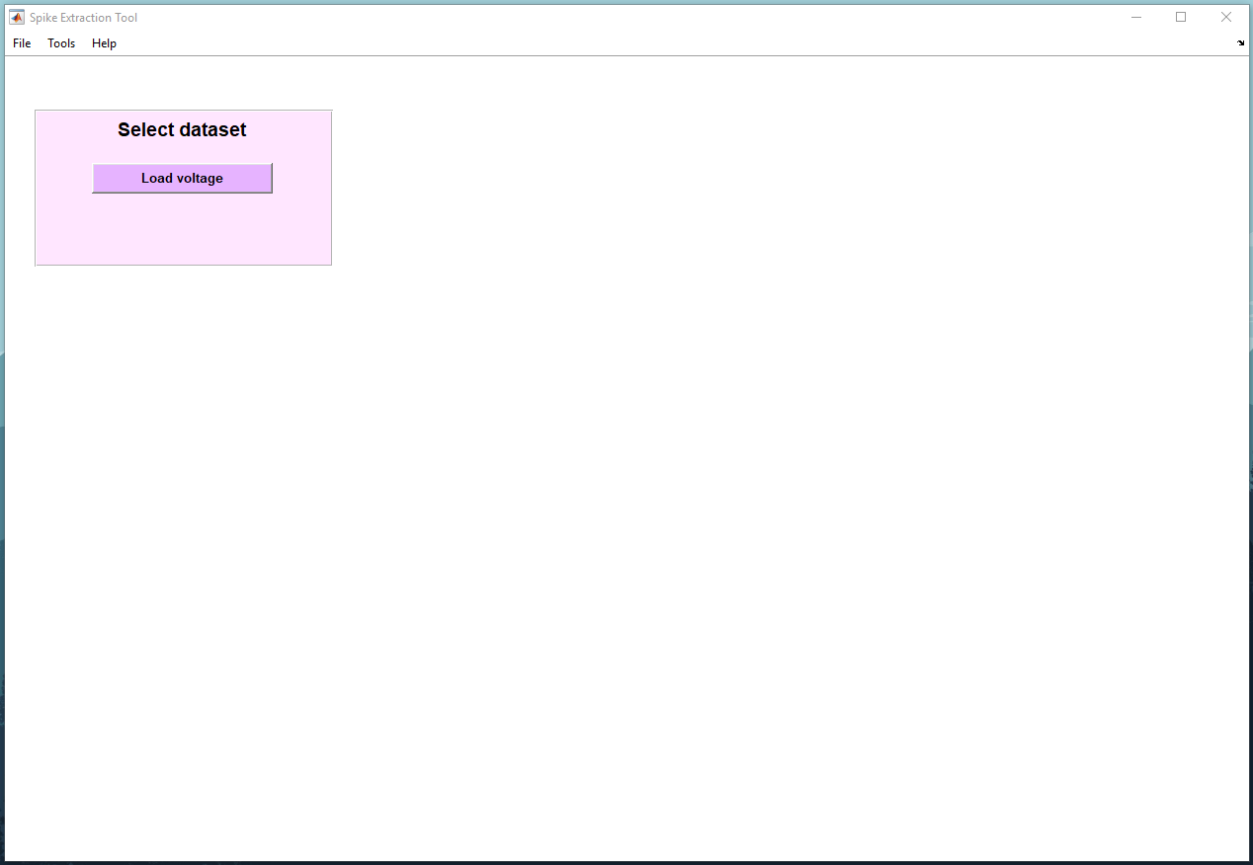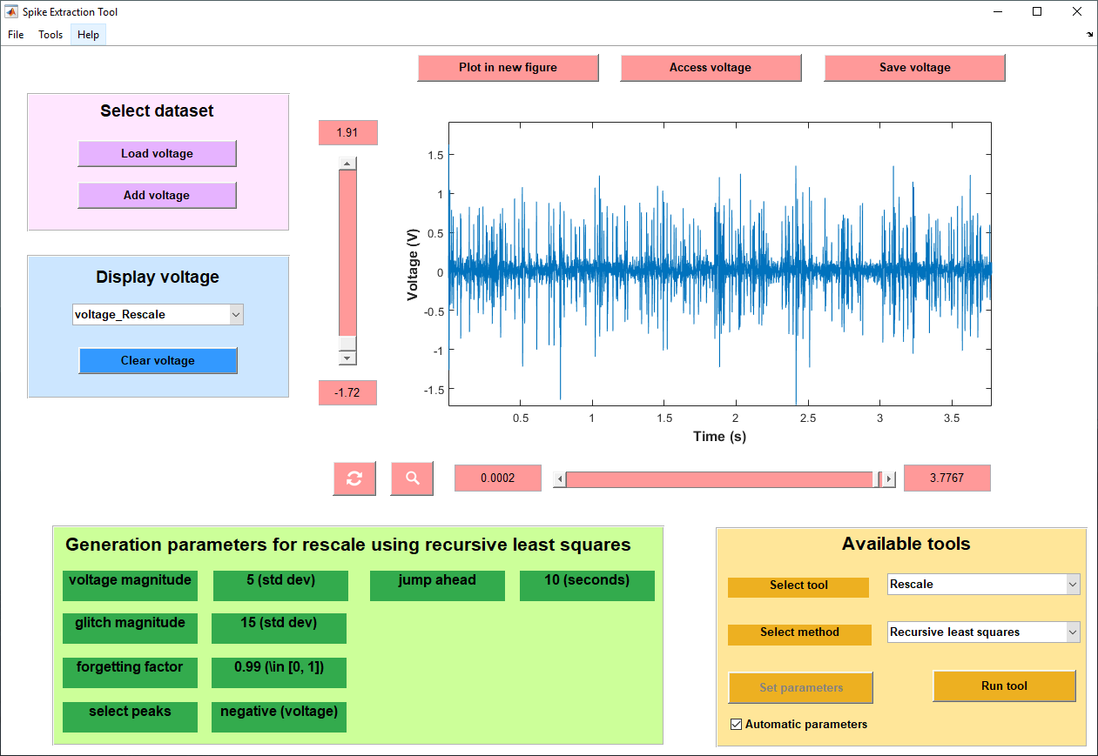Figure 1: Main window. Initial blank state.

Figure 2: Main window. There is available data currently loaded.

## Parts of the main window

The different parts and sections of the main window are illustrated in Figure 3.

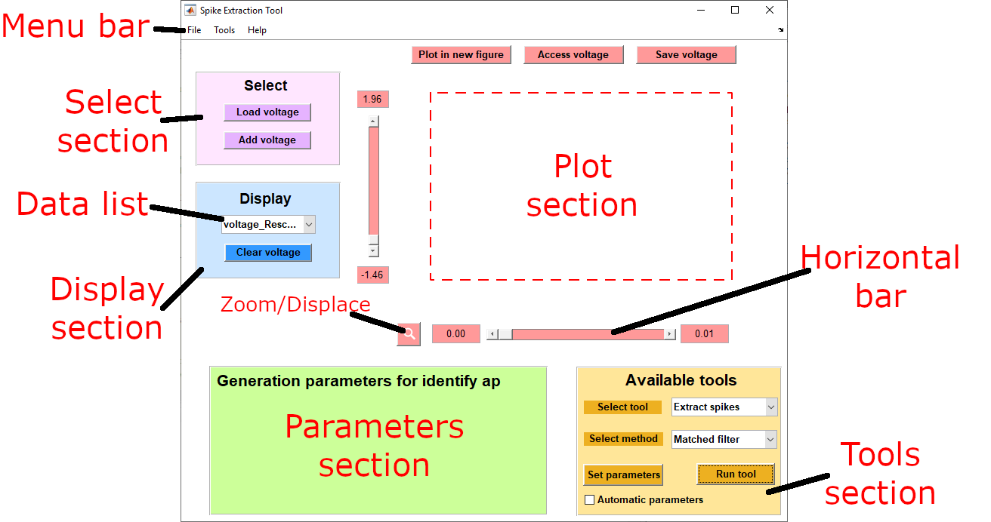

Figure 3

## Load Voltage

Press the button ‘Load voltage’ to load a recording from the hard drive or external disks. SET supports *.mat* and *.smr* files. MATLAB type files (.*mat*) must contain a variable of type ‘struct’ with the following fields:

* type (string): ‘voltage’, ‘ap’, ‘spike’, ‘firing rate’.
* name (string): the name of the recording, can be any MATLAB compatible string
* dt (float): sampling time in seconds, , where is the sampling frequency of the recording.
* time (float array): time in seconds of every samples. ‘time’ must be the same length as ‘data’.
* data (float array): amplitude of the recording at every sample. ‘data’ must be the same length as ‘time’.

Pressing the  button prompts the user to select a file. Once the file is selected, SET loads the recording and adds it to the data list of the ‘Display’ section.

If there is currently data loaded by SET, loading a new recording with ‘Load voltage’ will clear all current data. To load new data without losing the current data, use ‘Add voltage’.

## Add voltage

Pressing the  button, loads a new recording without losing current data. New recordings will be added to the data list in the ‘Display’ section. The newest loaded data becomes the active data, gets selected in the data list, and is displayed in the plot section.

## Data list

‘Data list’ is the dropdown menu in the ‘Display’ section. When retracted, it shows the currently active data. Upon clicking the ‘Data list’, the dropdown menu is expanded and it shows all the current data loaded by SET. Click the name of the recording you want to make active and display on the plot section.

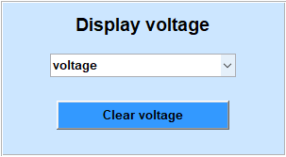

## Clear voltage

Press  to remove the currently active data. If there is more than one recording in the data list, only the active data is removed and every other recording remains in the data list. If ‘Clear voltage’ is pressed when there is only one recording in the data list, all the data from SET is cleared and the Main window returns to its initial blank state (Figure 1).

To clear more than one recording at a time, or a recording different to the active data, refer to the ‘Context menu’ section.

# Available tools

Once a recording has been loaded, the tool list is updated for the data type of that recording (‘voltage’, ‘ap’, ‘spike’ or ‘firing rate’). See section ‘Data types’ for more information and for the available tools for each type of data.

## Selecting a tool

Click on the dropdown menu with the legend  to choose the tool you want to run on the active data. The available tools will depend on the type of data (‘voltage’, ‘ap’, ‘spike’ or ‘firing rate’) to which the active data belongs. See the ‘Tools’ section for more information.

## Selecting a method

Click on the dropdown menu with the legend  to choose the method for the chosen tool. Each tool has different methods to be performed, e.g. a recording can be Rescaled using Recursive Least Squares or a Particle Filter. See the ‘Tools’ section for more information.

## Setting the tools parameters

Click on the button  to open a window that allows you to set all the parameters needed for the selected tool. Alternatively, tick the box  to allow SET to choose the best parameters based on an automatic algorithm.

### Automatic parameters

When the  box is ticked, the  button becomes disabled and the parameters can no longer be set manually, until you untick . Certain parameters are not calculated automatically, even if the box is ticked. In such cases, the value assigned to the parameter is the default value (if the parameter has not been set manually yet), or the last value manually set. See the ‘Tools section’ for a detailed description of each parameter and to know if it is an ‘Automatic parameter’ or not.

## Running a tool

To run a tool with the selected method and parameters, click on the  button. Once  is clicked, SET starts processing the data. Depending on the size of the data and complexity of the tool, this process could take up to several minutes.

To indicate that a tool is running, the mouse pointer will turn into a loading wheel, MATLAB’s command window will print the progress every 10% as in Figure 4 (only if you are using the Spike Extraction Tool toolbox on MATLAB, not with the Standalone version), and a loading bar window will appear (with most tools). The loading bar can be disabled by unticking the option  in the context menu (see the ‘Context menu’ section).

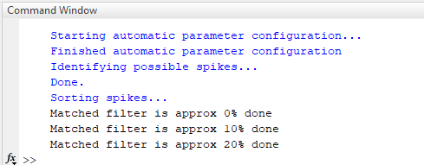Figure 4: Example of Spike Extraction using Matched filter. The progress is printed on the command window every 10%.

Once the Tool finishes running, the result will be added to the data list and will become the active data. The parameters used to generate the new active data (the parameters chosen before running the tool) are displayed in the ‘Parameters section’ (see Figure 3).

# Active data

The data that is currently displayed in the ‘plot section’ can be saved, accessed on MATLAB (in the Spike Extraction Tool toolbox only, not the Standalone version) and plotted on a new window.

## Plot in new figure

By clicking the  button, a new instance of the GUI will be created, i.e. a new SET window will appear and it will load the currently active data as the only current data. The initial GUI will remain unchanged.

## Access voltage

When using the SET toolbox within MATLAB, you can access the data from MATLAB’s workspace. This is useful if you wish to perform operations and analysis on the data that are outside the scope of SET. Clicking  will create a variable in MATLAB’s workspace with all the information regarding the active data. This option does not work on the Standalone version.

## Save voltage

You can save the active data into a *.mat* or *.smr* file by clicking . The file can then be loaded in SET for further analysis, or open in MATLAB as a variable. If you wish to save in *.smr* you can chose the channel on which the signal is stored.

## Zoom and displacement

The bottom part of the Plot section contains the Zoom ()/Displace () toggle button. Clicking the button will toggle between zooming and displacing. When the magnifier icon  is visible, ‘zoom’ is selected, and an action on the horizontal and vertical bars will result in zooming in and out in the x axis (horizontal bar) or in the y axis (vertical bar).

When the arrows icon  is visible, ‘displacement’ is selected, and an action on the horizontal and vertical bars will result in displacing left and right on the x axis (horizontal bar) or up and down on the y axis (vertical bar).

You can focus on different sections of a recording by manually changing the lower and upper limits of the plot. This can be achieved by modifying the value on the text boxes next to the horizontal and vertical bars.

# Context Menu

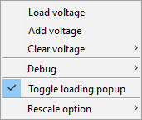

The context menu allows you to Load and Add voltages just as the buttons  and  do. Clearing a voltage can also be done in two ways, ‘clear current voltage’ does the same thing as , additionally, ‘clear a different voltage’ opens a dialog window where you can select one or various recordings to clear from a list of all the current data.

## Toggle loading popup

When  is ticked (default), a loading dialog will be visible while a tool is running. It contains a progress bar that gives an approximate of how much data has been processed. Unticking the  option disables the loading dialog. The tools will still run normally, the mouse will indicate when a tool is running and the MATLAB’s command window will print the progress every 10% (when using the Spike Extraction Tool toolbox, see Figure 4), but there is not going to be a progress bar visible.

## Debug

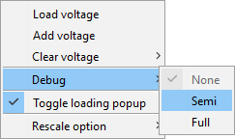There are 3 different ‘Debug’ options: None (default), Semi (advanced) and Full (advanced). Semi and Full generate different plots to track the performance of the tools. More detail can be provided upon request.

## Rescale option

The default rescale option is ‘separate’. More detail can be provided upon request.

# Data types

There are four different types of data: ‘voltage’, ‘ap’, ‘spike’ and ‘firing rate’. The available tools and type of graph in the ‘plot section’ vary depending on the type of the active data.

## Voltage

This is the main type of data, the start point for SET. It is the raw data loaded from an *.smr* or a *.mat* file that corresponds to an extracellular recording of neural activity. When loading data from an *.smr* file that contains more than 1 channel, the user will be prompted to choose which channel to load.

The tools that can be applied to a ‘voltage’ recording are: Rescale, Identify AP templates, Extract spikes and . Once a voltage has been Rescaled, the rescaled data is also a ‘voltage’ type. Other tools return different data types, refer to ‘Tools’ section for more information.

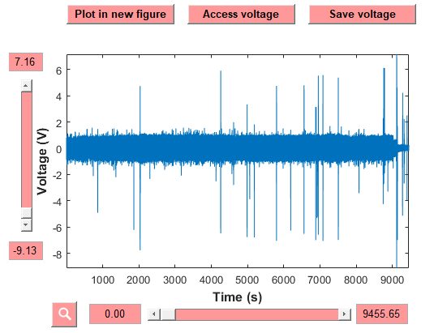Figure 5: Example of a ‘voltage’ data type as the active data.

## AP

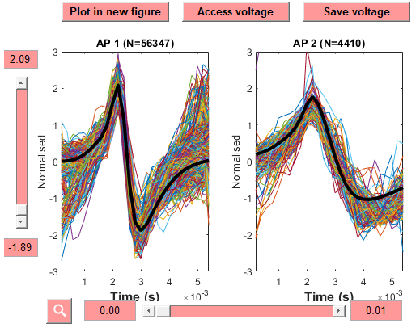The action potential templates are stored in an ‘ap’ data type. It contains the different templates identified from a ‘voltage’. The different templates can be merged or removed, as well as used to extract action potentials (spike sorting) from a ‘voltage’.

Figure 6: Example of an ‘ap’ data type as the active data.

## Spike

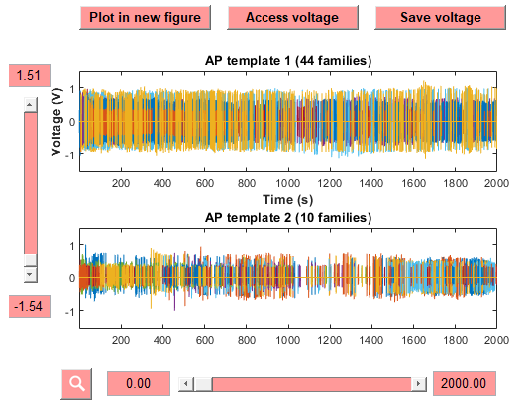The tool Extract spikes returns a ‘spike’ data type. A ‘spike’ contains different templates and different families within a template, each family belongs to a unit, or what SET identifies as an independent axon. A family might not be precisely one actual axon, but it is the best attempt to sort spikes based on size and shape.

Figure 7: Example of a ‘spike’ data type as the active data.

## Firing rate

When the firing rate of a ‘spike’ data type is calculated, the result is returned as a ‘firing rate’ data type. It contains the firing rate of each family from the ‘spike’.

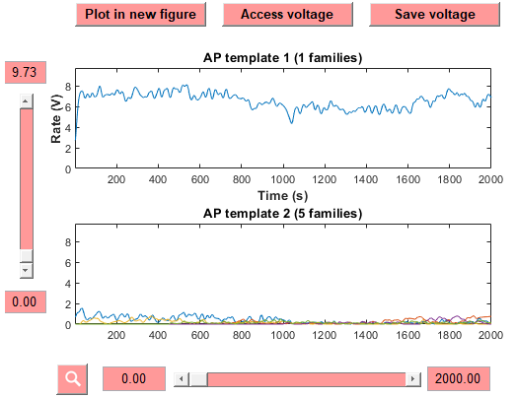Figure 8: Example of a ‘firing rate’ data type as the active data.

# Tools

Available tools:

|  |  |  |  |
| --- | --- | --- | --- |
| Input data type | Tool | Output data type | Methods |
| Voltage | Rescale | Voltage | Recursive least squares |
| Recursive mean |
| Particle filter |
| Variance |
| Denoise | Voltage | Wavelets |
| Threshold |
| Filter |
| Identify AP templates | AP | Threshold |
| Wavelets |
| K-means |
| Extract spikes | Spike | Matched filter |
| K-means |
| Utilities | Voltage | Down-sample |
| Truncate |
| AP | Extract spikes | Spike | Matched filter |
| Merge templates | AP | User selection |
| Delete templates | AP | User selection |
| Spike | Firing rate | Firing rate | Moving average |
| Statistics | None* | Inter-spike interval |
| Amplitude change |
| PSTH |
| Raster |
| Spike operations | Spike | Merge spikes |
| Export to excel | None* | Spike rate and count |
| Firing rate | Statistics | None* | Autocorrelation |

*Tools that indicate ‘None’ as the output data type do not return any variable and do not change the active data. The results of such tools are displayed in a new Figure window.

## Rescale

Rescale is a drift compensation algorithm that estimates the relative change in spike amplitude due to changes in the nerve-electrode interface and compensates it. The rescaling results in a compensated recording in which spikes from the same axon family have a consistent amplitude throughout the whole recording.

### Recursive Least Squares

This method recursively calculates the coefficients that minimize the mean squared error between spike peaks and the spike drift estimate as a function of time.

The parameters needed for recursive least squares are:

* Size of voltage when it is considered a spike rather than noise (*Th*):
  + Unit: standard deviations
  + Description: The algorithm detects peaks that seem to be spikes based on shape and size, when a peak is smaller than *Th* times the standard deviation of then noise, they are dismissed because they are considered to be noise, instead of spikes.
  + Default: 5
  + Automatic parameter: Yes (if  is ticked, this parameter will be calculated automatically. See ‘Setting the tools parameters Section’)
* Threshold at which voltage is considered a glitch of some sort (*GTh*):
  + Unit: mean resistance
  + Description: When a peak is larger than *GTh* times the mean Resistance estimate, it is considered a glitch and ignored.
  + Default: 5
  + Automatic parameter: Yes
* Select positive, negative or both positive and negative peaks:
  + Unit: voltage
  + Options:
    - Positive – The algorithm rescales the recording based only on the measurement of the positive peaks, i.e. the positive part of the spikes.
    - Negative – The algorithm rescales the recording based only on the measurement of the negative peaks, i.e. the negative part of the spikes.
    - All – The algorithm rescales the recording based on the measurement of positive peaks and negative peaks. It considers all peaks (positive and negative) at the same time, and rescales both parts of the signal (positive and negative) equally.
    - Separate – The algorithm rescales the recording based on the measurement of positive peaks and negative peaks. It considers positive and negative peaks separately and rescales each part of the signal (positive and negative) with a different value, calculated independently of each other.
  + Default: Separate
  + Automatic parameter: No (if  is ticked, this parameter will take the last value set manually or the default value. See ‘Setting the tools parameters Section’)
* Jump ahead to get largest spike in this amount of time:
  + Unit: seconds
  + Description: It is the sampling interval between chosen spikes to calculate the resistance.
  + Default: 10
  + Automatic parameter: Yes

### Recursive mean

The parameters needed for recursive mean are:

* Size of voltage when it is considered a spike rather than noise (*Th*):
  + Unit: standard deviations
  + Description: The algorithm detects peaks that seem to be spikes based on shape and size, when a peak is smaller than *Th* times the standard deviation of then noise, they are dismissed because they are considered to be noise, instead of spikes.
  + Default: 5
  + Automatic parameter: Yes
* Threshold at which voltage is considered a glitch of some sort (*GTh*):
  + Unit: mean resistance
  + Description: When a peak is larger than *GTh* times the mean Resistance estimate, it is considered a glitch and ignored.
  + Default: 5
  + Automatic parameter: Yes
* Select positive, negative or both positive and negative peaks:
  + Unit: voltage
  + Options:
    - Positive – The algorithm rescales the recording based only on the measurement of the positive peaks, i.e. the positive part of the spikes.
    - Negative – The algorithm rescales the recording based only on the measurement of the negative peaks, i.e. the negative part of the spikes.
    - All – The algorithm rescales the recording based on the measurement of positive peaks and negative peaks. It considers all peaks (positive and negative) at the same time, and rescales both parts of the signal (positive and negative) equally.
    - Separate – The algorithm rescales the recording based on the measurement of positive peaks and negative peaks. It considers positive and negative peaks separately and rescales each part of the signal (positive and negative) with a different value, calculated independently of each other.
  + Default: Separate
  + Automatic parameter: No

### Particle filter

Particle filter requires the same parameters as Recursive least squares. Refer to ‘Recursive Least Squares’ for details.

### Variance

The parameters needed for recursive mean are:

* Duration of moving average window:
  + Unit: seconds
  + Description: Length of the moving average window
  + Default: 10
  + Automatic parameter: No
* Skip ahead time to next averaging window:
  + Unit: seconds
  + Description: Amount of seconds the moving average window shifts on each step
  + Default: 5
  + Automatic parameter: No
* Consider positive and negative voltages separately
  + Unit: Boolean
  + Options: True (all)/False (separate)
  + Description: See ‘Recursive Least Squares’ for a description.
  + Automatic parameter: No
* Remove voltages larger than this many std devs from 0:
  + Units: standard deviations
  + Description: When a peak is larger than this value times the standard deviation of the noise, it is considered a glitch and ignored
  + Default: 10
  + Automatic parameter: No
* Assumed distribution of data:
  + Units: distribution
  + Options:
    - Gaussian
    - Student’s t
  + Default: Gaussian
  + Automatic parameter: No

## Denoise

Denoise filters the recording through different methods.

### Wavelets

When choosing the parameters to denoise the signal using wavelets, SET shows you a figure with the different wavelet options (Figure 9). The figure provides the information required to choose the parameters.

Figure 9: Wavelet options

* Name of mother wavelet to use:
  + Unit: wavelet
  + Options: symlets, daubechies, biorthogonal, coiflets, fejer-korovkin, discrete meyer, reverse biorthogonal
  + Default: symlets
  + Automatic parameter: No
* Index of wavelet to use in wavelet family:
  + Unit: integer
  + Default: 7
  + Automatic parameter: No
* Number of wavelet levels to use:
  + Unit: integer
  + Default: 5
  + Automatic parameter: No

# Disclaimer

This software was created as a part of our research interests and has been made publicly available responding to our desire to contribute towards the improvement of the field of Neuroscience worldwide. The creators bear no responsibility from the use or misuse of the Spike Extraction Tool. This User Manual is given as a guide for the easy use of SET. We understand that certain details might be missing in the User Manual and that SET might contain bugs, we appreciate any communication in regards of the User Manual, the use of SET or the report of any bugs that might be found in the application.

# Contact

Please direct any correspondence to our MATLAB Community Profile: <https://mathworks.com/matlabcentral/profile/authors/6308084-artemio-soto-breceda> ,

or to:

catherine.davey@unimelb.edu.au