A new approach for interfacial stress analysis of beams bonded with a thin plate

B. W. Lau ¹, J. S. Lee ² and C. K. Chan³
¹ Department of Land Surveying and Geomatics,
The Hong Kong Polytechnic University, Hong Kong, China.
² Department of Building Services Engineering,
The Hong Kong Polytechnic University, Hong Kong, China. Email: bejslee@polyu.edu.hk
³ Department of Civil and Structural Engineering,
The Hong Kong Polytechnic University, China.

ABSTRACT

Extensive research has shown that bonding a fibre-reinforced polymer (FRP) plate to the tension face of a reinforced concrete (RC) or steel beam can effectively enhance its serviceability and ultimate strength. The controlling failure mode of such a strengthened beam often involves the premature debonding of the FRP plate from the original beam in a brittle manner. A solid understanding of the cause and mechanism of this debonding failure mode is important for the development of an accurate strength model so that this strengthening technique can be used more effectively and economically. This paper presents a new analytical solution for the interfacial stresses in simply supported beams bonded with a thin plate and subjected to arbitrary symmetric loads. The solution is represented by Fourier series and is based on the minimisation of the complementary energy. It not only takes into consideration the non-uniform stress distribution in the adhesive layer and the stress-free boundary condition at the ends of the plate, but also correctly predicts the drastic difference in the interfacial normal stress between the plate-to-adhesive interface and adhesive-to-concrete interface as revealed by finite element analysis.

KEYWORDS

FRP, RC beams, strengthening, interfacial stresses, analytical solution.

Introduction

Extensive research has shown that bonding a fibre-reinforced polymer (FRP) plate to the tension face (or the soffit in the context of a simply supported beam) of a reinforced concrete (RC) beam can effectively enhance its serviceability and ultimate strength (Teng et al. 2002a). More recently, FRP plate bonding has also been used to strengthen steel beams. Central to the success of this technique is the effective stress transfer from the existing beam to the externally bonded FRP reinforcement. Research has shown that the controlling failure mode of such a strengthened beam often involves the premature debonding of the FRP plate from the beam in a brittle manner (Smith and Teng 2001a, 2001b, 2003). As this debonding failure mode is closely related to the interfacial stresses between the FRP plate and the existing beam, extensive studies have been carried out during the last decade on the prediction of interfacial stresses, generally within the context of RC beams strengthened with an FRP plate, although a substantial amount of work on interfacial stresses in steel plated RC beams had been carried out before FRP plate bonding became popular. These include experimental studies (e.g. Garden et al. 1998; Ahmed et al. 2001; Bonacci and Maalej 2001); numerical studies using the linear finite element method (e.g. Täljsten 1997; Malek et al. 1998; Rabinovich and Frostig 2000; Teng et al. 2002b) and the nonlinear finite element method (e.g. Ascione and Feo 2000; Rahimi and Hutchinson 2001; Aprile et al. 2001), discrete section analysis (e.g. Arduini and Nanni 1997) and analytical solutions (e.g. Smith and Teng 2001). This paper presents a new analytical solution for interfacial stresses in an existing beam strengthened with a bonded FRP plate.

METHOD OF SOLUTION

Geometry and Loading

Consider a simply supported RC beam with a span of 2L. The bonded plate has a length of 2l (Figure 1). The beam is subjected to an axial force N₀, a pair of end moments M₀ and a symmetrically distributed arbitrary transverse load q(x). It may be noted that any thermal loading due to the difference in thermal properties between the materials for the beam and the plate (e.g. FRP, concrete, cast iron) can be easily included in N₀.

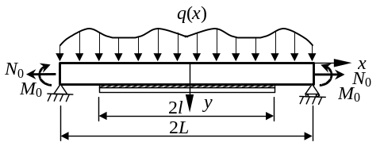
Figure 1 A plated beam under symmetric loads

Assumptions

The present analysis takes into consideration the transverse shear stress and strain in the RC beam and the FRP plate but ignores the transverse normal stress in them. Additionally, the following four assumptions are adopted:
(1) each individual layer is elastic, homogeneous and orthotropic. Note that the assumption of orthotropic behaviour has implications only for the shear moduli of the materials for the RC beam and the bonded plate;
(2) the three layers are perfectly bonded (no slips or opening-up at the interfaces);
(3) the Euler-Bernoulli beam theory is adopted for the beam and the plate, whereas the adhesive layer is considered to be in a plane stress state; and
(4) the longitudinal stress in the adhesive is assumed to vary linearly across its thickness.

Equilibrium Equations of Beam and Plate

For the beam and plate (i^{th} layer, i = 1, 3), equilibrium considerations lead to the following relations
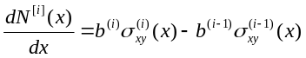 (1a)
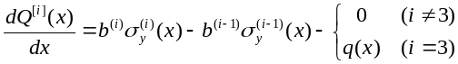 (1b)
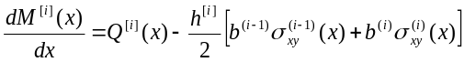 (1c)
where 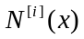, 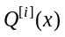 and 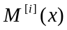 are the axial force, shear force and bending moment respectively in the i^{th} layer and 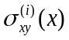 and 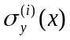 are the shear and transverse normal stresses respectively at the i^{th} interface. In Eq. 1 and the rest of this paper, the superscript in x^{[i]} is omitted because the global and the three local co-ordinate systems share the same horizontal axis.

Representation of Stress Fields

Stress field in the adhesive layer
The adhesive layer is treated as an elastic continuum without any body force. The equilibrium equations in its local coordinate system are
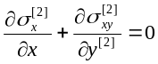 (2)
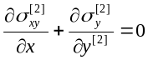 (3)
where 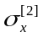, 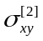 and 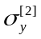 denote the longitudinal, shear and transverse stresses respectively. The equilibrium conditions of Eqs 2 and 3 lead to other equations.

Stress fields in the plate and the RC beam

Using Assumption 3, the longitudinal and shear stresses in the plate and the beam can be expressed as
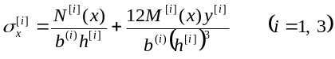 (4a)
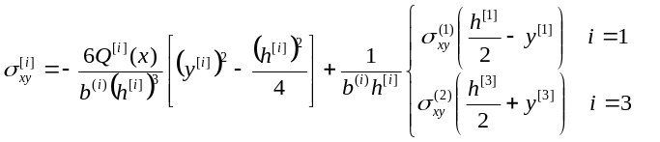 (4b)
Eqs 4a and 4b form the basis of the solution.

RESULTS AND DISCUSSIONS

In Figure 2, the bond strengths predicted using the proposed bond-slip models are compared with the results of the 253 pull tests in Lu et al.’s (2005) database. It can be seen that the proposed bond-slip models give results in close agreement with the test results and perform better than any other bond-slip models. The results of the precise model and the simplified model are almost the same, with the precise model performing very slightly better. Table 1 shows that the prediction of the proposed bi-linear model for the bond strength, which can be given as a closed-form expression (Lu et al. 2005), performs significantly better than all existing bond strength models except Chen and Teng’s (2001) model. For the prediction of bond strength, Chen and Teng’s (2001) model is still recommended for use in design due to its simple form and good accuracy.

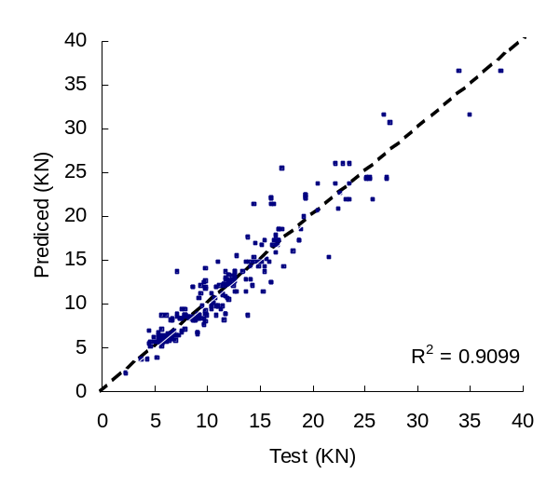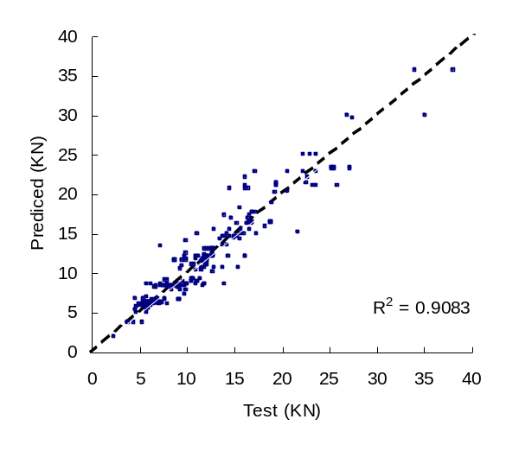
(a) Precise model (b) Bilinear model
Figure 2 Bond strengths: test results versus predictions of proposed bond-slip models

Table 1 Predicted-to-test bond strength ratios: bond strength models
Bond strength model | Average Predicted-to-test bond strength ratio | Coefficient of variation | Correlation coefficient
Chaallal et al. (1998) | 1.683 | 0.749 | 0.240
Khalifa et al. (1998) | 0.680 | 0.293 | 0.794
Chen and Teng (2001) | 1.001 | 0.163 | 0.903
Proposed, bilinear model | 1.001 | 0.156 | 0.908

CONCLUSIONS

This paper has presented materials extracted from existing papers to illustrate the style requirements of papers to be submitted for publication in the proceedings of the International Symposium on Bond Behaviour of FRP in Structures to be held on 7-10 December, 2005.

ACKNOWLEDGMENTS

The authors gratefully acknowledge the financial support provided by the Research Grants Council of Hong Kong (Project No: PolyU 5151/03E), the Natural Science Foundation of China (National Key Project No. 50238030) and The Hong Kong Polytechnic University through the Area of Strategic Development (ASD) Scheme for the ASD in Mitigation of Urban Hazards.

References

Ahmed, O., Van Gemert, D. and Vandewalle, L. (2001). “Improved model for plate-end shear of CFRP strengthened RC beams”, Cement and Concrete Composites, 23, 3-19.
Aprile, A., Spacone, E. and Limkatanyu, S. (2001). “Role of bond in RC beams strengthened with steel and FRP plates”, Journal of Structural Engineering, ASCE, 127(12), 1445-1452.
Arduini, M. and Nanni, A. (1997). “Parametric study of beams with externally bonded FRP reinforcement”, ACI Structural Journal, 94(5), 493-501.
Ascione, L. and Feo, L. (2000). “Modeling of composite/concrete interface of RC beams strengthened with composite laminates”, Composites: Part B, 31, 535-540.
Bonacci, J.F. and Maalej, M. (2001). “Behavioural trends of RC beams strengthened with externally bonded FRP”, Journal of Composites for Construction, ASCE, 5(2), 102-113.
Chaallal, O., Nollet, M.J. and Perraton, D. (1998). “Strengthening of reinforced concrete beams with externally bonded fiber-reinforced-plastic plates: Design guidelines for shear and flexure”, Canadian Journal of Civil Engineering, 25(4), 692-704.
Chen, J.F. and Teng, J.G. (2001). “Anchorage strength models for FRP and steel plates bonded to concrete”, Journal of Structural Engineering, ASCE, 127(7), 784-791.
Garden, H.N., Quantrill, R.J., Hollaway, L.C., Thorne, A.M. and Parke, G.A.R. (1998). “An experimental study of the anchorage length of carbon fiber composite plates used to strengthen reinforced concrete beams”, Construction and Building Materials, 12, 203-219.
Lu, X.Z., Teng, J.G., Ye, L.P and Jiang, J.J. (2005). “Bond-slip models for FRP sheets/plates bonded to concrete”, Engineering Structures, 27(6), 920-937.
Malek, A.M., Saadatmanesh, H. and Ehsani, M.R. (1998). “Prediction of failure load of R/C beams strengthened with FRP plate due to stress concentration at the plate end”, ACI Structural Journal, 95(1), 142-152.
Rabinvich, O. and Frostig, Y. (2000). “Closed-form high-order analysis of RC beams strengthened with FRP strips”, Journal of Composites for Construction, ASCE, 4, 65-74.
Rahimi, H. and Hutchinson A. (2001). “Concrete beams strengthened with externally bonded FRP plates”, Journal of Composites for Construction, ASCE, 5(1), 44-56.
Smith, S.T. and Teng, J.G. (2001). “Interfacial stresses in plated beams”, Engineering Structures, 23, 857-871.
Smith, S.T. and Teng, J.G. (2002a). “FRP-strengthened RC beams-I: Review of debonding strength models”, Engineering Structures, 24(4), 385-395.
Smith, S.T. and Teng, J.G. (2002b). “FRP-strengthened RC beams-II: Assessment of debonding strength models”, Engineering Structures, 24(4), 397-417.
Smith, S.T. and Teng, J.G. (2003). “Shear-bending interaction in debonding failures of FRP-plated RC beams”, Advances in Structural Engineering, 6(3), 183-199.
Täljsten, B. (1997). “Strengthening of beams by plate bonding”, Journal of Materials in Civil Engineering, ASCE, 9(4), 206-212.
Teng, J.G., Chen, J.F., Smith, S.T. and Lam, L. (2002a). FRP strengthened RC Structures, Wiley, Chichester, U.K.
Teng, J.G., Zhang, J.W. and Smith, S.T. (2002b). “Interfacial stress in RC beams bonded with a soffit plate: a finite element study”, Construction and Building Materials, 16(1), 1-14.

