1. home page

It is necessary put the checkup in the position that I posted in the following image. Must show all checkup, noto ne and must hav ethe informations of small image af all checkup.

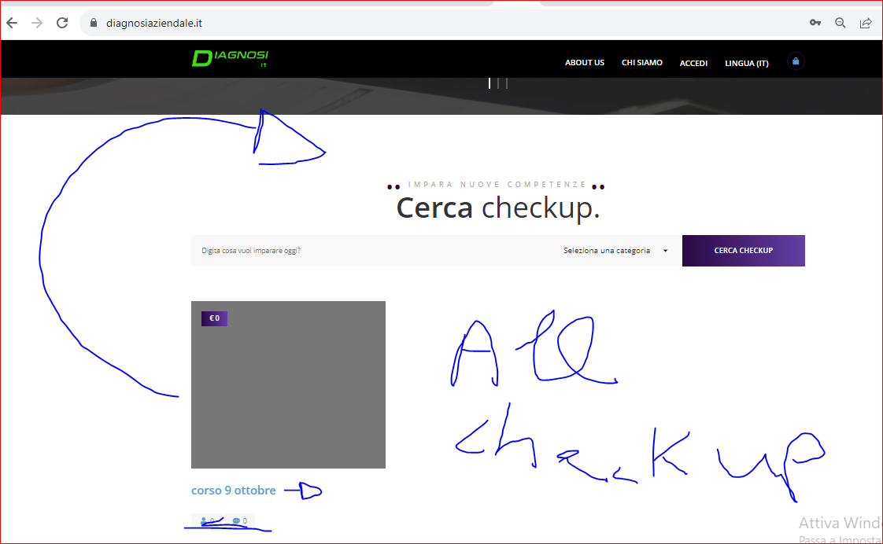

I see there is the sky blue colors. It is necessary use the colors that I wrote inside the document (only 3 colors for all, so ble grey and black). we can also decide to use not black but whute and a ble more   
clearer, but not the actual sky ble

1. down page:

It is necessary solve how my image

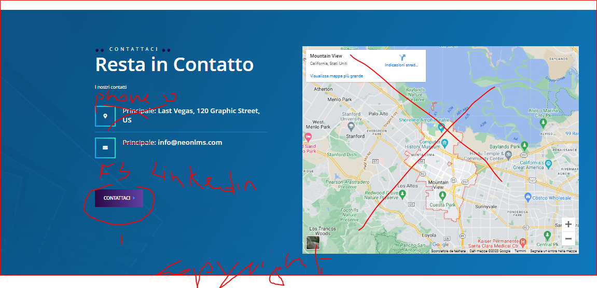



1. image. we must research where is this image and change. I can change alone after. But can tel me where i can change (file)?

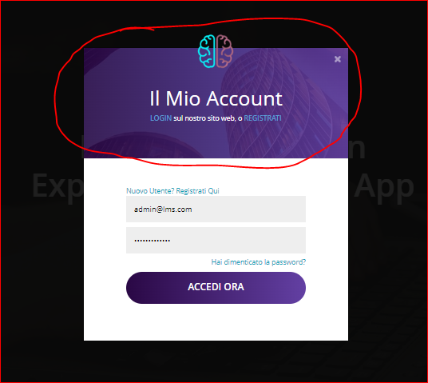

4 Can reduce the hight of that box of image?. use the same grey of all web. Can use a more big the font of text (A) and can use a standard color of web, for example black-white (I am not use that use the ble all web, but you caì n verify)

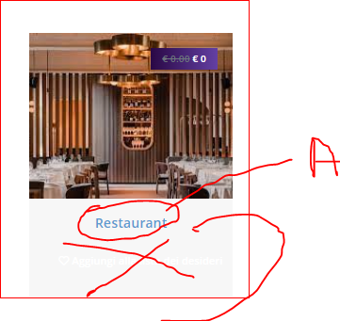

1. Can change the text “corsi” with “checkup”?

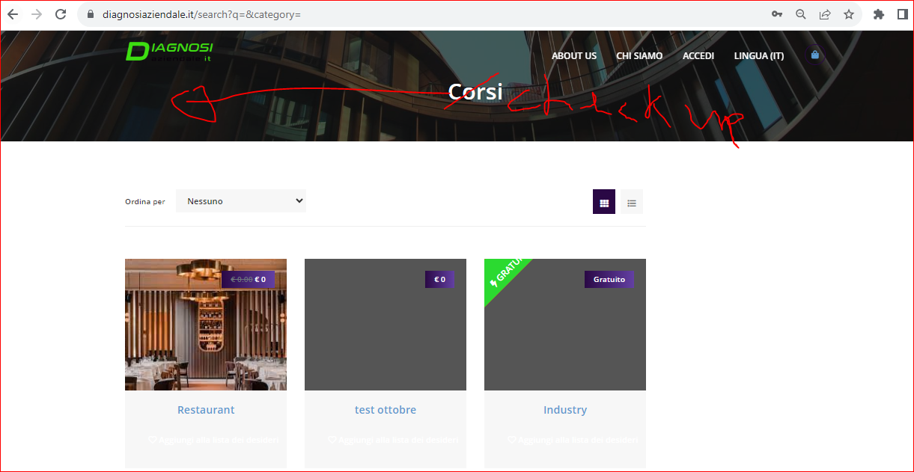

1. I am sorry, can delate this and chanhe the text to: Argomenti

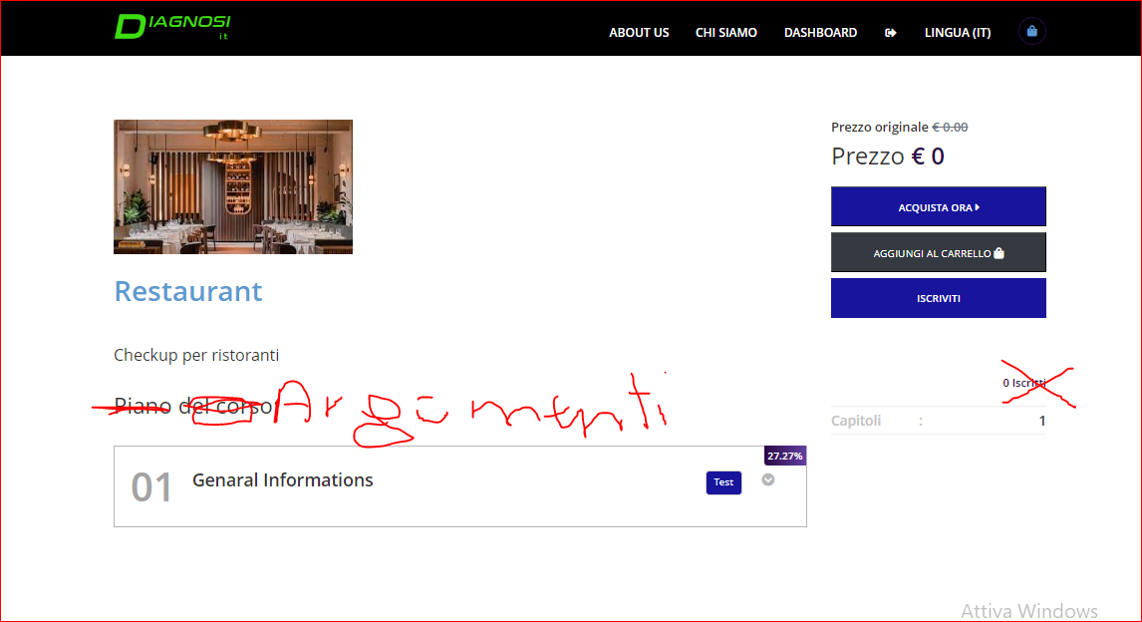

1. distance by bord and colors

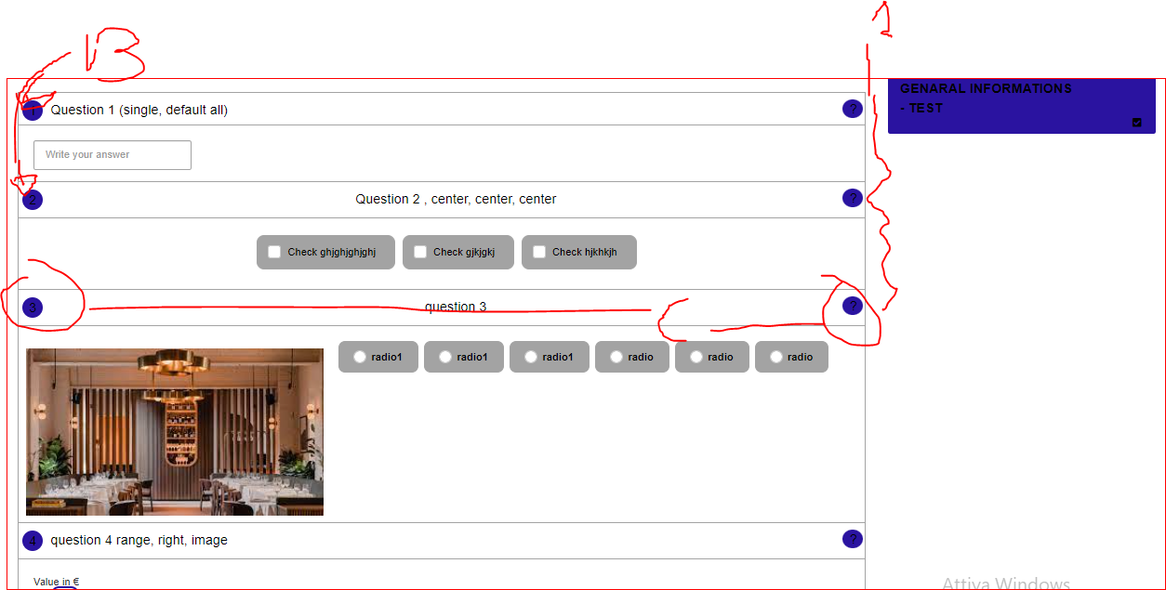

1. make better these bord. It is necessary elinate the bord of text HELP and chaange the xt to: GUIDA INFORMATIVA. Font respect the other title. the bord of description you can do fix or eliminae. The goal is have some think more visible

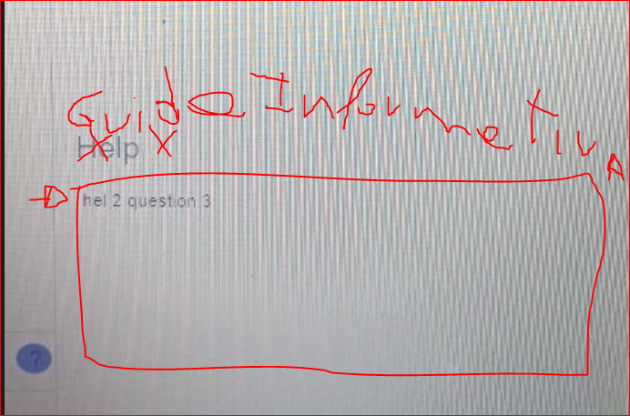

delate text: text:

and more big interlnee beetween two texts

the % of progression have some problem. first it s necessary use the same logic of color

second, when the value ave decimal the number go out of cirke. so yiu can also delate the decimal

three. it is neessary verify if the software update correctly the %



infact don’t work because I didn’ answer to all question

I saw an other big problem. before the software saved the questions answr. the last developer corrupt this. I explain by example: if the user today make a test that have 100 questions, buti t want interrupt to 60 questons. when open the next day the application, he didn’t manswr ll from sccratch. so the software must save the questions answred. so wwhn open again he can see the answer and continue.

the two % of progression must be identical

1. dashboard user page

it is necessary delate student, change color of bar of % of progress. and change the text study with “checkup” or delate and use the box to go inside the checkup

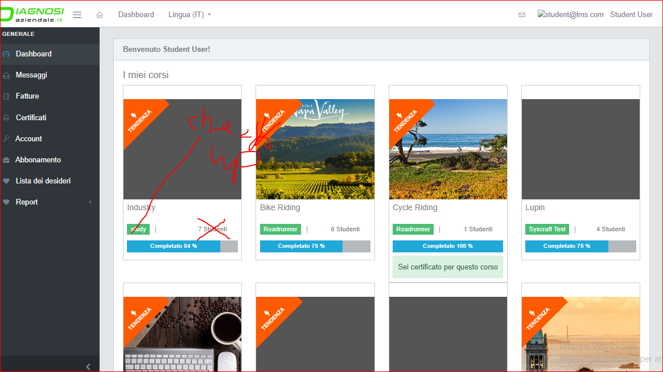

- Message. My project don’t have the th epossibility to comunicate with other student, so the mesage must be send to the adminstartor. So t is possible delate all that informations

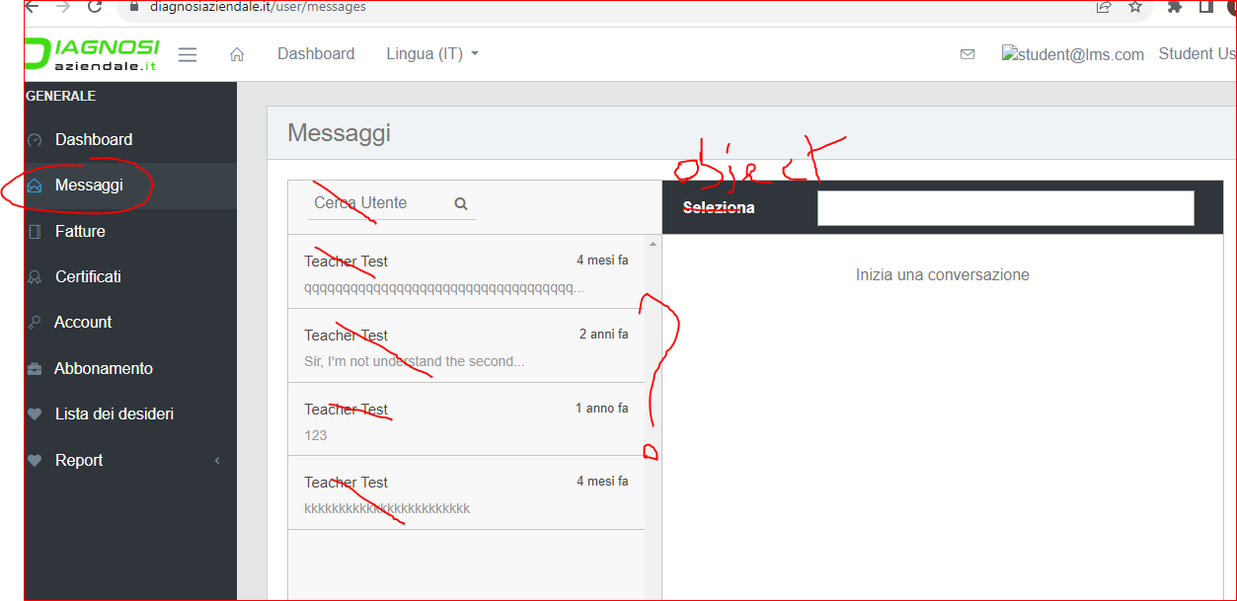

- information status checkiup. It is necessary make the following change and solve the error of visualization of page (lenght). change the text “certificati” with “Checkup”

- 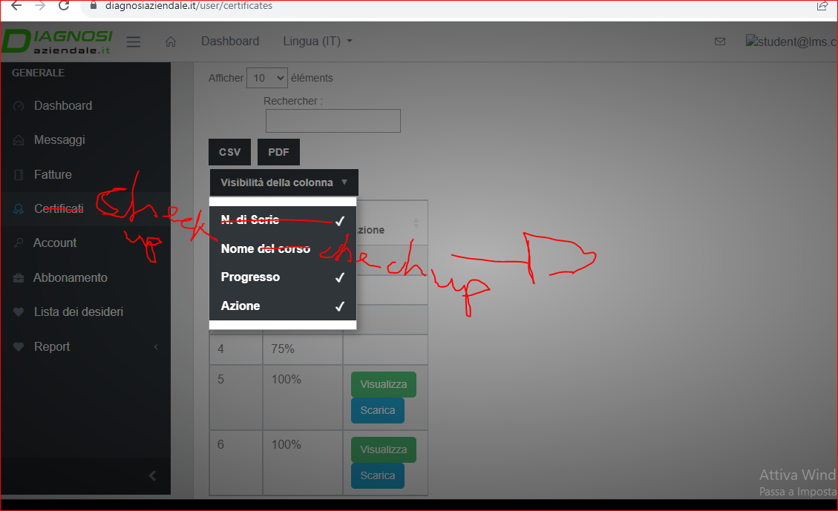

- change regard the language

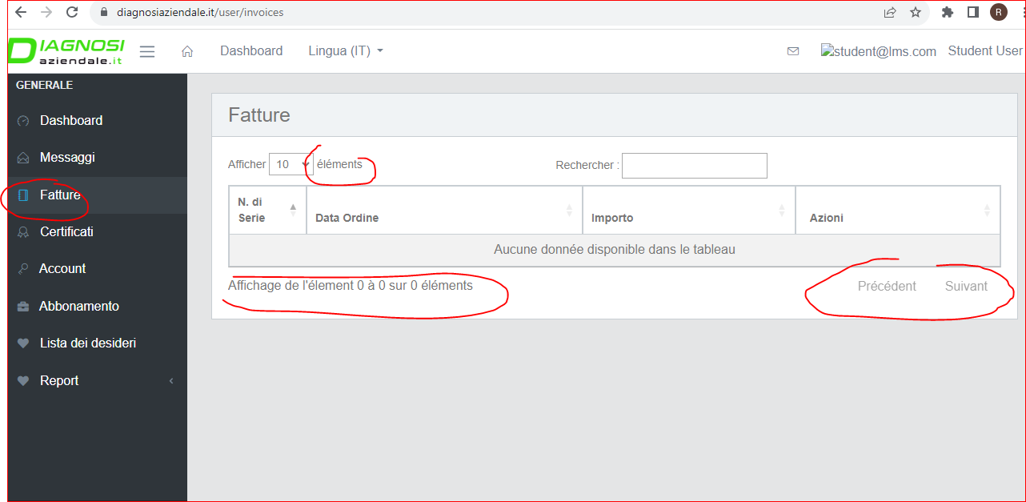

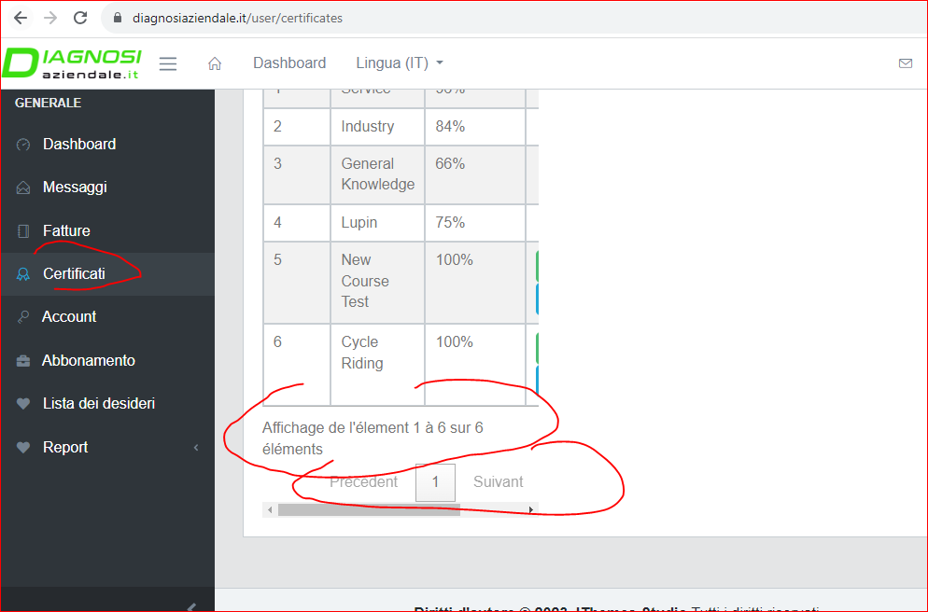

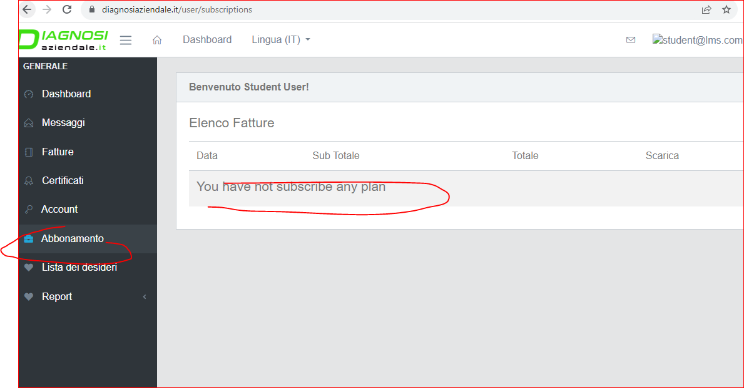

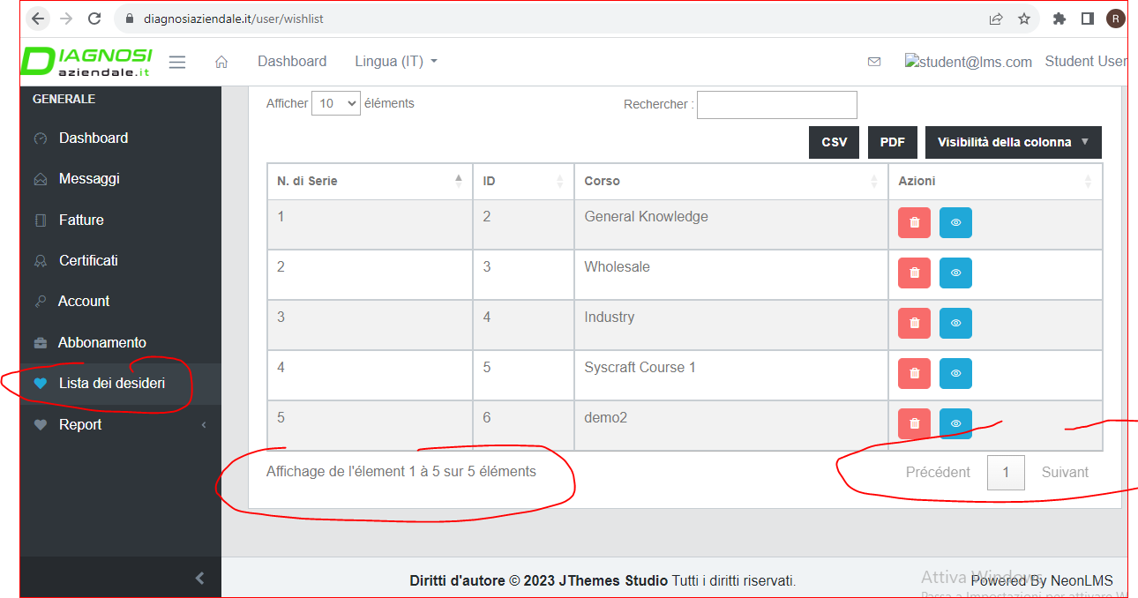

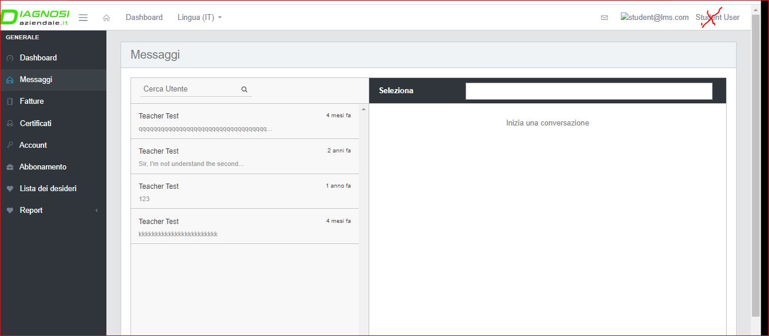

regard the page Test in admin now the software use how default two text and the colors black. at the end we must decide the defult font and colors. buti f you want we can decide to use the same text of all web black. and the colors of logo, so ble and grey.

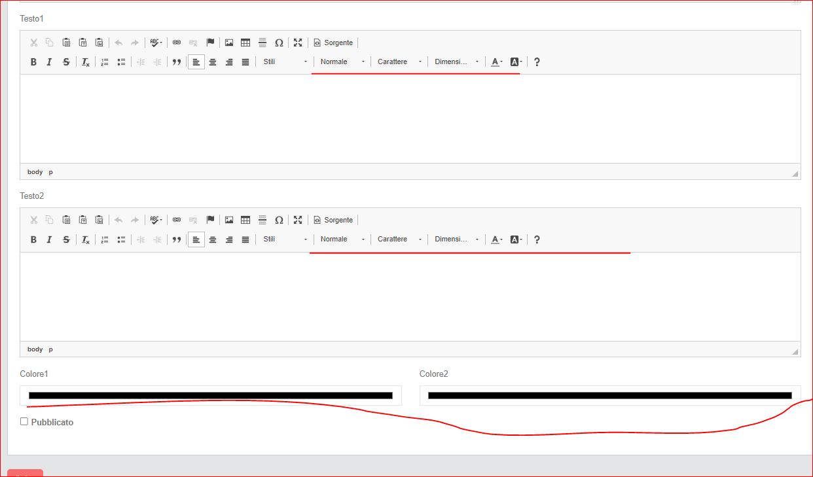

Regard the ble we can use this but I am not sure. pheraps it is better use a better ble (more important). and regard the grey we can decide, but don’t must be too clear and not too dark. Give me also you an advice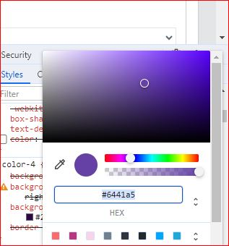

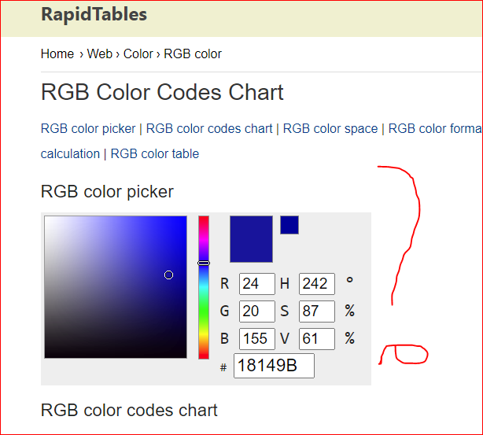

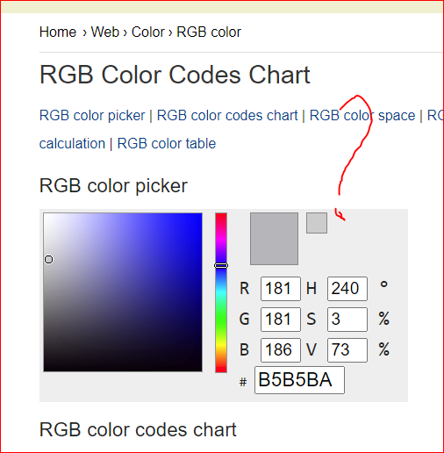

Delate the database