# ADMIN PANEL

Please refer sample on this web <https://demo.yo-gigs.com/public/manager/>

* We want **similar function**. All function that do is flexible and admin **can change anytime**. All **modules can be activate or deactivate** that set by
* Once ADMIN has logged in, it will display the ADMIN’s Dashboard with overall
  + total ACTIVE USERS,
  + PENDING USERS,
  + total of VENDORS as well as clickable to their created VOUCHERS,
  + Chatting Notification
  + Finance Report
* Each of the ADMIN PANEL section should be separated by TABS, example, GENERAL TAB for general settings, USERS for things related to USERS setting, VENDORS … etc
* In the ADMIN PANEL, will have a GENERAL SECTION to control the MENU (HOME, CONTACT US, Blogs as well as other related CMS here. TITLE / NAME, Content description (WYSIWYG), URL … *
* 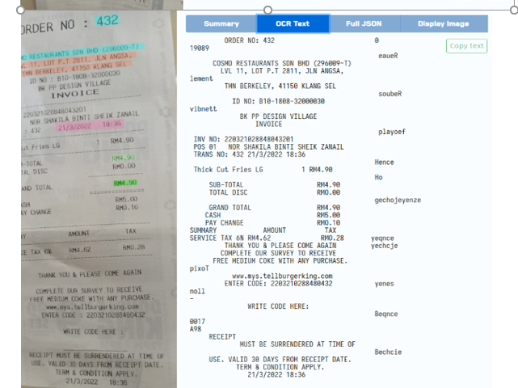
* In OCR system, will get all data
  + Admin not need set many variables to get TOTAL AMOUNT
  + Admin not need set many variables to get DATE
  + Admin not need set many variables to get INVOICE ID
  + System need check the receipt is duplicate, expired or not
* ADMIN can set the points allocation as if receipt $1 = 1 points etc. The BONUS settings should be set here as well where BONUS Status = xx points etc.
* **USER tab** to view all the USER list, ability to change the STATUS, link to see their HISTORY Redemption, EDIT to change their password (encrypted), ability to resend activation email / change password, see total Points they have and also list of pending / approved / rejected receipts so ADMIN can change the status to APPROVED, REJECTED, PENDING anytime as well.
* Next TAB should contain the **template for the Voucher**.
* Next TAB will be on VENDOR where it contains basic information like list of VENDORS, status, edit, send forgotten password etc.
* For all the table listing, it should have the ability to **SEARCH, FILTER, SORT** functions just as basic function in Web.
* Admin Roles - [**https://demo.yo-gigs.com/manager/role**](https://demo.yo-gigs.com/manager/role)
  + **Admin User Listing**
  + **Admin Role Management**

* Agent Module
* Set x% commission to agent when complete job from vendor that he find that vendor
* Set y year that he can take.
* Reward Point
* Admin will approve the review from user
* Admin will approve job complete from tasker.
* Reward point for tasker complete job is set by admin.
* Reward point for user upload receipt is set by Admin.
* VIP Package
* Admin need set charge for this package. When vendor make payment so need let vendor select
* 1) every month make payment or
* 2) Auto make payment.
* If expired coming soon, need have alert inform tasker. **Alert is admin set time when alert them.**
* Allow chat with customer.
* Admin need **set how many photos** for VIP package.
* Admin ***need set how many videos*** that allow tasker upload video of his products.
* Video duration - 10-60 sec
* Max - 30mb
* resolution - 1280px x 1280px
* Format : MP4.
* Need admin approve
* When upload video, tasker still can do other thing like upload image so not need wait video upload. when successful, will inform tasker.
* **Money Management** [https://demo.yo-gigs.com/manager/money/withdrawal_request]
* Report of milestone that user create and release time.
* Admin will also need confirm all **service task** is done by tasker. [**Customer Signature**] is required then just can release money to tasker.
* When user “release” fund so amount will go to vendor after deduct commission.
* Report of vendor complaint that user no release amount.
* System need show that **job is transfer money already or pending transfer**. So admin will know
* Each must have records. And also allow **super-admin upload payment receipt**
* In a table must show amount sale, how many commission will deduct, display category for product sale, % will deduct, action button.
* Admin need **set amount penalty**, x% cancel job from customer
* admin need set "reason" in drop-box why cancel job so user can select it.
* Report of cancel job so need filter company, date, comment from customer. so admin will know how many times that company cancel job from customer.
* Too many time will penalty for that tasker company.
* Admin will set x% for cancel task.
* Report [https://demo.yo-gigs.com/manager/reports]
* Report for user release time and money- Set time to release to tasker.
* Report of milestone that user create and release time.
* Report of vendor complaint that user no release amount.
* Report of cancel job
* Report of voucher
* Report of financial/ wallet
* Report job from tasker. Display how many job in progress, complete, pending
* Finance Report – income from ads, income for commission, total sales, amount need to transfer to vendor.
* Report of ADS
* Marketing Tool
* **Admin can Create voucher**. And sent to what category user
* Sent to all user OR certain user under that category
* **Need approve** if tasker create vouchers
* Admin need set amount charge if user download voucher. REMEMBER, after user click download - JUST display code. This is because admin and vendor can know how many people download.
* Each customer can **download how many times in month** is tasker set? System need record each user in databases. So system will know this customer download how many time already.
* Admin will **set price of default Ads** for new subcategory - Admin set the price of package [weekly, days, monthly]
* Admin can **view, disable, active that product/ service images**. Need sorting and search category & subcategory.
* Commission
* When customer create milestone for that service, so admin will **take commission x%.**
* But admin also can set **FREE** in some period. So admin can set time.
* SEO
* Must have SEO function - Facebook pixel, meta description]
* Each blog mush have meta description , Meta Title, Meta keywords, Post SEO Name*, Post Title* [https://demo.yo-gigs.com/manager/blogposts] ->”Edit button”

