Context and business objectives
Pens and Printer is a company specialized in providing high quality office products as pens, notebooks, chairs and monitors to large organizations. As the way of consuming things is changing, the company needs to adapt to this change and improve their sales strategies and need to assess the performance of it based on data.
This time, the company launched a new line of office stationery including notebooks, pens and sticky notes. They tested during this period of time three different sales techniques and collected data to assess which sales method was the most efficient to generate revenue but also less time-consuming and in a way less energy consuming.
There are currently three sales methods used, ranging from the simplest to the most time-consuming:
- Email only : one to inform the customer and another three weeks later to follow-up
- Phone call only : cold 30 minutes call to inform the customers of those new products. Answer to their questions if necesary. Very time consuming
- Email followed by a phone call : one email to inform the customer about the new product line followed by one call a week later.

Methodology and Data Cleaning
Dataset provided and used: product_sales.csv
This dataset contains information collected over the past six weeks, including:
- The number of items sold
- The revenue generated
- The sales method used
- The week number that represents the week the sale was made
- The customer’s loyalty (measured in years with the company)
- The state where the sales were made
As a first step, I ensured the data was clean and reliable:
- I checked for duplicates and invalid values.
- I counted for each column all values and identified two main issues:
  - Missing values in the revenue column (NaN), which I chose not to take in account in my analysis, because as an unknown value, I did not know if there was any revenue not communicated by the sales team
  - Inconsistent entries in the sales_method field (e.g., mixed cases or typos). I created a new, cleaned column to unify the methods into three consistent categories, making it easier to compare performance.
As a second step, I made my analysis depending on the company’s needs including :
  - Number of customers per sales method
  - Spread of the overall revenu and for each method
  - The revenue for each sales method accross the passing weeks
  - A business metric to evaluate in the future which sales method can perform the best

DATA EXPLORATORY
The email is the most effective way to capture more customers
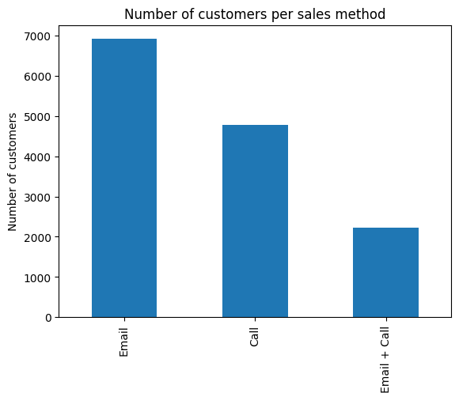
Over the past six weeks, email alone accounted for approximately 50% of all customer interactions. This confirms that email remains an efficient and scalable method to capture customer attention—especially in an increasingly digital world where quick communication is key.
However, does capturing attention via email alone translate into high revenue?
To answer this, we now dive deeper into the revenue analysis of each sales method.

Solid revenue performance driven by high-value office stationery
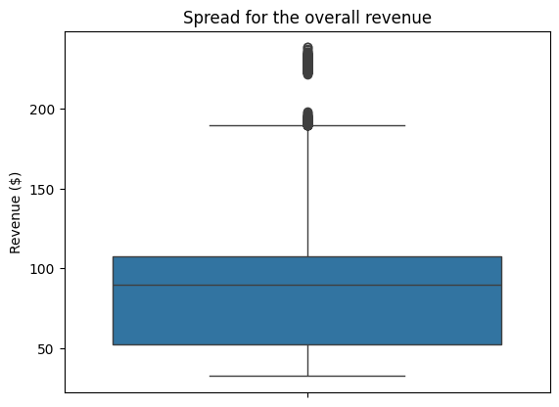
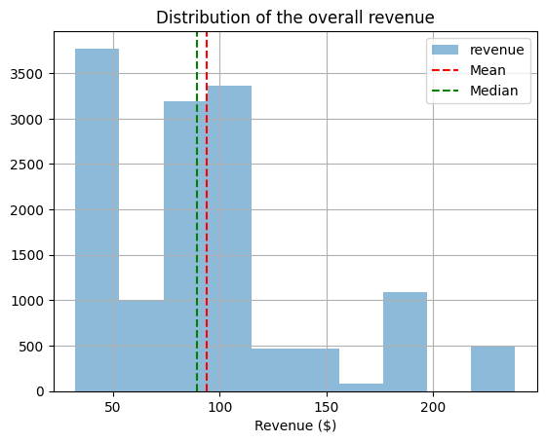

The median revenue around $100 is a solid result considering the type of products which was sold. Considering also, some products were sold for more that $200. That implies a good relationship with qualified customers ready to spend more to renew their office stationery products.

Email and call : the most effective combination tool for generating high revenues
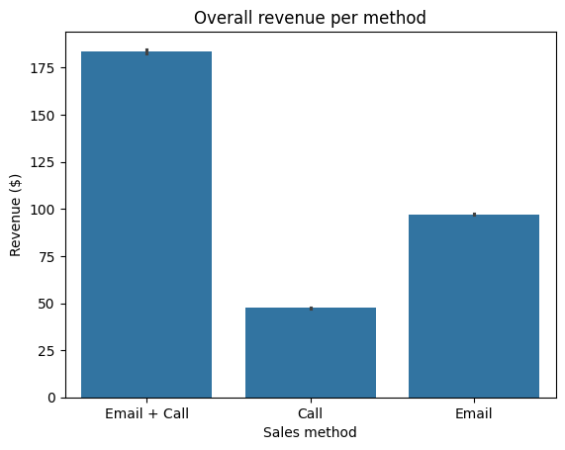
As per the number of customers captured, sending an email only is the best way to generate higher revenue returned. While the call, which is very time-consuming is the least effective.

Boosting revenue : Combining emails with follow-up calls for long term-gains.
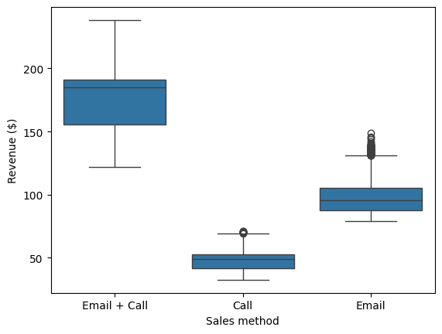
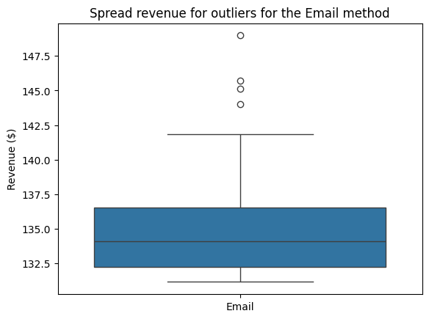
Email alone proves to be an efficient method for generating significant revenue, though individual transaction amounts can vary widely—some exceeding $142.50, while others fall below $100. To secure more consistent and sustainable revenue growth over the long term, combining email outreach with a follow-up call is far more effective

Ensuring stable revenue growth with email and follow-up calls
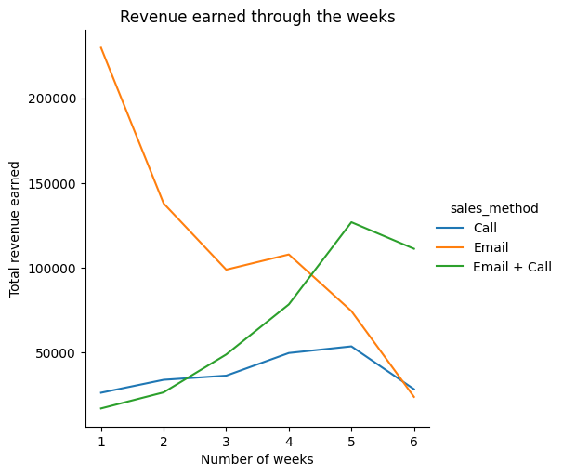
The combination of email and call is the safest approach to ensure steady and long-term revenue growth across the weeks. While email alone can generate high revenue, it is also prone to significant fluctuations, making it less reliable for consistent results. In contrast, the strategy of sending an email followed by a call as a follow-up has shown to maintain a more stable and increasing revenue trend.

Single-year customers generated the highest revenue
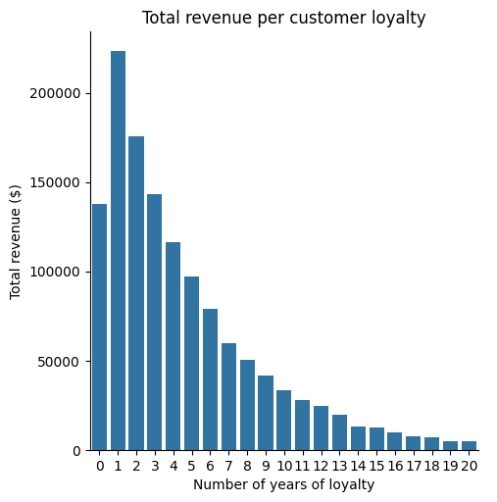
New customers and those who have been buying for around 5 years generated the highest revenues. Interestingly, the single-year customers stand out as the group with the highest spending on the new product line. Moreover, the longer a customer has been with the company, the less they tend to purchase the new products. This trend might be because long-term customers already know their preferred products or are less open to trying new offerings.

Email and follow-up increase the chance to get a higher revenue
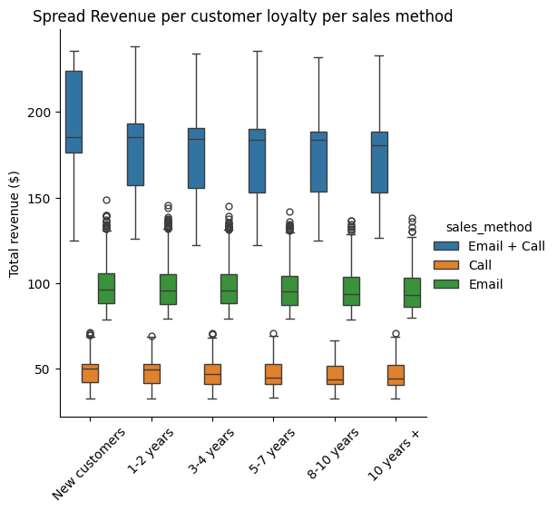
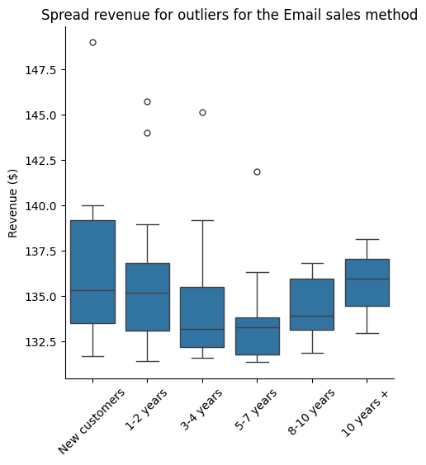
It seems that the Email + Call is the most efficient way of generating revenue remains really efficient even among the customer loyaly. groups Even though, the email can generate higher revenue, because we see many outliers that would show that in some cases, the email is enough to generate a high revenue.
Business metric to follow
Our analysis showed that the best sales method was the combination of Email + Call based on the revenue. In order for the company to assess and monitor closely each method performance, the revenue, the number of customers and the average revenue needs to be included as key components. Here bellow the equation :
Mean revenue per customer per sales method =
Total revenue earned per method
Number of customers per method
Here bellow how it could look like for future performance analysis
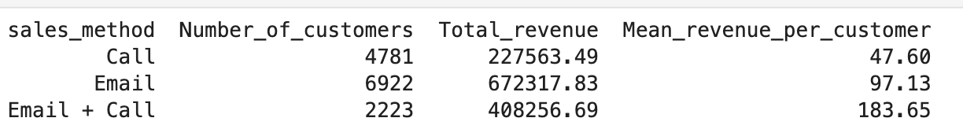
When evaluating this metric, sending only emails is a great way to generate a high revenue and reach a wide number of customers. But, sending an email and follow-up with a call a week later has a conversion rate with a higher mean revenue per customer contacted (twice more important than only sending an email).

Conclusion
The analysis reveals distinct perfomance patterns accross the three sales methods. While email alone are effective in reaching a wide audience in the easiest and fatest way, and can generate high-revenues, they also show a significant variability making them less reliable over time.
Phone call by itself without prior engagement perform the worst, suggesting that cold calls are not that well received by customers, especially when promoting new products.
However, the combination of email followed by a phone call consistently delivers both hogh and stable revenues, proving to be the most effective strategy. This method likely benefits from the scalability of emails and the personalized follow-up that builds trust and encourages conversion.
The business metric given in that report is also confirming that sending emails can capture more customers and generate a higher total revenue, but sending an email and adding a follow-up by phone has a better average revenue per customer contacted. With less customers but qualified customers, they will be willling to spend more money.
Interestingly, newer customers and customers who have been buying produts up 5 years, generated the highest revenues. However, long-standing customers show lower engagement with the new product line, potentially due to strong preferences or resistance to change

RecommEndations
Based on the analysis, the most effective and objective sales method is the combination of an email followed by a phone call.
Sending an email is a great first step to inform customers about the new product line and its key features. A follow-up call, ideally about a week later, helps establish a more personal connection with the customer. It provides an opportunity to answer specific questions, clarify details not included in the email, and address any hesitations. Additionally, some customers need human interaction or guidance before making a purchase decision—this follow-up can make the difference in converting interest into sales.
Focus efforts on new and up to 5-years loyal customers because they seemed to be more interesting in buying new products than longer loyal customers
For future performance analysis based on the revenue, I would recommend to keep using the business metric I gave you in order to not only to assess total revenue but also maximise high revenue efficiency.

