

**The Enigma of the Anelloviridae**

Author: Cedric CS Tan

Supervisor: Prof. Joanne M Santini

Department of Structural and Molecular Biology

Faculty of Life Sciences

BIOC0021: Advanced Investigative Project in Molecular Biosciences (20/21)

**Table of contents**

Contents

Abstract (200 words) 3

Introduction (430 words) 4

Accumulation of Genomic diversity 6

Genome structure and replication (310 words) 6

Genomic diversity (255) 8

Mutation rates (325) 8

Host-editing and recombination (530) 10

The potential for cross-species transmission 11

Transmission routes: anelloviruses are everywhere (761) 11

Host range and animal reservoirs 14

Animal-animal transmission, zoonoses and anthroponoses 16

Host-virus interactions (1000 words) 16

Pathogenicity (1000 words) 17

References 17

Appendix 31

Checklist 35

# Abstract (200 words)

# Introduction (truncated)

XXXX 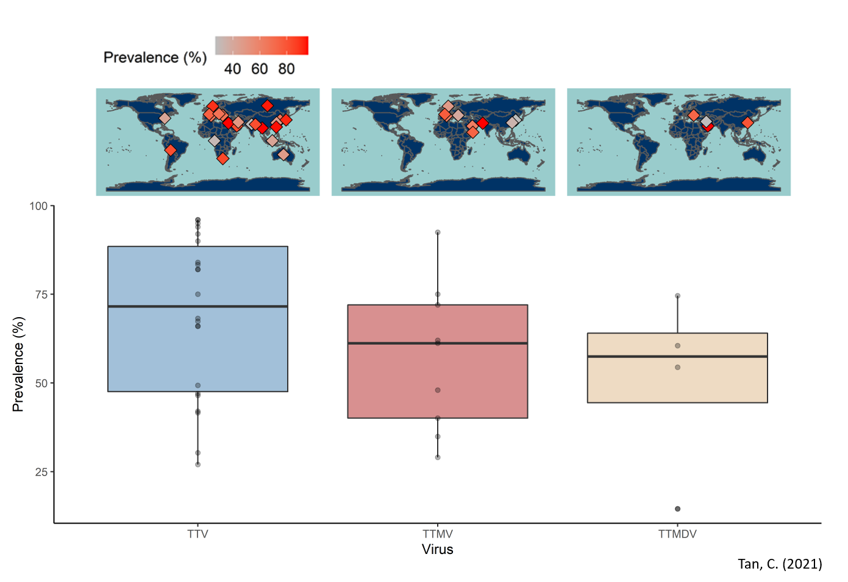

**Figure 1. Global distribution of human anelloviruses**. Prevalence estimates of human anelloviruses in healthy individuals were obtained from 26 independent studies and used to generate this figure. The world maps were generated using the *ne_countries* function from the *rnaturalearth* package in *R*.

While no anelloviruses have been found to cause disease in humans, the high prevalence and transmissibility of anelloviruses around the world warrants further surveillance. The extensive contact between farm animals or pests and humans facilitates zoonoses or anthroponoses that might result in the emergence of new infectious diseases, which could significantly affect human health or livestock productivity. Indeed, pathogens capable of human-animal transmission are twice as likely to be associated with emerging infectious diseases than those that are not (8). While global health efforts mainly involve post-emergence outbreak control (9), it is prudent to pre-empt and mitigate the emergence of the next infectious disease. This review therefore focuses on the potential of anelloviruses as a pathogen for human and animal hosts. Possible mechanisms for the accumulation of genomic diversity in the Anelloviridae will be explored. Additionally, transmission routes, potential animal reservoirs and evidence for cross-species transmission will be discussed. Lastly, an overview of host-virus interactions and pathogenicity will be provided.

# **Accumulation of Genomic diversity**

## Genome structure and replication (310 words)

Anelloviruses have a largely conserved genome organisation, containing three to four overlapping open reading frames (ORFs) (10) within a coding region demarcated by a TATA-box and poly-A tail sequence. There is also an untranslated region (UTR) containing a GC-rich region (11) (**Figure 2a**). Transfection experiments of human TTV found that at least six proteins are generated by alternative translation initiation (12) on three mRNA species, which were produced by alternative splicing (13). ORF1 putatively encodes the nucleocapsid (14) and a Rep-like protein that are conserved in circular DNA replicons like plasmids (15). Additionally, ORF2 potentially encodes a phosphatase (16) and ORF3, the TTV-derived apoptosis-inducing protein (TAIP) (17,18). Currently, the genome replication mechanism of anelloviruses is poorly understood relative other families of circular ssDNA viruses such as *Geminiviridae* (19) or *Circoviridae* (20). This is largely due to the lack of a stable cell culture system for anelloviruses to date (21,22). Kakkola et al. (23) showed that TTV replication is inhibited by administering the DNA polymerase inhibitor, Aphidicolin, suggesting dependency on the host’s replication machinery. In addition to this, the presence of Rep-like motifs and putative stem-loop structures formed by the GC-rich region (24) alludes to a rolling circle mechanism, which is typical of ssDNA viruses (25). Further investigation into the genome replication of anelloviruses may prove to be useful in the future, especially when developing antiviral therapeutics and strategies. For example, transgenic expression of non-functional viral Rep proteins in plants was shown to interfere with Rep-mediated recruitment of host polymerases for genome replication, inducing resistance to tomato yellow leaf curl geminivirus (26–28). A similar strategy could be explored to reduce the impact of anellovirus-related mortality in livestock.

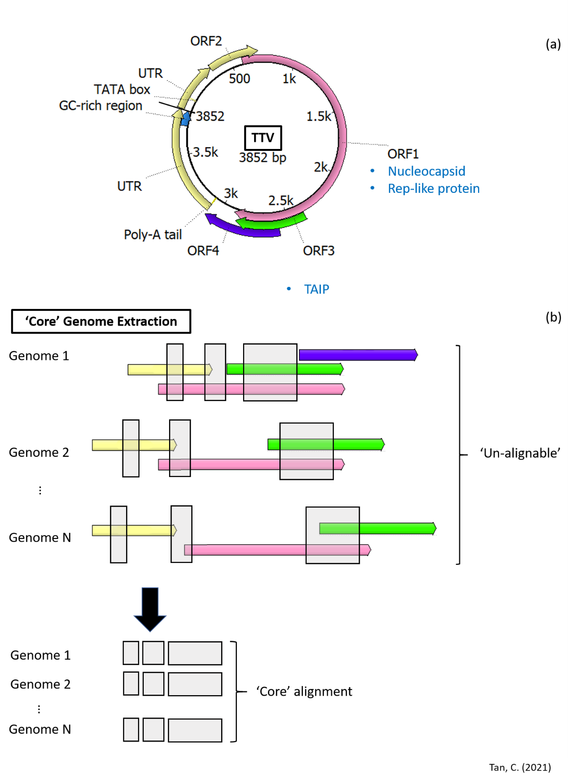

**Figure 2. Genome structure of TTV and ‘core’ genome extraction**. (a) The complete genome of TTV retrieved from NCBI GenBank (NC_002076.2) was visualised and annotated using UGene (29). (b) Illustration of ‘core’ gene extraction to obtain alignable conserved genomic regions for phylogenetic analysis.

## Genomic diversity (255)

Even though anelloviruses have similar genome structures, there is great sequence divergence within the family. Indeed, the mean genetic distance of aligned amino acid sequences for human TTVs alone is approximately 7.6, 2.2 and 2.1 fold greater than that for hepatitis B virus, human immunodeficient virus-1 and hepatitis C virus, respectively (21). This diversity poses a major challenge for full-genome alignments during the reconstruction of phylogenetic relationships. As such, the ICTV recommends restricting family-wide phylogenetic reconstruction analyses to ORF1 and a 35% nucleotide sequence identity threshold to demarcate viral species (1). Several studies have presented a family-wide phylogeny (10,30–33) in accordance with this. However, doing so does not consider the full-length genomic diversity of the family. Additionally, sequence alignment algorithms are known to have limited accuracy when used for aligning highly divergent sequences (34). As such, alignment-free methods may be more appropriate for future studies investigating the family-wide diversity of the *Anelloviridae*. Notably, many sophisticated methods in population genetics such as those for phylogenetic dating (35) or inferring past population dynamics (36,37) are alignment-dependent. As such, future studies seeking to employ such methods could consider extracting conserved ‘core’ genes or genomic regions from the ‘un-alignable’ viral sequences (**Figure 2b**), which has been previously used on highly divergent members of microbial communities (38) and recently for the family *Coronaviridae* (39). This can be done using gene annotation tools such as *Prokka* (40), *Roary* (41)or *Mauve* (42) and would allow the construction of a sequence alignment that retains a larger proportion of the viral genomes.

## Mutation rates (325)

Understanding how viruses mutate and accumulate genomic diversity has profound practical implications. For example, the emergence of SARS-CoV-2 mutations that putatively aid in immune escape has been of great concern with regards to vaccine efficacy and development (43) in the present COVID-19 pandemic. Additionally, elevating short-term viral mutation rates via mutagen treatment, termed lethal mutagenesis, has been shown to enhance the effectiveness of antiviral treatments (44). Only a few studies to date have provided estimates of the mutation rate of anelloviruses (45–47), which ranges from 2.3-7.3 × 10-4 substitutions/site/year (s/s/y). Cadar et al. (45) reported a substitution rate of 5.4 × 10-4 s/s/y for the TTSuV genomic region containing the UTR, ORF2 and 5’ end of ORF1 sequences sampled from wild boars over six years. Umemura et al. (46) reported a synonymous substitution rate of 7.3 × 10-4 s/s/y for TTV-positive sera over 12 years. Lastly, Bedarida et al. (47) reported a value of ~2 × 10-4 s/s/y for anellovirus sequences obtained from human sera and cat saliva reported over 16 and 6.5 years, respectively. These rates were compared to that of other viruses, which were collated from eight other studies (48–55) (**Figure 3**). The mutation rates of anelloviruses are similar to that of RNA viruses. Additionally, they are discernibly higher than that of double-stranded DNA (dsDNA) viruses, which echoes previous findings that single-stranded viruses mutate faster than their double-stranded counterparts (44). This phenomenon has been suggested to be due to single-stranded viruses being more prone to chemical damage such as oxidative deamination (56).

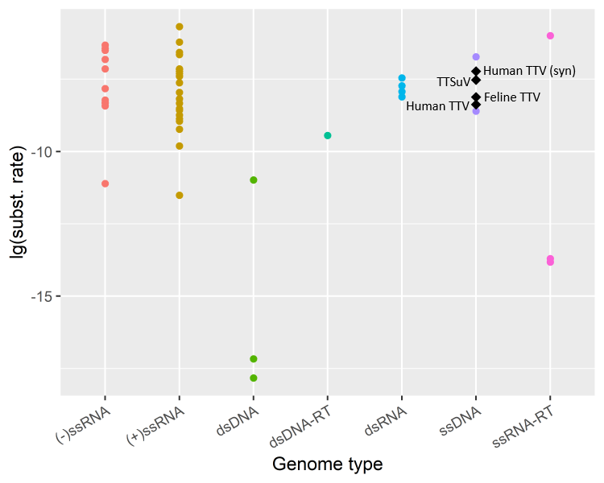

**Figure 3. Mutation rates of Anelloviridae in the context of other viruses**. The substitution rates of all genomic sites, obtained from the literature and expressed as substitutions/site/year, was visualised in log10 scale for the different human and animal viruses, stratified by their genome types. Anelloviruses are indicated by black diamonds and annotated with their corresponding names. The substitution rate where only synonymous mutations were considered is denoted by “syn”.

## Host-editing and recombination (530)

There has been limited studies to date investigating potential sources of genomic diversity. Given that genome replication is performed by host polymerases (23), which are highly accurate, nucleotide misincorporation may play only a minor role in the accumulation of mutations. Alternatively, host innate antiviral responses may contribute to the genomic diversity. For example, host APOBEC3 proteins are cytidine deaminases that have been found to cause C->T hypermutations in other DNA viruses like human papillomavirus (57,58). While such host-editing by APOBEC3 has not been demonstrated for anelloviruses, *in vitro* experiments found that these proteins preferentially bind ssDNA over dsDNA and may account for higher C->T mutations on the negative-sense strand of HIV reverse transcripts (59). This suggests that negative-sense ssDNA anelloviruses are likely to be subject to host-editing. Investigations of how anelloviruses evade or overcome APOBEC3-mediated editing may prove to be invaluable in our understanding of how viruses evolve.

Recombination also plays a substantial role in shaping the extant genomic diversity of the *Anelloviridae* by allowing viruses to sample a larger region of the sequence space than by mutation (60). Indeed, a single recombination event between two viral genomes could generate new combinations of their existing mutations, introducing several nucleotide polymorphisms at a time, which putatively prevents the accumulation of deleterious mutations (61–63). Using the popular recombination detection tool RDP4 (64), which identifies recombination using an ensemble of different detection methods, Fahsbender et al. (65) found that 89% of torque teno Leptonychotes weddellii virus (TTLwV)-1 and 26% of TTLwV-2 had at least one and one putative recombination event, respectively. They also found that putative recombination breakpoints in TTLwV-1 tend to fall within the UTR region. This agrees with a previous study (60), which found a significantly higher density of recombination breakpoints outside coding regions and at the edges of genes for almost all of 14 ssDNA viruses spanning 6 families (including TTV and TTMV). Other studies have similarly detected recombination within the different human TTV species (66,67) and within TTSuVs isolated from wild boars and domestic pigs (45). While no studies to date have formally estimated the rate of recombination in anelloviruses, multiple studies have found a high frequency of co-infections of different anellovirus species (68–72), one even reporting a 48% frequency of dual or triple infection of TTV, TTMV and TTMDV in infants. This high frequency of co-infection, together with the strong recombination signals detected by the abovementioned studies, suggest that anelloviruses recombine frequently and that recombination may be a major contributor to the accumulation of genomic diversity. This has significant implications for phylogenetic inference since recombination results in portions of genomes representing different evolutionary histories. This violates the assumption of most phylogeny estimation methods – that a single evolutionary history underlies the sequences analysed (73). In such cases, the resultant phylogeny topologies obtained often differs from the true phylogeny (74), especially when recombination occurs between divergent sequences (73), as in the case of anelloviruses. Future studies attempting phylogenetic estimations should opt for alignment-free methods, which are minimally affected by recombination (34). Alternatively, they may remove putative recombinant segments using breakpoints identified by tools such as GARD (75) or RDP (64,76), which was demonstrated by Cadar et al. (45).

# The potential for cross-species transmission

## Transmission routes: anelloviruses are everywhere (761)

In line with its high prevalence, anelloviruses may be transmitted via multiple routes, both vertically (*i.e.* from mother to offspring) and horizontally (*i.e.* between organisms not in a mother-offspring relationship) (**Figure 3**). Most studies probed the transmission of anelloviruses in humans or animals via the PCR-based detection of viral DNA. However, only a few studies demonstrated the viability of detected anelloviruses (highlighted in green; Figure 1). Anelloviruses have been detected in bodily fluids like blood, bile, saliva, mucus, semen and faeces has been described repeatedly in many studies (77–83). This suggests that anelloviruses can be transmitted via sexual, faecal-oral and airborne routes. However, without confirming the viability of virions in the samples, the presence of viral DNA in samples could have been due to transient shedding of inactivated virus from a distal source. For faecal-oral transmission, stronger evidence was provided by visualising the mature virions extracted using electron microscopy (79). Additionally, anellovirus-positive blood could be shown to infect cells and proliferate (78,83). Notably, Okamoto et al. (84) detected human TTV in nine different tissue samples. The ability of anelloviruses to infect multiple tissues and cell types suggests that they are ubiquitously distributed inside their hosts, which potentiates multiple transmission routes.

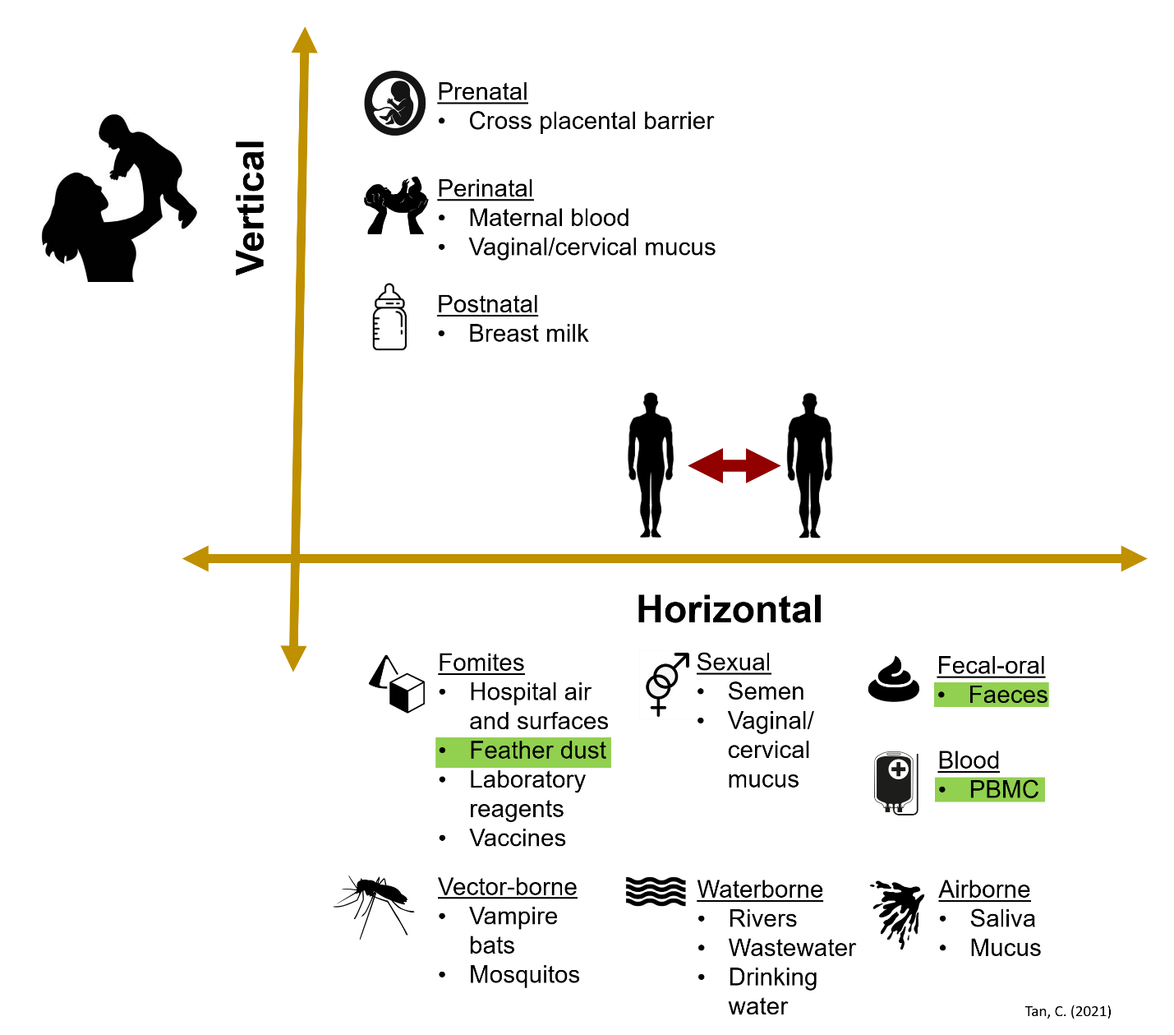

**Figure 3. Summary of potential transmission routes for anelloviruses**. Transmission routes where the infectious vehicle has been shown to contain viable virions are highlighted in green.

Anelloviruses may also be transmitted horizontally via environmental sources such as water or fomites, which are inanimate objects or surfaces that can become contaminated with pathogens (85). Studies have demonstrated their persistence in rivers (86–88), wastewaters (89), drinking water (90,91), feather dust (92), air and surfaces in hospitals (93) or even laboratory reagents (94) and vaccines (95). Alternatively, anelloviruses may be transmitted via vectors. Anellovirus sequences extracted from the liver of a vampire bat (*Carollia perspicillata*) and serum of an opossum (*Didelphis albiventris*) were phylogenetically clustered relative to other species of the Anelloviridae (30). Additionally, Shi et al. found viral sequences extracted from mosquitos and swine of pig farms were phylogenetically interspersed (96) with previously reported TTSuV sequences. These studies suggest potential bat-borne and mosquito-borne transmission via blood-feeding (*i.e.* hematophagy).

There is strong evidence for vertical transmission of anelloviruses, although the exact route(s) of infection – whether infection occurs before (prenatal), during and immediately after (perinatal), or after birth (postnatal) – has not been conclusively identified. Gerner et al. (97) detected human TTV in breast milk, and cord blood. Separately, Matsubara et al. (98) found TTV and TTMV DNA in breast milk, cord blood and amniotic fluid. Both studies employed polymerase chain reaction (PCR) followed by agarose gel electrophoresis to test the fluid samples. PCR amplicons were also sequenced via Sanger sequencing to rule out non-specific amplification. These studies suggest that breastfeeding might be a potential transmission route. However, cross-sample contamination during collection of cord blood or amniotic fluid is difficult to rule out and so these studies may not be sufficient to prove transplacental transmission. In fact, Tyschik et al. (99) did not find TTV in the cord blood from TTV-positive mothers using a highly sensitive quantitative PCR (qPCR) assay that could detect viral loads as low as 1000 viral DNA copies/ml of blood. The authors also detailed stringent measures to prevent cross-contamination, which the previous groups did not do. This suggests that the previous findings could have been due to contamination, which must be accounted for in future studies. Nevertheless, Gerner et al. (97) provided evidence for vertical transmission by showing that follow-up samples taken from infants with TTV-positive cord blood had persistent viremia.

Vertical transmission has also been demonstrated in animals. In particular, Martinez-Guino et al. showed in separate studies that sows, their breast milk and their aborted foetuses (100) or stillborns (101) were PCR positive for TTSuV. They also showed that TTSuV sequences in mother-offspring pairs had nucleotide sequence identities of 91-98%, implying that sample cross-contamination is unlikely. Indeed, it is likely that samples that were cross-contaminated at the point of collection should share identical sequences. As such, these findings may suggest that infections of the foetuses were acquired prenatally and that TTSuV may be transmitted through breast feeding. Vertical transmission of TTSuV through breast milk can be further confirmed in future studies by feeding of TTSuV-positive milk to TTSuV-negative offspring. Separately, human TTMDV was detected in domestic hens and the yolks of their eggs (102), providing evidence for vertical transmission. Confirmation that chicks that developed from TTMDV-positive eggs were also persistently infected would have provided stronger evidence for vertical transmission. Collectively, the studies discussed above provide substantial evidence for vertical transmission of anelloviruses.

## Host range and animal reservoirs

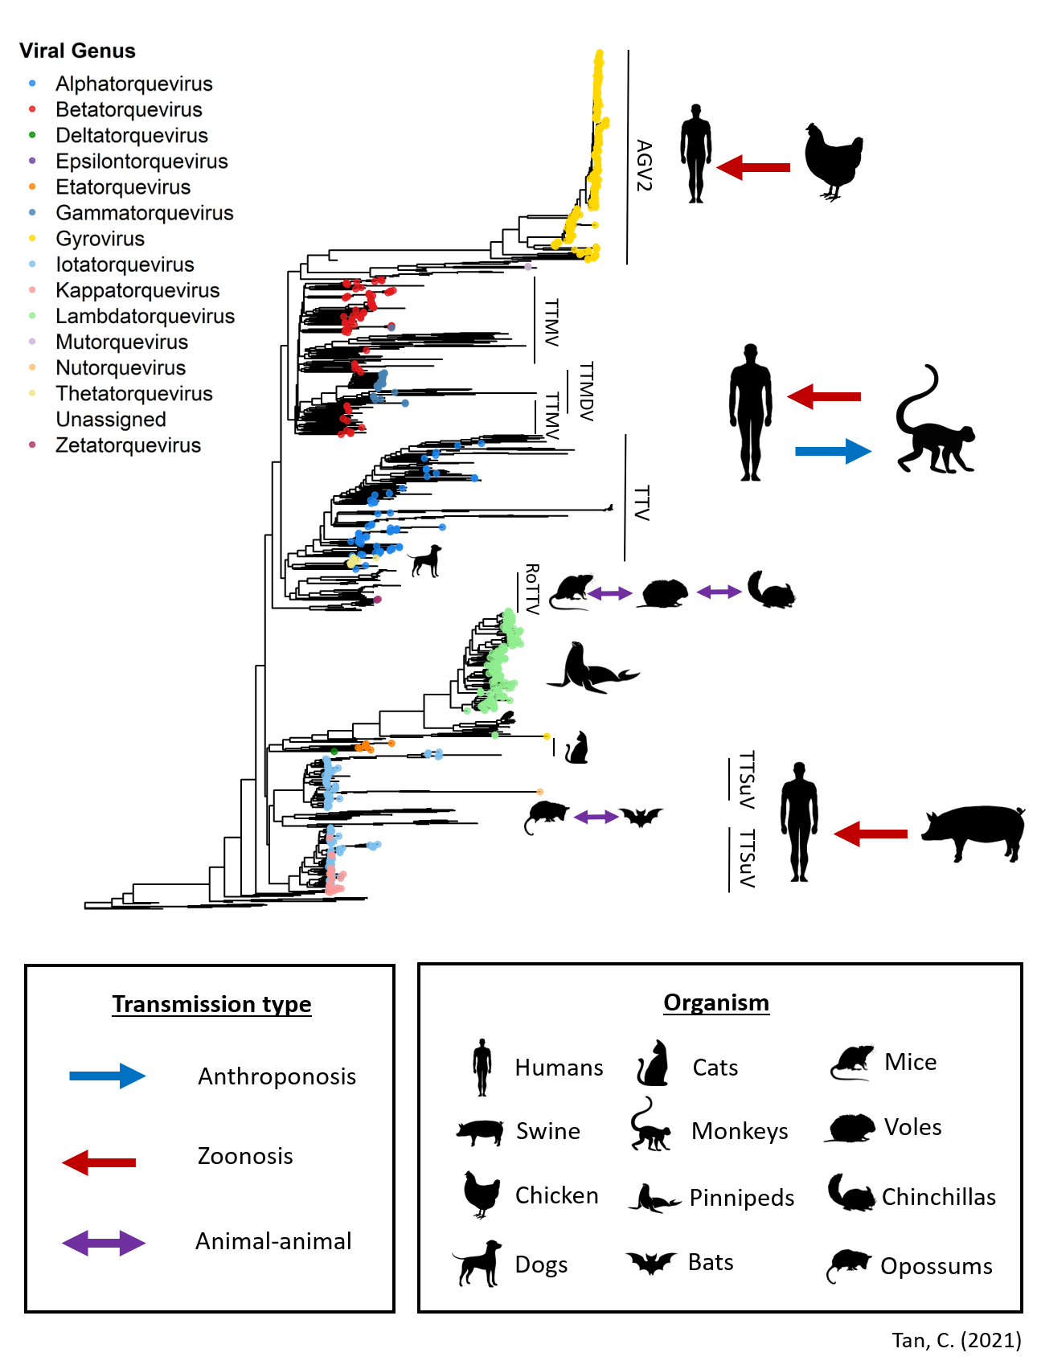

**Figure 4. Genomic diversity of the Anelloviridae and summary of evidence for cross-species transmission**. The genomic diversity of 1143 Anelloviridae genome sequences is represented here as a whole-genome neighbour-joining phylogeny, which was reconstructed using alignment-free Mash distances (110) and rooted with the genome accession MK012481 (see **Appendix**). This phylogeny is annotated with symbols illustrating the cross-species transmission of various viral species.

## Animal-animal transmission, zoonoses and anthroponoses

# Host-virus interactions (1000 words)

# Pathogenicity (1000 words)

# References

1. Walker PJ, Siddell SG, Lefkowitz EJ, Mushegian AR, Adriaenssens EM, Dempsey DM, et al. Changes to virus taxonomy and the Statutes ratified by the International Committee on Taxonomy of Viruses (2020). Springer; 2020.

2. Abe K, Inami T, Asano K, Miyoshi C, Masaki N, Hayashi S, et al. TT virus infection is widespread in the general populations from different geographic regions. J Clin Microbiol. 1999;37(8):2703–5.

3. Nishiyama S, Dutia BM, Stewart JP, Meredith AL, Shaw DJ, Simmonds P, et al. Identification of novel anelloviruses with broad diversity in UK rodents. J Gen Virol. 2014;95(Pt 7):1544.

4. Cibulski SP, Teixeira TF, de Sales Lima FE, do Santos HF, Franco AC, Roehe PM. A novel Anelloviridae species detected in Tadarida brasiliensis bats: first sequence of a chiropteran Anellovirus. Genome Announc. 2014;2(5).

5. Rosenberger JK, Cloud SS. Chicken anemia virus. Poult Sci. 1998;77(8):1190–2.

6. Kekarainen T, Segalés J. Torque teno sus virus in pigs: an emerging pathogen? Transbound Emerg Dis. 2012;59:103–8.

7. Nishizawa T, Okamoto H, Konishi K, Yoshizawa H, Miyakawa Y, Mayumi M. A novel DNA virus (TTV) associated with elevated transaminase levels in posttransfusion hepatitis of unknown etiology. Biochem Biophys Res Commun. 1997;241(1):92–7.

8. Taylor LH, Latham SM, Woolhouse MEJ. Risk factors for human disease emergence. Philos Trans R Soc London Ser B Biol Sci. 2001;356(1411):983–9.

9. Pike J, Bogich T, Elwood S, Finnoff DC, Daszak P. Economic optimization of a global strategy to address the pandemic threat. Proc Natl Acad Sci. 2014;111(52):18519–23.

10. Simmonds P, Sharp CP. Anelloviridae. Clin Virol. 2016;701–11.

11. Miyata H, Tsunoda H, Kazi A, Yamada A, Khan MA, Murakami J, et al. Identification of a novel GC-rich 113-nucleotide region to complete the circular, single-stranded DNA genome of TT virus, the first human circovirus. J Virol. 1999;73(5):3582–6.

12. Qiu J, Kakkola L, Cheng F, Ye C, Söderlund-Venermo M, Hedman K, et al. Human Circovirus TT Virus Genotype 6 Expresses Six Proteins following Transfection of a Full-Length Clone. J Virol [Internet]. 2005 May 15;79(10):6505 LP – 6510. Available from: http://jvi.asm.org/content/79/10/6505.abstract

13. Kamahora T, Hino S, Miyata H. Three Spliced mRNAs of TT Virus Transcribed from a Plasmid Containing the Entire Genome in COS1 Cells. J Virol [Internet]. 2000 Nov 1;74(21):9980 LP – 9986. Available from: http://jvi.asm.org/content/74/21/9980.abstract

14. Maggi F, Pistello MBT-RM in LS. Anelloviridae☆. In Elsevier; 2019. Available from: http://www.sciencedirect.com/science/article/pii/B9780128096338209965

15. Ilyina T V, Koonin E V. Conserved sequence motifs in the initiator proteins for rolling circle DNA replication encoded by diverse replicons from eubacteria, eucaryotes and archaebacteria. Nucleic Acids Res. 1992;20(13):3279–85.

16. Peters MA, Jackson DC, Crabb BS, Browning GF. Chicken anemia virus VP2 is a novel dual specificity protein phosphatase. J Biol Chem. 2002;277(42):39566–73.

17. Kooistra K, Zhang Y-H, Henriquez N V, Weiss B, Mumberg D, Noteborn MHM. TT virus-derived apoptosis-inducing protein induces apoptosis preferentially in hepatocellular carcinoma-derived cells. J Gen Virol. 2004;85(6):1445–50.

18. De Smit MH, Noteborn MHM. Apoptosis-inducing proteins in chicken anemia virus and TT virus. In: TT Viruses. Springer; 2009. p. 131–49.

19. Gutierrez C, Ramirez-Parra E, Mar Castellano M, Sanz-Burgos AP, Luque A, Missich R. Geminivirus DNA replication and cell cycle interactions. Vet Microbiol [Internet]. 2004;98(2):111–9. Available from: http://www.sciencedirect.com/science/article/pii/S0378113503003262

20. Faurez F, Dory D, Grasland B, Jestin A. Replication of porcine circoviruses. Virol J [Internet]. 2009;6(1):60. Available from: https://doi.org/10.1186/1743-422X-6-60

21. Kaczorowska J, van der Hoek L. Human anelloviruses: diverse, omnipresent and commensal members of the virome. FEMS Microbiol Rev. 2020;

22. Kekarainen T, Segalés J. Torque teno virus infection in the pig and its potential role as a model of human infection. Vet J. 2009;180(2):163–8.

23. Kakkola L, Tommiska J, Boele LCL, Miettinen S, Blom T, Kekarainen T, et al. Construction and biological activity of a full‐length molecular clone of human Torque teno virus (TTV) genotype 6. FEBS J. 2007;274(18):4719–30.

24. Lan D, Hua X, Cui L, Luo X, Liu Z, San T, et al. Sequence analysis of a Torque teno canis virus isolated in China. Virus Res [Internet]. 2011;160(1):98–101. Available from: http://www.sciencedirect.com/science/article/pii/S0168170211002176

25. Shulman LM, Davidson I. Viruses with Circular Single-Stranded DNA Genomes Are Everywhere! Annu Rev Virol [Internet]. 2017 Sep 29;4(1):159–80. Available from: https://doi.org/10.1146/annurev-virology-101416-041953

26. Noris E, Accotto GP, Tavazza R, Brunetti A, Crespi S, Tavazza M. Resistance to Tomato Yellow Leaf Curl Geminivirus inNicotiana benthamianaPlants Transformed with a Truncated Viral C1 Gene. Virology [Internet]. 1996;224(1):130–8. Available from: http://www.sciencedirect.com/science/article/pii/S0042682296905140

27. Brunetti A, Tavazza M, Noris E, Tavazza R, Caciagli P, Ancora G, et al. High Expression of Truncated Viral Rep Protein Confers Resistance to Tomato Yellow Leaf Curl Virus in Transgenic Tomato Plants. Mol Plant-Microbe Interact [Internet]. 1997 Jul 1;10(5):571–9. Available from: https://doi.org/10.1094/MPMI.1997.10.5.571

28. Lucioli A, Noris E, Brunetti A, Tavazza R, Ruzza V, Castillo AG, et al. Tomato Yellow Leaf Curl Sardinia Virus Rep-Derived Resistance to Homologous and Heterologous Geminiviruses Occurs by Different Mechanisms and Is Overcome if Virus-Mediated Transgene Silencing Is Activated. J Virol [Internet]. 2003 Jun 15;77(12):6785 LP – 6798. Available from: http://jvi.asm.org/content/77/12/6785.abstract

29. Okonechnikov K, Golosova O, Fursov M, team the U. Unipro UGENE: a unified bioinformatics toolkit. Bioinformatics [Internet]. 2012 Apr 15;28(8):1166–7. Available from: https://doi.org/10.1093/bioinformatics/bts091

30. de Souza WM, Fumagalli MJ, de Araujo J, Sabino-Santos Jr G, Maia FGM, Romeiro MF, et al. Discovery of novel anelloviruses in small mammals expands the host range and diversity of the Anelloviridae. Virology. 2018;514:9–17.

31. King AMQ, Adams MJ, Carstens EB, Lefkowitz EJBT-VT, editors. Family - Anelloviridae. In San Diego: Elsevier; 2012. p. 331–41. Available from: http://www.sciencedirect.com/science/article/pii/B9780123846846000331

32. Zhang W, Wang H, Wang Y, Liu Z, Li J, Guo L, et al. Identification and genomic characterization of a novel species of feline anellovirus. Virol J. 2016;13(1):1–3.

33. Eibach D, Hogan B, Sarpong N, Winter D, Struck NS, Adu-Sarkodie Y, et al. Viral metagenomics revealed novel betatorquevirus species in pediatric inpatients with encephalitis/meningoencephalitis from Ghana. Sci Rep. 2019;9(1):1–10.

34. Zielezinski A, Vinga S, Almeida J, Karlowski WM. Alignment-free sequence comparison: benefits, applications, and tools. Genome Biol [Internet]. 2017;18(1):186. Available from: https://doi.org/10.1186/s13059-017-1319-7

35. Rutschmann F. Molecular dating of phylogenetic trees: a brief review of current methods that estimate divergence times. Divers Distrib. 2006;12(1):35–48.

36. Minin VN, Bloomquist EW, Suchard MA. Smooth skyride through a rough skyline: Bayesian coalescent-based inference of population dynamics. Mol Biol Evol. 2008;25(7):1459–71.

37. Drummond AJ, Rambaut A, Shapiro B, Pybus OG. Bayesian coalescent inference of past population dynamics from molecular sequences. Mol Biol Evol. 2005;22(5):1185–92.

38. Segata N, Huttenhower C. Toward an Efficient Method of Identifying Core Genes for Evolutionary and Functional Microbial Phylogenies. PLoS One [Internet]. 2011 Sep 12;6(9):e24704. Available from: https://doi.org/10.1371/journal.pone.0024704

39. Tan CCS, Owen CJ, Tham CYL, Bertoletti A, van Dorp L, Balloux F. Pre-existing T cell-mediated cross-reactivity to SARS-CoV-2 cannot solely be explained by prior exposure to endemic human coronaviruses. bioRxiv [Internet]. 2020 Jan 1;2020.12.08.415703. Available from: http://biorxiv.org/content/early/2020/12/09/2020.12.08.415703.abstract

40. Seemann T. Prokka: rapid prokaryotic genome annotation. Bioinformatics. 2014;30(14):2068–9.

41. Page AJ, Cummins CA, Hunt M, Wong VK, Reuter S, Holden MTG, et al. Roary: rapid large-scale prokaryote pan genome analysis. Bioinformatics. 2015;31(22):3691–3.

42. Darling ACE, Mau B, Blattner FR, Perna NT. Mauve: multiple alignment of conserved genomic sequence with rearrangements. Genome Res. 2004;14(7):1394–403.

43. Koyama T, Weeraratne D, Snowdon JL, Parida L. Emergence of drift variants that may affect COVID-19 vaccine development and antibody treatment. Pathogens. 2020;9(5):324.

44. Sanjuán R, Nebot MR, Chirico N, Mansky LM, Belshaw R. Viral mutation rates. J Virol. 2010;84(19):9733–48.

45. Cadar D, Kiss T, Ádám D, Cságola A, Novosel D, Tuboly T. Phylogeny, spatio-temporal phylodynamics and evolutionary scenario of Torque teno sus virus 1 (TTSuV1) and 2 (TTSuV2) in wild boars: Fast dispersal and high genetic diversity. Vet Microbiol [Internet]. 2013;166(1):200–13. Available from: http://www.sciencedirect.com/science/article/pii/S0378113513003246

46. Umemura T, Tanaka Y, Kiyosawa K, Alter HJ, Shih JW-K. Observation of positive selection within hypervariable regions of a newly identified DNA virus (SEN virus). FEBS Lett. 2002;510(3):171–4.

47. Bédarida S, Dussol B, Signoli M, Biagini P. Analysis of Anelloviridae sequences characterized from serial human and animal biological samples. Infect Genet Evol. 2017;53:89–93.

48. Shackelton LA, Rambaut A, Pybus OG, Holmes EC. JC virus evolution and its association with human populations. J Virol [Internet]. 2006 Oct;80(20):9928–33. Available from: https://pubmed.ncbi.nlm.nih.gov/17005670

49. Shackelton LA, Holmes EC. Phylogenetic Evidence for the Rapid Evolution of Human B19 Erythrovirus. J Virol [Internet]. 2006 Apr 1;80(7):3666 LP – 3669. Available from: http://jvi.asm.org/content/80/7/3666.abstract

50. Chen Z, Ho WCS, Boon SS, Law PTY, Chan MCW, DeSalle R, et al. Ancient evolution and dispersion of human papillomavirus 58 variants. J Virol. 2017;91(21).

51. Sakaoka H, Kurita K, Iida Y, Takada S, Umene K, Kim YT, et al. Quantitative analysis of genomic polymorphism of herpes simplex virus type 1 strains from six countries: studies of molecular evolution and molecular epidemiology of the virus. J Gen Virol. 1994;75(3):513–27.

52. Osiowy C, Sauder C. Detection of TT virus in human hair and skin. Hepatol Res. 2000;16(2):155–62.

53. Switzer WM, Qari SH, Wolfe ND, Burke DS, Folks TM, Heneine W. Ancient origin and molecular features of the novel human T-lymphotropic virus type 3 revealed by complete genome analysis. J Virol [Internet]. 2006 Aug;80(15):7427–38. Available from: https://pubmed.ncbi.nlm.nih.gov/16840323

54. Jenkins GM, Rambaut A, Pybus OG, Holmes EC. Rates of molecular evolution in RNA viruses: a quantitative phylogenetic analysis. J Mol Evol. 2002;54(2):156–65.

55. Firth C, Charleston MA, Duffy S, Shapiro B, Holmes EC. Insights into the Evolutionary History of an Emerging Livestock Pathogen: Porcine Circovirus 2. J Virol [Internet]. 2009 Dec 15;83(24):12813 LP – 12821. Available from: http://jvi.asm.org/content/83/24/12813.abstract

56. Sanjuán R, Domingo-Calap P. Mechanisms of viral mutation. Cell Mol Life Sci [Internet]. 2016;73(23):4433–48. Available from: https://doi.org/10.1007/s00018-016-2299-6

57. Stavrou S, Ross SR. APOBEC3 proteins in viral immunity. J Immunol. 2015;195(10):4565–70.

58. Vartanian J-P, Guétard D, Henry M, Wain-Hobson S. Evidence for Editing of Human Papillomavirus DNA by APOBEC3 in Benign and Precancerous Lesions. Science (80- ) [Internet]. 2008 Apr 11;320(5873):230 LP – 233. Available from: http://science.sciencemag.org/content/320/5873/230.abstract

59. Yu Q, König R, Pillai S, Chiles K, Kearney M, Palmer S, et al. Single-strand specificity of APOBEC3G accounts for minus-strand deamination of the HIV genome. Nat Struct Mol Biol. 2004;11(5):435–42.

60. Lefeuvre P, Lett J-M, Varsani A, Martin DP. Widely conserved recombination patterns among single-stranded DNA viruses. J Virol. 2009;83(6):2697–707.

61. Felsenstein J. The evolutionary advantage of recombination. Genetics. 1974;78(2):737–56.

62. Keightley PD, Otto SP. Interference among deleterious mutations favours sex and recombination in finite populations. Nature. 2006;443(7107):89–92.

63. Charlesworth B. Mutation-selection balance and the evolutionary advantage of sex and recombination. Genet Res (Camb). 1990;55(3):199–221.

64. Martin DP, Murrell B, Golden M, Khoosal A, Muhire B. RDP4: Detection and analysis of recombination patterns in virus genomes. Virus Evol [Internet]. 2015 Mar 1;1(1). Available from: https://doi.org/10.1093/ve/vev003

65. Fahsbender E, Burns JM, Kim S, Kraberger S, Frankfurter G, Eilers AA, et al. Diverse and highly recombinant anelloviruses associated with Weddell seals in Antarctica. Virus Evol. 2017;3(1).

66. Worobey M. Extensive homologous recombination among widely divergent TT viruses. J Virol. 2000;74(16):7666–70.

67. Manni F, Rotola A, Caselli E, Bertorelle G, Luca D Di. Detecting Recombination in TT Virus: A Phylogenetic Approach . J Mol Evol [Internet]. 2002;55(5):563–72. Available from: https://doi.org/10.1007/s00239-002-2352-y

68. Saback FL, Gomes SA, Niel C. High frequency of mixed TT virus infections in healthy adults and children detected by a simplified heteroduplex mobility assay. J Virol Methods [Internet]. 2002;101(1):117–25. Available from: http://www.sciencedirect.com/science/article/pii/S0166093401004256

69. Al-Qahtani AA, Alabsi ES, AbuOdeh R, Thalib L, El Zowalaty ME, Nasrallah GK. Prevalence of anelloviruses (TTV, TTMDV, and TTMV) in healthy blood donors and in patients infected with HBV or HCV in Qatar. Virol J. 2016;13(1):208.

70. Jarosova V, Pogranichniy R, Celer V. Prevalence and age distribution of porcine torque teno sus virus (TTSuV) in the Czech Republic. Folia Microbiol (Praha). 2011;56(2):90–4.

71. Ball JK, Curran R, Berridge S, Grabowska AM, Jameson CL, Thomson BJ, et al. TT virus sequence heterogeneity in vivo: evidence for co-infection with multiple genetic types. J Gen Virol. 1999;80(7):1759–68.

72. Hussain T, Manzoor S, Waheed Y, Tariq H, Hanif K. Phylogenetic analysis of torque teno virus genome from Pakistani isolate and incidence of co-infection among HBV/HCV infected patients. Virol J. 2012;9(1):320.

73. Posada D, Crandall KA. The effect of recombination on the accuracy of phylogeny estimation. J Mol Evol. 2002;54(3):396–402.

74. Schierup MH, Hein J. Consequences of recombination on traditional phylogenetic analysis. Genetics. 2000;156(2):879–91.

75. Kosakovsky Pond SL, Posada D, Gravenor MB, Woelk CH, Frost SDW. GARD: a genetic algorithm for recombination detection. Bioinformatics [Internet]. 2006 Dec 15;22(24):3096–8. Available from: https://doi.org/10.1093/bioinformatics/btl474

76. Martin DP, Varsani A, Roumagnac P, Botha G, Maslamoney S, Schwab T, et al. RDP5: A computer program for analysing recombination in, and removing signals of recombination from, nucleotide sequence datasets. Virus Evol [Internet]. 2020 Dec 4; Available from: https://doi.org/10.1093/ve/veaa087

77. Fornai C, Maggi F, Vatteroni ML, Pistello M, Bendinelli M. High prevalence of TT virus (TTV) and TTV-like minivirus in cervical swabs. J Clin Microbiol. 2001;39(5):2022–4.

78. Maggi F, Fornai C, Zaccaro L, Morrica A, Vatteroni ML, Isola P, et al. TT virus (TTV) loads associated with different peripheral blood cell types and evidence for TTV replication in activated mononuclear cells. J Med Virol. 2001;64(2):190–4.

79. Itoh Y, Takahashi M, Fukuda M, Shibayama T, Ishikawa T, Tsuda F, et al. Visualization of TT virus particles recovered from the sera and feces of infected humans. Biochem Biophys Res Commun. 2000;279(2):718–24.

80. Itoh M, Shimomura H, Fujioka S-I, Miyake M, Tsuji H, Ikeda F, et al. High Prevalence of TT Virus in Human Bile Juice Samples. Dig Dis Sci. 2001;46(3):457–62.

81. Kekarainen T, Lopez-Soria S, Segales J. Detection of swine Torque teno virus genogroups 1 and 2 in boar sera and semen. Theriogenology. 2007;68(7):966–71.

82. Goto K, Sugiyama K, Ando T, Mizutani F, Terabe K, Tanaka K, et al. Detection rates of TT virus DNA in serum of umbilical cord blood, breast milk and saliva. Tohoku J Exp Med. 2000;191(4):203–7.

83. Mariscal LF, López-Alcorocho JM, Rodríguez-Inigo E, Ortiz-Movilla N, de Lucas S, Bartolomé J, et al. TT virus replicates in stimulated but not in nonstimulated peripheral blood mononuclear cells. Virology. 2002;301(1):121–9.

84. Okamoto H, Nishizawa T, Takahashi M, Asabe S, Tsuda F, Yoshikawa A. Heterogeneous distribution of TT virus of distinct genotypes in multiple tissues from infected humans. Virology. 2001;288(2):358–68.

85. Boone SA, Gerba CP. Significance of fomites in the spread of respiratory and enteric viral disease. Appl Environ Microbiol. 2007;73(6):1687–96.

86. Verani M, Casini B, Battistini R, Pizzi F, Rovini E, Carducci A. One-year monthly monitoring of Torque teno virus (TTV) in river water in Italy. Water Sci Technol. 2006;54(3):191–5.

87. Diniz‐Mendes L, Paula VS de, Luz SLB, Niel C. High prevalence of human Torque teno virus in streams crossing the city of Manaus, Brazilian Amazon. J Appl Microbiol. 2008;105(1):51–8.

88. Haramoto E, Kitajima M, Katayama H, Ohgaki S. Real-time PCR detection of adenoviruses, polyomaviruses, and torque teno viruses in river water in Japan. Water Res. 2010;44(6):1747–52.

89. Haramoto E, Katayama H, Oguma K, Yamashita H, Nakajima E, Ohgaki S. One-year monthly monitoring of Torque teno virus (TTV) in wastewater treatment plants in Japan. Water Res. 2005;39(10):2008–13.

90. Griffin JS, Plummer JD, Long SC. Torque teno virus: an improved indicator for viral pathogens in drinking waters. Virol J [Internet]. 2008;5(1):112. Available from: https://doi.org/10.1186/1743-422X-5-112

91. Dalla Vecchia A, Kluge M, da Silva JV dos S, Comerlato J, Rodrigues MT, Fleck JD, et al. Presence of Torque teno virus (TTV) in tap water in public schools from Southern Brazil. Food Environ Virol. 2013;5(1):41–5.

92. Davidson I, Artzi N, Shkoda I, Lublin A, Loeb E, Schat KA. The contribution of feathers in the spread of chicken anemia virus. Virus Res. 2008;132(1–2):152–9.

93. Carducci A, Verani M, Lombardi R, Casini B, Privitera G. Environmental survey to assess viral contamination of air and surfaces in hospital settings. J Hosp Infect [Internet]. 2011;77(3):242–7. Available from: http://www.sciencedirect.com/science/article/pii/S0195670110004652

94. Teixeira TF, Dezen D, Cibulski SP, Varela APM, Holz CL, Franco AC, et al. Torque teno sus virus (TTSuV) in cell cultures and trypsin. PLoS One. 2011;6(3):e17501.

95. Kekarainen T, Martínez-Guinó L, Segalés J. Swine torque teno virus detection in pig commercial vaccines, enzymes for laboratory use and human drugs containing components of porcine origin. J Gen Virol. 2009;90(3):648–53.

96. Shi C, Liu Y, Hu X, Xiong J, Zhang B, Yuan Z. A Metagenomic Survey of Viral Abundance and Diversity in Mosquitoes from Hubei Province. PLoS One [Internet]. 2015 Jun 1;10(6):e0129845. Available from: https://doi.org/10.1371/journal.pone.0129845

97. GERNER P, OETTINGER R, GERNER W, FALBREDE J, WIRTH S. Mother-to-infant transmission of TT virus: prevalence, extent and mechanism of vertical transmission. Pediatr Infect Dis J [Internet]. 2000;19(11). Available from: https://journals.lww.com/pidj/Fulltext/2000/11000/Mother_to_infant_transmission_of_TT_virus_.9.aspx

98. Matsubara H, Michitaka K, Horiike N, Kihana T, Yano M, Mori T, et al. Existence of TT virus DNA and TTV-like mini virus DNA in infant cord blood: mother-to-neonatal transmission. Hepatol Res [Internet]. 2001;21(3):280–7. Available from: http://www.sciencedirect.com/science/article/pii/S1386634601001152

99. Tyschik EA, Shcherbakova SM, Ibragimov RR, Rebrikov D V. Transplacental transmission of torque teno virus. Virol J. 2017;14(1):92.

100. Martínez-Guinó L, Kekarainen T, Maldonado J, Aramouni M, Llorens A, Segalés J. Torque teno sus virus (TTV) detection in aborted and slaughterhouse collected foetuses. Theriogenology [Internet]. 2010;74(2):277–81. Available from: http://www.sciencedirect.com/science/article/pii/S0093691X10001044

101. Martínez-Guinó L, Kekarainen T, Segalés J. Evidence of Torque teno virus (TTV) vertical transmission in swine. Theriogenology. 2009;71(9):1390–5.

102. Bouzari M, Salmanizadeh S. Detection of torque teno midi virus/small anellovirus (TTMDV/SAV) in the sera of domestic village chickens and its vertical transmission from hen to eggs. Iran J Vet Res. 2015;16(1):110.

103. Ng TFF, Willner DL, Lim YW, Schmieder R, Chau B, Nilsson C, et al. Broad surveys of DNA viral diversity obtained through viral metagenomics of mosquitoes. PLoS One. 2011;6(6):e20579.

104. Ng TFF, Suedmeyer WK, Wheeler E, Gulland F, Breitbart M. Novel anellovirus discovered from a mortality event of captive California sea lions. J Gen Virol. 2009;90(5):1256–61.

105. Ye J, Tian X, Xie Q, Zhang Y, Sheng Y, Zhang Z, et al. Avian gyrovirus 2 DNA in fowl from live poultry markets and in healthy humans, China. Emerg Infect Dis. 2015;21(8):1486.

106. Singh G, Ramamoorthy S. Potential for the cross-species transmission of swine torque teno viruses. Vet Microbiol. 2018;215:66–70.

107. da Costa PJ, Menezes J, Saramago M, García-Moreno JF, Santos HA, Gama-Carvalho M, et al. A role for DIS3L2 over human nonsense-mediated mRNA decay targets. bioRxiv [Internet]. 2019 Jan 1;722702. Available from: http://biorxiv.org/content/early/2019/08/02/722702.abstract

108. Bigarré L, Beven V, De Boisséson C, Grasland B, Rose N, Biagini P, et al. Pig anelloviruses are highly prevalent in swine herds in France. J Gen Virol. 2005;86(3):631–5.

109. Biagini P, Uch R, Belhouchet M, Attoui H, Cantaloube J-F, Brisbarre N, et al. Circular genomes related to anelloviruses identified in human and animal samples by using a combined rolling-circle amplification/sequence-independent single primer amplification approach. J Gen Virol. 2007;88(10):2696–701.

110. Ondov BD, Treangen TJ, Melsted P, Mallonee AB, Bergman NH, Koren S, et al. Mash: fast genome and metagenome distance estimation using MinHash. Genome Biol. 2016;17(1):132.

111. Du J, Li Y, Lu L, Zheng D, Liu B, Yang L, et al. Biodiversity of rodent anelloviruses in China. Emerg Microbes Infect. 2018;7(1):1–3.

112. Ssemadaali MA, Effertz K, Singh P, Kolyvushko O, Ramamoorthy S. Identification of heterologous Torque Teno Viruses in humans and swine. Sci Rep. 2016;6(1):1–10.

113. Ninomiya M, Takahashi M, Hoshino Y, Ichiyama K, Simmonds P, Okamoto H. Analysis of the entire genomes of torque teno midi virus variants in chimpanzees: infrequent cross-species infection between humans and chimpanzees. J Gen Virol. 2009;90(2):347–58.

114. Iwaki Y, Aiba N, Tran HTT, Ding X, Hayashi S, Arakawa Y, et al. Simian TT virus (s-TTV) infection in patients with liver diseases. Hepatol Res. 2003;25(2):135–42.

# Appendix

**Table 1. Summary of evidence for cross-species transmission of anelloviruses**.

|  |  |  |  |
| --- | --- | --- | --- |
| **Study** | **Information about host range** | **Transmission type** | **Notes** |
| De Souza et al. (30) | * Anelloviruses found in: * rodents (Criticidae) * bats (Molossidae, Phyllostomidae) * opossums (Didelphidae) * Bat and opossum viruses clustered phylogenetically with strong bootstrap support. Possible transmission via hematophagy. | Animal-animal | * Bat virus found in kidney and liver samples. Likely to be viable. |
| Nishiyama et al. (3) | * RoTTV1 and RoTTV2 found in: * wood mice (Apodemus sylvaticus) * field voles (Microtus agrestis) * bank voles (Myodes glareolus) | Animal-animal | * Absent in mus musculus |
| Du et al. (111) | RoTTV lineages found to infect hosts from one to three families (Circritidae, Muridae, Chinchillidae). | Animal-animal |  |
| Ng et al. (103) | * Mosquito TTV sequences phylogenetically clustered with TTSuVs. | Animal-animal | * Low bootstrap support * Viability of virions not confirmed |
| Shi et al. (96) | * TTSuV1-like viruses detected in mosquitos using TTSuV1-specific PCR primers. * Phylogenetically interspersed with TTSuV1 viruses isolated from pigs. | Animal-animal | * Viability of virions not confirmed |
| Singh et al. (106) | * TTSuV detected in: * Bovine * Equine * Ovine * Canine * Elk | Animal-animal |  |
| Ssemadaali et al. (112) | * Transfection of TTSuV1 genomes into human PBMCs resulted in viral proliferation. * TTSuV DNA detected in both human and swine sera samples. 27 of 40 human blood samples and twelve of 20 swine samples | Zoonotic |  |
| Ye et al. (105) | * 98.3-100% pairwise nucleotide sequence identities for AGV2 amplicons of 10/54 chicken feather samples and 2/178 human blood samples. | Zoonotic |  |
| Ninomiya et al. (113) | * 73 of 74 chimpanzees in capitivity tested positive for human TTV and TTMV * Coinfection of human TTV, TTMDV and simian TTMDV in one healthy human subject. * Chimpanzee TTV/TTMV phylogenetically clustered with human TTV/TTMV | Zoonotic/Anthroponotic |  |
| Iwaki et al. (114) | * Simian-associated TTVs found in 10.5% of a samples from a Japanese cohort * Phylogenetically distinct from human TTVs. | Zoonotic |  |

# Checklist

1. good use of figures and appropriate use of legends and references
2. “general-to-specific” structure
3. Understandable to the non-specialist
4. Introduction with relevance of the review topic, aims and roadmap present
5. Logical transitions between topics
6. Conclusions and perspectives present
7. Highlights limitations / challenges / questions in field.
8. Provides (few) directions for future experimental work based on the limits and challenges mentioned
9. Clear and relevant figures