

**Understanding the Enigmatic Anelloviridae**

Author: Cedric CS Tan

Supervisor: Prof. Joanne M Santini

Department of Structural and Molecular Biology

Faculty of Life Sciences

BIOC0021: Advanced Investigative Project in Molecular Biosciences (20/21)

Table of contents

Abstract (200 words) 3

Introduction (430 words) 4

Anelloviral proteins and their interactions 6

Genome structure and replication (310 words) 6

Host-virus interactions 9

Accumulation of genomic diversity 9

Genomic diversity (255) 9

Mutation rates (325) 12

Host-editing and recombination (530) 13

Transmission routes: anelloviruses can go anywhere (761) 15

Horizontal transmission 15

Vertical transmission 18

Potential for the emergence of infectious diseases 20

Anelloviruses are everywhere (485) 20

Evidence for cross-species transmission 22

The risk of zoonoses 25

Animal reservoirs 26

Conclusion (500 words) 28

References 28

Appendix 46

Checklist 50

# Abstract (200 words)

# Introduction (430 words)

The Anelloviridae is a diverse family of small, non-enveloped viruses comprising 14 genera and 76 species as of the 2019 release of the International Committee on Taxonomy of Viruses (ICTV) virus taxonomy [1]. The word ‘anello’ is Italian for ‘ring’, which refers to their circular, negative-sense, single-stranded DNA (ssDNA) genomes. As of 20 Oct 2020, there were 1143 complete anelloviruses genomes of length ranging from 1.5-4 kilobases deposited in the *NCBI Virus* database.

Anelloviruses infect a diverse range of hosts, including humans [2], rodents [3], bats [4], and livestock [5,6]. The first and most well-studied anellovirus is the human torque teno virus (TTV), which was discovered in the plasma of a hepatitis patient in 1997 [7]. The torque teno mini virus (TTMV) and torque teno midi virus (TTMDV) are also known to infect humans. Human anelloviruses are highly prevalent in the human population. Indeed, consolidation of the results from 26 studies found that the prevalence of TTV, TTMV and TTMDV were in the range of 27-96%, 29-92.5%, 14.5-74.6%, respectively (**Figure 1**). Despite this, there has been no convincing evidence thus far implicating human anellovirus infection in disease. The torque teno sus virus (TTSuV) in pigs and chicken anemia virus (CAV) in chicken are also anelloviruses in widespread circulation globally. The former has been associated with postweaning multisystemic wasting syndrome in pigs while the latter has been conclusively found to cause disease [5].

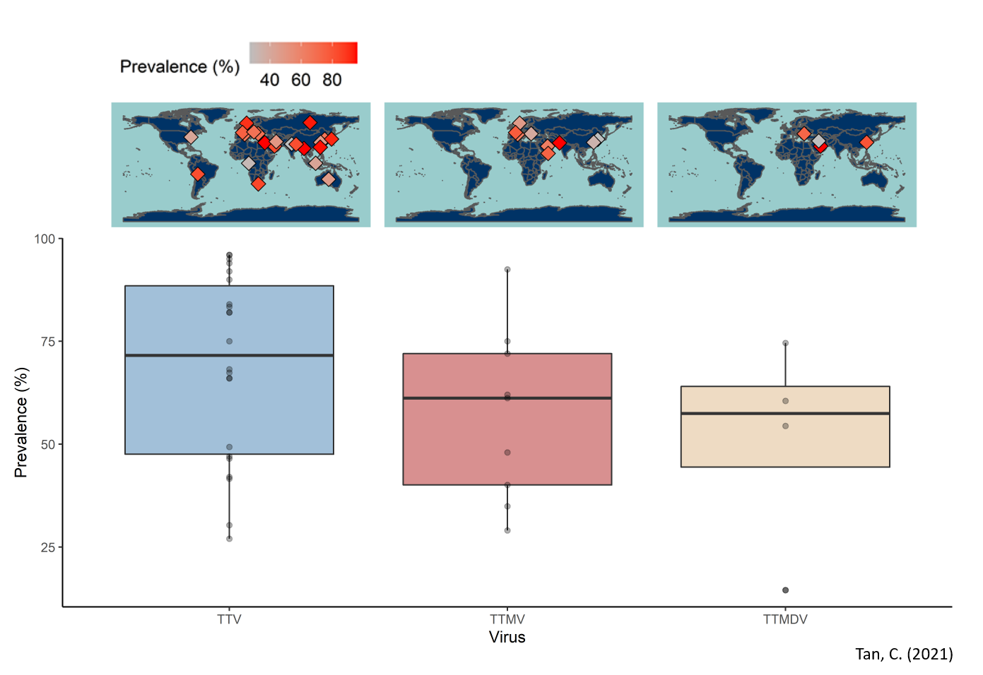

**Figure 1. Global distribution of human anelloviruses**. Prevalence estimates of human anelloviruses in healthy individuals were obtained from 26 independent studies and used to generate this figure. The world maps were generated using the *ne_countries* function from the *rnaturalearth* package in *R*.

The high prevalence and transmissibility of anelloviruses around the world warrants further surveillance. Indeed, it is possible that an animal anellovirus may acquire the ability to infect and transmit efficiently amongst humans, resulting in the emergence of a new human infectious disease that significantly affects public health. Even though global health efforts mainly involve post-emergence outbreak control [8], it is prudent to pre-empt and mitigate the emergence of the next infectious disease. However, our understanding of anelloviruses is limited relative to other more prominent pathogens. In fact, there are currently no stable cell culture systems or animal models available [9–11]. This review will draw insights from other viral families to explore the limits of our current knowledge about the *Anelloviridae*. Additionally, possible approaches to expand this knowledge will be outlined. Finally, the potential for anelloviruses to cause the next human infectious diseases will be discussed.

# **The genome, its proteins, and their interactions with the host**

## Genome structure and replication (310 words)

Anelloviruses possess two main open reading frames (ORFs), ORF1 and ORF2, but can have up to four ORFs in their genome [9]. These ORFs are found within a coding region demarcated by a TATA-box and poly-A tail sequence. There is also an untranslated region (UTR) containing a GC-rich region [12] (**Figure 2a**). Transfection experiments of human TTV found that at least six proteins are generated by alternative translation initiation [13] on three mRNA species, which were produced by alternative splicing [14]. ORF1 putatively encodes the capsid protein that contains an arginine-rich N-terminus [11], and a Rep-like protein. Additionally, ORF2 potentially encodes a phosphatase [15] and ORF3, the TTV-derived apoptosis-inducing protein (TAIP) [16,17].

Currently, the genome replication mechanism of anelloviruses is poorly understood relative to other families of circular ssDNA viruses such as *Geminiviridae* [18] or *Circoviridae* [19]. Fundamentally, anelloviruses are dependent on their hosts replication machinery since TTV replication is inhibited by administering the DNA polymerase inhibitor, aphidicolin [20]. It is believed that anelloviruses replicate via a rolling circle replication (RCR) mechanism. This is because anelloviral genomes contain a conserved motif that is part of a stem-loop structure, and a Rep-like sequence, both of which are found conserved in other circular ssDNA replicons including plasmids and viruses. In a hypothethical mechanism for anelloviral replication (**Figure 2b**), the negative-sense ssDNA anellovirus genome into double-stranded DNA (dsDNA) intermediate by host enzymes (A). Subsequently, a Rep-like protein nicks one of the two DNA strands at the origin of replication (ori) to generate a 3’OH, which acts as a primer for host DNA polymerase to incorporate new nucleotides using the other DNA strand as a template (B). As the former DNA strand is elongated, the parental strand is displaced (C). After a round of replication (D), the displaced parental strand is cleaved at the ori, the resultant 5’ and 3’ ends covalently linked, and the molecule released as circular DNA (E). The newly synthesised strand can then proceed for another of replication.



**Figure 2. Genome structure and replication.** (a) The complete genome of TTV retrieved from NCBI GenBank (NC_002076.2) was visualised and annotated using UGene [21]. (b) Hypothetical model of RCR for anelloviruses. Annotations: host DNA polymerase (DNAP); Rep-like proteins (Rep); origin of replication (ori).

Anelloviruses have conserved motifs within a stem-loop structure, reminiscent of other circular ssDNA replicons like plasmids or viruses that replicate via RCR. For example, CAVs and TTVs contain the conserved nona- and octanucleotide motifs, 5‘-TACTATTCC-3’ and 5’-AGTTTAAA-3’, respectively. The latter motif was proposed to contain the TTV origin of replication at the +5 position [22]. These motifs resemble the origin-containing nonanucleotide motifs in multiple other circular ssDNA replicons [22–24] (**Figure 3a**). Additionally, the nonanucleotide motifs in circular ssDNA replicons tend to be found within stem-loops, which are a type of DNA secondary structure. The proposed stem-loop structure for porcine circoviruses (PCVs; family *Circoviridae*) [24] is shown in **Figure 3b**. These stem-loop structures have been shown to be essential for RCR. For instance, mutations in PCVs [25] and tomato golden mosaic virus (family *Geminiviridae*) [26] that significantly affected these stem-loops disrupted RCR. Conversely, mutations that did not affect the stem-loop structures allowed RCR, suggesting that structural conservation is more important than sequence conservation. RNAStructure [27], a tool for predicting nucleic acid secondary structure, predicts that both the CAV nanonucleotide and TTV octanucleotide motifs are within similar stem-loop structures (**Figure 3c** and **d**), which further supports an RCR mechanism for anelloviruses.



**Figure 3.** (a) Manual alignment of the octanucleotide and nonanucleotide motifs conserved in anelloviruses and other ssDNA families, respectively (right). Abbreviations: chicken anemia virus (CAV); torque teno virus (TTV); porcine circovirus (PCV); coconut foliar decay virus (CDFV); subterranean clover stunt virus (SCSV); banana bunchy top virus (BBTV). (b) Proposed stem-loop structure containing the nonanucleotide motif in PCV (U49186.1). Predicted secondary structures of the region surrounding the octanucleotide and nonanucleotide motif in TTV (c; NC_002076.2) and CAV (d; AY843527.2), respectively. Structure prediction for TTV and CAV was performed using default parameters and all structures were renderred using RNAStructure [27]. Lower case nucleotide letters in (b) indicate the nucleotides that were forced to be single-stranded during rendering. (e) Mechanism underlying HUH endonuclease catalytic activity. M2+ indicates a divalent metal cation.

Anelloviral genomes also encode Rep-like proteins [28–32] that are conserved in other circular DNA replicons [33]. There are currently no solution structures for anelloviral Rep-like proteins. However, of the nine known families of eukaryotic DNA viruses other than the *Anelloviridae*, all except *Bidnaviridae* are believed to possess Rep proteins that of the HUH endonuclease superfamily [34]. Therefore, it is tempting to speculate that anelloviral Rep-like proteins are also of the same superfamily. HUH endonucleases recognise dsDNA and catalyse the breaking or joining of ssDNA [35]. Rep-like protein ofThe dsDNA-binding domains of PCV [36] and geminivirus [37] Rep proteins were both found to bind the oris of their circular genomes. Additionally, the endounuclease domains of most eukaryotic ssDNA viruses belong to the HUH endonuclease family

Further investigation into the genome replication of anelloviruses may prove to be useful in the future, especially when developing antiviral therapeutics and strategies. For example, transgenic expression of non-functional viral Rep proteins in plants was shown to interfere with Rep-mediated recruitment of host polymerases for genome replication, inducing resistance to tomato yellow leaf curl geminivirus [38–40]. A similar strategy could be explored to reduce the impact of anellovirus-related mortality in livestock.

## Host-virus interactions

* Suspected cause of death in pinnipeds (discuss Koch’s postulates)
* Synergistic co-infection causing fatal postweaning multisystemic wasting syndrome in pigs
* Chicken anemia virus causes atrophy of thymus and bone marrow
* No evidence for pathogenicity to humans; studies have only shown that TTV is marker of immune status
* However, we cannot rule out that human anelloviruses can alter disease progression or severity
* TTV has no stable cell culture or animal model so it is difficult to study
* Mechanisms for regulation of innate immunity
* Mechanisms for regulation of cell-mediated immunity
* All proteins are antigenic <https://www.sciencedirect.com/science/article/pii/S0042682208005928#bib28>
* Higher viral loads associated with disease. Competes with immune system

**Figure 4.** Host-viral interactions.

# **Accumulation of genomic diversity**

## Genomic diversity (255)

Even though anelloviruses have similar genome structures, there is great sequence divergence within the family. Indeed, the mean genetic distance of aligned amino acid sequences for human TTVs alone is approximately 7.6, 2.2 and 2.1 fold greater than that for hepatitis B virus, human immunodeficient virus-1 and hepatitis C virus, respectively [10]. This diversity poses a major challenge for full-genome alignments during the reconstruction of phylogenetic relationships. Typically, a phylogeny is reconstructed by first generating an alignment of the sequences in question. This alignment is then used as input in tree-building tools such as RAxML [41] or IQ-TREE [42] to reconstruct the evolutionary relationships of the sequences in the form of a phylogeny (**Figure 2a**). Due to the vast genomic diversity in the *Anelloviridae*, the ICTV recommends restricting family-wide phylogenetic reconstruction analyses to ORF1 and a 35% nucleotide sequence identity threshold to demarcate viral species [1]. Several studies have presented a family-wide phylogeny [9,43–46] in accordance with this. However, doing so does not consider the full-length genomic diversity of the family. Additionally, sequence alignment algorithms are known to have limited accuracy when used for aligning highly divergent sequences [47]. Moreover, as will be discussed below, there is evidence for recombination in anelloviruses. This has significant implications for phylogenetic inference since recombination results in portions of genomes representing different evolutionary histories. As such, recombinant genomes cannot be expressed by a single phylogeny (**Figure 6b**) [48]. In such cases, the resultant phylogeny topologies obtained often differs from the true phylogeny [49], especially when recombination occurs between divergent sequences [48], as in the case of anelloviruses. Alignment-free methods are minimally affected by recombination [47]. As such, alignment-free methods may be more appropriate for future studies investigating the family-wide diversity of the *Anelloviridae*.

Notably, many sophisticated methods in population genetics such as those for phylogenetic dating [50] or inferring past population dynamics [51,52] are alignment-dependent. As such, future studies seeking to employ such methods could consider extracting conserved ‘core’ genes or genomic regions from the ‘un-alignable’ viral sequences (**Figure 4c**) using gene annotation tools such as *Prokka* [53], *Roary* [54]or *Mauve* [55]. These ‘core’ genomic regions can then be combined together to produce a concatenated genome alignment. Such approaches have been previously used on highly divergent members of microbial communities [56] and recently for the family *Coronaviridae* [57]. This can be done and would allow the construction of a sequence alignment that retains a larger proportion of the viral genomes. Additionally, the effect of recombination can be minimised by removing putative recombinant segments using breakpoints identified by tools such as GARD [58] or RDP [59,60], which was demonstrated by Cadar et al. [61].



**Figure 4. Phylogenetic analysis.** Simplified workflows of (a) typical alignment-based and (b) alignment-free approaches. (b) (c) Extraction of ‘core’ genomic regions to obtain alignable conserved genomic regions for phylogenetic reconstruction.

## Mutation rates (325)

Understanding how viruses mutate and accumulate genomic diversity has profound practical implications. For example, the emergence of SARS-CoV-2 mutations that putatively aid in immune escape has been of great concern with regards to vaccine efficacy and development [62] in the present COVID-19 pandemic. Additionally, elevating short-term viral mutation rates via mutagen treatment, termed lethal mutagenesis, has been shown to enhance the effectiveness of antiviral treatments [63]. Only a few studies to date have provided estimates of the mutation rate of anelloviruses [61,64,65], which ranges from 2.3-7.3 × 10-4 substitutions/site/year (s/s/y). Cadar et al. [61] reported a substitution rate of 5.4 × 10-4 s/s/y for the TTSuV genomic region containing the UTR, ORF2 and 5’ end of ORF1 sequences sampled from wild boars over six years. Umemura et al. [64] reported a synonymous substitution rate of 7.3 × 10-4 s/s/y for TTV-positive sera over 12 years. Lastly, Bedarida et al. [65] reported a value of ~2 × 10-4 s/s/y for anellovirus sequences obtained from human sera and cat saliva reported over 16 and 6.5 years, respectively. These rates were compared to that of other viruses, which were collated from eight other studies [66–73] (**Figure 5**). The mutation rates of anelloviruses are similar to that of RNA viruses. Additionally, they are discernibly higher than that of double-stranded DNA (dsDNA) viruses, which echoes previous findings that single-stranded viruses mutate faster than their double-stranded counterparts [63]. This phenomenon has been suggested to be due to single-stranded viruses being more prone to chemical damage such as oxidative deamination [74].

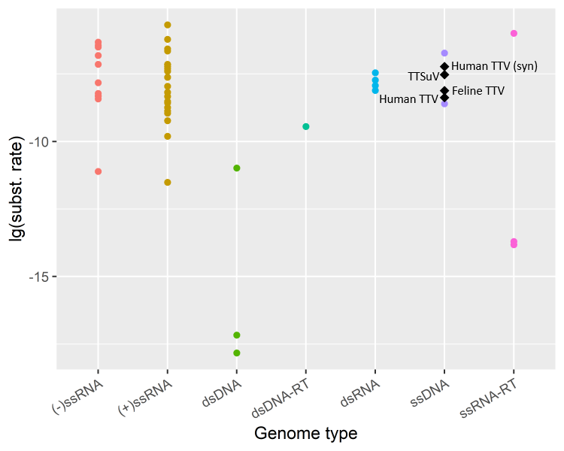

**Figure 5. Mutation rates of Anelloviridae in the context of other viruses**. The substitution rates of all genomic sites, obtained from the literature and expressed as substitutions/site/year, was visualised in log10 scale for the different human and animal viruses, stratified by their genome types. Anelloviruses are indicated by black diamonds and annotated with their corresponding names. The substitution rate where only synonymous mutations were considered is denoted by “syn”.

## Host-editing and recombination (530)

Given that genome replication is performed by host polymerases [20], which are highly accurate, nucleotide misincorporation may play only a minor role in the accumulation of mutations.

Host innate antiviral responses may contribute to the genomic diversity. For example, host APOBEC3 proteins are cytidine deaminases that have been found to cause C->T hypermutations in other DNA viruses like human papillomavirus [75,76]. Mechanism…. (**Figure 6a**) While such host-editing by APOBEC3 has not been demonstrated for anelloviruses, *in vitro* experiments found that these proteins preferentially bind ssDNA over dsDNA and may account for higher C->T mutations on the negative-sense strand of HIV reverse transcripts [77]. This suggests that negative-sense ssDNA anelloviruses are likely to be subject to host-editing. Investigations of how anelloviruses evade or overcome APOBEC3-mediated editing may prove to be invaluable in our understanding of how viruses evolve.



**Figure 6. Potential mechanisms of accumulating genomic diversity**. (a) Reaction equation catalysed by host cytidine deaminases. Cytidines on ssDNA is deaminated to form uradine, which is subsequently base-paired with adenosine during DNA replication, resulting in C 🡪 T and G 🡪 A mutations. (b) Schematic illustrating how recombination produces new combinations of point mutations and confounding phylogenetic inference.

Recombination also plays a substantial role in shaping the extant genomic diversity of the *Anelloviridae* by generating new genetic combinations that could not have been attained via point mutations alone [78]. Indeed, a single recombination event between two viral genomes could generate new combinations of their existing mutations, introducing several nucleotide polymorphisms at a time (**Figure 6b**), which could prevent the accumulation of deleterious mutations [79–81]. Using the popular recombination detection tool RDP4 [59], which identifies recombination using an ensemble of different detection methods, Fahsbender et al. [82] found that 89% of torque teno Leptonychotes weddellii virus (TTLwV)-1 and 26% of TTLwV-2 had at least one and one putative recombination event, respectively. They also found that the recombination breakpoints detected in TTLwV-1 tend to fall within the UTR region. This agrees with a previous study [78], which found a significantly higher density of recombination breakpoints outside coding regions and at the edges of genes for almost all of 14 ssDNA viruses spanning 6 families (including TTV and TTMV). Other studies have similarly detected recombination within the different human TTV species [83,84] and within TTSuVs isolated from wild boars and domestic pigs [61].

While no studies to date have formally estimated the rate of recombination in anelloviruses, multiple studies have found a high frequency of co-infections of different anellovirus species [85–89], one even reporting a 48% frequency of dual or triple infection of TTV, TTMV and TTMDV in infants. This high frequency of co-infection, together with the strong recombination signals detected by the abovementioned studies, suggest that anelloviruses recombine frequently and that recombination may be a major contributor to the accumulation of genomic diversity. Potential for emergence of recombinant strains (cf. human adenovirus from recombinant Chimp and Bonobo viruses)

# Transmission routes: anelloviruses can go anywhere (761)

## Horizontal transmission

In line with its high prevalence, anelloviruses may potentially be transmitted via multiple routes, both vertically (*i.e.* from mother to offspring) and horizontally (*i.e.* between organisms not in a mother-offspring relationship) (**Figure 7**). In general, most studies of transmission thus far have employed PCR-based methods of detecting anelloviral DNA. In such methods, PCR with anellovirus-specific primers is used amplify viral genomic fragments, which are then visualised via agarose gel electrophoresis. Suitably sized gel bands corresponding to the length of the PCR target are extracted and subsequently sequenced to confirm that the correct genomic sequences were amplified. Successful amplification of the PCR target is generally regarded as a positive result. However, even if anelloviral DNA is detected, this does not entail that infectious virions are present. Since most studies did not demonstrate the viability of detected anelloviral DNA and its ability to infect naïve hosts, only a few transmission routes have been confirmed (highlighted in green; **Figure 7**). The strength of evidence provided for the different transmission routes will be discussed in this section.

Anelloviral DNA has been detected in bodily fluids like blood, bile, saliva, mucus, semen and faeces [90–96]. This suggests that anelloviruses may potentially be transmitted horizontally via sexual, faecal-oral and airborne routes, or via direct contact with bodily fluids. However, since most studies did not confirm the viability of virions in the samples, the presence of viral DNA in samples could have been due to transient shedding of inactivated virus from a distal source that cannot infect a new host. Exceptionally, Itoh et al. showed that mature virions could be extracted from faeces and visualised using electron microscopy, providing stronger evidence for faecal-oral transmission [92]. Additionally, anellovirus-positive blood was shown to be able infect cells and proliferate [91,96]. Moreover, persistent viremia of TTV and TTMDV from blood donors was found in blood transfusion recipients [97], providing confirmatory evidence for blood as a vehicle of transmission.

Anelloviruses may potentially be transmitted via water or fomites, which are inanimate objects or surfaces that can become contaminated with pathogens [98]. Anelloviral DNA has been detected in multiple environmental sources. Studies have demonstrated their persistence in rivers [99–101], wastewaters [102], drinking water [103,104], shed feathers [105], air and surfaces in hospitals [106] or even laboratory reagents [107] and vaccines [108]. Of these studies, only one demonstrated the viability of detected anelloviral DNA. Davidson et al. [105] showed that dripping feather shaft extracts obtained from the feathers of CAV-infected chicks into the eyes and mouths of unexposed chicks resulted in infection, confirming that feathers can act as fomites to transmit CAV. However, while confirmation of infectivity is lacking, given the ubiquity and persistence of anelloviral DNA in the environment, the detected viral DNAs are likely to be stably packaged in their capsid protein shells and potentially infectious. Otherwise, ‘naked’ viral DNAs quickly degrade when exposed to the environment. For example, Zhu demonstrated that plasmid DNA in river and ground water is degraded beyond detectable levels after 48-96 h [109]. In contrast, the viral load of infectious, encapisdated human adenovirus remains stable even after 40 days in surface waters as quantitated by a plaque assay [110]. The relatively higher stability of DNA in infectious virions is likely due to the presence of the viral capsid protein which shields the DNA from degradation by chemical agents, UV irradiation or other means.

Alternatively, anelloviruses may potentially be transmitted via vectors. Shi et al. [111] and Hameed et al. [112] both found that viral sequences extracted from mosquitos and swine of pig farms were phylogenetically interspersed with previously reported TTSuV sequences. The viral sequences extracted from the mosquito samples were therefore likely to have descended from TTSuVs in pigs and may have been acquired during blood-feeding (*i.e.* hematophagy). However, both studies did not confirm that the viral DNA detected in mosquitos were infectious, which may provide stronger evidence for vector-borne transmission. Another study by de Souza et al. found that anellovirus sequences extracted from the liver of a vampire bat (*Desmodus rotundus*) and serum of an opossum (*Didelphis albiventris*) were of the same species at approximately 79% nucleotide sequence identity. Additionally, phylogenetic analysis suggests that these anelloviruses are likely to share a common ancestor that was transmitted between the two host types [43]. This is considerable evidence that vampire bats may be a vector of transmission for anelloviruses between the bats’ mammalian hosts.

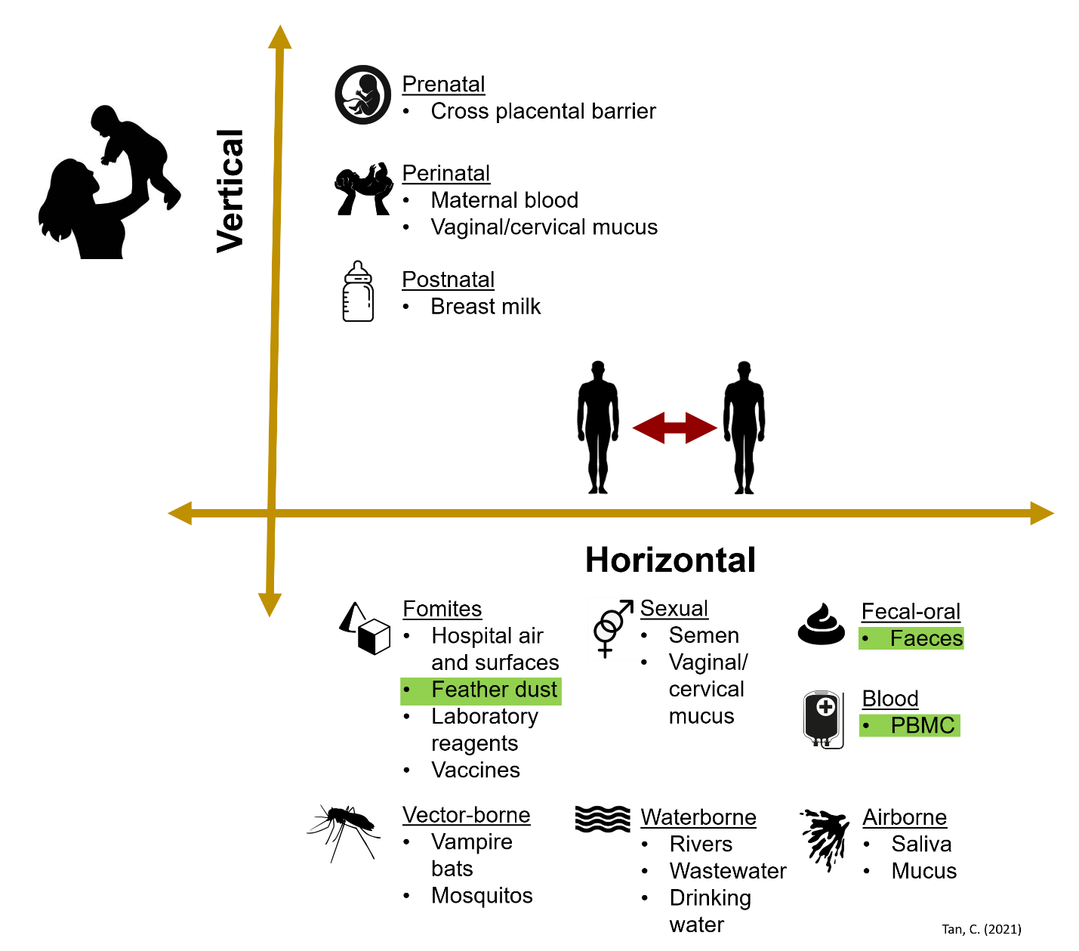

**Figure 7. Summary of potential transmission routes for anelloviruses**. Transmission routes that are supported by substantial evidence in the literature are highlighted in green.

## Vertical transmission

There is strong evidence for vertical transmission of anelloviruses, although the exact route(s) of infection – whether infection occurs before (prenatal), during and immediately after (perinatal), or after birth (postnatal) – is not known. Gerner et al. [113] detected human TTV in human breast milk, and umbilical cord blood. Separately, Matsubara et al. [114] found TTV and TTMV DNA in breast milk, cord blood and amniotic fluid. Both studies employed polymerase chain reaction (PCR) followed by agarose gel electrophoresis to test the fluid samples. PCR amplicons were also sequenced via Sanger sequencing to rule out non-specific amplification. These studies suggest that breastfeeding might be a potential transmission route. However, cross-sample contamination during collection of cord blood or amniotic fluid is difficult to rule out and so these studies may not be sufficient to prove transplacental transmission. In fact, Tyschik et al. [115] did not find TTV in the cord blood from TTV-positive mothers using a highly sensitive quantitative PCR (qPCR) assay that could detect viral loads as low as 1000 viral DNA copies/ml of blood. The authors also detailed stringent measures to prevent cross-contamination, which the previous groups did not do. This suggests that the previous findings could have been due to contamination, which must be accounted for in future studies. Nevertheless, Gerner et al. [113] provided evidence for vertical transmission by showing that follow-up samples taken from infants with TTV-positive cord blood had persistent viremia.

Vertical transmission has also been demonstrated in animals. In particular, Martinez-Guino et al. showed in separate studies that sows, their breast milk and their aborted foetuses [116] or stillborns [117] were PCR positive for TTSuV. They also showed that TTSuV sequences in mother-offspring pairs had nucleotide sequence identities of 91-98%, implying that sample cross-contamination is unlikely. Indeed, it is likely that samples that were cross-contaminated at the point of collection should share identical sequences. As such, these findings may suggest that infections of the foetuses were acquired prenatally and that TTSuV may be transmitted through breast feeding. Vertical transmission of TTSuV through breast milk can be further confirmed in future studies by feeding of TTSuV-positive milk to TTSuV-negative offspring. Separately, human TTMDV was detected in domestic hens and the yolks of their eggs [118], providing evidence for vertical transmission. Confirmation that chicks that developed from TTMDV-positive eggs were also persistently infected would have provided stronger evidence for vertical transmission. Collectively, the studies discussed above provide substantial evidence for vertical transmission of anelloviruses.

# Potential for the emergence of infectious diseases

## Anelloviruses are everywhere (485)

After the discovery of TTV, the first anellovirus, in 1997 [7], multiple studies have detected a diverse range of anelloviruses in humans and animals, including rodents [3], primates, birds, marine mammals [82,119,120], bats [4] and other wild or domesticated animals [43,121–124]. An alignment-free phylogeny of 1143 complete anellovirus genomes isolated from at least 43 annotated host species (NCBI Virus; accessed 20 Oct 2020) is presented here (**Figure 8**). There is significant clustering of the viral sequences by viral genus. The phylogeny demonstrates significant clustering by viral genus and a broad diversity of host types that are segregated by phylogenetically distinct clades (**Figure 8**). Given the extensive sampling of the broad diversity of anelloviruses from a variety of hosts, it may be feasible to investigate the selective pressures involved in viral speciation events (e.g. the emergence of TTMDV from a TTMV lineage; **Figure 8**) or changes to host-specificity. While unexplored in the literature, probing these ideas may yield valuable insights as to how new pathogens can emerge.

Studies that have explored the biodiversity of anelloviruses in humans and animals can be non-exhaustively categorised into virus-specific and metagenomic efforts. The former category refers to studies that performed PCR using anellovirus sequence-specific primers, followed by sequencing of the PCR amplicons. For example, Ye et al. characterised the sequences of avian gyrovirus 2 (AGV2) in chickens from live poultry markets [121]. Similarly, Singh et al. used TTSuV-specific primers to amplify and subsequently characterise anellovirus sequences in bovine, equine, ovine, canine and elk hosts [122]. The latter category refers to studies that do not employ sequence-specific primers but perform metagenomic sequencing, followed by *de novo* assembly (*i.e.* assembly without a reference genome) of sequencing reads. For example, studies have employed this approach for samples obtained from mosquitos [111,112,119], rodents [3,125] and pinnipeds [120,126]. To explore the host range and biodiversity of anelloviruses in different animal reservoirs, metagenomic-based approaches appear to yield much more information. Indeed, *a priori* knowledge of viral sequences is required for virus-specific approaches. Given the large sequence divergence within the family, species-specific PCR primers are unlikely to be able to amplify novel anellovirus sequences. In contrast, metagenomic-based approaches do not require *a priori* sequence information and therefore can detect novel anelloviruses. Furthermore, because anellovirus genomes are small, lesser sequencing reads are required for sufficient genomic coverage to produce reliable genome assemblies. This entails that while the genomic fragments retrieved via virus-specific PCR is restricted by the amplicon length, longer or even full-length genomic sequences can be assembled via metagenomics-based approaches. In short, metagenomics may capture more genomic information from a larger proportion of the anelloviral diversity.

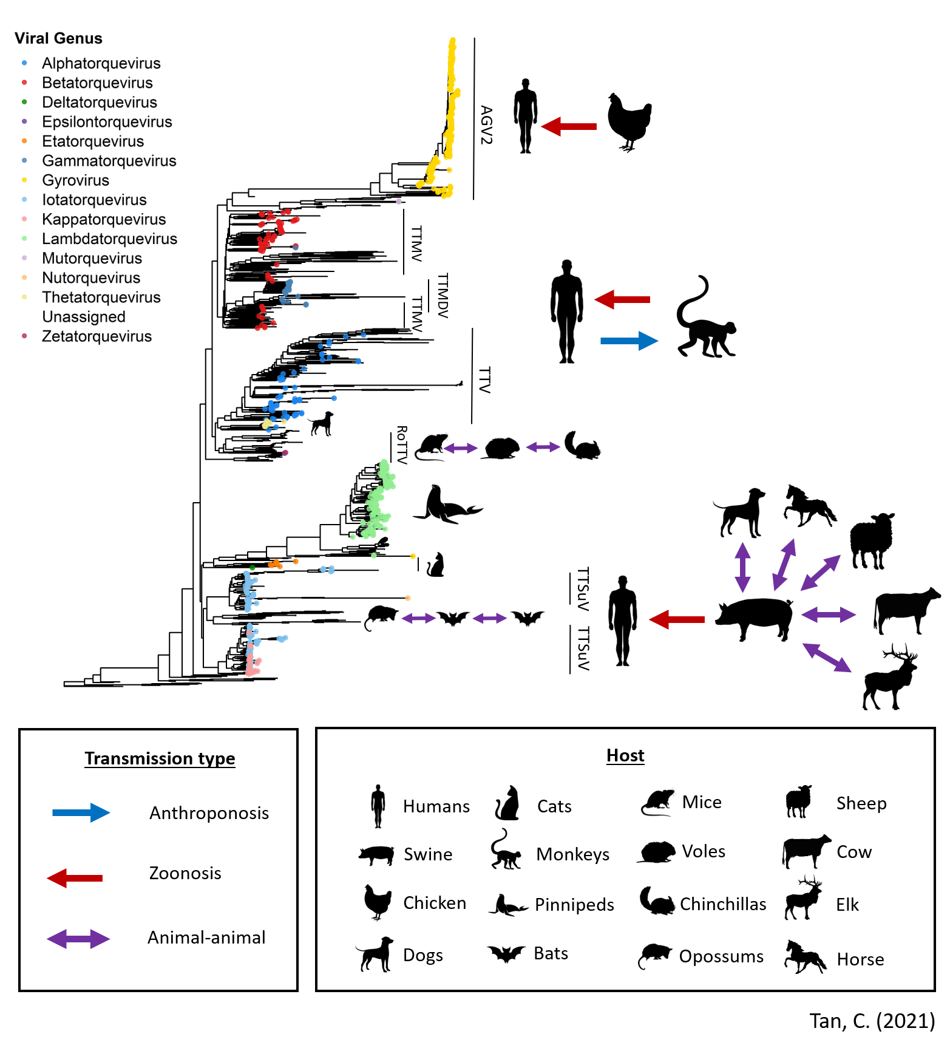

**Figure 8. Genomic diversity of the Anelloviridae and summary of evidence for cross-species transmission**. The genomic diversity of 1143 Anelloviridae genome sequences is represented here as a whole-genome neighbour-joining phylogeny, which was reconstructed using alignment-free Mash distances [127] and rooted with the genome accession MK012481 (see **Appendix**). This phylogeny is annotated with symbols illustrating the host range and cross-species transmission of various viral species.

## Evidence for cross-species transmission

There has been considerable evidence supporting the ability of anelloviruses to transmit between host species. Singh and Ramamoorthy [122] detected both TTSuV and human TTV sequences in canine, bovine, ovine, equine, and elk sera using species-specific PCR primers. They further detected TTSuV-specific antibodies in bovine, ovine and equine samples using enzyme-linked immunoabsorbant assays (ELISA), confirming the presence of productive TTSuV infection in these animals. Notably, the authors did not find TTSuV-specific antibodies in elk and canine samples despite the presence of TTSuV DNA, suggesting that either the magnitudes of antibody responses were below the limit of detection for the ELISA assay used, or that viral replication was insufficient to trigger the production of TTSuV-specific antibodies. The former possibility implies considerable variability in the strength of adaptive immune responses to anellovirus infection while the latter suggests that TTSuV may not be adapted for efficient replication in said hosts. Nonetheless, these findings provide strong evidence for the ability of TTSuV to infect multiple animal hosts and possible cross-species transmission of both TTSuV and human TTV. Separately, rodent TTVs have also been shown to infect a broad range of hosts. A large metagenomic surveillance study on rodent samples collected from 20 provinces in China found that rodent TTV lineages were found in multiple hosts from the same family, or even hosts from three different families (*Circitidae*, *Muridae* and *Chinchillidae*) [125]. Additionally, as mentioned previously, de Souza et al. [43] found two phylogenetically related anelloviruses in a vampire bat and an opossum. A third anellovirus sequence obtained from the frugivorous (i.e. fruit-eating) bat, *Carollia perspicillata*, was also estimated to share a common ancestor with the other two sequences [43]. Moreover, the node where the three sequences diverged from the other anelloviruses had a high bootstrap support value, suggesting that their evolutionary relationships can be confidently inferred. Given that *D. rotundus* and *C. perspicillata* are known to share roosts in caves [128,129], horizontal transmission of anelloviruses between the two hosts may have occurred during roosting. Collectively, these studies suggest that anelloviruses, or at least those associated with mammalian hosts, tend to be ‘generalists’ that have retained the ability to infect a broad range of hosts.

Understanding how anelloviruses are internalised by cells during infection may account for the broad host range of anelloviruses. However, the exact mechanism for viral entry is currently unknown. Generally, non-enveloped viruses, which include anelloviruses, enter host cells by the binding of capsid proteins to cell surface [130]. These viruses subsequently penetrate the cell membrane and release their genomes into the host cell where it proliferates. A potential mechanism for anellovirus viral entry may be modelled off that of porcine circovirus (PCV), a circular ssDNA virus from the family *Circoviridae.* A viral particle must first attach to extracellular host cell receptors and induce uptake (**Figure 9a**). PCV was shown to use proteoglycans, which consist of a core protein chain that is covalently attached to several glycosaminoglycan chains such as heparin sulfate (HS) and chondroitin sulfate-B (CSB), as their receptor for viral entry [131]. Additionally, an arginine-rich region at the N-terminus of the PCV capsid protein was shown to act as a cell-penetrating peptide (CPP) that triggers endocytosis and hence uptake of its cargo into the cell [132]. While a direct binding interaction between the N-terminal sequence of the PCV capsid and proteoglycan receptors has not been described, most CPPs are understood to allow the translocation of macromolecules into cells by proteoglycan-binding [133,134]. Visualisation of PCV and anellovirus capsid protein sequences found a similar arginine-rich region conserved in anellovirus capsid proteins (**Figure 9b**). This suggests that proteoglycans are possible candidates for receptors used by anelloviruses during viral entry. Future studies may consider investigating whether the anellovirus-derived N-terminal capsid sequences can function as CPPs to probe the mechanism(s) of viral entry.

Interestingly, PCVs were found to be able to infect cells lacking both HS and CS proteoglycans [131]. Additionally, inhibition of major endocytotic pathways such as clathrin-mediated endocytosis or macropinocytosis was found to reduce uptake of PCV-derived N-terminal sequences [132]. These findings suggest that multiple cellular pathways are involved in PCV viral entry. This, in addition to the fact that HS proteoglycans are expressed on the surface of most animal cells, [135] may explain why PCV can infect multiple cell types and host species [136]. Similarly, the promiscuous cell- [137] and host-specificity of anelloviruses points to the involvement of common host cell receptors during viral entry. Arguably, with a better understanding of viral entry mechanisms, it may be possible to estimate the full host range of anelloviruses and their potential for cross-species transmission.

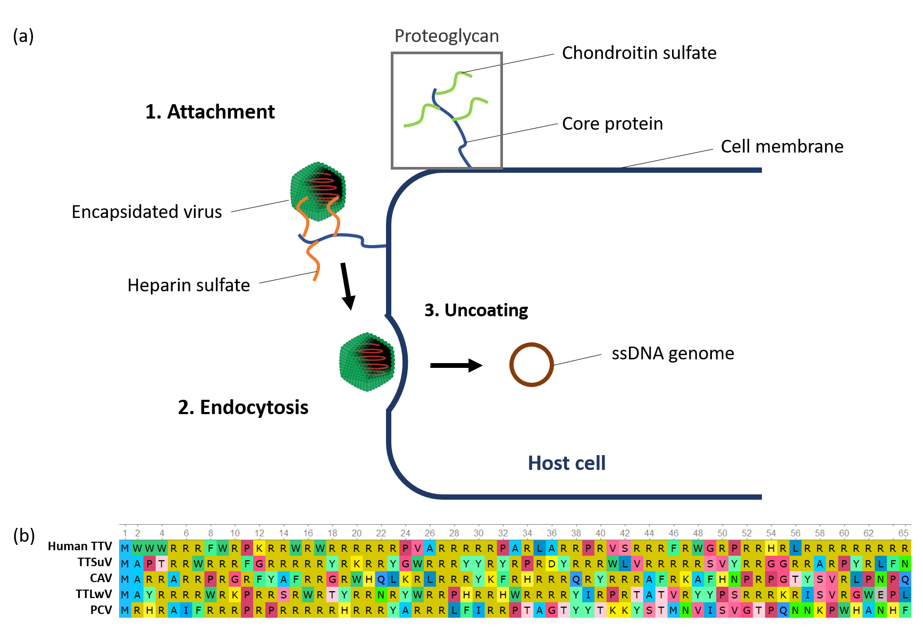

**Figure 9. Potential mechanism of viral entry** (a) Schematic of a possible mechanism for anelloviral entry modelled off that of PCVs. (b) UGene [21] visualisation of the first 65 amino acid residues in the capsid protein of Human TTV (QHS01920.1), TTSuV (YP_003587901.1), CAV (AYN79688.1), TTLwV (YP_009388631.1) and PCV (YP_009315911.1). A meaningful alignment of these sequences could not be produced.

## The risk of zoonoses

The ‘generalist’ nature of anelloviruses is a risk factor for the emergence of zoonotic infectious diseases. Statistical modelling of 1415 human-associated pathogens, which includes viruses, bacteria and other types of pathogens, found that pathogens capable of infecting multiple hosts were at least 1.29 times more likely to emerge as zoonotic infectious diseases [138]. This echoes another study of 162 zoonotic viruses, which found that 63% of zoonotic viruses can be found in hosts from at least two different taxonomic orders [139]. These findings may be explained, in part, by the importance of virus-receptor interactions during viral entry that was highlighted in the previous section. In alpharetroviruses, a single amino acid substitution was sufficient for the extension of host range from avian cell types to include human, canine, feline, and rodent cells [140]. If receptor binding is the first barrier to viral entry, pathogens that already possess a promiscuous host-specificity may require the accumulation of fewer mutations to overcome this barrier. Since anelloviruses have a broad host range, there is a higher risk that they can emerge as novel pathogens responsible for infectious diseases that affect humans and livestock.

In fact, several studies have already demonstrated the zoonotic transmission of anelloviruses from several hosts. Using a PCR-based method, AGV2 was detected in the blood of 4/301 [141] , 2/178 [121] and 3/352 [142] human samples in three independent studies. …..

## Animal reservoirs

The rich biodiversity of anelloviruses in animals suggest that there may be multiple animal reservoirs where zoonotic spillover may occur, especially those in frequent contact with humans. Animal reservoirs are groups of animals that harbour viral pathogens, some of which may be transmitted to humans (*i.e.* zoonoses), resulting in the emergence of novel human infectious diseases. A study of 415 viruses found that the number of zoonotic viruses is proportional to the number of viral species maintained by each animal reservoir [143]. That is, the richer the diversity of viruses in different animals, the higher the likelihood of observing viruses that cause zoonotic infectious diseases. This is the case for anelloviruses, where metagenomic-based studies often detect different species of anelloviruses, sometimes from different viral genera. For instance, a survey of anelloviruses in civets (*Paguma larvata*) found viral species from at least four genera [144], while that in rodents spanned at least two viral genera [125].

A network visualising the number of viruses shared between different hosts showed that wild rodents and domestic animals such as dogs, pigs, cats and cattle were centrally located and highly connected [139]. This may reflect the potential of such animals to act as vectors that facilitate the movement of viruses between humans and wild-animal reservoirs. Further, animal reservoirs that are in extensive contact with humans are of greater a minimum of 20% geographical overlap was suggested to be necessary for viral sharing (resulting from cross-species transmission) [145] and the probability of sharing increases with overlap up till a 50% overlap [146]. This implies that livestock and wildlife such as bats or rodents that are in reasonably close contact with humans are potential animal reservoirs and warrant closer surveillance. Given the vast amount of metagenomic sequencing data from bats [147–149], rodents [150,151] and livestock [152–154], a meta-analysis of these datasets may yield valuable insights on the current diversity of anelloviruses and novel anelloviruses that are emerging in these potential reservoirs.

Whilst the focus of infectious disease research has traditionally been on zoonoses, the importance of anthroponotic transmission was brought to the forefront in the recent COVID-19 pandemic. Indeed, there has been great concern that anthroponotic transmission of SARS-CoV-2 into animal populations that can sustain transmission may result in the formation of animal reservoirs [155,156]. These reservoirs in turn serve as vectors of transmission between humans. Further, upon successful anthroponosis, there is evidence for rapid viral adaptation to its new host, contributing to the extant genomic diversity of the virus [157].

* Anthroponosis as mechanism for creating animal reservoirs

1. TTV and TTMV in captive chimps
2. TTV in swine and cattle
3. Human TTV in swine, bovine and simian sera

Another risk factor for zoonotic spillover is extensive contact between humans and the reservoir. This is intuitive given that there must be ample opportunity for host-specific adaption of the virus to jump into humans [158].

Anthroponosis might also result in mortality in livestock.

* High prevalence in livestock and humans
* We find that the fraction of pathogens shared between two hosts decreases with the phylogenetic distance between them. Our results suggest that host phylogenetic similarity is the primary factor for host‐switching in pathogens. (liam)

# Conclusion (500 words)

* If anelloviruses are arguably not pathogenic to humans, why should we care?

1. Kills livestock
2. Generalist nature potentiates cross-species transmission and possibly the emergence of pathogenic strains

* Stress importance of viral surveillance in animal reservoirs

# References

1. Walker PJ, Siddell SG, Lefkowitz EJ, Mushegian AR, Adriaenssens EM, Dempsey DM, et al. Changes to virus taxonomy and the Statutes ratified by the International Committee on Taxonomy of Viruses (2020). Springer; 2020.

2. Abe K, Inami T, Asano K, Miyoshi C, Masaki N, Hayashi S, et al. TT virus infection is widespread in the general populations from different geographic regions. J Clin Microbiol. 1999;37(8):2703–5.

3. Nishiyama S, Dutia BM, Stewart JP, Meredith AL, Shaw DJ, Simmonds P, et al. Identification of novel anelloviruses with broad diversity in UK rodents. J Gen Virol. 2014;95(Pt 7):1544.

4. Cibulski SP, Teixeira TF, de Sales Lima FE, do Santos HF, Franco AC, Roehe PM. A novel Anelloviridae species detected in Tadarida brasiliensis bats: first sequence of a chiropteran Anellovirus. Genome Announc. 2014;2(5).

5. Rosenberger JK, Cloud SS. Chicken anemia virus. Poult Sci. 1998;77(8):1190–2.

6. Kekarainen T, Segalés J. Torque teno sus virus in pigs: an emerging pathogen? Transbound Emerg Dis. 2012;59:103–8.

7. Nishizawa T, Okamoto H, Konishi K, Yoshizawa H, Miyakawa Y, Mayumi M. A novel DNA virus (TTV) associated with elevated transaminase levels in posttransfusion hepatitis of unknown etiology. Biochem Biophys Res Commun. 1997;241(1):92–7.

8. Pike J, Bogich T, Elwood S, Finnoff DC, Daszak P. Economic optimization of a global strategy to address the pandemic threat. Proc Natl Acad Sci. 2014;111(52):18519–23.

9. Simmonds P, Sharp CP. Anelloviridae. Clin Virol. 2016;701–11.

10. Kaczorowska J, van der Hoek L. Human anelloviruses: diverse, omnipresent and commensal members of the virome. FEMS Microbiol Rev. 2020;

11. Maggi F, Pistello MBT-RM in LS. Anelloviridae☆. In Elsevier; 2019. Available from: http://www.sciencedirect.com/science/article/pii/B9780128096338209965

12. Miyata H, Tsunoda H, Kazi A, Yamada A, Khan MA, Murakami J, et al. Identification of a novel GC-rich 113-nucleotide region to complete the circular, single-stranded DNA genome of TT virus, the first human circovirus. J Virol. 1999;73(5):3582–6.

13. Qiu J, Kakkola L, Cheng F, Ye C, Söderlund-Venermo M, Hedman K, et al. Human Circovirus TT Virus Genotype 6 Expresses Six Proteins following Transfection of a Full-Length Clone. J Virol [Internet]. 2005 May 15;79(10):6505 LP – 6510. Available from: http://jvi.asm.org/content/79/10/6505.abstract

14. Kamahora T, Hino S, Miyata H. Three Spliced mRNAs of TT Virus Transcribed from a Plasmid Containing the Entire Genome in COS1 Cells. J Virol [Internet]. 2000 Nov 1;74(21):9980 LP – 9986. Available from: http://jvi.asm.org/content/74/21/9980.abstract

15. Peters MA, Jackson DC, Crabb BS, Browning GF. Chicken anemia virus VP2 is a novel dual specificity protein phosphatase. J Biol Chem. 2002;277(42):39566–73.

16. Kooistra K, Zhang Y-H, Henriquez N V, Weiss B, Mumberg D, Noteborn MHM. TT virus-derived apoptosis-inducing protein induces apoptosis preferentially in hepatocellular carcinoma-derived cells. J Gen Virol. 2004;85(6):1445–50.

17. De Smit MH, Noteborn MHM. Apoptosis-inducing proteins in chicken anemia virus and TT virus. In: TT Viruses. Springer; 2009. p. 131–49.

18. Gutierrez C, Ramirez-Parra E, Mar Castellano M, Sanz-Burgos AP, Luque A, Missich R. Geminivirus DNA replication and cell cycle interactions. Vet Microbiol [Internet]. 2004;98(2):111–9. Available from: http://www.sciencedirect.com/science/article/pii/S0378113503003262

19. Faurez F, Dory D, Grasland B, Jestin A. Replication of porcine circoviruses. Virol J [Internet]. 2009;6(1):60. Available from: https://doi.org/10.1186/1743-422X-6-60

20. Kakkola L, Tommiska J, Boele LCL, Miettinen S, Blom T, Kekarainen T, et al. Construction and biological activity of a full‐length molecular clone of human Torque teno virus (TTV) genotype 6. FEBS J. 2007;274(18):4719–30.

21. Okonechnikov K, Golosova O, Fursov M, team the U. Unipro UGENE: a unified bioinformatics toolkit. Bioinformatics [Internet]. 2012 Apr 15;28(8):1166–7. Available from: https://doi.org/10.1093/bioinformatics/bts091

22. de Villiers E-M, Borkosky SS, Kimmel R, Gunst K, Fei J-W. The diversity of torque teno viruses: in vitro replication leads to the formation of additional replication-competent subviral molecules. J Virol. 2011;85(14):7284–95.

23. Mankertz A, Persson F, Mankertz J, Blaess G, Buhk H-J. Mapping and characterization of the origin of DNA replication of porcine circovirus. J Virol. 1997;71(3):2562–6.

24. Meehan BM, Creelan JL, McNulty MS, Todd D. Sequence of porcine circovirus DNA: affinities with plant circoviruses. J Gen Virol. 1997;78(1):221–7.

25. Cheung AK. A stem–loop structure, sequence non-specific, at the origin of DNA replication of porcine circovirus is essential for termination but not for initiation of rolling-circle DNA replication. Virology [Internet]. 2007;363(1):229–35. Available from: https://www.sciencedirect.com/science/article/pii/S0042682207000463

26. Orozco BM, Hanley-Bowdoin L. A DNA structure is required for geminivirus replication origin function. J Virol. 1996;70(1):148–58.

27. Reuter JS, Mathews DH. RNAstructure: software for RNA secondary structure prediction and analysis. BMC Bioinformatics [Internet]. 2010;11(1):129. Available from: https://doi.org/10.1186/1471-2105-11-129

28. Lan D, Hua X, Cui L, Luo X, Liu Z, San T, et al. Sequence analysis of a Torque teno canis virus isolated in China. Virus Res [Internet]. 2011;160(1):98–101. Available from: http://www.sciencedirect.com/science/article/pii/S0168170211002176

29. Rosario K, Duffy S, Breitbart M. Diverse circovirus-like genome architectures revealed by environmental metagenomics. J Gen Virol. 2009;90(10):2418–24.

30. Li K, Wang L-Q, Wu Y-Y, Chao A-J, Lu Q-W, Wei Z-Y, et al. Molecular detection and genomic characterization of Torque teno sus virus 1 and 2 from domestic pigs in central China. Virus Genes. 2013;46(3):479–86.

31. Zhang Z, Dai W, Dai D. Molecular characterization of pigeon torque teno virus (PTTV) in Jiangsu province. Comput Biol Chem. 2017;69:10–8.

32. Zhu CX, Shan TL, Cui L, Luo XN, Liu ZJ, Tang SD, et al. Molecular detection and sequence analysis of feline Torque teno virus (TTV) in China. Virus Res. 2011;156(1–2):13–6.

33. Ilyina T V, Koonin E V. Conserved sequence motifs in the initiator proteins for rolling circle DNA replication encoded by diverse replicons from eubacteria, eucaryotes and archaebacteria. Nucleic Acids Res. 1992;20(13):3279–85.

34. Krupovic M, Varsani A, Kazlauskas D, Breitbart M, Delwart E, Rosario K, et al. Cressdnaviricota: a virus phylum unifying 7 families of Rep-encoding viruses with single-stranded, circular DNA genomes. J Virol. 2020;

35. Chandler M, de la Cruz F, Dyda F, Hickman AB, Moncalian G, Ton-Hoang B. Breaking and joining single-stranded DNA: the HUH endonuclease superfamily. Nat Rev Microbiol [Internet]. 2013;11(8):525–38. Available from: https://doi.org/10.1038/nrmicro3067

36. Steinfeldt T, Finsterbusch T, Mankertz A. Rep and Rep′ Protein of Porcine circovirus Type 1 Bind to the Origin of Replication in Vitro. Virology [Internet]. 2001;291(1):152–60. Available from: https://www.sciencedirect.com/science/article/pii/S0042682201912036

37. Fontes EP, Eagle PA, Sipe PS, Luckow VA, Hanley-Bowdoin L. Interaction between a geminivirus replication protein and origin DNA is essential for viral replication. J Biol Chem [Internet]. 1994;269(11):8459–65. Available from: https://www.sciencedirect.com/science/article/pii/S0021925817372162

38. Noris E, Accotto GP, Tavazza R, Brunetti A, Crespi S, Tavazza M. Resistance to Tomato Yellow Leaf Curl Geminivirus inNicotiana benthamianaPlants Transformed with a Truncated Viral C1 Gene. Virology [Internet]. 1996;224(1):130–8. Available from: http://www.sciencedirect.com/science/article/pii/S0042682296905140

39. Brunetti A, Tavazza M, Noris E, Tavazza R, Caciagli P, Ancora G, et al. High Expression of Truncated Viral Rep Protein Confers Resistance to Tomato Yellow Leaf Curl Virus in Transgenic Tomato Plants. Mol Plant-Microbe Interact [Internet]. 1997 Jul 1;10(5):571–9. Available from: https://doi.org/10.1094/MPMI.1997.10.5.571

40. Lucioli A, Noris E, Brunetti A, Tavazza R, Ruzza V, Castillo AG, et al. Tomato Yellow Leaf Curl Sardinia Virus Rep-Derived Resistance to Homologous and Heterologous Geminiviruses Occurs by Different Mechanisms and Is Overcome if Virus-Mediated Transgene Silencing Is Activated. J Virol [Internet]. 2003 Jun 15;77(12):6785 LP – 6798. Available from: http://jvi.asm.org/content/77/12/6785.abstract

41. Stamatakis A. RAxML version 8: a tool for phylogenetic analysis and post-analysis of large phylogenies. Bioinformatics. 2014;30(9):1312–3.

42. Minh BQ, Schmidt HA, Chernomor O, Schrempf D, Woodhams MD, von Haeseler A, et al. IQ-TREE 2: New Models and Efficient Methods for Phylogenetic Inference in the Genomic Era. Mol Biol Evol [Internet]. 2020 May 1;37(5):1530–4. Available from: https://doi.org/10.1093/molbev/msaa015

43. de Souza WM, Fumagalli MJ, de Araujo J, Sabino-Santos Jr G, Maia FGM, Romeiro MF, et al. Discovery of novel anelloviruses in small mammals expands the host range and diversity of the Anelloviridae. Virology. 2018;514:9–17.

44. King AMQ, Adams MJ, Carstens EB, Lefkowitz EJBT-VT, editors. Family - Anelloviridae. In San Diego: Elsevier; 2012. p. 331–41. Available from: http://www.sciencedirect.com/science/article/pii/B9780123846846000331

45. Zhang W, Wang H, Wang Y, Liu Z, Li J, Guo L, et al. Identification and genomic characterization of a novel species of feline anellovirus. Virol J. 2016;13(1):1–3.

46. Eibach D, Hogan B, Sarpong N, Winter D, Struck NS, Adu-Sarkodie Y, et al. Viral metagenomics revealed novel betatorquevirus species in pediatric inpatients with encephalitis/meningoencephalitis from Ghana. Sci Rep. 2019;9(1):1–10.

47. Zielezinski A, Vinga S, Almeida J, Karlowski WM. Alignment-free sequence comparison: benefits, applications, and tools. Genome Biol [Internet]. 2017;18(1):186. Available from: https://doi.org/10.1186/s13059-017-1319-7

48. Posada D, Crandall KA. The effect of recombination on the accuracy of phylogeny estimation. J Mol Evol. 2002;54(3):396–402.

49. Schierup MH, Hein J. Consequences of recombination on traditional phylogenetic analysis. Genetics. 2000;156(2):879–91.

50. Rutschmann F. Molecular dating of phylogenetic trees: a brief review of current methods that estimate divergence times. Divers Distrib. 2006;12(1):35–48.

51. Minin VN, Bloomquist EW, Suchard MA. Smooth skyride through a rough skyline: Bayesian coalescent-based inference of population dynamics. Mol Biol Evol. 2008;25(7):1459–71.

52. Drummond AJ, Rambaut A, Shapiro B, Pybus OG. Bayesian coalescent inference of past population dynamics from molecular sequences. Mol Biol Evol. 2005;22(5):1185–92.

53. Seemann T. Prokka: rapid prokaryotic genome annotation. Bioinformatics. 2014;30(14):2068–9.

54. Page AJ, Cummins CA, Hunt M, Wong VK, Reuter S, Holden MTG, et al. Roary: rapid large-scale prokaryote pan genome analysis. Bioinformatics. 2015;31(22):3691–3.

55. Darling ACE, Mau B, Blattner FR, Perna NT. Mauve: multiple alignment of conserved genomic sequence with rearrangements. Genome Res. 2004;14(7):1394–403.

56. Segata N, Huttenhower C. Toward an Efficient Method of Identifying Core Genes for Evolutionary and Functional Microbial Phylogenies. PLoS One [Internet]. 2011 Sep 12;6(9):e24704. Available from: https://doi.org/10.1371/journal.pone.0024704

57. Tan CCS, Owen CJ, Tham CYL, Bertoletti A, van Dorp L, Balloux F. Pre-existing T cell-mediated cross-reactivity to SARS-CoV-2 cannot solely be explained by prior exposure to endemic human coronaviruses. bioRxiv [Internet]. 2020 Jan 1;2020.12.08.415703. Available from: http://biorxiv.org/content/early/2020/12/09/2020.12.08.415703.abstract

58. Kosakovsky Pond SL, Posada D, Gravenor MB, Woelk CH, Frost SDW. GARD: a genetic algorithm for recombination detection. Bioinformatics [Internet]. 2006 Dec 15;22(24):3096–8. Available from: https://doi.org/10.1093/bioinformatics/btl474

59. Martin DP, Murrell B, Golden M, Khoosal A, Muhire B. RDP4: Detection and analysis of recombination patterns in virus genomes. Virus Evol [Internet]. 2015 Mar 1;1(1). Available from: https://doi.org/10.1093/ve/vev003

60. Martin DP, Varsani A, Roumagnac P, Botha G, Maslamoney S, Schwab T, et al. RDP5: A computer program for analysing recombination in, and removing signals of recombination from, nucleotide sequence datasets. Virus Evol [Internet]. 2020 Dec 4; Available from: https://doi.org/10.1093/ve/veaa087

61. Cadar D, Kiss T, Ádám D, Cságola A, Novosel D, Tuboly T. Phylogeny, spatio-temporal phylodynamics and evolutionary scenario of Torque teno sus virus 1 (TTSuV1) and 2 (TTSuV2) in wild boars: Fast dispersal and high genetic diversity. Vet Microbiol [Internet]. 2013;166(1):200–13. Available from: http://www.sciencedirect.com/science/article/pii/S0378113513003246

62. Koyama T, Weeraratne D, Snowdon JL, Parida L. Emergence of drift variants that may affect COVID-19 vaccine development and antibody treatment. Pathogens. 2020;9(5):324.

63. Sanjuán R, Nebot MR, Chirico N, Mansky LM, Belshaw R. Viral mutation rates. J Virol. 2010;84(19):9733–48.

64. Umemura T, Tanaka Y, Kiyosawa K, Alter HJ, Shih JW-K. Observation of positive selection within hypervariable regions of a newly identified DNA virus (SEN virus). FEBS Lett. 2002;510(3):171–4.

65. Bédarida S, Dussol B, Signoli M, Biagini P. Analysis of Anelloviridae sequences characterized from serial human and animal biological samples. Infect Genet Evol. 2017;53:89–93.

66. Shackelton LA, Rambaut A, Pybus OG, Holmes EC. JC virus evolution and its association with human populations. J Virol [Internet]. 2006 Oct;80(20):9928–33. Available from: https://pubmed.ncbi.nlm.nih.gov/17005670

67. Shackelton LA, Holmes EC. Phylogenetic Evidence for the Rapid Evolution of Human B19 Erythrovirus. J Virol [Internet]. 2006 Apr 1;80(7):3666 LP – 3669. Available from: http://jvi.asm.org/content/80/7/3666.abstract

68. Chen Z, Ho WCS, Boon SS, Law PTY, Chan MCW, DeSalle R, et al. Ancient evolution and dispersion of human papillomavirus 58 variants. J Virol. 2017;91(21).

69. Sakaoka H, Kurita K, Iida Y, Takada S, Umene K, Kim YT, et al. Quantitative analysis of genomic polymorphism of herpes simplex virus type 1 strains from six countries: studies of molecular evolution and molecular epidemiology of the virus. J Gen Virol. 1994;75(3):513–27.

70. Osiowy C, Sauder C. Detection of TT virus in human hair and skin. Hepatol Res. 2000;16(2):155–62.

71. Switzer WM, Qari SH, Wolfe ND, Burke DS, Folks TM, Heneine W. Ancient origin and molecular features of the novel human T-lymphotropic virus type 3 revealed by complete genome analysis. J Virol [Internet]. 2006 Aug;80(15):7427–38. Available from: https://pubmed.ncbi.nlm.nih.gov/16840323

72. Jenkins GM, Rambaut A, Pybus OG, Holmes EC. Rates of molecular evolution in RNA viruses: a quantitative phylogenetic analysis. J Mol Evol. 2002;54(2):156–65.

73. Firth C, Charleston MA, Duffy S, Shapiro B, Holmes EC. Insights into the Evolutionary History of an Emerging Livestock Pathogen: Porcine Circovirus 2. J Virol [Internet]. 2009 Dec 15;83(24):12813 LP – 12821. Available from: http://jvi.asm.org/content/83/24/12813.abstract

74. Sanjuán R, Domingo-Calap P. Mechanisms of viral mutation. Cell Mol Life Sci [Internet]. 2016;73(23):4433–48. Available from: https://doi.org/10.1007/s00018-016-2299-6

75. Stavrou S, Ross SR. APOBEC3 proteins in viral immunity. J Immunol. 2015;195(10):4565–70.

76. Vartanian J-P, Guétard D, Henry M, Wain-Hobson S. Evidence for Editing of Human Papillomavirus DNA by APOBEC3 in Benign and Precancerous Lesions. Science (80- ) [Internet]. 2008 Apr 11;320(5873):230 LP – 233. Available from: http://science.sciencemag.org/content/320/5873/230.abstract

77. Yu Q, König R, Pillai S, Chiles K, Kearney M, Palmer S, et al. Single-strand specificity of APOBEC3G accounts for minus-strand deamination of the HIV genome. Nat Struct Mol Biol. 2004;11(5):435–42.

78. Lefeuvre P, Lett J-M, Varsani A, Martin DP. Widely conserved recombination patterns among single-stranded DNA viruses. J Virol. 2009;83(6):2697–707.

79. Felsenstein J. The evolutionary advantage of recombination. Genetics. 1974;78(2):737–56.

80. Keightley PD, Otto SP. Interference among deleterious mutations favours sex and recombination in finite populations. Nature. 2006;443(7107):89–92.

81. Charlesworth B. Mutation-selection balance and the evolutionary advantage of sex and recombination. Genet Res (Camb). 1990;55(3):199–221.

82. Fahsbender E, Burns JM, Kim S, Kraberger S, Frankfurter G, Eilers AA, et al. Diverse and highly recombinant anelloviruses associated with Weddell seals in Antarctica. Virus Evol. 2017;3(1).

83. Worobey M. Extensive homologous recombination among widely divergent TT viruses. J Virol. 2000;74(16):7666–70.

84. Manni F, Rotola A, Caselli E, Bertorelle G, Luca D Di. Detecting Recombination in TT Virus: A Phylogenetic Approach . J Mol Evol [Internet]. 2002;55(5):563–72. Available from: https://doi.org/10.1007/s00239-002-2352-y

85. Saback FL, Gomes SA, Niel C. High frequency of mixed TT virus infections in healthy adults and children detected by a simplified heteroduplex mobility assay. J Virol Methods [Internet]. 2002;101(1):117–25. Available from: http://www.sciencedirect.com/science/article/pii/S0166093401004256

86. Al-Qahtani AA, Alabsi ES, AbuOdeh R, Thalib L, El Zowalaty ME, Nasrallah GK. Prevalence of anelloviruses (TTV, TTMDV, and TTMV) in healthy blood donors and in patients infected with HBV or HCV in Qatar. Virol J. 2016;13(1):208.

87. Jarosova V, Pogranichniy R, Celer V. Prevalence and age distribution of porcine torque teno sus virus (TTSuV) in the Czech Republic. Folia Microbiol (Praha). 2011;56(2):90–4.

88. Ball JK, Curran R, Berridge S, Grabowska AM, Jameson CL, Thomson BJ, et al. TT virus sequence heterogeneity in vivo: evidence for co-infection with multiple genetic types. J Gen Virol. 1999;80(7):1759–68.

89. Hussain T, Manzoor S, Waheed Y, Tariq H, Hanif K. Phylogenetic analysis of torque teno virus genome from Pakistani isolate and incidence of co-infection among HBV/HCV infected patients. Virol J. 2012;9(1):320.

90. Fornai C, Maggi F, Vatteroni ML, Pistello M, Bendinelli M. High prevalence of TT virus (TTV) and TTV-like minivirus in cervical swabs. J Clin Microbiol. 2001;39(5):2022–4.

91. Maggi F, Fornai C, Zaccaro L, Morrica A, Vatteroni ML, Isola P, et al. TT virus (TTV) loads associated with different peripheral blood cell types and evidence for TTV replication in activated mononuclear cells. J Med Virol. 2001;64(2):190–4.

92. Itoh Y, Takahashi M, Fukuda M, Shibayama T, Ishikawa T, Tsuda F, et al. Visualization of TT virus particles recovered from the sera and feces of infected humans. Biochem Biophys Res Commun. 2000;279(2):718–24.

93. Itoh M, Shimomura H, Fujioka S-I, Miyake M, Tsuji H, Ikeda F, et al. High Prevalence of TT Virus in Human Bile Juice Samples. Dig Dis Sci. 2001;46(3):457–62.

94. Kekarainen T, Lopez-Soria S, Segales J. Detection of swine Torque teno virus genogroups 1 and 2 in boar sera and semen. Theriogenology. 2007;68(7):966–71.

95. Goto K, Sugiyama K, Ando T, Mizutani F, Terabe K, Tanaka K, et al. Detection rates of TT virus DNA in serum of umbilical cord blood, breast milk and saliva. Tohoku J Exp Med. 2000;191(4):203–7.

96. Mariscal LF, López-Alcorocho JM, Rodríguez-Inigo E, Ortiz-Movilla N, de Lucas S, Bartolomé J, et al. TT virus replicates in stimulated but not in nonstimulated peripheral blood mononuclear cells. Virology. 2002;301(1):121–9.

97. Bernardin F, Operskalski E, Busch M, Delwart E. Transfusion transmission of highly prevalent commensal human viruses. Transfusion. 2010;50(11):2474–83.

98. Boone SA, Gerba CP. Significance of fomites in the spread of respiratory and enteric viral disease. Appl Environ Microbiol. 2007;73(6):1687–96.

99. Verani M, Casini B, Battistini R, Pizzi F, Rovini E, Carducci A. One-year monthly monitoring of Torque teno virus (TTV) in river water in Italy. Water Sci Technol. 2006;54(3):191–5.

100. Diniz‐Mendes L, Paula VS de, Luz SLB, Niel C. High prevalence of human Torque teno virus in streams crossing the city of Manaus, Brazilian Amazon. J Appl Microbiol. 2008;105(1):51–8.

101. Haramoto E, Kitajima M, Katayama H, Ohgaki S. Real-time PCR detection of adenoviruses, polyomaviruses, and torque teno viruses in river water in Japan. Water Res. 2010;44(6):1747–52.

102. Haramoto E, Katayama H, Oguma K, Yamashita H, Nakajima E, Ohgaki S. One-year monthly monitoring of Torque teno virus (TTV) in wastewater treatment plants in Japan. Water Res. 2005;39(10):2008–13.

103. Griffin JS, Plummer JD, Long SC. Torque teno virus: an improved indicator for viral pathogens in drinking waters. Virol J [Internet]. 2008;5(1):112. Available from: https://doi.org/10.1186/1743-422X-5-112

104. Dalla Vecchia A, Kluge M, da Silva JV dos S, Comerlato J, Rodrigues MT, Fleck JD, et al. Presence of Torque teno virus (TTV) in tap water in public schools from Southern Brazil. Food Environ Virol. 2013;5(1):41–5.

105. Davidson I, Artzi N, Shkoda I, Lublin A, Loeb E, Schat KA. The contribution of feathers in the spread of chicken anemia virus. Virus Res. 2008;132(1–2):152–9.

106. Carducci A, Verani M, Lombardi R, Casini B, Privitera G. Environmental survey to assess viral contamination of air and surfaces in hospital settings. J Hosp Infect [Internet]. 2011;77(3):242–7. Available from: http://www.sciencedirect.com/science/article/pii/S0195670110004652

107. Teixeira TF, Dezen D, Cibulski SP, Varela APM, Holz CL, Franco AC, et al. Torque teno sus virus (TTSuV) in cell cultures and trypsin. PLoS One. 2011;6(3):e17501.

108. Kekarainen T, Martínez-Guinó L, Segalés J. Swine torque teno virus detection in pig commercial vaccines, enzymes for laboratory use and human drugs containing components of porcine origin. J Gen Virol. 2009;90(3):648–53.

109. Zhu B. Degradation of plasmid and plant DNA in water microcosms monitored by natural transformation and real-time polymerase chain reaction (PCR). Water Res. 2006;40(17):3231–8.

110. Rigotto C, Hanley K, Rochelle PA, De Leon R, Barardi CRM, Yates M V. Survival of adenovirus types 2 and 41 in surface and ground waters measured by a plaque assay. Environ Sci Technol. 2011;45(9):4145–50.

111. Shi C, Liu Y, Hu X, Xiong J, Zhang B, Yuan Z. A Metagenomic Survey of Viral Abundance and Diversity in Mosquitoes from Hubei Province. PLoS One [Internet]. 2015 Jun 1;10(6):e0129845. Available from: https://doi.org/10.1371/journal.pone.0129845

112. Hameed M, Liu K, Anwar MN, Wahaab A, Li C, Di D, et al. A viral metagenomic analysis reveals rich viral abundance and diversity in mosquitoes from pig farms. Transbound Emerg Dis. 2020;67(1):328–43.

113. GERNER P, OETTINGER R, GERNER W, FALBREDE J, WIRTH S. Mother-to-infant transmission of TT virus: prevalence, extent and mechanism of vertical transmission. Pediatr Infect Dis J [Internet]. 2000;19(11). Available from: https://journals.lww.com/pidj/Fulltext/2000/11000/Mother_to_infant_transmission_of_TT_virus_.9.aspx

114. Matsubara H, Michitaka K, Horiike N, Kihana T, Yano M, Mori T, et al. Existence of TT virus DNA and TTV-like mini virus DNA in infant cord blood: mother-to-neonatal transmission. Hepatol Res [Internet]. 2001;21(3):280–7. Available from: http://www.sciencedirect.com/science/article/pii/S1386634601001152

115. Tyschik EA, Shcherbakova SM, Ibragimov RR, Rebrikov D V. Transplacental transmission of torque teno virus. Virol J. 2017;14(1):92.

116. Martínez-Guinó L, Kekarainen T, Maldonado J, Aramouni M, Llorens A, Segalés J. Torque teno sus virus (TTV) detection in aborted and slaughterhouse collected foetuses. Theriogenology [Internet]. 2010;74(2):277–81. Available from: http://www.sciencedirect.com/science/article/pii/S0093691X10001044

117. Martínez-Guinó L, Kekarainen T, Segalés J. Evidence of Torque teno virus (TTV) vertical transmission in swine. Theriogenology. 2009;71(9):1390–5.

118. Bouzari M, Salmanizadeh S. Detection of torque teno midi virus/small anellovirus (TTMDV/SAV) in the sera of domestic village chickens and its vertical transmission from hen to eggs. Iran J Vet Res. 2015;16(1):110.

119. Ng TFF, Willner DL, Lim YW, Schmieder R, Chau B, Nilsson C, et al. Broad surveys of DNA viral diversity obtained through viral metagenomics of mosquitoes. PLoS One. 2011;6(6):e20579.

120. Ng TFF, Suedmeyer WK, Wheeler E, Gulland F, Breitbart M. Novel anellovirus discovered from a mortality event of captive California sea lions. J Gen Virol. 2009;90(5):1256–61.

121. Ye J, Tian X, Xie Q, Zhang Y, Sheng Y, Zhang Z, et al. Avian gyrovirus 2 DNA in fowl from live poultry markets and in healthy humans, China. Emerg Infect Dis. 2015;21(8):1486.

122. Singh G, Ramamoorthy S. Potential for the cross-species transmission of swine torque teno viruses. Vet Microbiol. 2018;215:66–70.

123. Bigarré L, Beven V, De Boisséson C, Grasland B, Rose N, Biagini P, et al. Pig anelloviruses are highly prevalent in swine herds in France. J Gen Virol. 2005;86(3):631–5.

124. Biagini P, Uch R, Belhouchet M, Attoui H, Cantaloube J-F, Brisbarre N, et al. Circular genomes related to anelloviruses identified in human and animal samples by using a combined rolling-circle amplification/sequence-independent single primer amplification approach. J Gen Virol. 2007;88(10):2696–701.

125. Du J, Li Y, Lu L, Zheng D, Liu B, Yang L, et al. Biodiversity of rodent anelloviruses in China. Emerg Microbes Infect. 2018;7(1):1–3.

126. Ng TFF, Wheeler E, Greig D, Waltzek TB, Gulland F, Breitbart M. Metagenomic identification of a novel anellovirus in Pacific harbor seal (Phoca vitulina richardsii) lung samples and its detection in samples from multiple years. J Gen Virol. 2011;92(6):1318–23.

127. Ondov BD, Treangen TJ, Melsted P, Mallonee AB, Bergman NH, Koren S, et al. Mash: fast genome and metagenome distance estimation using MinHash. Genome Biol. 2016;17(1):132.

128. Wray AK, Olival KJ, Morán D, Lopez MR, Alvarez D, Navarrete-Macias I, et al. Viral Diversity, Prey Preference, and Bartonella Prevalence in Desmodus rotundus in Guatemala. Ecohealth [Internet]. 2016;13(4):761–74. Available from: https://doi.org/10.1007/s10393-016-1183-z

129. Trajano E. Movements of cave bats in southeastern Brazil, with emphasis on the population ecology of the common vampire bat, Desmodus rotundus (Chiroptera). Biotropica. 1996;121–9.

130. Dimitrov DS. Virus entry: molecular mechanisms and biomedical applications. Nat Rev Microbiol [Internet]. 2004;2(2):109–22. Available from: https://doi.org/10.1038/nrmicro817

131. Misinzo G, Delputte PL, Meerts P, Lefebvre DJ, Nauwynck HJ. Porcine circovirus 2 uses heparan sulfate and chondroitin sulfate B glycosaminoglycans as receptors for its attachment to host cells. J Virol. 2006;80(7):3487–94.

132. Yu W, Zhan Y, Xue B, Dong Y, Wang Y, Jiang P, et al. Highly efficient cellular uptake of a cell-penetrating peptide (CPP) derived from the capsid protein of porcine circovirus type 2. J Biol Chem. 2018;293(39):15221–32.

133. Eto Y, Yoshioka Y, Asavatanabodee R, Kida S, Maeda M, Mukai Y, et al. Transduction of adenovirus vectors modified with cell-penetrating peptides. Peptides [Internet]. 2009;30(8):1548–52. Available from: http://www.sciencedirect.com/science/article/pii/S0196978109002083

134. Bechara C, Sagan S. Cell-penetrating peptides: 20 years later, where do we stand? FEBS Lett. 2013;587(12):1693–702.

135. Bernfield M, Götte M, Park PW, Reizes O, Fitzgerald ML, Lincecum J, et al. Functions of Cell Surface Heparan Sulfate Proteoglycans. Annu Rev Biochem [Internet]. 1999 Jun 1;68(1):729–77. Available from: https://doi.org/10.1146/annurev.biochem.68.1.729

136. Ouyang T, Niu G, Liu X, Zhang X, Zhang Y, Ren L. Recent progress on porcine circovirus type 3. Infect Genet Evol [Internet]. 2019;73:227–33. Available from: http://www.sciencedirect.com/science/article/pii/S1567134819300875

137. Okamoto H, Nishizawa T, Takahashi M, Asabe S, Tsuda F, Yoshikawa A. Heterogeneous distribution of TT virus of distinct genotypes in multiple tissues from infected humans. Virology. 2001;288(2):358–68.

138. Cleaveland S, Laurenson MK, Taylor LH. Diseases of humans and their domestic mammals: pathogen characteristics, host range and the risk of emergence. Philos Trans R Soc London Ser B Biol Sci. 2001;356(1411):991–9.

139. Kreuder Johnson C, Hitchens PL, Smiley Evans T, Goldstein T, Thomas K, Clements A, et al. Spillover and pandemic properties of zoonotic viruses with high host plasticity. Sci Rep [Internet]. 2015;5(1):14830. Available from: https://doi.org/10.1038/srep14830

140. Rainey GJA, Natonson A, Maxfield LF, Coffin JM. Mechanisms of avian retroviral host range extension. J Virol. 2003;77(12):6709–19.

141. Maggi F, Macera L, Focosi D, Vatteroni ML, Boggi U, Antonelli G, et al. Human gyrovirus DNA in human blood, Italy. Emerg Infect Dis. 2012;18(6):956.

142. Biagini P, Bédarida S, Touinssi M, Galicher V, de Micco P. Human gyrovirus in healthy blood donors, France. Emerg Infect Dis. 2013;19(6):1014.

143. Mollentze N, Streicker DG. Viral zoonotic risk is homogenous among taxonomic orders of mammalian and avian reservoir hosts. Proc Natl Acad Sci [Internet]. 2020 Apr 28;117(17):9423 LP – 9430. Available from: http://www.pnas.org/content/117/17/9423.abstract

144. Nishizawa T, Sugimoto Y, Takeda T, Kodera Y, Hatano Y, Takahashi M, et al. Identification and whole genome characterization of novel anelloviruses in masked palm civets (Paguma larvata): segregation into four distinct clades. Virus Res. 2018;256:183–91.

145. Olival KJ, Hosseini PR, Zambrana-Torrelio C, Ross N, Bogich TL, Daszak P. Host and viral traits predict zoonotic spillover from mammals. Nature [Internet]. 2017;546(7660):646–50. Available from: https://doi.org/10.1038/nature22975

146. Albery GF, Eskew EA, Ross N, Olival KJ. Predicting the global mammalian viral sharing network using phylogeography. Nat Commun [Internet]. 2020;11(1):2260. Available from: https://doi.org/10.1038/s41467-020-16153-4

147. Geldenhuys M, Mortlock M, Weyer J, Bezuidt O, Seamark ECJ, Kearney T, et al. A metagenomic viral discovery approach identifies potential zoonotic and novel mammalian viruses in Neoromicia bats within South Africa. PLoS One. 2018;13(3):e0194527.

148. Mishra N, Fagbo SF, Alagaili AN, Nitido A, Williams SH, Ng J, et al. A viral metagenomic survey identifies known and novel mammalian viruses in bats from Saudi Arabia. PLoS One. 2019;14(4):e0214227.

149. Ge X, Li Y, Yang X, Zhang H, Zhou P, Zhang Y, et al. Metagenomic analysis of viruses from bat fecal samples reveals many novel viruses in insectivorous bats in China. J Virol. 2012;86(8):4620–30.

150. Phan TG, Kapusinszky B, Wang C, Rose RK, Lipton HL, Delwart EL. The fecal viral flora of wild rodents. PLoS Pathog. 2011;7(9):e1002218.

151. Tan Z, Yu H, Xu L, Zhao Z, Zhang P, Qu Y, et al. Virome profiling of rodents in Xinjiang Uygur Autonomous Region, China: Isolation and characterization of a new strain of Wenzhou virus. Virology. 2019;529:122–34.

152. Wang W, Hu H, Zijlstra RT, Zheng J, Gänzle MG. Metagenomic reconstructions of gut microbial metabolism in weanling pigs. Microbiome. 2019;7(1):1–11.

153. Zhang B, Tang C, Yue H, Ren Y, Song Z. Viral metagenomics analysis demonstrates the diversity of viral flora in piglet diarrhoeic faeces in China. J Gen Virol. 2014;95(7):1603–11.

154. Masembe C, Michuki G, Onyango M, Rumberia C, Norling M, Bishop RP, et al. Viral metagenomics demonstrates that domestic pigs are a potential reservoir for Ndumu virus. Virol J. 2012;9(1):1–7.

155. Santini JM, Edwards SJL. Host range of SARS-CoV-2 and implications for public health. The Lancet Microbe. 2020;1(4):e141–2.

156. Edwards SJL, Santini JM. Anthroponotic risk of SARS-CoV-2, precautionary mitigation, and outbreak management. The Lancet Microbe. 2020;1(5):e187–8.

157. van Dorp L, Tan CCS, Lam SD, Richard D, Owen C, Berchtold D, et al. Recurrent mutations in SARS-CoV-2 genomes isolated from mink point to rapid host-adaptation. bioRxiv [Internet]. 2020 Jan 1;2020.11.16.384743. Available from: http://biorxiv.org/content/early/2020/11/16/2020.11.16.384743.abstract

158. Warren CJ, Sawyer SL. How host genetics dictates successful viral zoonosis. PLoS Biol. 2019;17(4):e3000217.

159. Ssemadaali MA, Effertz K, Singh P, Kolyvushko O, Ramamoorthy S. Identification of heterologous Torque Teno Viruses in humans and swine. Sci Rep. 2016;6(1):1–10.

160. Ninomiya M, Takahashi M, Hoshino Y, Ichiyama K, Simmonds P, Okamoto H. Analysis of the entire genomes of torque teno midi virus variants in chimpanzees: infrequent cross-species infection between humans and chimpanzees. J Gen Virol. 2009;90(2):347–58.

161. Iwaki Y, Aiba N, Tran HTT, Ding X, Hayashi S, Arakawa Y, et al. Simian TT virus (s-TTV) infection in patients with liver diseases. Hepatol Res. 2003;25(2):135–42.

# Appendix

**Table 1. Summary of evidence for cross-species transmission of anelloviruses**.

|  |  |  |  |
| --- | --- | --- | --- |
| **Study** | **Information about host range** | **Transmission type** | **Notes** |
| De Souza et al. [43] | * Anelloviruses found in: * rodents (Criticidae) * bats (Molossidae, Phyllostomidae) * opossums (Didelphidae) * Bat and opossum viruses clustered phylogenetically with strong bootstrap support. Possible transmission via hematophagy. | Animal-animal | * Bat virus found in kidney and liver samples. Likely to be viable. |
| Nishiyama et al. [3] | * RoTTV1 and RoTTV2 found in: * wood mice (Apodemus sylvaticus) * field voles (Microtus agrestis) * bank voles (Myodes glareolus) | Animal-animal | * Absent in mus musculus |
| Du et al. [125] | RoTTV lineages found to infect hosts from one to three families (Circritidae, Muridae, Chinchillidae). | Animal-animal |  |
| Ng et al. [119] | * Mosquito TTV sequences phylogenetically clustered with TTSuVs. | Animal-animal | * Low bootstrap support * Viability of virions not confirmed |
| Shi et al. [111] | * TTSuV1-like viruses detected in mosquitos using TTSuV1-specific PCR primers. * Phylogenetically interspersed with TTSuV1 viruses isolated from pigs. | Animal-animal | * Viability of virions not confirmed |
| Singh et al. [122] | * TTSuV detected in: * Bovine * Equine * Ovine * Canine * Elk | Animal-animal |  |
| Ssemadaali et al. [159] | * Transfection of TTSuV1 genomes into human PBMCs resulted in viral proliferation. * TTSuV DNA detected in both human and swine sera samples. 27 of 40 human blood samples and twelve of 20 swine samples | Zoonotic |  |
| Ye et al. [121] | * 98.3-100% pairwise nucleotide sequence identities for AGV2 amplicons of 10/54 chicken feather samples and 2/178 human blood samples. | Zoonotic |  |
| Ninomiya et al. [160] | * 73 of 74 chimpanzees in capitivity tested positive for human TTV and TTMV * Coinfection of human TTV, TTMDV and simian TTMDV in one healthy human subject. * Chimpanzee TTV/TTMV phylogenetically clustered with human TTV/TTMV | Zoonotic/Anthroponotic |  |
| Iwaki et al. [161] | * Simian-associated TTVs found in 10.5% of a samples from a Japanese cohort * Phylogenetically distinct from human TTVs. | Zoonotic |  |

# Checklist

1. good use of figures and appropriate use of legends and references
2. “general-to-specific” structure
3. Understandable to the non-specialist
4. Introduction with relevance of the review topic, aims and roadmap present
5. Logical transitions between topics
6. Conclusions and perspectives present
7. Highlights limitations / challenges / questions in field.
8. Provides (few) directions for future experimental work based on the limits and challenges mentioned
9. Clear and relevant figures