# 权限设置



C:\Program Files\Java\jre1.8.0_45\lib\security



在结尾 添加如下配置：

permission java.util.PropertyPermission "*", "read,write";

permission java.awt.AWTPermission "*", "read,write";

permission java.net.SocketPermission "*", "connect,resolve";

添加后效果：

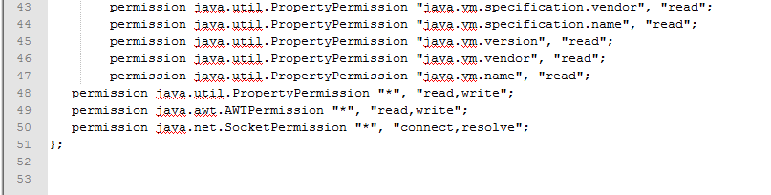

# Chrome 42 and later插件无法运行

<https://java.com/en/download/faq/chrome.xml#npapichrome>

#### Enabling NPAPI in Chrome Version 42 and later

As of Chrome Version 42, an additional configuration step is required to continue using NPAPI plugins.

1. In your URL bar, enter:  
   chrome://flags/#enable-npapi
2. Click the **Enable** link for the **Enable NPAPI** configuration option.
3. Click the **Relaunch** button that now appears at the bottom of the configuration page.

完成后效果如下：

