# Motor-controller windows development environment

## Preparation

* Install a git client
  + <http://git-scm.com/download/win>
  + Use default settings for everything but the following screen:  
    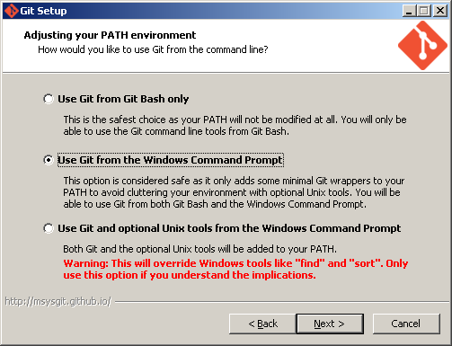
* Install node.js
  + <http://nodejs.org/>
  + Use default settings for installation.
* Install supervisor
  + Open a command shell
  + Enter following command  
    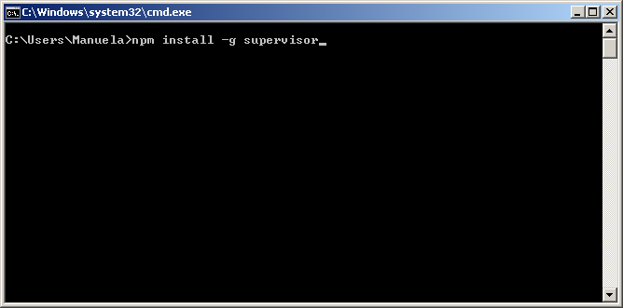
* Create a folder in a location you desire
  + Open a command shell in the specific folder  
    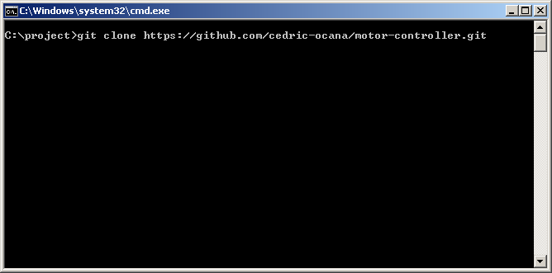
  + The result should look like this  
    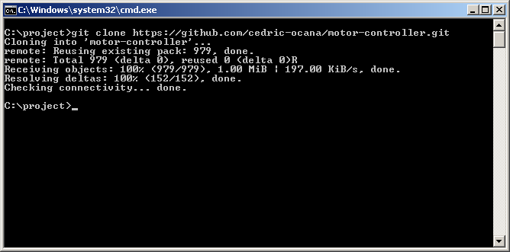

## Start the application

* Enter the subfolder motor-controller and enter the following command
  + 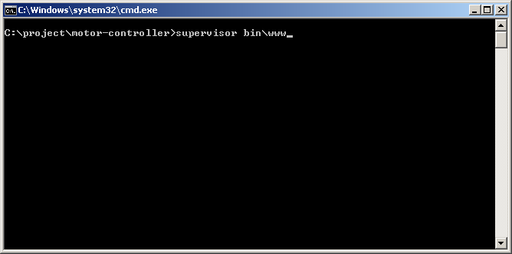
* The result is
  + 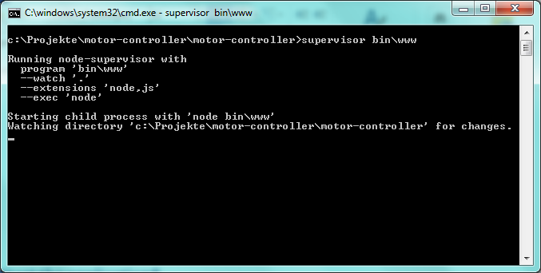
* Now navigate to:
  + <http://localhost:3000>
  + The result should look like this in the command shell

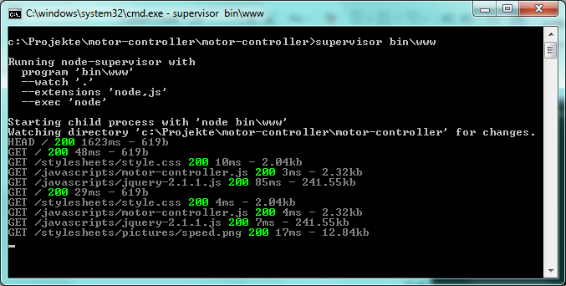

* + And like this in the webbrowser

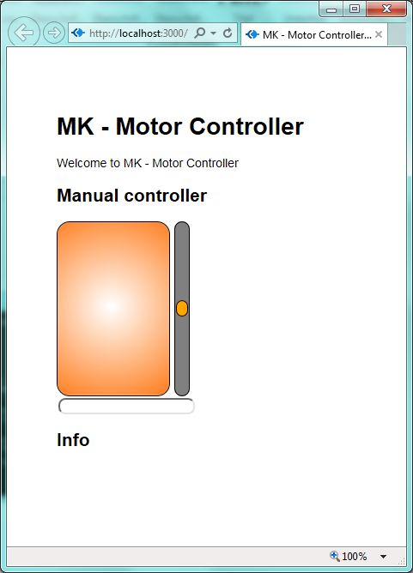

## Update from git

To get the latest updates from the git server open an command shell navigate to the directory where you executed the *git clone* command and enter

