Name: Ce Sun
UFID: 2043-9924
UF Email: sunce@ufl.edu

Project Structure
The project consists of the main class `bplustree` in the default package, and the implementation of the B+ Tree in the package named `dsimpl`, as shown in Illustration 1.

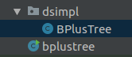
Illustration 1: Project Structure
For the sake of cohesion, all components are inner classes in `BPlusTree`. The structure of the `BPlusTree` class is as displayed in Illustration 2:
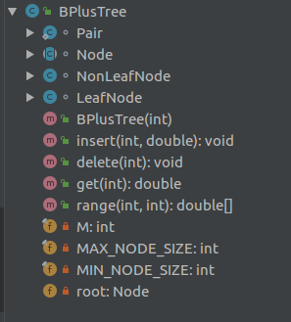
Illustration 2: BPlusTree class structure
Pair is an immutable class representing an dictionary pair, as displayed in Illustration 3.

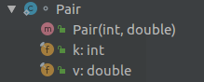
Illustration 3: Pair class
Node is an abstract class and is the super class of both LeafNode and NonLeafNode, it has only one field, namely the parent reference of a node. Illustration 4 shows the structure of Node class.

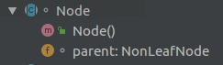
Illustration 4: Node class
LeafNode is where dictionary pairs are stored in a B+ tree. It is implemented by an ArrayList of Pair instances.
- 2 binary search methods are provided to find relevant index.
- Between returns all the v of (k,v) pairs stored in this node such that left<=key<=right, where left and right are the parameters of this method, respectively.
- Insert and delete trigger rebalancing if necessary.

Illustration 5 shows the structure of the LeafNode class.

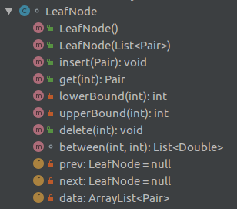
Illustration 5: LeafNode class
NonLeafNode is internal nodes used for navigation. Only integer keys are stored in NonLeafNode and is used to direct which child reference to descend to. It’s implemented by 2 ArrayList, one for keys and one for children references. The size of the children ArrayList is exactly one more than the keys, and the indice of the 2 ArrayLists correspond in the obvious way. Illustration 6 shows the structure of NonLeafNode.
- 2 binary search methods are provided for the same reason in LeafNode
- promisingChild(int k) navigates searching of key k (i.e. where to go)
- insert and delete trigger rebalancing if necessary.

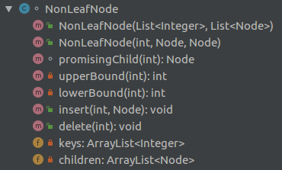
Illustration 6: NonLeafNode class

