Hansen Cédric

Chatbot Rapport

1. Informations

Our concept was to create a small chatbot capable of recommending you some song.

We decide to use as a host discord and to use python to write our chatbot. It’s not only easier to link our recommendation system to our input, but also helpful because in discord we can create a bot who can play some song. And if you got a song recommended to you, you obviously want to listen it.

1. Intent

To parse our intent, we create a dictionary of different intent: greetings, goodbye, help, yes, no, information’s, play, recommend. Thanks to an NLP library in python name NLTK we can get a list of synonyms of our intent. For example, the first synonym of goodbye is as follow:



We got this list of intent; we match with some regex code to see if our user message is link to some intent. We also retrieve variable from regex, for example in the phrase: “recommend me a metal song” we get the intent is a recommendation and metal are a genre.

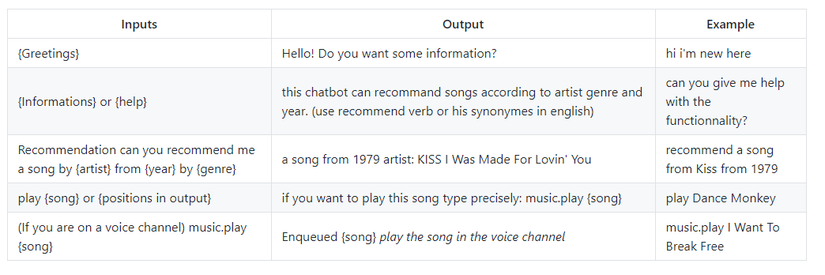

1. Recommandations

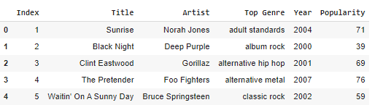

Our dataset is as follow, in order to recommend some song we filter by whatever year, artist and specifical genre we’ve got, then we show the most popular song according to the filter. Because the best way to recommend something to someone is to check the popularity among other people, especially people with the same taste.

1. Play Song

We use an open access python code from github which can retrieve a song from youtube or spotify, and giving the data to our bot. It’s the content of the file playmusic.py, on the other end the back of all our back is written

1. Heroku

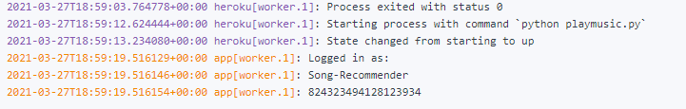

We upload our code to Heroku, this way it is always available. You can check our bot at https://discord.gg/ukfmUH5Q5e