TableView Manager

Overview
This Document describes how to use the TableView-Manager. The TableView Manger is a way to make TableView easy to use and configure. It has an Interface which functions could be implement in an own logic to simplify the work. The document shows accurately for each function how they have to be call in which order and for which purpose when you are about to build a TableView. The project is almost in built state that means some functions could be improved, names can be changed and other function can be added. That is why always take a look at the documentation before using the Manager.

Inhaltsverzeichnis
1. Initialize TableView Manager 1
2. Initialize Tables columns 1
2.1. Without giving columns name 1
2.2. With given columns name 1
3. Exclude columns 1
4. ApplyCellFactory 1
5. SetGraphics 1
6. Moi meme 1

Pre-Request
The first thing to do is to create an instance of TableViewManager and initialize the columns. After this two first steps you can do or call every function you want.

Initialize TableView Manager
Initialize TableViewManager by assigning the table to be configured to its construct.
table = new TableView<T>();
TableViewManager<T> tableViewManager = newTableViewManager<T>(table);

Initialize Tables columns
We will use a class call Task to illustrate our example along the documentation. This class contains attributes of every type.
public class Task {
@Id
private SimpleLongProperty id;
private SimpleStringProperty name;
private SimpleStringProperty description;
private ObjectProperty<Date> start_date;
private ObjectProperty<Date> end_date;
private SimpleLongProperty userID;
private SimpleLongProperty projectID;
private SimpleIntegerProperty projectActiv;

public Task() {
this.id = new SimpleLongProperty();
this.name = new SimpleStringProperty();
description = new SimpleStringProperty();
userID = new SimpleLongProperty();
projectID = new SimpleLongProperty();
projectActiv = new SimpleIntegerProperty();
start_date = new SimpleObjectProperty<>();
end_date = new SimpleObjectProperty<>();
}

public long getId() {
return id.get();
}
public void setId(long id) {
this.id.set(id);
}
public void setId(SimpleLongProperty id) {
this.id = id;
}

public String getName() {
return name.get();
}
public void setName(String name) {
this.name.set(name);
}
public String getDescription() {
return description.get();
}
public void setDescription(String description) {
this.description.set(description);
}
…

Without given columns name
The columns name will be represented by the fields name
tableViewManager.initColumnSetValueFactory(Task.class);
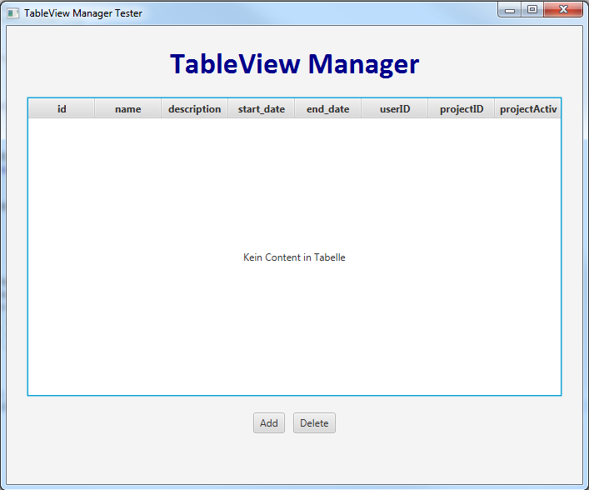

With given columns name
Map the columns name by assigning to each field the desired name and give the hash variable as argument to the init function.
HashMap<String, String> hmColName = new HashMap<String, String>();
hmColName.put("id", "1");
hmColName.put("name", "12");
hmColName.put("description", "13");
hmColName.put("start_date", "14");
…
tableViewManager.initColumnSetValueFactory(Task.class, hmColName);
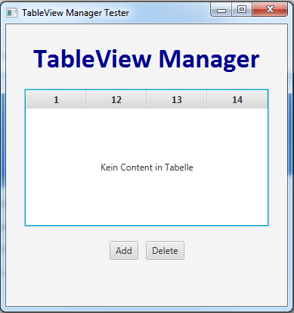

Exclude columns
To exclude the columns field you don’t need
tableViewManager.excludeColumns(Task.class, "id", "name");
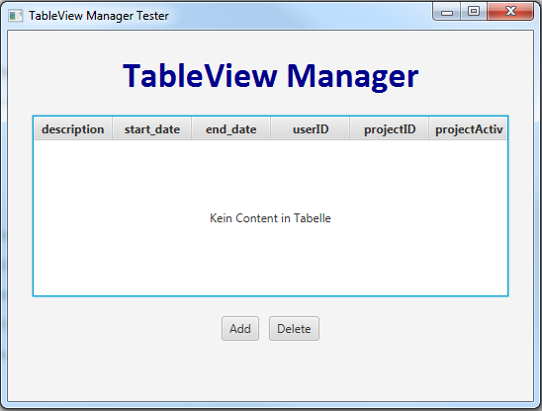

ApplyCellFactory
Consist on applying the three common cell factories (Combo-box, Checkbox and Text-field) on the table cell and perform a given operation after the enter-button has been clicked. The method to be performed is located in the class which must also be given.

Combobox Factory
tableViewManager.applyCellFactoryTo(CellFactoryTyp.COMBOBOXTABLECELL, data/*olList*/, "name");
tableViewManager.performOnEditCommit(Service.class, "update");

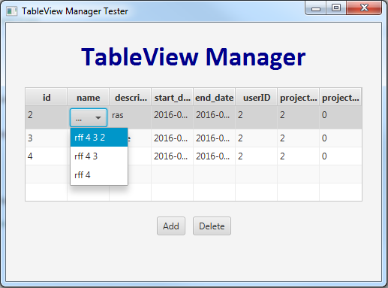

Textfield Factory

tableViewManager.applyCellFactoryTo(CellFactoryTyp.TEXTFIELDTABLECELL, data , "name");
tableViewManager.performOnEditCommit(Service.class, "update");

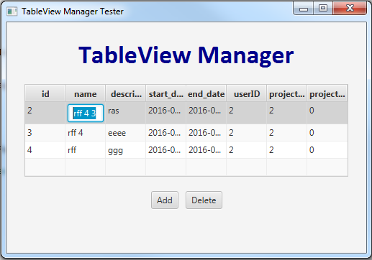

Checkbox Factory
tableViewManager.applyCellFactoryTo(CellFactoryTyp.CHECKBOXTABLECELL, dataT, "name");
tableViewManager.performOnEditCommit(Service.class, "update");
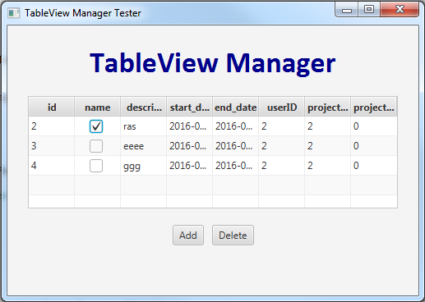

SetGraphics

