Nom : Prénom :

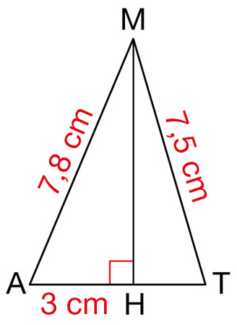
Exercice 1 (5 pts) : Le triangle MAT est représenté ci-contre. [MH] est la hauteur issue de M.
On connaît les longueurs suivantes : AM = 7,8 cm ; AH = 3 cm et MT = 7,5 cm.
Quelle est, en cm, la longueur du segment [MH] ?
_________________________________________
_________________________________________
_________________________________________
_____________________________________________________________
_____________________________________________________________
_____________________________________________________________
_____________________________________________________________
_____________________________________________________________
_____________________________________________________________
_____________________________________________________________
_____________________________________________________________
_____________________________________________________________
_____________________________________________________________
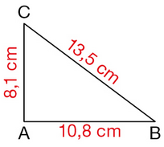
Exercice 2 (5 pts) : Le triangle ABC est tel que : AB = 10,8 cm ; AC = 8,1 cm et BC = 13,5 cm.
Le triangle RST est-il rectangle ? Si oui, en quel sommet ?
________________________________________
________________________________________
________________________________________
_____________________________________________________________
_____________________________________________________________
_____________________________________________________________
_____________________________________________________________
_____________________________________________________________
_____________________________________________________________
_____________________________________________________________
_____________________________________________________________
_____________________________________________________________
_____________________________________________________________
_____________________________________________________________
_____________________________________________________________
_____________________________________________________________
_____________________________________________________________
_____________________________________________________________
_____________________________________________________________

