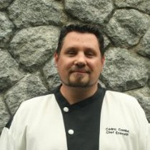
Cedric Combe
Marital status: Single status no children
Nationality: French
Date of Birth: August 07/08/1977
Perfect Knowledge in Cost control and Management software
(PRESTO, MMS, MICROS-FIDELIO, MICROSOFT, OFFICE and PROJECT)
French Certification on hygiene HACCP and ISO 22000 (2014)
Language: French mother tongue, English read, spoken, written
Availability: March /2016
Email: Ced.combe77@gmail.com mobil-phone : +66 613173450 Skype: cedric.combe77

Professional experience
November, 2014 to February 2016 (1 year and tree month)
Maikhao Dream and Spa 5 star Villa hotel in Phuket Thailand
Position: Executive Chef
22 luxury villa with oversized rooms minimum area (457 square meters) with a lavish private infinity pool and wooden deck with jet pool with stunning views of the sea.
World Luxury Spa Awards – 2015/2016- World Luxury Hotel nominee– 2016- 2015/2016- Awarded by Tripadvisor
Haute Grandeur Global hotel Awards nominee 2016
1 fine dining restaurant, 1 beachfront restaurant, 1 sea view bar & tapas, premium in-villa dining
Cuisine: creative French & Asian fusion
Number of seats per week: 500 / 800

Food cost monthly goal 29% directed 25% Staff Management: 25 chef
Reference: Elias Pertoft general director TEL: +66 993196903 mails: eliaspertoft@gmail.com
April 1, 2014 / September 31, 2014 (6 month)
Hideaway Beach Resort & Spa Maldives 5 star hotel -Private Island
Position: Executive Chef Consultant for the re-opening
A Member of the responsible Hotels of the World- World Luxury Hotel Awards – 2014- top 25 Hotels for Family’s in Asia 2012- Awarded by Tripadvisor- Best Small Hotels Maldives 2011- Awarded by International Hotels Award. Certificate of Excellence 2011- Awarded by Tripadvisor- Best Spa in a Beach Resort 2010- Awarded by Tripadvisor Award of Excellence 2010- Awarded by Wine Spectator-Indian ocean's Best Leading villa 2009- Awarded by World Travel awards.- Best Independent Hotel Worldwide, Runner Up 2008-Awarded by luxury travel Awards
Selection and design for one main kitchens and one Mediterranean restaurant ordering the small materiel for the 5 restaurant, Set up of all the restaurant, start the new materiel, standardize hygiene norm, creating supplier list menus and costing for all restaurant 1 Mediterranean, 1 asian,1 pizza grill ,1 Teppanyaki table 1 gastronomic level Michelin star , technical sheet for all the restaurant,
Staff training (51 chef), waiter training (65 waiter) steward training (19 steward)
Reference: Stephan Sandman general director TEL: +960 7925000 mails: stephansandmann@hotmail.com
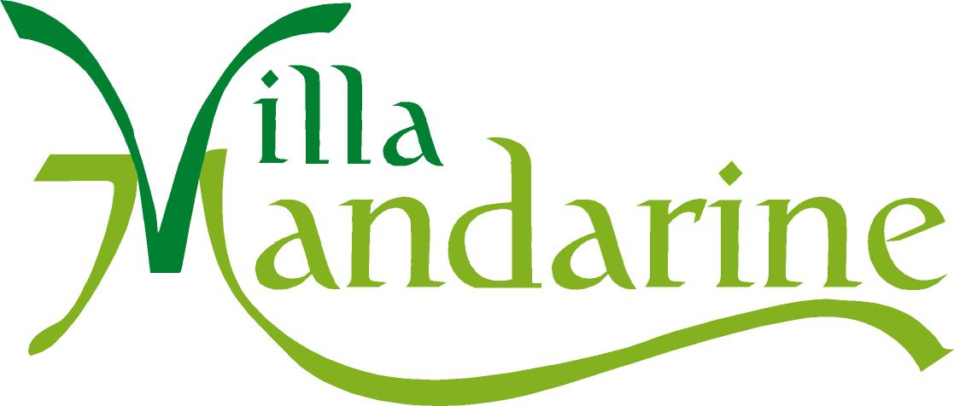
September 1 to March 31, 2014 (7 months) season as a dive master in Thailand + consulting for restaurant openings + training on hygiene HACCP and ISO 22000
September 1, 2011 / August 31, 2013: (2 year)
Villa Mandarine hotel (5 stars) Rabat Morocco
Position: Executive Chef
Travellers’Choice Award 2013
Publishing of a Moroccan Cuisine Cookbook with Marie-Claire, in collaboration with a second chef
Cuisine: creative French &fusion Cuisine level Michelin star
Number of seats per week: 2100
Monthly Banquet / 1800
Food cost monthly goal 32% directed 28% Staff Management: 28 people
Recognized as one of the best tables in Morocco, the restaurant, as well as the banquet and conference rooms of the Villa Mandarine is a reference for diplomats, government officials and businessmen for business lunches and private dinners with clients.
Reference: Antoine Ansart general director TEL: +212 661385003 mails: antoine@villamandarine.com

1 JUIN 2010 / 1JUIN 2011: (1 year)
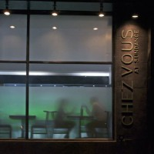
CHEZ-VOUS French Restaurant in MUMBAI, India
Position: Executive Chef (owner)
Number of seats per week: 2000
Catering / 3000 seats per week
Food cost monthly goal 30% directed 24% Staff Management: 50 people
Cuisine: French gourmet cuisine and Mediterranean fusion
Creation of the 1st French restaurant in Mumbai (Bombay), with overseeing of the works, purchasing of equipment, conception of the kitchen plans and equipment, training of the staff (80 staff ) as well as the suppliers.


1 DEC 2008 / 1 DEC 2009: (1 year)
The OURE LODGE, 4 star luxury pine islands New Caledonia
Position: Executive Chef
Number of seats per week: 1050
Monthly Banquet / 500
Food cost monthly goal 35% directed 31% Staff Management: 12 people
Cuisine: creative French& fusion Cuisine level Michelin star
Establishment of a gourmet restaurant and upgrade from luxury 3 stars to 4 stars Boutique Hotel.

March 1 to November 31, 2008 (9 months) tour of the world

1 OCT 2006 /1 MAR 2008 (2 year)
THE CHARLOTTE JANE BOUTIQUE HOTEL 5 stars New Zealand
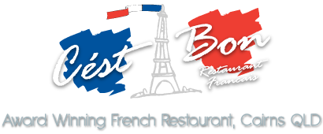
C’est bon RESTAURANT CAIRNS AUSTRALIA
Position: head chef & Executive Chef
Voted Best Restaurant in QUEENSLAND 3 times totally .during the mandate 1 times
Number of seats per week:1 500
Monthly / Banquet 1300
Food cost monthly goal 30% directed 29% Staff Management: 15 people
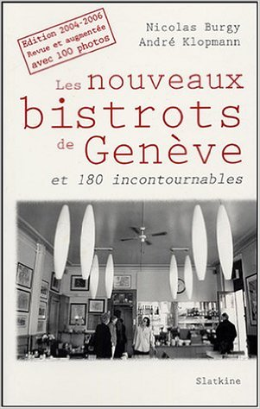
Cuisine: French gourmet cuisine. Creative market Cuisine, Mediterranean fusion


2 FEV 2000 / 1 SEPT 2006
Restaurant LE CAFE DU MARCHE (GENEVA) (3 year)
Restaurant- Le CHEVAL-BLANC (Carouge, GENEVA) (3 year)
Position: Chef de cuisine
Number of seats per week: 1000
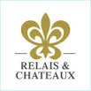
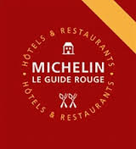
The CAFE DU MARCHE Restaurant voted ‘Bistro of the Year 2005’ with numerous articles in the Press and different guides. 13/20 at Gault&Millau
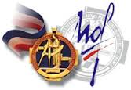
Food cost monthly goal 30% directed 27 % Staff Management: 5 to 7 people
Cuisine: French gourmet cuisine level Michelin star
1 November 95 / January 2000
Position: Chef to sous-chef
HÔTEL D’ANGLETERRE in GENEVA Mr. Brant Sous-chef of Mr. ROUX (3 étoiles Michelin)
Le PERRON Restaurant in GENEVA Gérard LEBOUHEC (2 star Michelin -17 /20 at Gault&Millau and Golden Key)
AUBERGE DU FLORIS in GENEVA Claude LEGRAS (maître ouvrier de France) 2 étoile Michelin-17/20 at Gault&Millau
AUBERGE DU LION D’OR COLOGNY GENEVA Gilles DUPONT & Tony BURN 16/20 at Gault&Millau and 2 star Michelin CASA-BLANCA Restaurant (TAHITI) (one of the best restaurant of Tahiti)

Apprentice Training: September 93/September 95

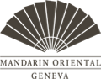
Hotel du Rhone (Mandarin Oriental 5 stars palace Geneva Switzerland) restaurant Neptune 2 stars Michelin17 /20 Gault &Milau Executive Chef: Gilles Dupont
DIPLOMA: Federal Capacity Certificate / 4th Best Apprentice in the ‘Gastronomia’ Cooking Competition

Activities Dive Master: Level 4 FFESSM Nitrox SCUBA, snorkeling

