BlocklistManager

**Version 1.8.3**

**10 March 2025**

Quick Start Guide

# GETTING STARTED

Execute BlocklistManager with no command line arguments from the location you installed it into, e.g: **%ProgramFiles**%**\BlocklistManager.exe**

The application will present its user interface:

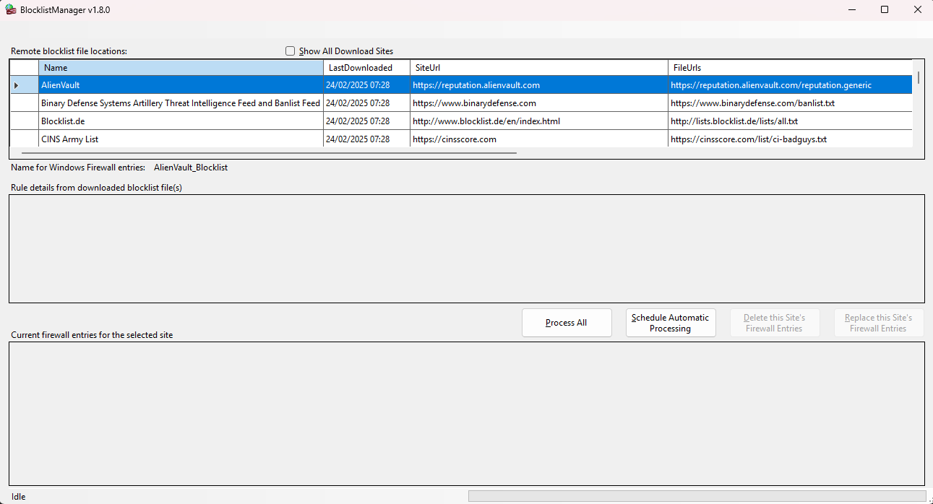

The first grid (“Remote blocklist file locations”) lists the details of the currently configured blocklist download sites:

Name: A descriptive name for a download site;

LastDownloaded: This is the most recent date and time (as UTC – Coordinated Universal Time) that blocklists were read from the site by your device;

SiteUrl: The main site URL of the blocklist provider;

FileUrls: One or more file URLs that blocklist data is read from

FileTypeID: The file type produced by the site (for internal processing purposes)

Active: Indicates whether or not the site is currently used

When you select a row in the grid (by clicking on it), the latest blocklist(s) are downloaded from that site, cleaned up, consolidated and displayed in the second grid ("Rule details from the downloaded blocklist(s)".

Any existing Windows Firewall rules previously created by the application are displayed in grey in the third grid.

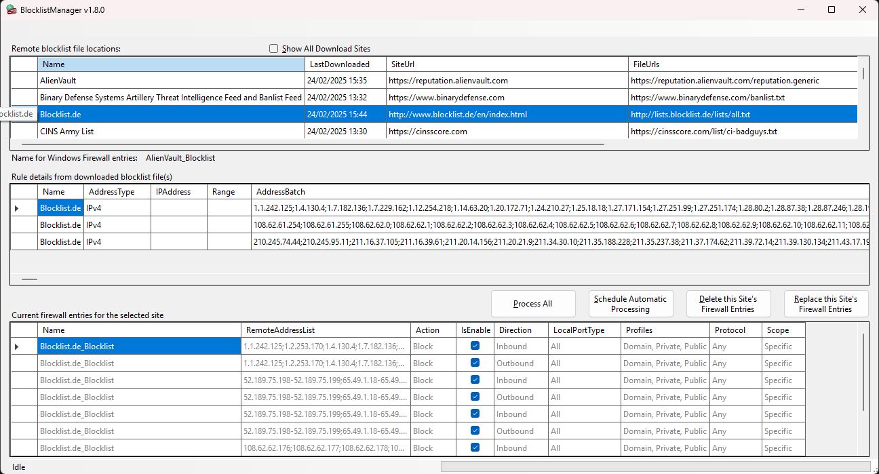

# OPTIONS / BUTTONS

## Process All

Clicking on this button will download blocklists from all active current blocklist sites and replace any existing Windows Firewall rules for these sites with new rules for the downloaded blocklists.

## Schedule Automatic Processing...

Clicking on this button opens a second form which makes the task of scheduling regular automated execution of the application as a background process a bit simpler and easier to get to than going through Windows:

(NOTE: Your screen will have more familiar content for “Author”, “Run under account” and the two log file directory paths)

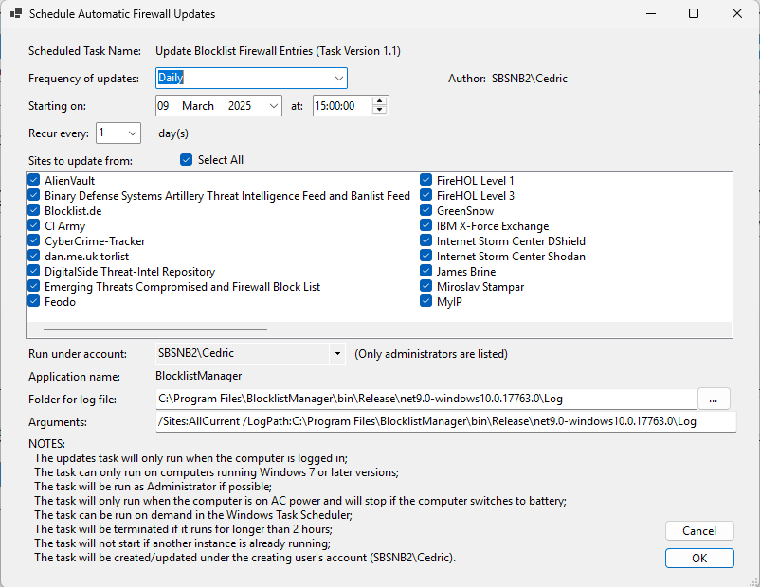

Notes:

1) Frequency: You can choose for the application to update firewall entries Hourly, Daily or Weekly. For “Recur every”, the available recurrence frequencies will depend on this selection.

2) The “Author” field should display the login name of the logged in user, or the user running the application if different from that.

3) You are able to select/deselect which sites you want updates to be processed for.

4) “Run under account” allows you to select an administrator account from a dropdown list of users who are members of the local computer “Administrators” group.

5) “Folder for log file” is the name of the directory which will contain the application log file. Note that the application only appends entries to the file so that history is accessible unless somebody deletes it.

6) “Arguments”: The application runs in background mode when at least a valid /Sites command line argument is provided. Valid command line arguments are:

- `/sites:` followed by a semicolon-separated list of site IDs to specify the blocklists to be processed, e.g. '/sites:1;2;3' or the value 'allCurrent' to process all active blocklists (e.g. '/sites:allCurrent').

- `/logpath:` followed by the path to the log file (e.g. '/logpath:C:\Logs').

Clicking on “Cancel” will cancel task creation and return to the main screen

Clicking on “OK” saves the new or modified scheduled task with a new task version number.

## Delete this Site's Firewall Entries

Clicking on this button will delete all firewall entries with the rule name composed of appending ‘_Blocklist’ to the name of the selected site in the first grid.

## Replace this Site's Firewall Entries

Clicking on this button will delete old rules and create new firewall rules for the selected site for the blocklist(s) which were downloaded when you clicked on the site’s row in the first grid.

# OTHER

BlocklistManager rules in the Windows Firewall can easily by isolated from other rules by filtering the firewall rules using Group Name “BlocklistManger”:

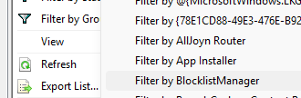

The BlocklistManager scheduled task in Windows Task Scheduler is placed in the BlocklistManager folder under Task Scheduler Library:

